Proteomic Strategy for Identification of Proteins Responding to DNA Damage by Platinum Anticancer Drugs
Fuyi Wang, PhD; Wenjuan Zeng; Yanyan Zhang, PhD；Institute of Chemistry, Chinese Academy of Sciences, P. R. China

Abstract
Statement of the Problem: Cisplatin, and the second and third generation of platinum anticancer drugs are classic cytotoxic chemotherapeutic drugs. They have been thought to attack DNA to form crosslinked DNA adducts which distort the conformation of DNA duplex, leading to cellular apoptosis and necrosis. However, the details about how cells respond to the DNA damages by the drugs and trigger a series of downstream signaling processes largely remain unclear. The purpose of this study is to develop novel MS-based proteomic methods to identify intracellular proteins which specifically respond to DNA damages by platinum anticancer drugs. Combined with bioinformatic analysis, the MS data were further analysed to elucidate the molecular mechanism of action of platinum drugs. Methodology: A 16-mer oligodeoxynucleotide (ODN) duplex and its 1,2-GpG-cisplatin-crosslinked adduct were immobilized on magnetic nanoparticles via click reaction, respectively, to fabricate negative and positive affinity probes which were utilized to capture and enrich proteins interacting with the intact ODN and cisplatin-crosslinked ODN from cellular protein extracts. The proteins enriched by negative and positive probes were individually digested by trypsin, and isotopically labelled by light and heavy alkylation reagents, respectively. Then the light and heavy labelled peptides were equally mixed for nanoLC-MS/MS analysis to identify the proteins specifically interacting with cisplatin-crosslinked ODN. Findings: HMGB1 and HMGB2, the well-established specific readers and binders of 1,2-cisplatin-crosslinked DNA, was found to bind predominantly to the cisplatin-crosslinked ODN, and five RNA or single-stranded DNA binding proteins, namely hnRNP A/B, RRP44, RL30, RL13 and NCL, were demonstrated for the first time to recognize specifically the cisplatinated ODN, indicating the significantly unwinding of the ODN duplex by cisplatin crosslinking. In contrast, the binding of a transcription factor TFIIFa to DNA was retarded due to cisplatin damage, implying that cisplatin lesion stalls DNA transcription.

Image

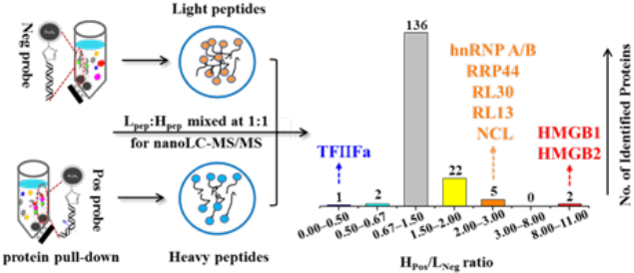
Figure 1. Schematic illustration of workflow of the capture, identification and quantification of proteins responding to cisplatin-crosslinked DNA by the proteomic method based on magnetic nanoparticle affinity probes and mass spectrometry.
Recent Publications
- Du J, Wang FY et al. (2018) A Photoactive Platinum(IV) Anticancer Complex Inhibits Thioredoxin-Thioredoxin Reductase System Activity by Induced Oxidization of the Protein, Inorganic Chemistry 57:5575-5584.
- Liu SY, Wang FY et al. (2017) Correlated mass spectrometry and confocal microscopy imaging verifies the dual-targeting action of an organoruthenium anticancer complex, Chemical Communications, 53:4136-4139.
- Du ZF, Wang FY et al. (2014) Mass Spectrometric Proteomics Reveals that Nuclear Protein Positive Cofactor PC4 Selectively Binds to Crosslinked DNA by a Trans-platinum Anticancer Complex, Journal of the American Chemical Society, 136:2948-2951.
- Zhao, Y, Wang FY, Sadler PJ et al. (2013) De Novo Generation of Singlet Oxygen and Ammine Ligands by Photoactivation of A Platinum Anticancer Complex, Angewandte Chemie International Edition, 52:13633 –13637.
5. Xi ZY, Wang FY, Liu YZ et al.(2013) Copper binding promotes the interaction of cisplatin with human copper chaperone Atox1, Chemical Communications, 49:11197-11200

Biography (150 word limit)
Fuyi Wang is a full professor in Chemistry at the Institute of Chemistry, Chinese Academy of Sciences. He has his expertise in development and application of mass spectrometry based methods for investigating the molecular mechanism of action of metal-based anticancer drugs. He has built a series of MS-based approaches to decipher the binding sites of metal-based anticancer drugs/candidates to DNA and proteins, and to explore the effect of such interactions on the structure and function of the biological targets. Up to date, Dr. Wang has published more than 100 papers in high impact international journals such as Journal of the American Chemical Society, Angewandte Chemie, Chemical Communications and Analytical Chemistry.
Email: fuyi.wang@iccas.ac.cn

Notes/Comments:

