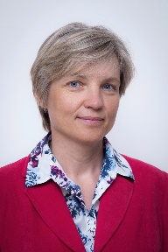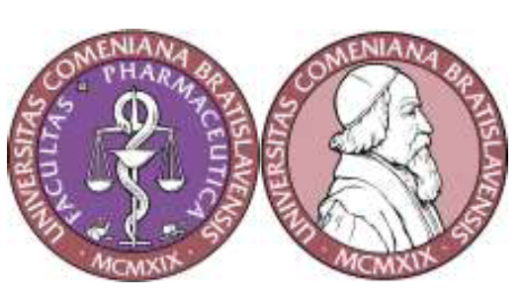
Title: Identification of designer drugs by real time-mass spectrometry (DART-MS)
Jindra Valentová
Comenius University in Bratislava, Slovakia
Abstract:
Over the past decade, the availability of new psychoactive substances on European illicit drug market has increased considerably. These new synthetic compounds often termed „designer drugs“ or „legal highs“ exhibit modified molecular structure as compared to the established illicit substances. Synthetic cannabinoids and cathinones make up the largest groups of designer drugs.They were developed with the intention of mimicking the effect of traditional illicit drugs of abuse and are aimed at circumventing the laws regulating sale and use of controlled substances.
Wide structure diversity limits the possibilities of their detection with conventional colour tests or immunoassays. Great effort is undergoing to develop new methods for identification and quantification of these modern drugs, in particular new mass spectrometry techniques. DART (Direct Analysis in Real Time) mass spectrometry is an ambient ionization method which allows direct analysis of all types of samples (solid, gas, liquid) without the need for any sample preparation.
In our work, the usefulness of DART ion source in combination with the high-resolution ORBITRAP mass spectrometer is demonstrated for screening of cathinones and synthetic cannabinoids. Several different cannabinoids in complex herbal matrices were detected. The analysis enabled rapid detection of these substances without the necessity of pre-treatment of the samples. This method could be also used for fast and reliable identification of contamination of e.g. money notes touched with fingers stained by illicit drugs.

Biography
Assoc prof. Jindra Valentova, PhD is associate professor and vice-dean at Faculty of Pharmacy, Comenius University in Bratislava. Her research interest is focused on bioanalysis of new pharmaceuticals and illicit drugs using modern mass spectrometry methods. She is leader of numerous research domestic and international projects and she has published more than 50 papers in reputed journals.

valentova@fpharm.uniba.sk

