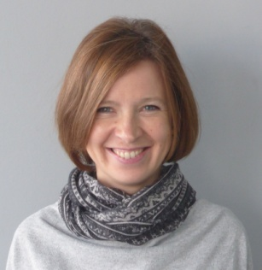
Title of speech: Total reflection X-ray fluorescence spectrometry (TXRF) as a convenient tool for quantification of biological samples
Name: JOANNA FIEDOR
AGH-University of Science and Technology, Poland
Abstract: (up to 250 Words)
Total reflection X-ray fluorescence spectrometry (TXRF) is one of the well-established spectroscopic techniques used for elemental profiling of variety of samples. Among its major advantages the extension of the detection limit to one part per billion, simplicity of sample preparation along with the need of only 10⁻⁶ to 10⁻⁹ g of the material, and, eventually versatility of application should be highlighted. Apart from a number of non-biological studies, TXRF has been successfully used in medical, pharmaceutical, nutritional and other biologically-derived quantification analyses. However, not much has been done on bacterial systems. One of the few examples might be the examination of the ionome of phototrophic bacteria. Purple non-sulphur bacteria constitute a unique group of “photosynthetic” organisms capable of adjusting their metabolism in response to alteration of environmental growth conditions (light intensity, oxygen pressure). Recently, purple bacteria have attracted considerable attention due to their potential in a range of scientific and industrial applications. In view of the lack of consistent and systematic information on their microelemental content, the aims of the recent study were to qualify and quantify trace elements present in intact cells, bacterial phototrophic membranes and selected photosynthetic structures as well as to gain information on their distribution and mutual correlation in response to change in oxygen growth conditions. Finally, usefulness and vast analytical potential of TXRF was verified and confirmed.
Biography (up to 100 words)
Joanna Fiedor received her Ph.D. degree in Biochemistry at the age of 33 from the Jagiellonian University, Kraków, Poland. From 1997-1999 she worked at the Ludwig- Maximilians University (LMU) in Munich, Germany, and in 2002 at the Kwansei Gakuin University, Sanda, Japan. Currently, she is an Assistant Professor at the AGH-University of Science and Technology, Kraków, Poland. Her research interests are focused on natural biocompounds in relation to human health.
fiedor@agh.edu.pl

