Photo Tokyo University of Marine Science and Technology,
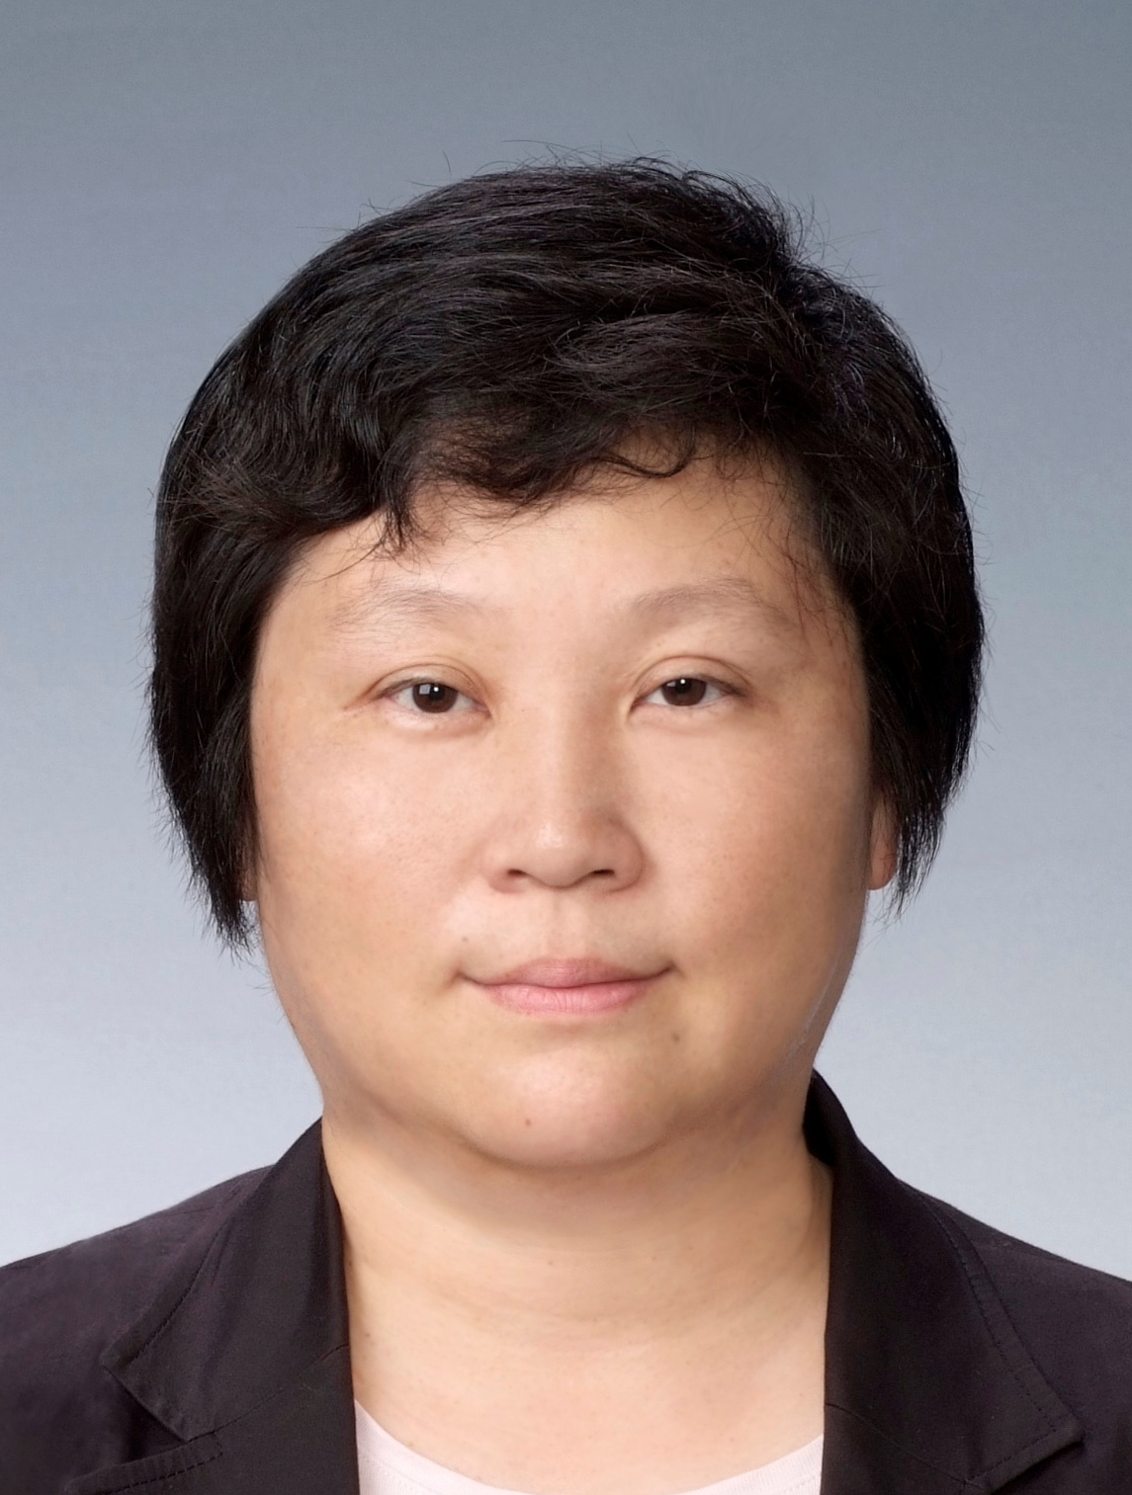
Title of speech: Laser ablation inductively coupled plasma mass spectrometry for quantitative imaging of elements in ferromanganese nodule
Name: Miho TANAKA・Junichi HIRATA
University/ Organization, Country：Graduate School of Marine Science and Technology, Tokyo University of Marine Science and Technology, 4-5-7 Konan，Minato-ku，Tokyo 108-8477, Japan

Abstract: (up to 250 Words)
Laser ablation inductively coupled plasma mass spectrometry (LA-ICP-MS) has been used for the quantitative elemental imaging of ferromanganese nodules to obtain the distributions of both major and trace elements, owing to its high sensitivity and wide dynamic range. In our study, data treatment system was developed for the quantitative imaging of elements in ferromanganese nodules. For obtaining a calibration line, a signal of Mg was monitored as an internal standard for correction. The validity of the values determined by LA-ICP-MS was confirmed by comparison with elemental contents obtained by ICP-MS. A two-dimensional plotting system for LA-ICP-MS was established for expressing elemental contents as colors along with spatial information. The simple method describes the ease with which the colors can be changed to define the content ranges of elements, and the elemental distributions show the layered structure, clearly depicting the contrast. Reproducibility of these analytical processes was also confirmed by analyzing two ferromanganese nodules. The method is expected to be a powerful tool for investigating paleo-environmental changes in the region surrounding a ferromanganese nodule and its formation processes.
Biography (up to 100 words)
Miho TANAKA completed PhD at the age of 28 years from The Tokyo University (Tokyo, Japan). She is specialized in Analytical Chemistry, Solution Chemistry and Mass spectrometry. Presently, she is actively involved in “chemical speciation” in solution, as well as other topics. She has published more than 70 papers in peer reviewed journals, and is the corresponding author in 90% of them.
Mail Id: mihotnk@kaiyodai.ac.jp
Co-author: Junichi HIRATA got his PhD at the age of 27 from Tokyo University of Marine Science and Technology. He is presently working at Materials Characterization Research Lab. Advanced Technology Research Labs. Nippon Steel & Sumitomo Metal Corp.

