A Novel Microfluidic Biosensor for Rapid Detection of Foodborne Bacteria
Xuan Weng, PhD, School of Mechanical and Electrical Engineering, University of Electronic Science and Technology of China, Chengdu, Sichuan, 611731, China

Abstract (300 word limit)
Vibrio parahaemolyticus is one of the foodborne bacteria that widely present in seafood as well as the leading cause of seafood-associated bacterial gastroenteritis. Traditional identification of such pathogens mainly relies on culturing methods, ELISA or PCR. These methods are usually laborious, time-consuming with poor diagnosis competences, or require costly and bulky equipment though of high sensitivity. In this project, we proposed a thread-based microfluidic electrochemical biosensor for rapid and accurate detection of V. parahaemolyticus in pure culture and raw food sample. Threads were used to fabricate the microchannel network as well as the electrodes for the electrochemical measurement. The V. parahaemolyticus aptamer functionalized MoS2 nanosheets were immobilized on the thread-based electrodes for selective sensing. A variation in charge on the surface of the electrode can be generated by the interaction between targeted bacteria and specific aptamer. The presence of targeted bacteria would result in decreased current output and the decreasing degree of which is associated with the concentration of the targeted bacteria in the sample. When used in detecting Vibrio parahaemolyticus, the proposed biosensor had a dynamic detection range of 10–106 CFU mL−1 with a detection limit of 5.74 CFU mL−1. Compared with traditional plate counting method, the proposed biosensor had higher detection sensitivity and less assay time (30 min), while high specificity and accuracy are kept. It can be concluded that the proposed thread-based electrochemical biosensor provides a rapid, easy-to-use, low cost and accurate method for the detection of foodborne bacteria, and it is promising for point-of-care and on-field assay. For the future developments of such microfluidic electrochemical biosensor, emphasis can be placed on the optimization of the conjugation protocol and binding chemistry of bio-receptors with viable nanomaterials to further enhance the sensitivity while withstanding regeneration conditions, multiplexed detection, regeneration of the used biosensor, integration of on-chip sample preparation unit, etc.

Image
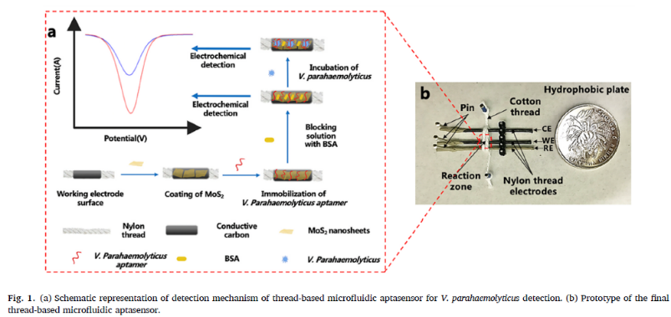

Recent Publications (minimum 5)
- Weng, X., Zhang, C., & Jiang, H. (2021). Advances in microfluidic nanobiosensors for the detection of foodborne pathogens. LWT, 112172.
- Jiang, H., Guo, Q., Zhang, C., Sun, Z., & Weng, X. (2021). Microfluidic origami nano-aptasensor for peanut allergen Ara h1 detection. Food Chemistry, 365, 130511.
- Jiang, H., Sun, Z., Guo, Q., & Weng, X. (2021). Microfluidic thread-based electrochemical aptasensor for rapid detection of Vibrio parahaemolyticus. Biosensors and Bioelectronics, 182, 113191.
- Weng, X., Kang, Y., Guo, Q., Peng, B., & Jiang, H. (2019). Recent advances in thread-based microfluidics for diagnostic applications. Biosensors and Bioelectronics, 132, 171-185.
- Gong, Y., Jiang, H., Bai, Y., Wu, Z., Peng, B., & Weng, X. (2019). Numerical Studies of Electrokinetically Controlled Concentration of Diluted DNA Molecules in a T-Shaped Microchannel. IEEE Access, 8, 5601-5610.


Xuan Weng’s primary research focus on Microfluidics and Lab-on-a-Chip in the fields of biomedical, food safety and environmental monitoring for the point-of-care (POC) applications. Within this work frame, she has conducted many projects on microfluidic system development towards portable devices capable of rapid, accurate, automated detection and raw-sample-to-result capabilities.
Email: xuanweng@uestc.edu.cn

Notes/Comments:

Presenting author details
Full name: Xuan Weng
Contact number: 1-028-61830229
Mail id: xuanweng@uestc.edu.cn
Category: Oral presentation

