A 30 second, 98.6% sensitive home test for SARS-CoV-2
Mark R Baker D,Phil, Medichain Ltd. Complex Systems Laboratory UK

Abstract (300 word limit)

Statement of the Problem:. Existing tests for SARS-CoV-2 like PCR slow, expensive and and the case of lateral flow insensitive. There is a need for better for flash testing and variants.

Findings: Our method detects the early immune response by looking at variation in the leucocyte ratios, a methods that we publisehed in the peer reviewed press in 2020.

Using training data from the COVID-19 Risk and Treatments (CORIST) collaboration and the Moli-Sani Project, both from southern Italy, comprising WBC differential data for 72 positive (RT-PCR confirmed) and 4742 negative COVID patients, respectively, two variations of the test were applied. Algorithmic ensemble CLDC 21-04- SE optimized for sensitivity has a sensitivity of 97·29% and specificity of 67·95%. Algorithmic ensemble 21-04-SP has a sensitivity of 81·82% with a specificity of 96·50%.

Using data from the Regional Service for the Epidemiology and Surveillance of Infectious Diseases database, a longitudinal cohort study of 379 patients with laboratory-confirmed COVID-19 admitted at the Italian National Institute for Infectious Diseases “Lazzaro Spallanzani” (INMI), in Rome (Italy). The 21-04-SE algorithm showed a sensitivity of 98·64% during the first seven days during symptom onset and 96·73% sensitivity for data taken over 21 days after initial symptoms. The 21-04-SP algorithm showed a sensitivity of 79.0%.

Conclusion & Significance:

We have a robust repeatable test for SARS-CoV2 with a turnaround time of 30 seconds for a self-test from patient presenting to getting a positive or negative result. The ability to turn around tests very rapidly and de-skill the data collection promises to have a massive impact on COVID worldwide. The fact that no test laboratory is needed, just a smartphone, and the tests can be carried out by an unskilled individual gives a huge improvement.
Image
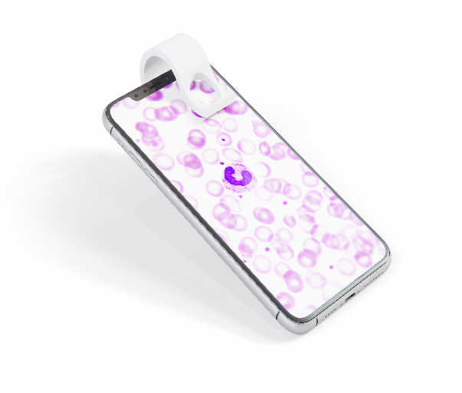
Recent Publications (minimum 5)
.
- Baker, M.R., Early Mass Detection of COVID-19 using Characteristic Differential Leucocyte Count. Life Research, 2020.
- Di Castelnuovo, A., et al., Common cardiovascular risk factors and in-hospital mortality in 3,894 patients with COVID-19: survival analysis and machine learning-based findings from the multicentre Italian CORIST Study. Nutr Metab Cardiovasc Dis, 2020. 30(11): p. 1899-1913.
- Dropkin, G., Covid-19: Safety of lateral flow tests questioned after they are found to miss half of cases. 2020: BMJ.
- Horton, S., et al., The Top 25 Laboratory Tests by Volume and Revenue in Five Different Countries. Am J Clin Pathol, 2019. 151(5): p. 446-451.
- Iacoviello, L., et al., The Moli-Sani Project, a randomized, prospective cohort study in the Molise region in Italy; design, rationale and objectives. Italian Journal of Public Health, 2012. 4(2).

Biography (150 word limit)
Paste your Logo here
Mark Baker Doctorate (D.Phil) in Cancer Research, University of Oxford, Post Doctoral Fellowship with UK National Physical Laboratory (UK Standards Authority) and University of Cambridge. Head of Laboratory in the Medical Research Council's Brain and Behaviour Centre, University of Oxford University and NHS's Radcliffe Infirmary, Oxford. Chief Technology Officer Peerius (Episerver) - Europe's Largest AI & Predictive Analytics provider, Project lead & Scientist Johnson & Johnson. Imperial College & King's College Alum. Designs research systems running in universities such as Harvard. Associate of the Royal College of Science. Fellow of the Royal Astronomical Society.
Email: mark.baker@medichain.online

Notes/Comments:

Presenting author details
Full name: Dr Mark R Baker
Contact number: +44 843 523 5110
Mail id:
Category: (Oral presentation)

