A Case Report on Listeria monocytogenes Meningoencephalitis, Acute Disseminated Encephalomyelitis, and Cytomegalovirus Viremia in an Immunocompromised Patient on Steroid Therapy
Roberto Salvino, MD; Rainier Mark Alegria, MD; Ma. Isabel Duavit, MD; Ana Marie Javelosa, MD

ABSTRACT

Introduction
Listeria monocytogenes is an opportunistic pathogen that affects immunocompromised patients and has a very high mortality rate. Central nervous system (CNS) infection and bacteremia are the foremost clinical manifestation in susceptible hosts. Infection with multiple pathogens is not common but still possible especially in the immunocompromised.

Case
Presenting a 57-year-old female with chronic kidney disease from probable glomerulonephritis treated with prednisone for 7 weeks. She was admitted for progressive neurologic symptoms that began with Broca’s aphasia followed by decreased level of consciousness and fever. There was also concomitant hematochezia. Empiric treatment for CNS infection and pneumonia with intravenous (IV) Ceftriaxone, Vancomycin, Metronidazole, and Acyclovir were given. Lower gastrointestinal bleeding from jejunal angioectasia was treated and resolved. Cerebsospinal fluid (CSF) and blood cultures turned positive for Listeria monocytogenes on the 3rd hospital day. Antimicrobial regimen was shifted to Ampicillin and Meropenem. Marked clinical improvement was evident 1-2 days after anti-infectives were shifted. Blood CMV PCR was positive on the 9th hospital day thus IV Ganciclovir was started. Meropenem was shifted to Cefepime and Metronidazole due to progression of pneumonia. On the 16th hospital day, there was recurrence of Broca’s aphasia. Non-contrast Brain MRI showed multiple tiny subcortical white matter FLAIR hyperintense foci in the right frontal area with noted low CSF IgG. Acute disseminated encephalomyelitis (ADEM) treatment with Dexamethasone was effective and improved speech production after 3 days. Antimicrobial treatment resolved the infection and the patient was discharged coherent and conversant.

Conclusion
The authors conclude that early detection and treatment of Listeria infection is essential for a good prognosis. Infection with multiple pathogens should be watched out for in susceptible hosts. ADEM may develop post CNS infection and should be watched for.


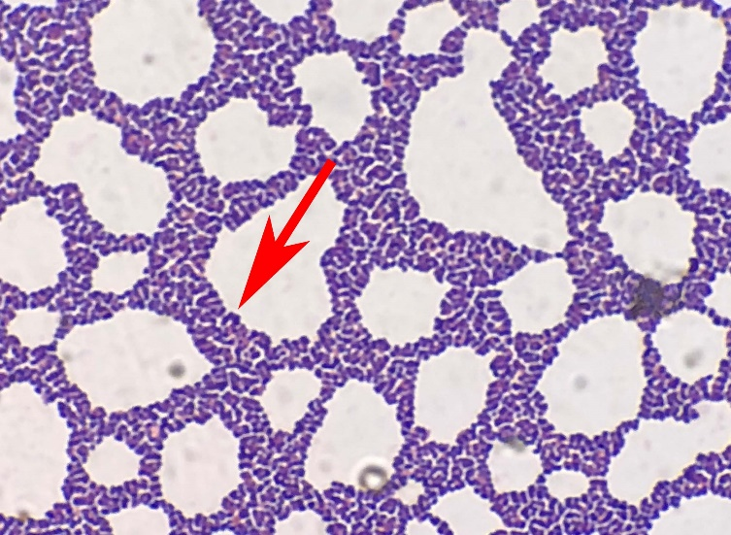
Figure 1. Gram stain of culture growth of cerebrospinal fluid, showing Listeria monocytogenes, gram positive rods

REFERENCES
- Buchanan, R., Gorris, L., Hayman, M., Jackson, T. and Whiting, R. (2017). A review of Listeria monocytogenes : An update on outbreaks, virulence, dose-response, ecology, and risk assessments. Food Control, 75, pp.1-13.
- Chp.gov.hk. (2018). Epidemiology of Listeriosis and Prevention Strategies [online] Available at: https://www.chp.gov.hk/files/pdf/epidemiology_of_listeriosis_and_prevention_strategies_r.pdf [Accessed 20 Aug. 2018].
- F. Arslan, E. Meynet, M. Sunbul et al., “The clinical features, diagnosis, treatment, and prognosis of neuroinvasive listeriosis: a multinational study,” European Journal of Clinical Microbiology and Infectious Diseases, vol. 34, no. 6, pp. 1213–1221, 2015.
- M. C. Brouwer, A. R. Tunkel, and D. van de Beek, “Epidemiology, diagnosis, and antimicrobial treatment of acute bacterial meningitis,” Clinical Microbiology Reviews, vol. 23, no. 3, pp. 467–492, 2010.
- Franciotta, D., Columba-Cabezas, S., Andreoni, L., Ravaglia, S., Jarius, S., Romagnolo, S., Tavazzi, E., Bergamaschi, R., Zardini, E., Aloisi, F. and Marchioni, E. (2008). Oligoclonal IgG band patterns in inflammatory demyelinating human and mouse diseases. Journal of Neuroimmunology, 200(1-2), pp.125-128.

Rainier Mark Alegria, MD is an Internal Medicine Resident of Asian Hospital and Medical Center. He aspires to improve the quality of health-care in the Philippines by being very active in research and case publication.

Email: rainier.alegria@gmail.com

