Role of co-inhibitory pathways during experimental infection by Trypanosoma cruzi Tulahuen strain.
Yanina H. Arana P, PhD candidate, BNITM, Germany
Rosa Grote-Galvez, PhD candidate, BNITM, Germany
Thomas Jacobs, PD Dr., BNITM, Germany

Abstract
Statement of the Problem: The protozoa parasite Trypanosoma cruzi is the etiological agent of Chagas disease or American trypanosomiasis. Nearly 18 million people in Latin America and 90 million worldwide are at risk of infection. To establish life-long infections which are often asymptomatic or with digestive or cardiac alterations that can lead to host death, T. cruzi must subvert the host immune system employing several strategies that involve effectors and regulatory mechanisms. Preliminary studies have shown that during chronic parasite infections, Ag-specific T cells become dysfunctional, upregulate the expression of inhibitory receptors, involving these regulatory pathways in the control of the infection. Recent studies have shown that T. cruzi modulates the expression of these receptors on lymphocytes after the infection however, there are a variety of natural strains of T. cruzi and it appears that their immune modulatory effects are strain-dependent, a feature that may influence parasite-host interaction. The aim of this study is to evaluate the role of two inhibitory pathways: BTLA:HVEM and PD-1:PD-L1 during the experimental infection by T. cruzi Tulahuen strain in a murine model, focusing on the effects of a blockade of these pathways as a potential strategy to design future therapeutic approaches for Chagas disease. Methodology & Theoretical Orientation: Knockout mice for these inhibitory molecules were employed in a previously established infection model. The immune response was evaluated by flow cytometry and cytokine analysis by cytometric bead assays. Findings: BTLA and PD-1-deficiency was not associated with a reduced parasitemia neither improved resistance to infection. No difference in the frequency of activated T cells or other immune cells populations were observed in both groups of infected knockout mice in comparison to control groups, however reduced levels of cytokines (IL-2, IL-6 and IL-9) were observed in both infected knockout mice. Strikingly, upon PD-1:PD-L1 blockade, upregulation of another inhibitory receptor (Tim-3) were observed on activated T cells. Conclusion & Significance: In vivo assays demonstrated that these inhibitory pathways might play an important role in the control of parasite during infection. The interruption of these pathways could not improve the resistance to the infection but favored a pronounced exhaustion stage of immune cells suggesting a compensatory mechanism, specifically upon PD-1:PD-L1 blockade that induced the upregulation of another inhibitory receptor (Tim-3) during the infection, mechanism that have been reported to be involved in the anti PD-1 therapy resistance in several cancers.

Image

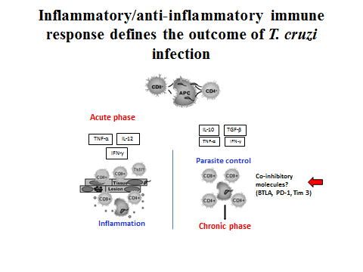
Recent Publications
- Shayan G and et al. (2017) Adaptive resistance to anti-PD1 therapy by Tim-3 upregulation is mediated by the PI3K-Akt pathway in Head and Neck cancer. Oncoimmunology Vol. 6, N°1 (11 pages).
- Mateus J and et al. (2017) Antiparasitic treatment induces and improved CD8+Tcell response in chronic chagasic patients. The Journal of Immunology 198: 1-10.
- Lasso P and et al. (2015) Inhibitory receptor expression on CD8+Tcells is linked to functional responses against Trypanosoma cruzi antigens in chronic chagasic patients. The Journal of Immunology 195: 3748-3758.
- Kamphorst A and et al. (2013) Manipulating the PD-1 pathway to improve immunity. Current Opinion in Immunology 25: 381-388.
- Gutierrez F and et al. (2011) Regulation of Trypanosoma cruzi-induced myocarditis by programmed death cell receptor 1. Infection and Immunity Vol. 79, N°5: 1873-1881.

 Biography
Yanina Arana has been involved in the study of several infectious diseases that are considered public health problems in many Latin American countries. By her interest in science, she has participated in different research projects showing compromise, autonomy and valuable analytical skills that allowed to her to lead a research group in Cysticercosis in collaboration with other national and international professionals in this disease. Her expertise in several methodologies, leadership, objectivity and criticism has been reflected in her publications. Currently, she develops her doctoral thesis project at the BNITM focusing in the evaluation of regulatory pathways during the Trypanosoma cruzi infection. This experience, allow her to obtain valuable theoretical knowledge and practical skills that will be of benefit for the continuity of her research in her institution in Peru as a member of a group that have the aim to form researchers that contribute to the solution of health problems that affect this country.
Email: sterella@hotmail.com

Notes/Comments:

