A tetravalent subunit vaccine candidate against dengue viruses based on domain III-capsid proteins induces a functional immune response in mice and monkeys

Lázaro Gil, PhD, Center for Genetic Engineering and Biotechnology, Cuba

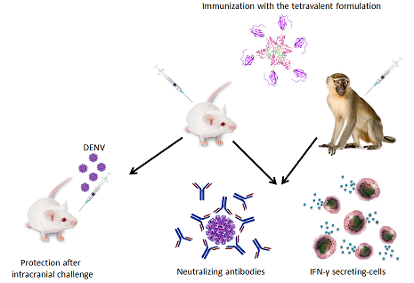
Abstract

Dengue virus (DENV) is the most prevalent mosquito-borne virus affecting humans. Infection with any of the four dengue serotypes can cause a range of clinical manifestations that goes from self-limiting illness to potentially lethal severe dengue disease. ChimeriVaxTM, a dengue vaccine developed by Sanofi Pasteur, has recently been registered in a number of countries. However, this vaccine has exhibited low protective capacity against DENV-1 and DENV-2 during efficacy trials conducted in endemic areas, despite the induction of neutralizing antibodies. The Cuban vaccine candidate is based on recombinant proteins that contain two viral regions to induce B and T cells: the domain III of the envelope protein and the capsid protein. The chimeric protein from DENV-2 (domain III-capsid (DIIIC-2)), when presented as aggregated incorporating oligodeoxynucleotides, induced antiviral and neutralizing antibodies, cellular immune response, and conferred significant protection to mice and monkeys. After this proof of concept the remaining constructs were obtained and characterized using mice and human DENV-positive sera. Later, the immunogenicity, in terms of humoral and cell-mediated immunity, and the protective capacity of each protein were assessed in mice. Significant protection was afforded as measured by the limited viral load in the mouse encephalitis model. The assessment of the tetravalent formulation (Tetra DIIIC) in non-human primates also demonstrated that the formulation induced neutralizing antibodies and memory cell-mediated immune response with IFN-γ-secreting and cytotoxic capacity, regardless the route of immunization used. On the other hand, Tetra DIIIC is able to recall memory B and T cell responses induced in monkeys by an experimental dengue virus infection, suggesting this vaccine candidate can be combined with live-attenuated viruses under different prime-boost regime of immunization. Taken together, it can be asserted that the tetravalent formulation of DIIIC proteins constitutes a promising vaccine candidate against dengue virus.
Image

Recent Publications
- Gil L, et al. (2015) The protein DIIIC-2, aggregated with a specific oligodeoxynucleotide and adjuvanted in alum, protects mice and monkeys against DENV-2. Immunol Cell Biol 93:57–66
- Gil L, et al. (2015) A novel tetravalent formulation combining the four aggregated domain III-capsid proteins from dengue viruses induces a functional immune response in mice and monkeys. Int Immunol 27(8):367–79.
- Valdés I, Gil L, et al. (2016) Could an experimental dengue virus infection fail to induce solid immunity against homologous viral challenge in non-human primates? Arch Virol 161:465–470.
- Marcos E, Lazo L, Gil L, et al. (2016) Dengue encephalitis-associated immunopathology in the mouse model: Implications for vaccine developers and antigens inducer of cellular immune response. Immunol Lett 176:51–56.
- Gil L, et al. (2016) A tetravalent formulation based on recombinant nucleocapsid-like particles from dengue viruses induces a functional immune response in mice and monkeys. J Immunol 197(9):3597-3606.

 Biography
Lázaro Gil earned his PhD in Biological Sciences in 2010. Dr. Gil has worked on the fields of Virology and Immunology to develop different antigens for vaccine against Dengue virus. Dr. Gil has been the recipient of numerous awards including: five National awards of the Cuban Academy of Sciences, National Health awards and a National award from the Ministry of Science and Technology of Cuba. He has also been tutor of Bachelor and Doctoral theses and has revised several theses to obtain Bachelor, Master or PhD degree. Dr. Gil has presented his researches in international conference meetings and workshops and his works has been published in several peer-review international journals: Journal of General Virology, The Journal of Immunology, Immunology and Cell Biology, Virology, Vaccine, International Immunology, Viral Immunology, Clinical and Vaccine Immunology, Archives of Virology, Immunology Letters among others.

Email: lazaro.gil@cigb.edu.cu

Notes/Comments:

