EVALUATION OF THE PULMONARY ARTERY PRESSURE DURING PERCUTANEOUS TRANSVENOUS MITRAL COMMISSUROTOMY IN RHEUMATIC MITRAL STENOSIS.
Dr. Ananda G.C.
Chitwan Medical College, Bharatpur, Chitwan, Nepal

Introduction:
Rheumatic heart disease is one of the most common heart diseases in developing country. One of the most common complications of Rheumatic Heart Disease is Mitral Stenosis which ultimately lead to pulmonary hypertension and heart failure and death. So, PTMC (Percutaneous Transluminal Mitral Commissurotomy) is a well established simple, effective and safe therapeutic intervention for mitral stenosis.
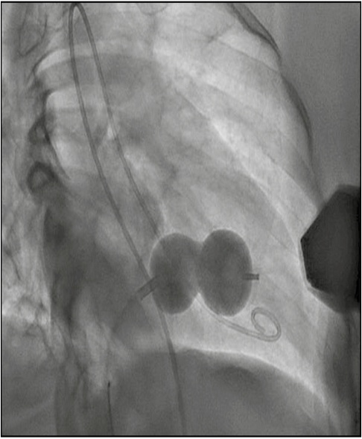
While many literatures reviewed till date have shown that it takes 3-6 months time period for the reduction of pulmonary artery pressure after PTMC, this study is designed to see the result in pulmonary artery pressure immediately after procedure.
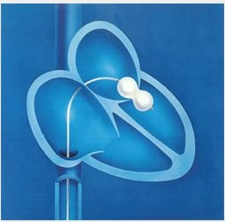

Method

Total 42 patients with Rheumatic Mitral Stenosis in Cath Lab under Department of Cardiology of Chitwan Medical College from October 1 2018 to August 30 2019 were included in the study. Pulmonary artery pressure was assessed by Right heart catheterization by using multipurpose /pigtail catheter under conscious sedation.

Results
It is a prospective observational study on a total of 42 patients who underwent PTMC, 30 were female and 12 were male. Age ranged from 30 to 61 years with the mean age of 45.36±10 years. The mean mitral valve area increased from 0.87±0.2 cm2 to 1.74±0.17 cm2 whereas Mean Pressure Gradient decreased from 13.59± 7.30 mmHg to 5.15±30 mmHg. Mean Pulmonary Artery Pressure decreased from 41.50 ±16.00 mmHg to 33.50±12.00 mmHg. Similarly, the mean left atrial pressure decreased from 26.57±8.62 mmHg to 15.50±5.95 mmHg whereas, the mean Aortic Pressure increased from 91.43 ±23.02 mmHg to 98.29±24.92 mmHg . Eighteen (42.85%) patients had an increase in MR by 2 grades but there is no need of immediate mitral valve replacement. During procedure, paroxysmal PSVT was noted in six (14.285%) patients and also local hematoma was observed in five (11.90%) patients.

Conclusion
There is reduction in pulmonary artery pressure immediately post PTMC which is directly correlated with left atrial pressure without significant MR and tachycardia.
This study is limited in terms of single center with small sample size.

