A case of misdiagnosed cardiomyopathy with rising plasma MMP9 long before sudden cardiac arrest

Annamaria Vianello,
Gabriele Monasterio Foundation, Pisa, Italy

Abstract
Introduction. Out-of-hospital cardiac arrest in the absence of structural heart disease is rare and can be due to subclinical cardiomyopathy or primary electrical disorders. Adverse collagen remodeling may occur in cardiac arrest patients; MMP-9 are proven to help risk stratification.
Clinical case description. In 2005, R.R, a 35 year old metal-worker, surprisingly began to show high values of MMP9. TIMPs, MMP2, NT-pro-BNP, all the other laboratory tests, abdominal echography, electrocardiogram, echocardiography were within the reference range.
Ten years later, R.R suddenly collapsed at home; his wife promptly began a successful cardiac massage, supported by territorial Tele-Emergency Network. R.R was admitted to the Intensive Unit with frequent ventricular extrasystoles, left ventricular dysfunction. Two paternal uncles died suddenly; mother with Takotsubo syndrome. Unremarkable clinical examination and electrocardiogram. No biochemical evidence of acute myocardial infarction; CRP elevation. Unobstructed coronary arteries on coronary angiography. Mild interstitial fibrosis on chest X-ray. No signs of arrhythmogenic cardiomyopathy on Cardio-NMR. Discharge diagnosis: ”Resuscitated cardiac arrest, in subject without evidence of structural heart disease, treated with ICD bicameral system”.
Reviewing clinical information and diagnosis. Familial history of sudden death, mild endocardial irregularities, left ventricle enlargement, reduced ejection fraction, low EKG voltage are suggestive of “familial cardiomyopathy”. Welding, chest X-ray fibrosis, RCP are suggestive of “welder’s lung”. Then, reformulated diagnosis is: “Resuscitated cardiac arrest in subclinical familial cardiomyopathy, chronically subjected to a professional cardio-toxic damage”
Conclusions and implications for clinical practice. R.R lethal arrhythmia was firstly considered as “idiopathic” in nature, since process laboratory and radiology testing were not analyzed properly. Interestingly, long before cardiac arrest, MMP9 had begun to rise, announcing a cardio-pulmonary adverse remodeling. The case of R.R teaches us that early biomarkers such as MMP9, correct and timely diagnosis, Tele-Medicine and Emergency Services Network could really save lives of patients at high risk of sudden death.

Image

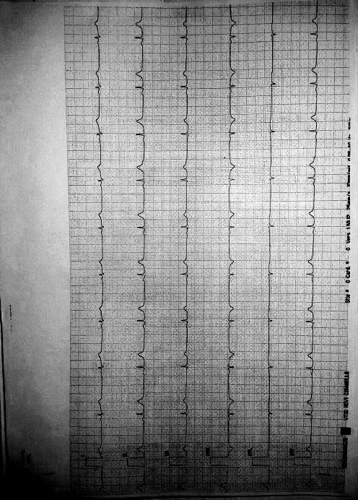
Figura 1. Low EKG voltage on peripheral leads.
Recent Publications
- Flevari P, Theodorakis G, Leftheriotis D, Kroupis C, Kolokathis F, Dima K, Anastasiou-Nana M, Kremastinos D (2012) Serum markers of deranged myocardial collagen turnover: their relation to malignant ventricular arrhythmias in cardioverter-defibrillator recipients with heart failure. Am Heart J 164 (4):530-537.
- Turkdogan KA, Zorlu A, Guven FM, Ekinozu I, Eryigit U, Yilmaz MB (2012) Usefulness of admission matrix metalloproteinase 9 as a predictor of early mortality after cardiopulmonary resuscitation in cardiac arrest patients. Am J Emerg Med 30(9): 1804-1809.
- Hästbacka J, Tiainen M, Hynninen M, Kolho E, Tervahartiala T, Sorsa T, Lauhio A, Pettilä V (2012) Serum matrix metalloproteinases in patients resuscitated from cardiac arrest. The association with therapeutic hypoyhermia. Resuscitation 83(2): 197-201.
- Fang AC, Cassidy A, Christiani DC (2010) Systematic Review of Occupational Exposure to Particulate Matter and Cardiovascular Disease. Int J Environ Res Public health 7: 1773-1806.
- Schiff GD, Hasan O, Kim S, Abrams R, Cosby K, Lambert BL, Elstein AS, Hasler S, Kabongo ML, Krosnjar N, Odwazny R, Wisniewski MF, McNutt RA (2009) Diagnostic error in medicine: analysis of 583 Physician-Reported Errors. Arch Inter Med 169(20): 1881-1887.

 Biography

Annamaria Vianello graduated in Medical School at Pisa University, where she obtained Specialization both in Internal Medicine and in General Medicine, PhD both in “Medical Physiopathology and Pharmacology” and in “Normal and Pathological Morphology of Cells and Tissues” and a second-level Short Specialization Degree in “Clinical Pharmacological Research”. She obtained a second-level Short Specialization Degree on “Hypertrophic Cardiomyopathies” at Pavia University. She worked as fellow at Department of Internal Medicine and Sport Medicine, Pisa University; at Heart Hospital of Massa, CNR, Italy. Her research interests are Athlete’s Heart Remodeling, Failing Heart Remodeling and Cardio-Renal Remodeling. She is currently coordinating a Tele-Health Project for out-of-hospital Care of Chronic Heart Failure. She is author of original papers dealing with the clinical role of circulating and tissue profiles of inflammatory biomarkers, MMPs and TIMPs in different models of heart remodeling such as Athlete’s Heart, Valvular Heart Disease, Cardio-Renal Failure and Chronic Heart Failure.

Email: annamariavianello@med.unipi.it

