Characterization of the Extreme Hydrophilic & Oleophobic Behaviors of Bioengineered Ultrapure Nanocellulosic Gels

Lucian Lucia†‡§*, Zahra Ashrafi†
†Fiber and Polymer Science, NC State University, Campus Box 7616, Raleigh, North Carolina 27695, United States
‡Department of Forest Biomaterial, NC State University, Campus Box 8005, Raleigh, North Carolina 27695, United States; Department of Chemistry, NC State University, Campus Box 8204, Raleigh, North Carolina 27695, United States
§State Key Laboratory of Bio-based Materials & Green Papermaking, Qilu University of Technology / Shandong Academy of Sciences, Jinan City, Shandong Province 250353, PR China

The development of an innovative interfacial wetting strategy known as liquid infused systems offers great promise for design of super-wetting and super-antiwetting substrates that overcome the drawbacks of textured surfaces classified as Cassie/Wenzel states. The value of such nature-inspired surfaces can address practical scientific and technological challenges within interfacial chemistry such as ease of manufacture, separation efficiency, rechargeability, anti-fouling, and robustness. For example, we demonstrate that nanocellulose fibers from bacteria can form a high-performance three-dimensional crosslinked network confining a dispersed liquid medium such as water that leads to interfacial engineering marvels. More specifically, the strong chemical and physical interactions between dispersed water molecules and entangled cellulosic network endow these substrates with effective liquid separation capabilities.
This type of phenomenon is green virtually without antecedent in the literature; its performance relative to natural or synthetic media is superior. We demonstrate bacterial cellulosic membranes offer a stable liquid infused system with superwettability and adhesion to thus address traditionally intractable issues associated with solid surfaces.
In the quest for developing sustainable materials that utilize natural polymers such as cellulose, many attempts have been attempted which often require time-consuming multi-step processing, but more importantly, they are elaborated by harsh chemical reagents and high temperatures compared to the systems in this report.^{1,2,3,4,5} For instance, Chang et al. fabricated a nanoporous cellulose membrane derived from renewable marine resources for oil-water separation as a sustainable replacement for carbon nanotubes. However, to isolate cellulose from natural resources, strong acid hydrolysis at 70 ºC with bleaching is necessary.⁶ In another example, a cellulose sponge with robust superwettability properties for separation application was reported. Although the membrane is effective and greener than its polymeric counterparts, the fabrication step requires dissolution of cellulose in ZnCl₂ at 80 ºC with additional pore-forming agents.⁷
Bacterial nanocellulose membrane, however, is obtainable by a very sustainable and ecofriendly biosynthesis to offer filtration that is sufficiently efficient for separating oil-water nanoemulsions which makes it far more powerful and efficient compared to existing superhydrophilic-superoleophobic cellulosic membranes that often require harmful chemicals.
In our study, water-infused nanocellulosic membranes produced by bacteria in a static cultivation method were investigated as green promising materials that meet the criteria of the liquid infused systems for oil-water separation. Bacterial cellulose membranes have already seen great exposure; however, the purpose of current work was to examine these materials from a fundamental perspective. We explored a very unique aspect of bacterial cellulose that had not been studied previously. This study introduces a proof of concept for exploiting BC membranes as a liquid infused system. Further in-depth studies are required to fully utilize the intrinsic potential of these superior biomaterials for practical applications and technical developments, but that is beyond the current report. Nevertheless, these membranes display superhydrophilicity and superoleophobicity with ultralow oil-adhesion properties that arise from—
- A unique three-dimensional porous network made up of cellulose nanofibers that have an extraordinarily high surface area that can easily trap water molecules; moreover, the entangled cellulosic network not only provides a confined structure for trapping water, but also contain richly abundant pendant hydroxyl groups that play a crucial role in oil repellency;
- the native hydrophilicity of the cellulose polymer. The large number of hydroxyl groups on the backbone of the cellulose polymer chains allow for hydrogen bonding with water molecules as evidenced by its extremely excellent water sorption (> 97% of its dry weight).
The bacterial nanocellulose membrane used in the current report was produced by Gluconacetobacter hansenii. For the inoculation of this bacteria strain, the standard sterilized Hestrin & Schramm media (HS media) was used which contains sugar and protein as a nutrient source. As shown in Figure 2B, bacteria grow in this media to gradually synthesize an extracellular matrix (ECM) also known as a pellicle (mat) at the air/liquid interface that becomes thicker over time.
Bacterial nanocellulose membrane feature high purity; yet, to expose larger numbers of hydroxyl groups and greater pore volumes, we treated them with very mild alkali solution to remove bacterial cells from the bulk of the membrane. After treatment with a mild alkali solution the residual cells removed serendipitously results in more void spaces that effectively trap water.
Figure 1 shows the super-hydrophilicity and super-oleophobicity of the BC membrane. Figure 1A illustrates a droplet of light oil (n-dodecane 3 µL, surface tension 24.91 @ 20 °C in mN/m) on a BC membrane immersed in water. As is evident, the oil contact angle of 174.5 ± 2.5° exceeds by a large margin the established super-oleophobicity threshold (> 150°). BC membrane surfaces with a stable, intercalated lubricant water layer therefore demonstrate no contact line pinning and hence the oil droplet base is circular in shape and not elongated; this latter result proves that it is impossible for a small underwater oil droplet to adhere and foul the surface of the water-infused BC membrane. Figure 1B demonstrates super-spreading properties of the membrane for water, a phenomenon that can be justified by the chemical composition as well as the pores in the BC membrane.
To test the under-oil water repellency of the BC membrane, oil-impregnated BC membranes were prepared. For that, a piece of BC membrane was freeze-dried in order to maintain pore structures. The obtained dry membrane was soaked in an n-dodecane liquid until fully wetted. As shown in Figure 1C, once the water droplet touches the surface of the oil infused BC membrane immersed in oil media, it infiltrates the membrane in under two seconds. One explanation for such a behavior is that hydroxyl groups show better chemical compatibility with the water droplet when it comes into contact with the surface.
Underwater oil-adhesion tests were dynamically measured using an oil droplet (n-dodecane 2 µL) suspended on a microsyringe needle tip (Figure 1D). First, the oil droplet was placed in contact with the membrane surface, pushed against the surface, and retracted. However, the oil droplet was strongly repelled from the surface and showed no adhesion force toward the surface. In fact, the oil droplet did not leave the needle during the entire process even after pushing it forcefully toward the surface. When the microsyringe was lifted, the oil droplet did not deform and leave any residue on the surface of the membrane. As shown, the water-impregnated layer of the BC membrane, whose surface is homogenous and smooth due to the present of the water layer, exhibited a very low contact angle hysteresis of 1.7±0.6 toward the oil droplet.

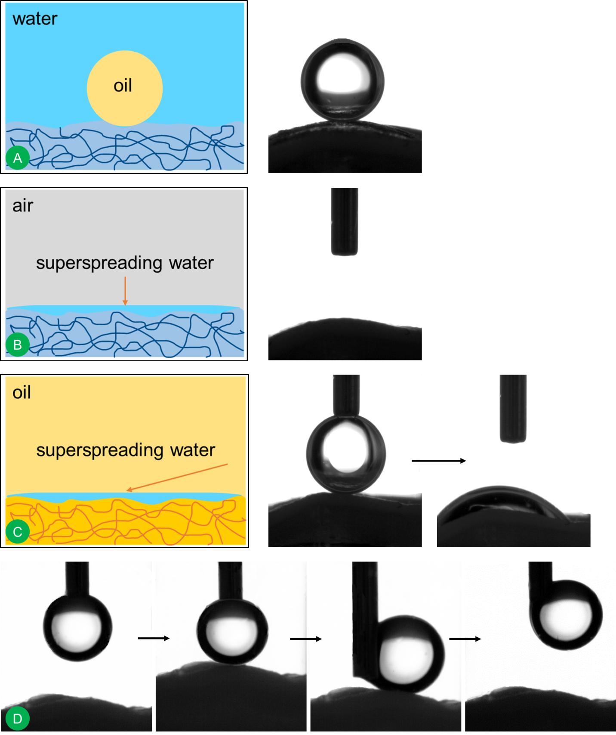
Figure 1. A) Illustrates the under-water super-oleophobicity properties of a BC membrane from the static contact angle of an oil droplet (n-dodecane) on the water infused BC membrane. B) Super-hydrophilicity properties of the BC membrane; no matter if the membrane is in dry or wet state, the water droplet spreads on the surface immediately. C) Shows under-oil static contact angle of a water droplet on an oil infused BC membrane. D) Ultralow oil adhesion properties of a BC membrane in water shown by dynamically pushing the oil droplet toward the membrane surface.

Water-infused BC membranes repel immiscible liquids of virtually any surface tension. For instance, the oil-water separation property of the membrane was investigated (Figure 2). A feed of oil-water mixture (20 ml:25 ml) was passed through a wet BC membrane (effective diameter: 47 mm, thickness: ~ 300 µm) without any external pressure (gravity-driven) to yield a clear permeate (water) with no oil droplets after less than 30 seconds, highlighting the fact that that an oil phase can be separated from the mixture with extremely high separation efficiency.
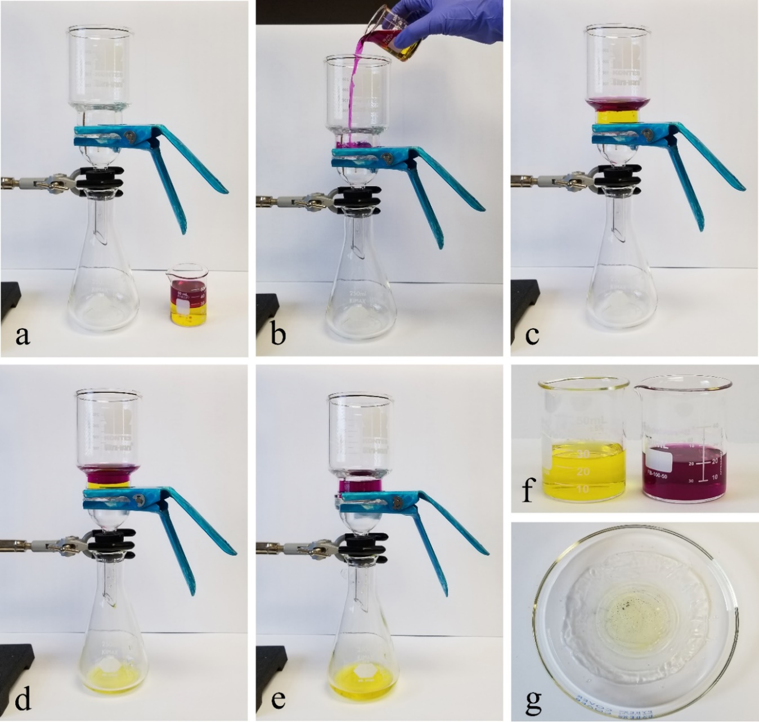
Figure 2. Oil–water separation using a water-infused BC membrane. (a) Experimental setup. (b) A mixture of water 25 ml (yellow color) and hexane 20 ml (purple color) was poured into the upper glass jar. (c-e) filtration takes place. (f) The filtrate (left) and the oil phases remained on top of the membrane (right). (g) Membrane after filtration. The yellow hue revealing that it can even concentrate aqueous dyes from the feed solution.

The underlying mechanism behind this separation phenomenon is referred to as gating. Gating occurs when the capillary-stabilized water in pore structures form a reconfigurable doorway which selectively allow water to pass through the membrane while prohibiting oil molecules from penetration. Therefore, gating enables water-infused BC membranes to effectively suppress fouling and oil clogging. Meanwhile, reusability of the membrane was studied by adding new oil-water mixture to the upper tube to reveal no reduction in separation efficiency and filtration flux. This result proves that this membrane has resistance to oil fouling; therefore, separation can be repeated as long as the BC membrane remains water infused. It should be noted that BC membrane can be washed for reuse with a mild alkali solution after each use to remove any contamination during handling and utilization. The membrane maintained a separation efficiency > 99.9 % and stable recyclability even after 5 cycles (Figure 3A).
The permeability of a water-oil mixture through BC membranes of different thicknesses was measured. In Figure 3B, the water flux was inversely proportional to the thickness of the membranes. In contrast, water permeance through the membranes increased linearly as a function of feed pressure over 0–20 psi (Figure 3C). A membrane of thickness = 312 ± 54 µm exhibited an appreciable gravity-driven pure water flux of 1350 ± 260 L.m⁻².h⁻¹ which is in the range of commercial filters.⁸
It is very difficult and challenging to design a substrate that confines a liquid layer robustly; yet, the lack of interaction between impregnated liquid and substrate can affect the repellency performance and stability of the whole system. In fact, a infused liquid film may drain under external shear flow and pressure due to the lack of proper entrapping and thus negatively impact the operation of the whole system.^{9,10} The under pressure filtration efficiency results showed that a thin BC membrane is able to withstand high pressures up to 20 psi without a concomitant reduction in filtration efficiency (Figure 3C). Even 100 psi pressure did not cause damage to membrane integrity.

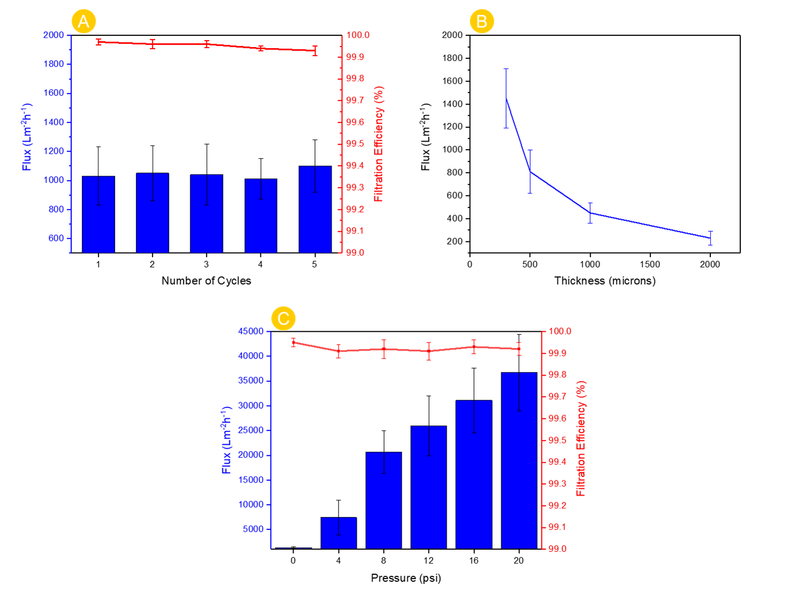
Figure 7. A) The reusability and anti-oil fouling properties of the membrane (membrane thickness = 290 ± 47 µm). B) Thickness-dependent changes in permeability of filtrate through the membrane. C) Influence of pressure on the water flux and filtration efficiency (membrane thickness = 312 ± 54 µm).

In conclusion, we provide the first account of a bacterial cellulose membrane displaying underwater superoleophobicity with ultralow oil-adhesion properties due to its intrinsically powerful water absorbing / retention capacities. Meanwhile, the presence of a micro re-entrant surface texture due to the inherent curvature of nanofibers led to the establishment of a stable Cassie state / composite interface where water forms a continuous defect-free overlying film. A BC membrane can thus be a promising alternative to overcome the weak intermediary liquid trapping ability of artificial porous matrices made of metals, ceramic, etc.

REFERENCES
(1) Hong, S. K.; Bae, S.; Jeon, H.; Kim, M.; Cho, S. J.; Lim, G. An Underwater Superoleophobic Nanofibrous Cellulosic Membrane for Oil/Water Separation with High Separation Flux and High Chemical Stability. Nanoscale 2018, 10 (6), 3037–3045.
(2) Sai, H.; Fu, R.; Xing, L.; Xiang, J.; Li, Z.; Li, F.; Zhang, T. Surface Modification of Bacterial Cellulose Aerogels’ Web-like Skeleton for Oil/Water Separation. ACS Appl. Mater. Interfaces 2015, 7 (13), 7373–7381.
(3) Goetz, L. A.; Jalvo, B.; Rosal, R.; Mathew, A. P. Superhydrophilic Anti-Fouling Electrospun Cellulose Acetate Membranes Coated with Chitin Nanocrystals for Water Filtration. J. Memb. Sci. 2016, 510, 238–248.
(4) Kollarigowda, R. H.; Abraham, S.; Montemagno, C. D. Antifouling Cellulose Hybrid Biomembrane for Effective Oil/Water Separation. ACS Appl. Mater. Interfaces 2017, 9 (35), 29812–29819.
(5) Ashrafi, Z.; Mazinani, S.; Ghareaghaji, A. A.; Lucia, L. Fabrication of Cross-Linked Starch-Based Nanofibrous Mat with Optimized Diameter. TAPPI J. 2019, 18 (6), 381–389.
(6) Cheng, Q.; Ye, D.; Chang, C.; Zhang, L. Facile Fabrication of Superhydrophilic Membranes Consisted of Fibrous Tunicate Cellulose Nanocrystals for Highly Efficient Oil/Water Separation. J. Memb. Sci. 2017, 525, 1–8.
(7) Wang, G.; He, Y.; Wang, H.; Zhang, L.; Yu, Q.; Peng, S.; Wu, X.; Ren, T.; Zeng, Z.; Xue, Q. A Cellulose Sponge with Robust Superhydrophilicity and Under-Water Superoleophobicity for Highly Effective Oil/Water Separation. Green Chem. 2015, 17 (5), 3093–3099.
(8) Shi, Z.; Zhang, W.; Zhang, F.; Liu, X.; Wang, D.; Jin, J.; Jiang, L. Ultrafast Separation of Emulsified Oil/Water Mixtures by Ultrathin Free-Standing Single-Walled Carbon Nanotube Network Films. Adv. Mater. 2013, 25, 2422–2427.
(9) You, A.; Be, M. A. Y.; In, I. Overflow Cascades in Liquid-Infused Substrates. Phys. Fluids 2015, 27, 082101–082113.
(10) Zhang, P.; Liu, H.; Meng, J.; Yang, G.; Liu, X.; Wang, S.; Jiang, L. Grooved Organogel Surfaces towards Anisotropic Sliding of Water Droplets. Adv. Mater. 2014, 26, 3131–3135.

