

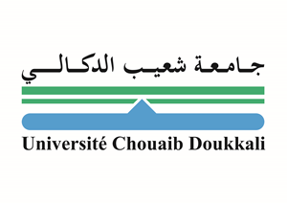

Paste your Logo here
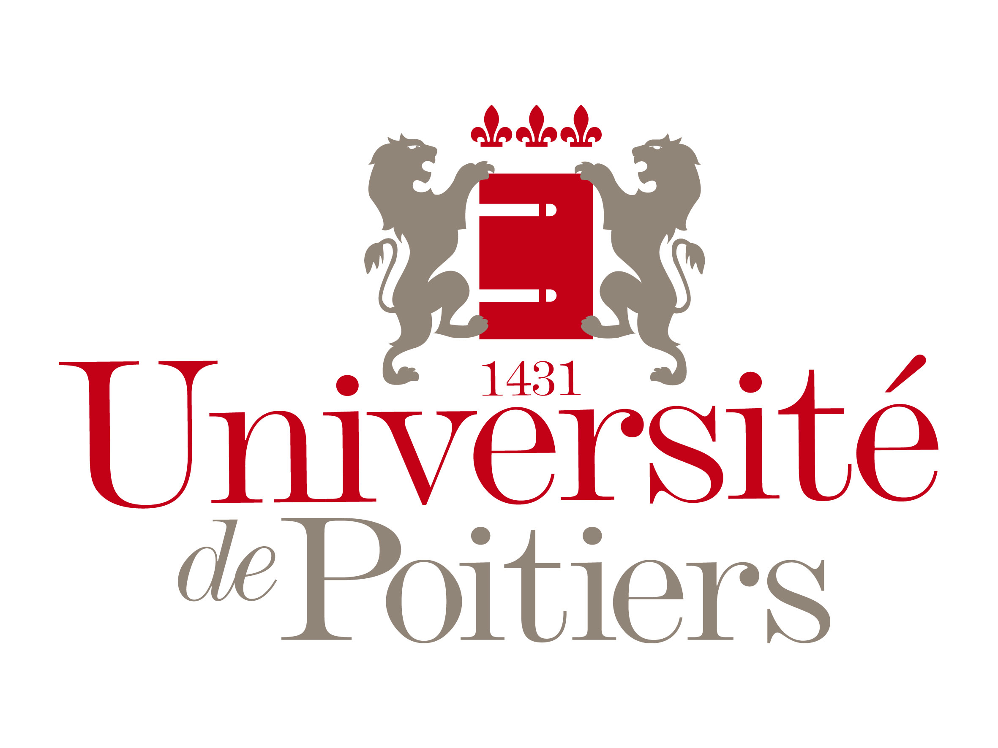

Paste your Logo here

Title: Preparation of activated carbon from olive waste. Application as adsorbent for persistent organic pollutants in water.

Name: Nadia El Ouahedy^{1, 3}, Satu Ojala², Laurence Pirault-Roy¹, Rachid Brahmi³

¹University of Poitiers, IC2MP, B27, 4 Rue Michel Brunet, 86073 Poitiers Cedex 9, France.
²University of Oulu, Faculty of Technology in the Environmental and Chemical Engineering research unit. Pentti Kaiteran katu 1, 90014 Oulu, Finland.
³University of Chouaib Doukkali, Dep. of Chemistry (LCCM), 24000 El Jadida, Morocco.

In the present study, we have investigated the adsorption, by activated carbon prepared from olive stones, of two pollutants, Bisphenol A, a substance causes a disruption of endocrine systems and ubiquity in the aquatic environment, and Diuron, a pesticide detected in groundwater and may reach higher levels than health-based standards. The olive stones were chemically activated and then pyrolysed (thermal treatment under nitrogen). On the other hand, to optimize the preparation method, the effect of the main process parameters (such as activating agent used, impregnation ratio, temperature of pyrolysis step) on the performances of the obtained activated carbons (expressed in terms of adsorption capacity of BPA and Diuron and specific surface area) was studied. The physicochemical properties of the activated carbon prepared were characterized by N₂ adsorption/desorption, FTIR, SEM, X-Ray diffraction, CHNS and TGA/DTA. To optimize the adsorption parameters of the activated carbon, preliminary experiments were achieved, such as the effects of solution initial pH and temperature, effect of initial concentration of the pollutants. Promising performances were pointed out as 70 % of Diuron and 92 % of BPA can be removed from aqueous solution for an initial concentration respectively 35 mg/L and 20 mg/L, when the usual concentrations of BPA in environmental waters are in the range of 10 ng/L to 400 μg/L and Diuron is around 1 600 ng/L. This innovative process is based on valorization of agricultural waste biomass, of which billions of kilograms are produced annually, to low cost but efficient adsorbent that can contribute to environmental remediation.
Biography

Nadia El Ouahedy is a 2nd year PhD student in University of Chouaib Doukkali in Morocco and University of Poitiers in France working on depollution of water by hybrid system as a part of the project PHC Maghreb 2016. She is doing the preparation of adsorbents from olive waste providing from Morocco, such as the charcoal prepared by the hydrothermal carbonization process at Triers University in Germany, and activated carbon at University of Poitiers in France and Oulu University in Finland, to apply them for the adsorption of Bisphenol A and Diuron followed by a catalytic oxidation of those pollutants.

