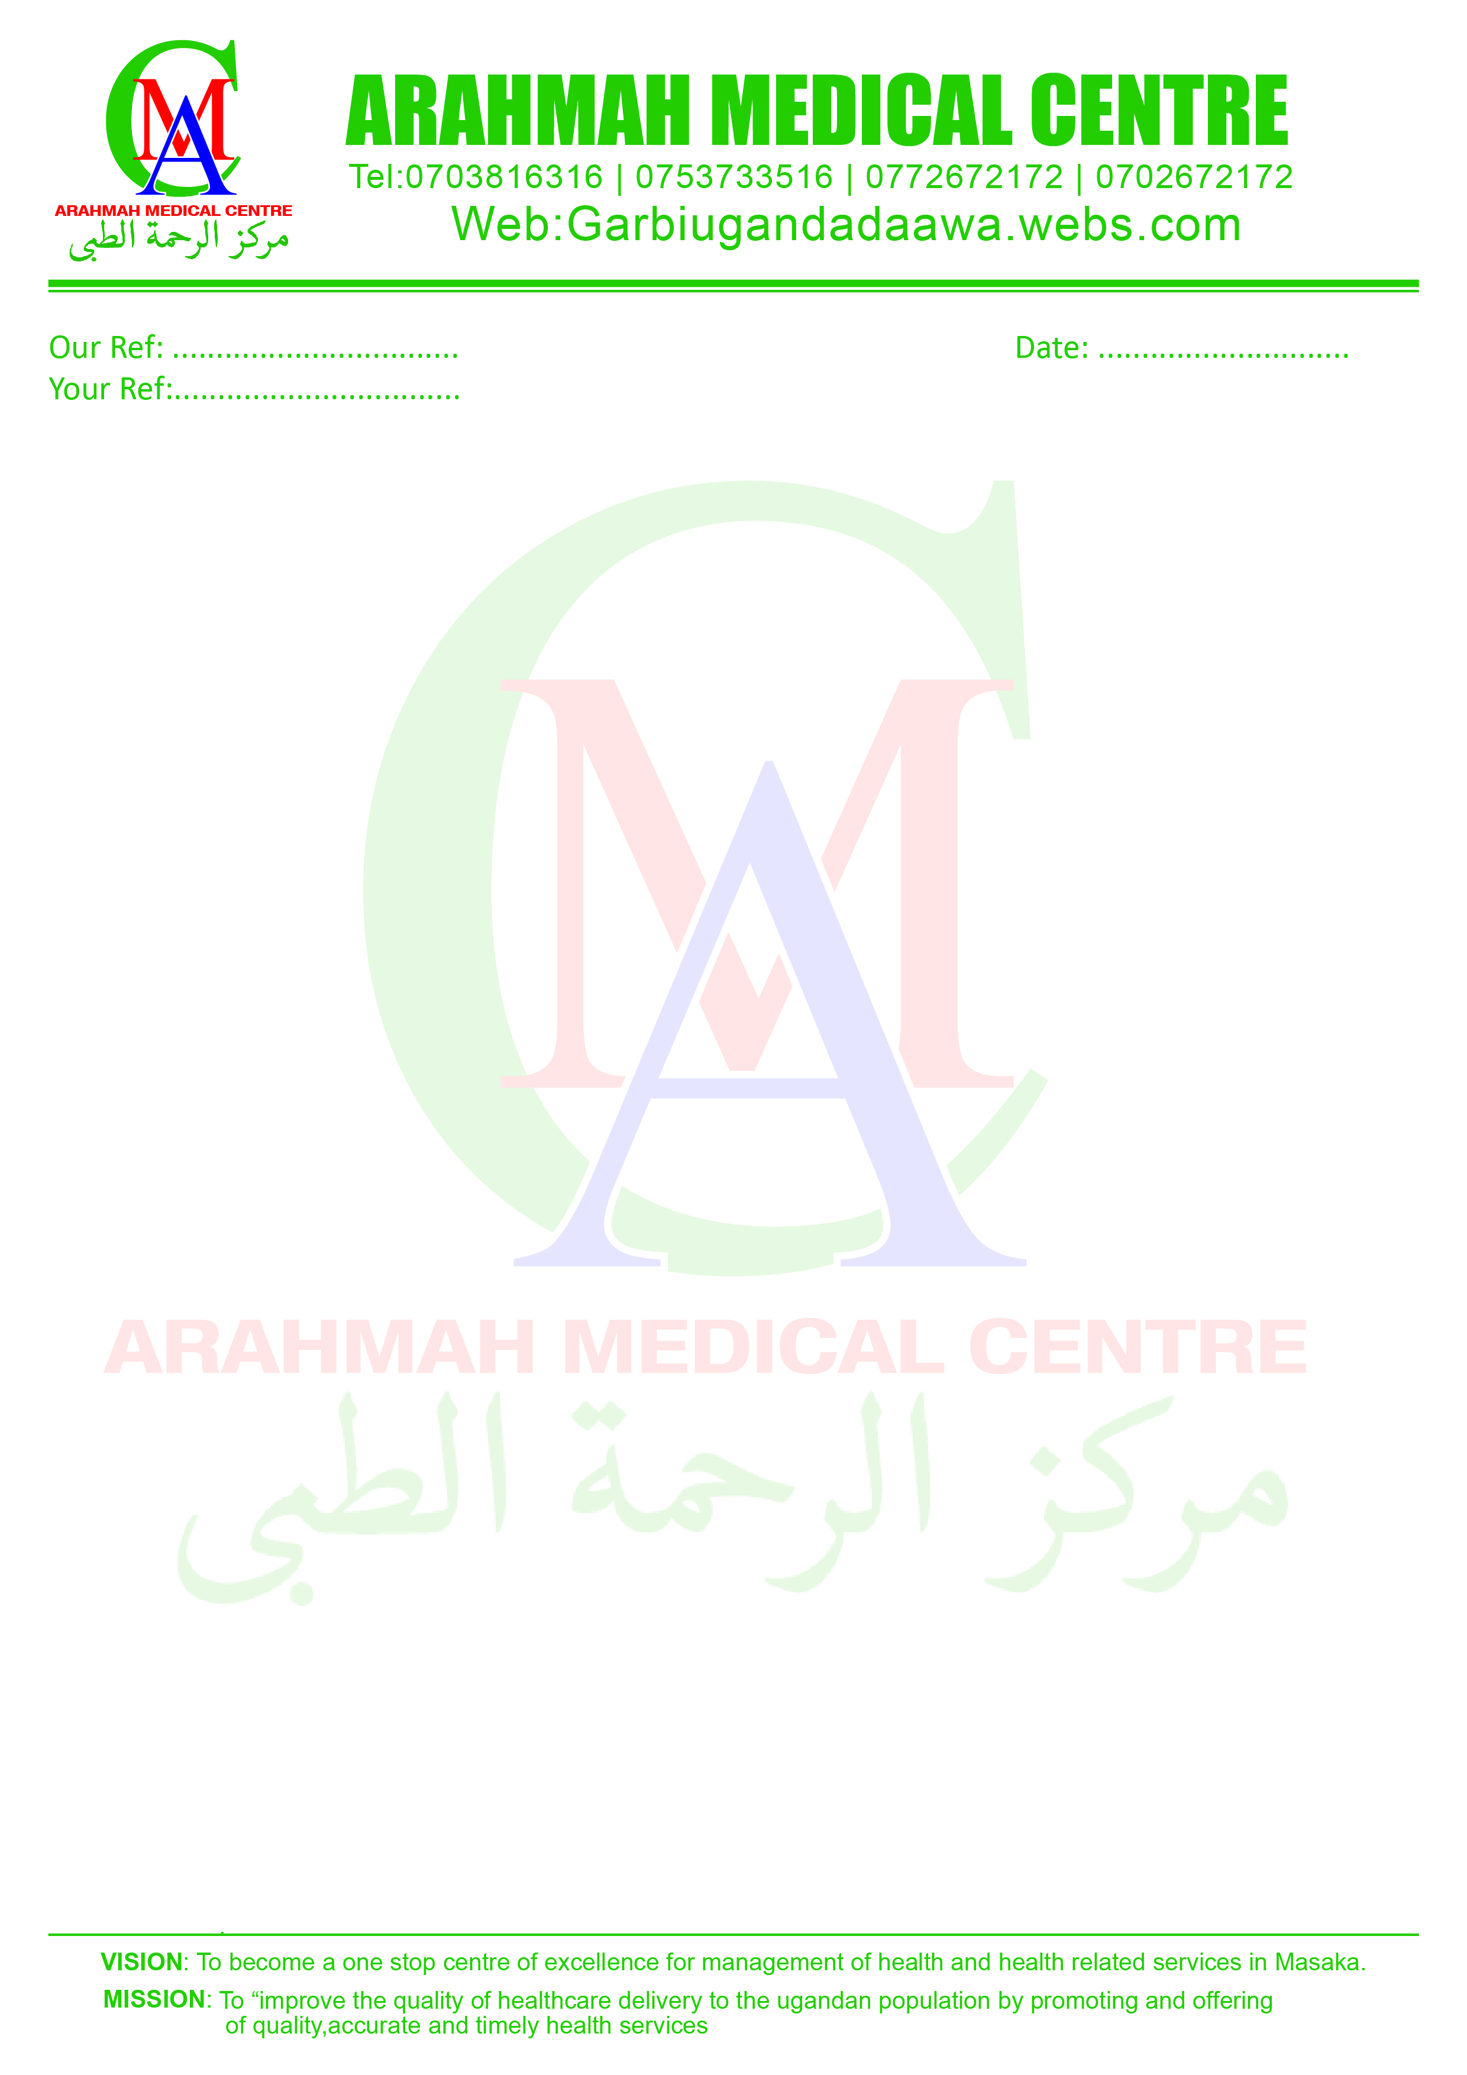
Email: arahmahmc@gmail.com
This Concept Paper spells out the main functions and the principals of Arahmah Medical center.
NAME OF THE UNIT
This unit is registered by the Ministry of Health as; ARAHMAH MEDICAL CENTRE. The facility operates under the stewardship of the Uganda Muslim Medical Bureau. (UMMB)
GEOGRAPHICAL LOCATION
ARAHMAH medical centre is located at the building of GARBI-Uganda Da-awah Association opposite Nyendo Market in Nyendo- Ssenyange Division. Nyendo is the biggest suburb in Masaka town located in Masaka Municipality. The population of Nyendo doubles that of Masaka main town but the majority of its dwellers are engaged in informal sector and low income earning activities though a few have formal occupation.
HOW DID ARAHMAH MEDICAL CENTRE START
Arahmah medical centre was started by GARBI Uganda Da-awah association which is a Muslim Association operating in Southern region of the Central Uganda.
The facility started with construction of a storied building that accommmodates Masjid Jamia- Nyendo Market and the medical centre. It was realized that the Southern region of the Central Uganda as a whole lacked a health facility that was Muslim faith based which could offer advanced health services to the community which upholds Islamic principles and values. Consultations were made between the Moslem leadership of the community and the Muslim medical fraternity about the setting up of the facility, services to be offered and the careers to be employed. Conclusions were reached and the medical centre was setup and it started its operations on the 15th January 2015.
GARBI Uganda Da-awah Association agreed to erect a permanent structure to start with, that could house a health unit with a laboratory room, lavatory, labor suit, consultation room, dispensary and two admission wards with a bed capacity of twenty, the dental unit, imaging services and an operation theatre. This was done as part of their community commitment. The construction works was completed in 2014 and the unit became functional on the 15th January 2015. The unit is fully registered with the Uganda medical and dental practioners’ council under the supervision of Dr Ismael Mwesigye (General Surgeon) (+256701054044).
MISSION STATEMENT
To render affordable quality medical services to the community in an acceptable manner regardless of their religious backgrounds, tribe and race
OWNERSHIP
GARBI Uganda Da-awah Association established the health unit which is their dedication to the community; it was put under the governance of the Moslem Community through the Board of Governors, regulates and ensures the correct running of the health unit.
IDENTITY AND PURPOSE
Arahmah medical centre is a Muslim health unit; therefore it upholds the values, norms and the principals of Islam as held in the holy Quran and Sunnah. The health unit fully subscribes to the Principles of the Uganda Muslim Medical Bureau.
The health unit is purely private not for profit (PNFP), the Board of Governors sets the amount of money that is supposed to be paid by the patients at a cost sharing basis. The money paid is used to purchase drugs, medical supplies and the surplus caters for staff payments.
The unit operates in pursuit of good individual person, of sick and common good of the people; the services are fully committed to a holistic approach by treating, prevention of diseases and promotion of health conditions.
The unit works in collaboration with other parties in healthcare provision including the district and the central government in line with the standing laws and regulations in provision of its services. The unit does not discriminate on the grounds of race, tribe, religion, political, affiliation and social-economic status.
Arahmah operates in line with government policies in concurrence with the Islamic principles. It aims at providing a package of services comprehensive of curative, preventive, promotion and rehabilitative health care to the entire population.
The catchment area of Arahmah medical centre is Nyendo, neighboring villages and Southern region of the Central Uganda. The facility is open to serve the people of all attitudes and work as a referral to the lower health units in the area.
The health unit in addition to its health services promotes the values, norms and practices of Islam and Centralizes Islamic principles and demonstrations through care and practice.
ORGANISATION OF THE HEALTH UNIT
A spirit of stewardship and shared responsibility, transparency and accountability guides the unit management.
Arahmah medical Centre is managed by the Board of Governors appointed by GARBI-Uganda D-AWA Association on behalf of the Muslim community the BOD comprises of nine members as stated below;
BOARD OF GOVERNORS
The Board is comprised of nine members as per positions below;
- The Chairperson
- The Vice Chairperson
- The Treasurer
- The Secretary
- The in Charge
- Four Committee members
Garib Uganda D’awa Association led by the Chairperson reserves the powers to appoint and fire the Board.
The day to day running of the health unit is done by the unit in-charge who reports directly to the Board.
ACCOUNTABILITY
For its operations and management, the unit is accountable to Garbi Uganda D’awa Association, Uganda Muslim medical bureau, District health officer and the Central Government. Accountability is secured by;
- Maintenance of clear records of every financial transaction of the unit. The financial records are kept and maintained by the health unit in-charge with copies to the chairman.
- Regular and timely submission of statutory financial and activity reports to the district health office and the executive secretary of Uganda Muslim medical bureau.
- Audited accounts by the Board presented to the relevant offices at the end of each financial year.
ORGANISATIONAL STRUCTURE AND STAFFING NORMS
The health unit shall consist of the following structural establishments.
- The executive committee of Garbi Uganda.
- Board of Governors.
- The unit staff

Garbi Uganda Da-awah Association;
This is the policy making body of the unit on behalf of the Muslim community. It oversees the interest of the funders and donors in the management of the unit.
The Board of Governors
This is responsible for the day-to-day running of the unit. In addition it manages the unit on behalf of Garbi Uganda. It assists in overseeing the interest of the funders and donors in the management of the unit.
SERVICES OFFERED
- General Medicare 24hrs.
- In patients.
- Reproductive health.
- Oral and dental care
- Immunization.
- Mental health.
- Health education.
- Routine testing and counseling.
OTHER SERVICES SOON TO BE INCLUDED.
- Prevention of mother to child transmission of HIV.
- Primary eye care.
- Anti-retro viral clinic.
The unit staff;
This is made of all the health workers. It is responsible for the day to day running of the unit. It directly reports to the BOG. The unit staff organizes themselves into departments of which the health unit in-charge oversees all the departmental and usually reports to the district health authority.

BASIC STAFF FOR THE HEALTH UNIT
DESIGNATION NO QUALIFICATION
1. Supervisor 1 postgraduate/graduate
2. In-charge 1 graduate/postgraduate
3. Medical Clinical Officer 1 Diploma
4. Medical Lab Tech 1 Diploma
5. Dentist 1 Diploma
6. Radiographer 1 Diploma
7. Midwife 1 certificate
8. Enrolled nurse 3 certificate
11. Nursing assistants 2 certificate
14. Administrator 1 Graduate
15. Cleaners 2 --------

MEDICAL CENTRE ORGANISATIONAL CHART
Garbi Uganda D’awa Ass. executive committee

Board of Governors

In-charge health unit
Nursing staff
Midwife
Laboratory assistant
Dental assistant
Non technical staff

SALARY STRUCTURE
The salary structure of all health unit employees is laid out as follows;
The salary structure for all the health workers is composed of:
- A basic salary determined and revised every after one year by the BOG.
- Any benefit, allowance determined as percentage of the basic salary.
- Accommodation as percentage of the basic salary.
- Transport allowance determined by the BOG.
- Salaries are paid at the end of every month.
THE SALARY SCALES
The health centre salary scales will be graded in the following category.
- AMC I ; Clinical officer/in-charge
- AMC II; Midwife, laboratory assistant and comprehensive nurses.
- AMC III; Nursing assistant.
- AMC IV; Support staff
DESCRIPTION | AMC I | AMC II | AMC III | AMC IV
Basic salary | 300,000= | 200,000= | 100,000= | 50,000=
Lunch allowance | 10% | 5% | 5% | 5%
Accommodation | 10% | 5% | 5% | 5%
Living allowance
Transport allowance | 5%
Acting allowance | 10% | 10%
Risk allowance |  | 20%
TOTAL | 450,000= | 280,000= | 102,500= | 55,000=

TERMS OF REFERENCE
The main purpose of the Board of Governors is to ensure the effective and efficient running of the health unit.
FUNCTIONS
- Monitoring the general administration of the health unit on behalf of the Muslim community and the district health office.
- Supervision and management of health unit finances specifically to;
- Ensure that financial regulations and accounting instructions are observed.
- Approve annual budgets prepared by the unit staff and the executive.
- Ensure that annual work plans are drawn and reflect priorities.
- Monitor performance in accordance to approved budget.
- Ensure that funds are diverted to other activities without prior notice.
- Ensure that funds collected and disbursed to the health unit have been accounted for to the relevant authorities
- To monitor the procurement and utilization of all health unit goods and services in line with Uganda Muslim medical bureau and ministry of health regulations.
- To foster improved communication with public thereby encouraging community participation in health activities within and outside the unit.
- Mobilize the community to utilize the available services at the unit and outreach points.
TERMS OF OFFICE AND TENURE
- The appointed Board of Governors stays in office for a period of five years.
- Any member of the BOG who may wish to cease being a member does so in writing to the chairman or for the case of the chairman to the Amiir in either case a notice of at least two weeks is required.
- Any member of the BOG who without reasonable excuse misses three consecutive meetings ceases to be a member. In this regard the member is informed of that fact in writing by the secretary.
- In case of occurrence of a vacant position on the committee, the Amiir fills the position by appointing a member who will hold it for the term of that committee.
PROCEDURE
- The chairman presides over of all meetings and in his absence the vice chairman takes over and in case both are absent, the committee elects a member among themselves who presides over the meeting.
- Two thirds of the BOG members form a quorum for all meetings.
- The committee meets at least every six months with extra meetings where necessary.
- The meetings of the BOG is as much as possible held at the unit premises.
- The chairman may at any time convene a special meeting to consider a subject that might have been raised by the community in writing.
- Issues discussed are decided by a simple majority of the voting members and the chairman has the conclusive vote in case of equal votes.
- Members of the BOG are given a written notice of seven days which includes the agenda. In case of an emergency the chairman has powers to waive the said time as he may see it necessary and possible for the meeting.
- The minutes of the proceedings of the BOG meetings entered in the minute book maintained by the secretary. The minutes are circulated to members within 20 days of the meeting. Minutes are always confirmed in the next meetings.
JOB DISCRIPTION FOR HEALTH UNIT STAFF
SUPERVISER
The health unit is supervised by Dr. Mwesigye Ismael (Surgeon).
ROLES OF THE SUPERVISER
- To ensure that the health unit is at all times registered and authorized to operate by the dental and medical practitioner’s council (ministry of health).
- To ensure that all health workers are registered and licensed to operate by their respective councils.
- To ensure that there is timely submission of reports to the relevant authorities and adequate flow of health information management system.
- The supervisor shall from time to time inspect any place, books, record minutes and stores and may request for information relevant to the health unit.
HEALTH UNIT IN-CHARGE
The health unit employs one medical doctor who is the unit in-charge.
RECRUITMENT AND STAFF APPOINTMENT
Garbi Uganda established a recruitment committee of five members including the chairperson, Secretary, two members and a technical person. The recruitment committee reserves the mandate to recruit staff in the following categories;
- Permanent.
- Temporary.
- Support staff.
PROCESS OF EMPLOYMENT.
Application
All employees were required to submit in their applications in writing addressed to the secretary recruitment committee.
Short listing
All applications were and shall be subjected to preliminary sorting by the Recruitment committee.
Interviews
All potential applicants were and shall be interviewed in the nature that shall be determined by the appointment committee.
Contract employment;
The recruitment committee shall sanction all employment on contract basis. In all cases all employees employed on this basis shall sign an agreement between the employee and the health unit.
Temporary employment;
The secretary of BOG can within limits of these regulations employ a person on temporary basis pending regularization of the individual permanent or contractual appointment of employment. In all circumstances temporally employment should not exceed six months.
JOB DESCRIPTION AND TERMS OF REFERENCE
All employees are availed with a job description, terms of reference for the post they are holding and a copy of Human resource policy as soon as they are employed.
COMFIRMATION OF APPOINTMENT;
Eligible employees are confirmed after the probation period of six months. Any employee who fails to meet the basic requirement of a good responsible worker is not confirmed and the health unit reserves the right to terminate his/her services.
Every employee is subjected to an induction course not exceeding one week after engagement.
APPRAISAL
Employees’ performance is appraised every year to enable the health unit keep track of his/her performance.
DISCPLANARY PROCEDURES
In all disciplinary proceedings the following procedure shall apply. The secretary shall keep a confidential file for all employees.
The nature of the cases shall be recorded on the personal file with the knowledge of the employee for the case committed.
The power to discipline the employee is vested in the manner that the in-charge can suspend but the responsibility to decide on the disciplinary action is vested in the recruitment committee.

Activities Done to Support health system strengthening.
- We offer excellent care to our clients so that we don’t lose any. At Arahmah “Its Client first”
- Carried out promotion activities in Mosques and Schools to inform people about the health centre; Many Institutions were positive except at Masaka Main Masjid where we were denied the opportunity to inform the Muslims about the facility.
- Introduced free Immunization to Children
- We are offering free antenatal service for up to the end of December 2015
- We registered with Muslim Medical Bureau and we are supported with anti-malarials and Mosquito nets
- We have partnered with Kitovu Mobile for support
- We work with PACE and supported in reproductive health, these facilitate two VHTs to mobilize people come for services at the facility.
- We wrote and requested partnership with Kibuli Muslim Hospital
- We visited the P.S Min of health and requested for support
- Information sharing during the monthly staff meeting
Our Strength

Good working relationship; with Government and other Service providers; Masaka District is giving us vaccines to carryout immunization for free and Antenatal services. This takes place on every Tuesday. This activity has also helped us to popularize the facility. Of recent The District donated to us a UNEPI fridge to enable us carryout immunization at any time.

The good will of the Muslims; To a larger extent the Muslim community has supported the facility by providing the first clientele. It is from the Muslims that we capitalize from.

Technical support from the Muslim Doctors; Drs. Like Nkoyoyo Abdullah, Kawooya Sulayiman, Nakato Aisha and others have greatly advised and helped in the establishment and running of the facility. We pray to Allah to reward them abundantly.

Support from the board members; these are working tirelessly for uplifting of the facility.

Pictorial of Some activities taking place at the Facility
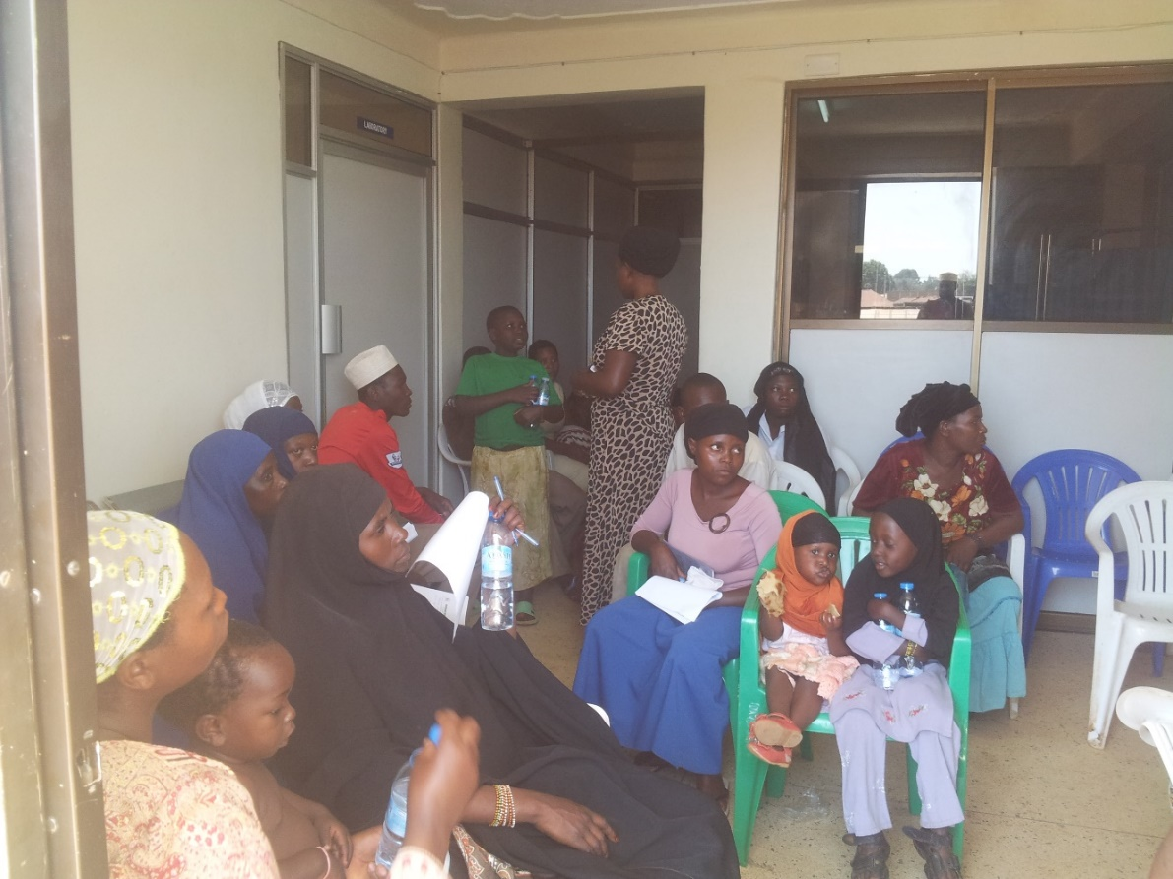
Patients waiting for the medical service

District 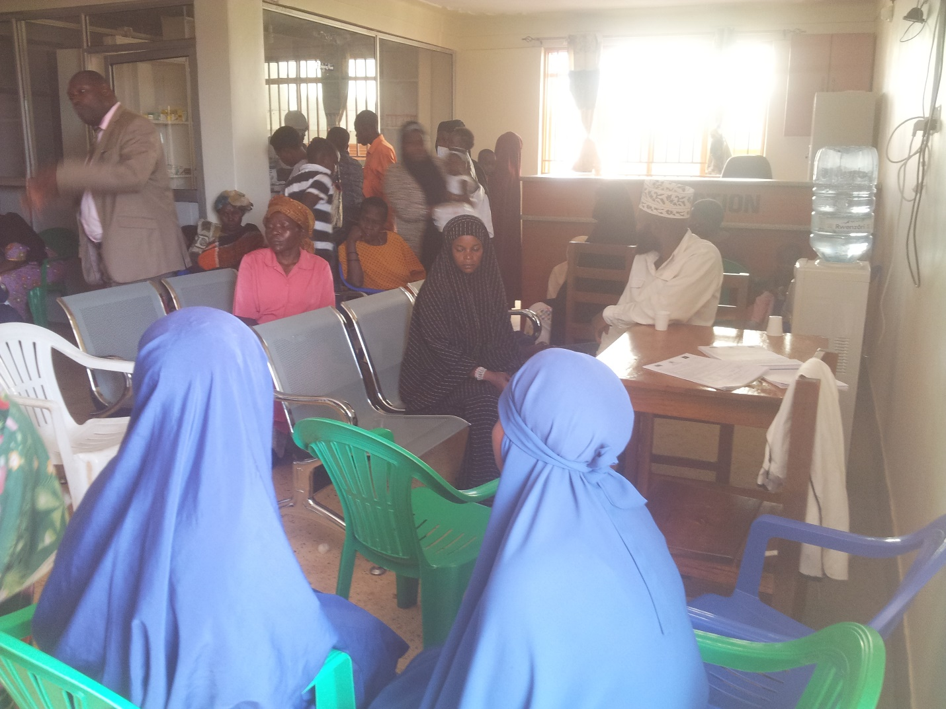 Former chair person Lcv masaka sak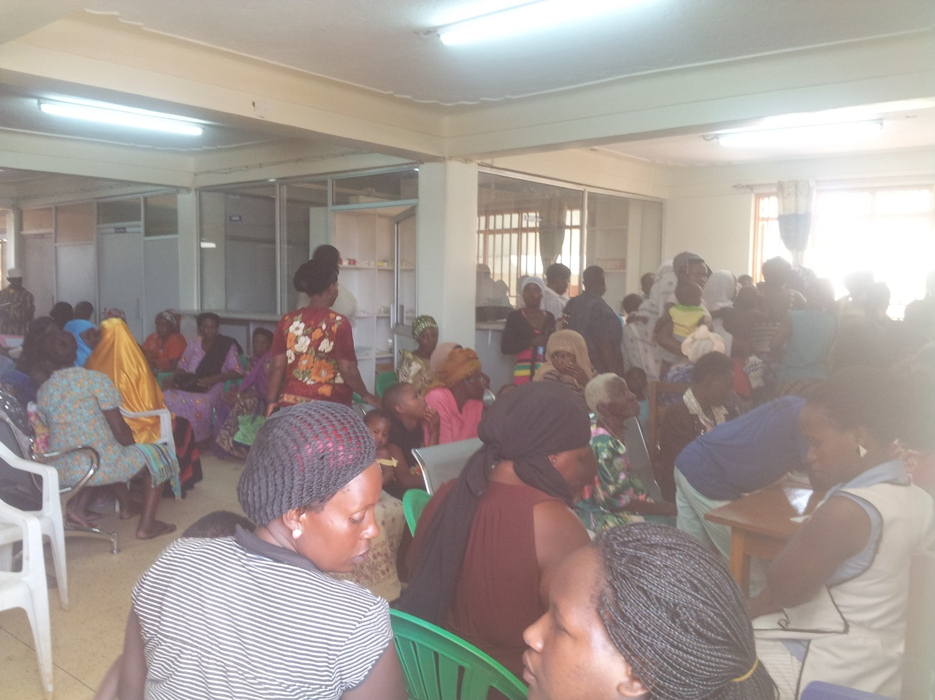

Mr. Kisolo Ronald, Enrolled Nurse preparing a treatment.
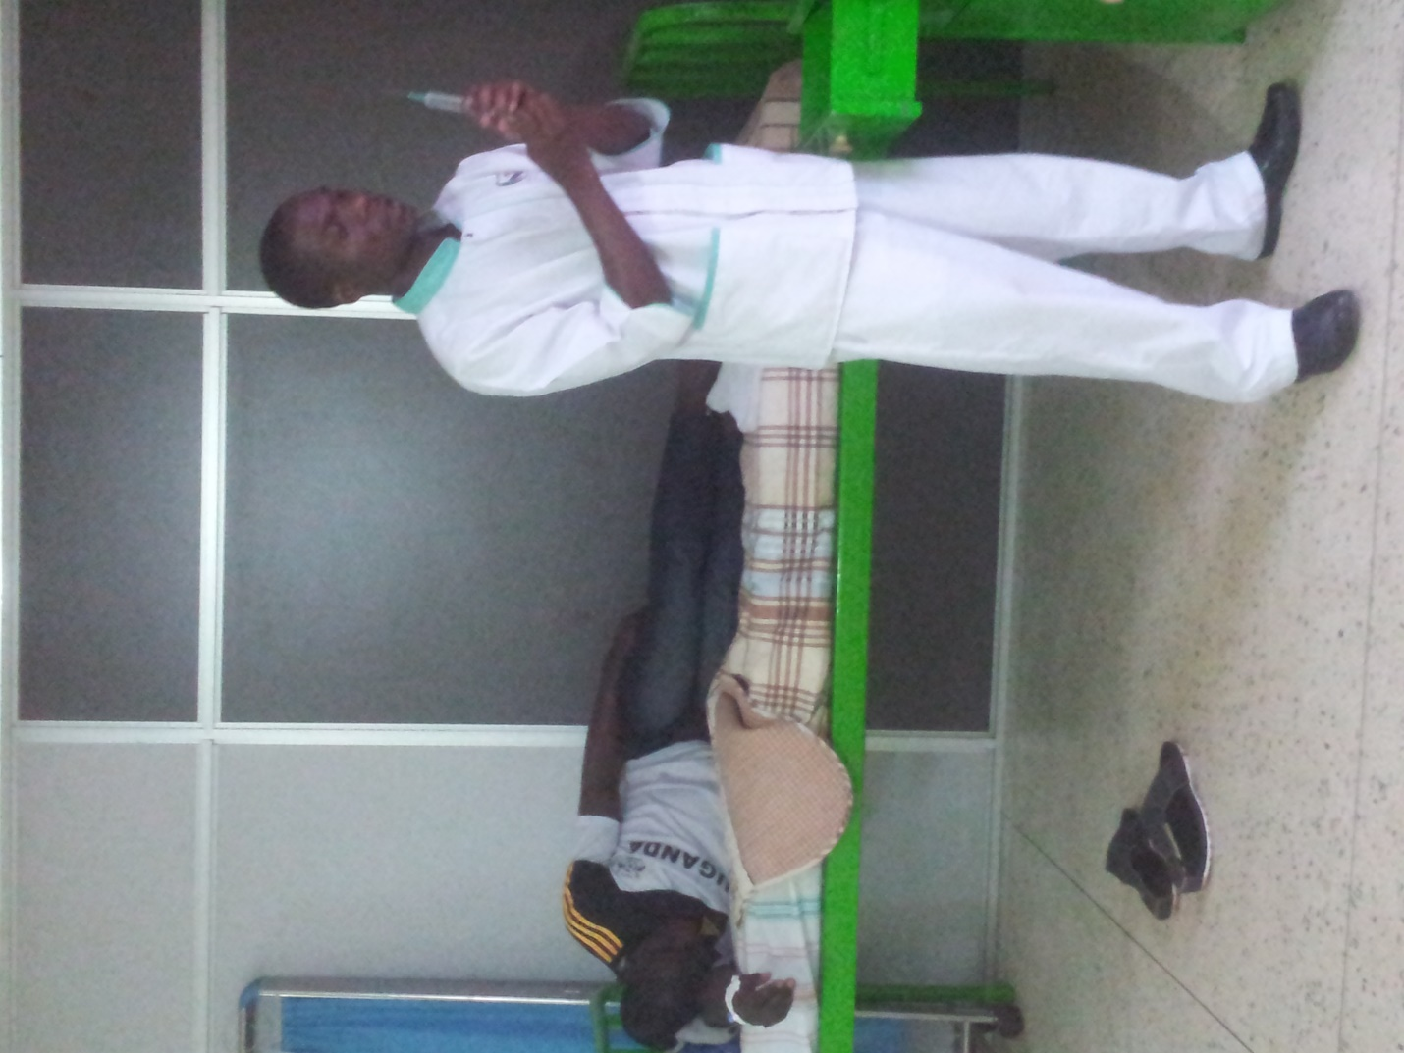
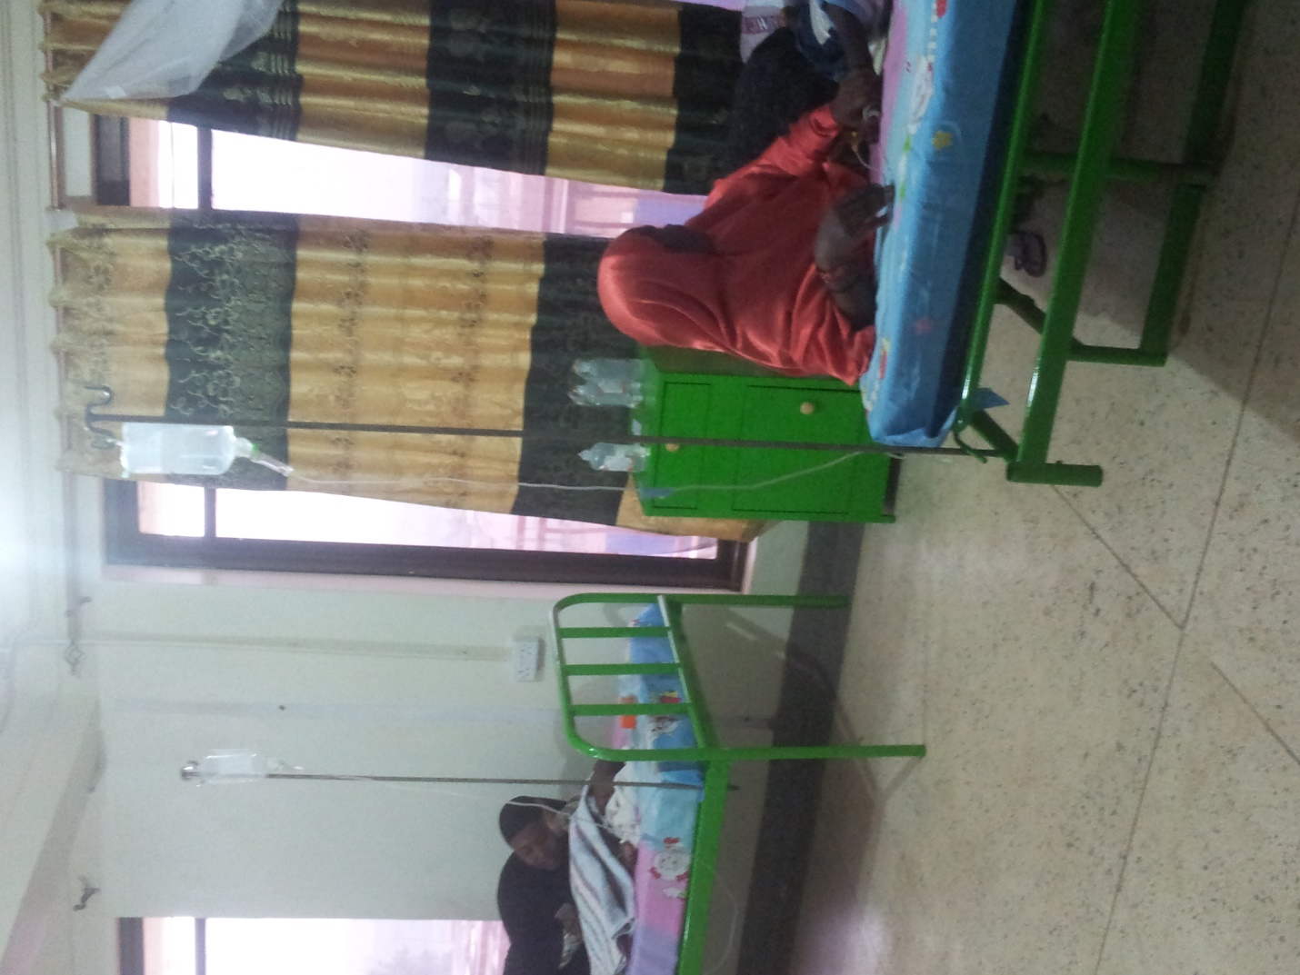
Mothers after delivery
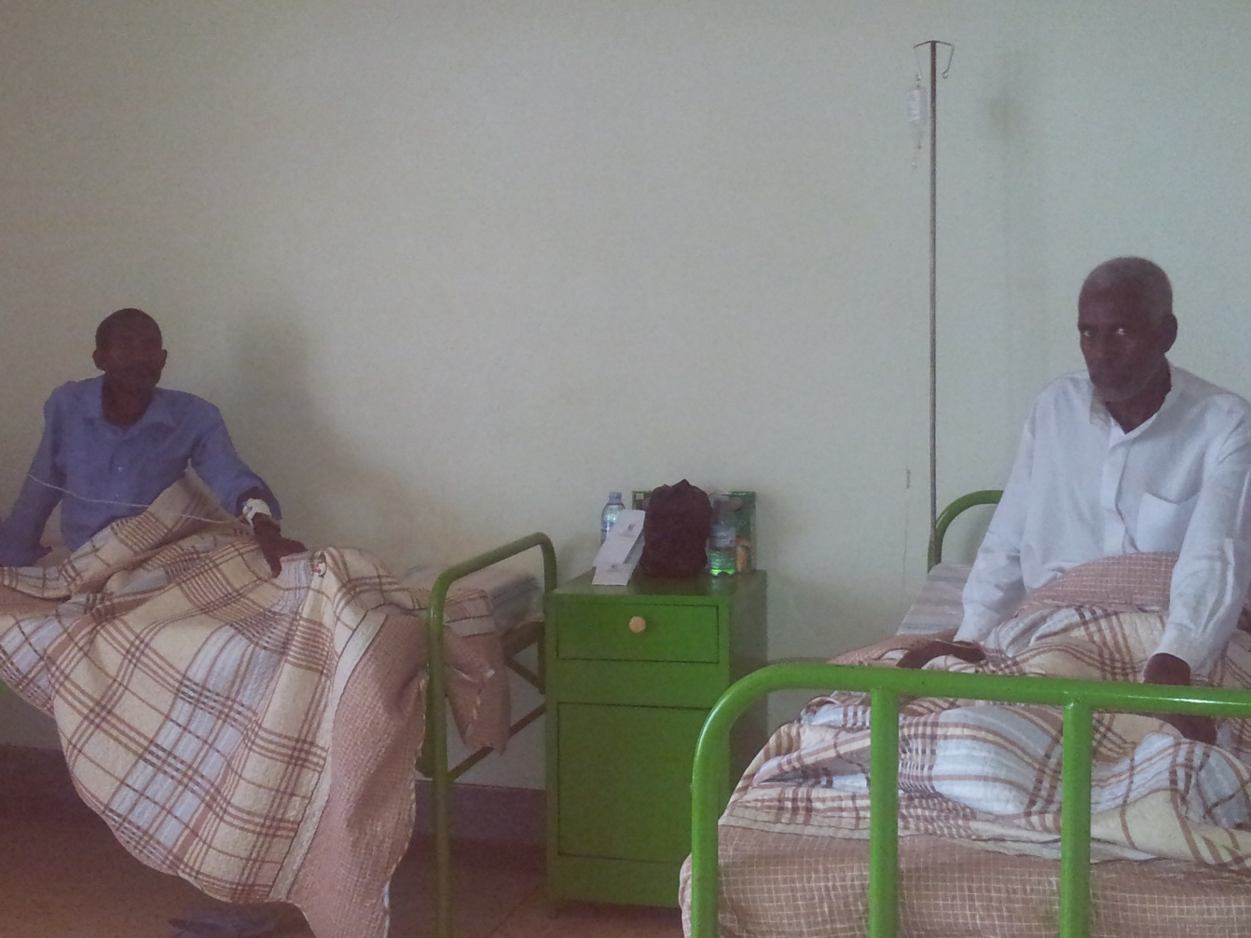
Patients in Male ward

Doctor and Nurse Giving Treatment

During Immunization

Constraints
Lack of some theatre equipment
We lack resources to give a helping hand to many critically vulnera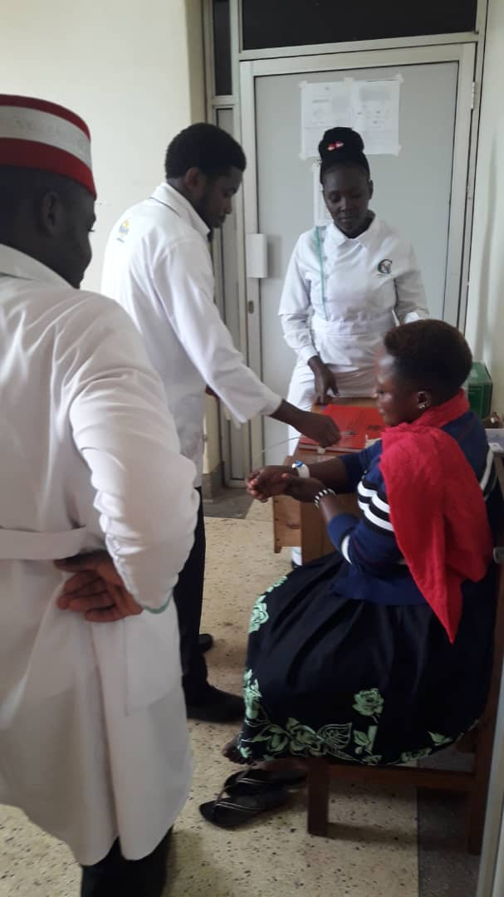ble population of our community.
Challenges.
It is our humble request that you come in and give a hand for the good of this noble cause

- Lack of an ambulance to facilitate emergency cases mobility
- Lack of incubators for premature neonates
- An X-RayMachine, 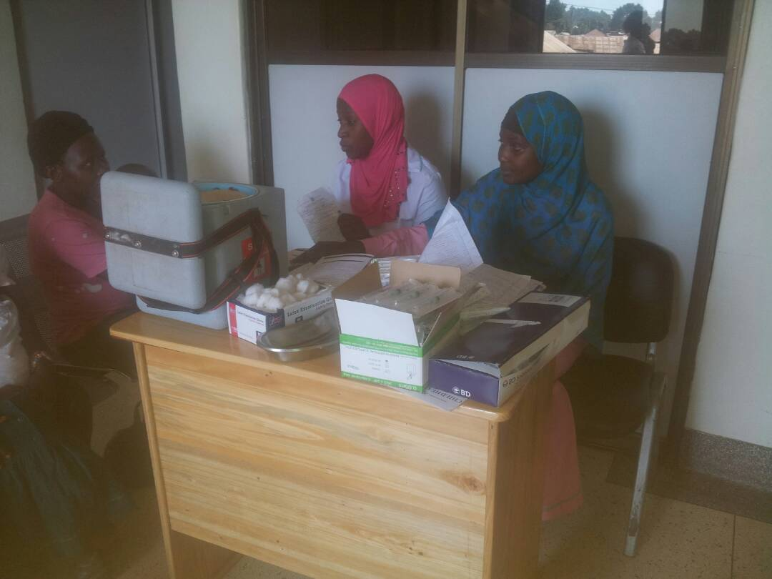
- Limited space for the maternal cases and admissions.
………………………………………
Sheikh Mustwafa Kasule
Chairperson Garbi- Uganda

F

