Post Harvest Mycoflora of Some Fruits from Ad Darb Market , Jizan , Saudi Arabia .
Syeda Fatima Manzelat*
Department of Botany , College of Science and Arts , Ad Darb , Jizan University , Jizan , Saudi Arabia.
E mail : drsyedafatima@hotmail.com Mobile : 00966-553708986
Abstract
This is the first study of post harvest mycoflora of fruits from Ad Darb region of Jizan province. A total number of fourteen samples of fruits from the local markets of the place with post harvest spoilage fungi were collected and screened for mycoflora during March 2015 to February 2017 .The mycoflora was cultured on Potato Dextrose Agar plates and Czapek Dox agar plates . A qualitative and quantitative assessment of mycoflora was carried out by the fungal cultures on the petri plates and the slides were identified by microscopic and macroscopic characteristics. A total of 64 fungal isolates represented by 9 fungal genera were isolated from the samples belonging to the three classes of fungi i.e. Oomycetes , Zygomycetes and Ascomycetes.. The post harvest mycoflora was represented by Pythium , Rhizopus, Saccharomyces sp., Aspergillus, Cladosporium, Dresclera ,Fusarium, Penicillium and Sphearotheca. The most predominant genera were Aspergillus followed by Fusarium and Penicillium. % Disease Incidence ranged from 20% - 30 %. The information on the diverse groups of post harvest mycoflora can help in effective management and minimization of post harvest economic losses .Apart from the economic losses the post harvest mycoflora are pathogenic.Aspergillus, Fusarium and Penicillium isolated are highly mycotoxigenic and are a potential risk to human health.They produce mycotoxins which are responsible for a number of diseases .

Key words: Fruits, Mycoflora, , Post Harvest, , Ad Darb, Jizan, Saudi Arabia.

Photomicrographs of different Fungal genera on the fruits.
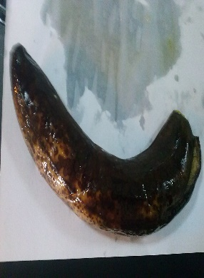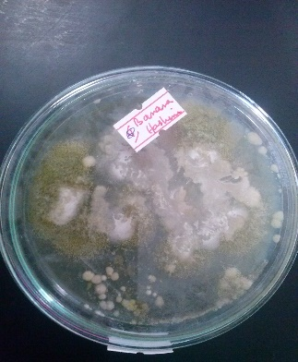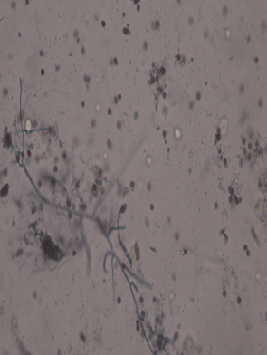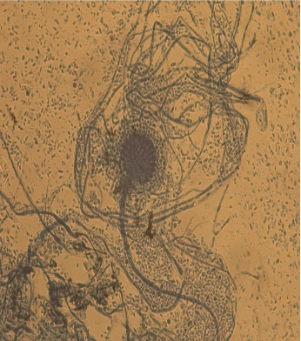
Fig. 5 Infected banana and its culture with Cladosporium and Aspergillus
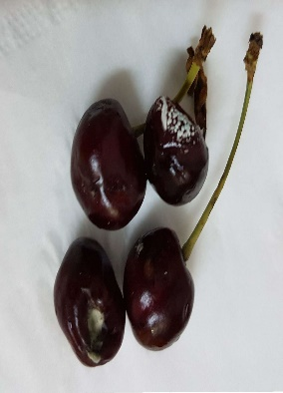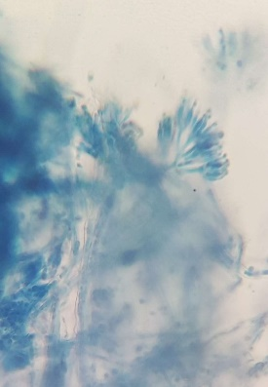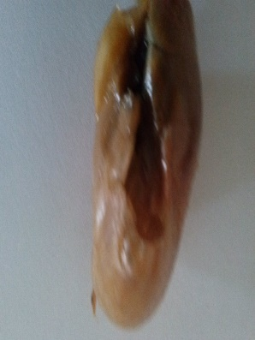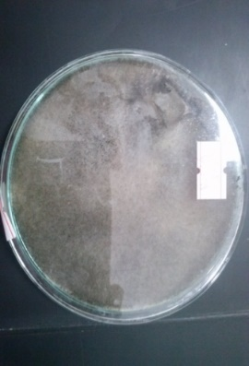
Fig. 6 Cherry with Penicillium Fig. 7 Date and its culture with Aspergillus
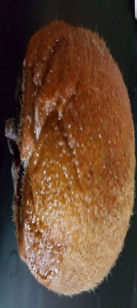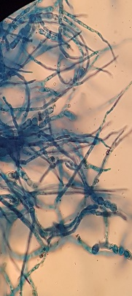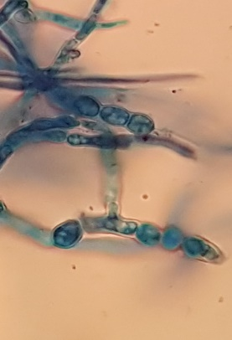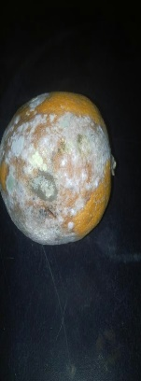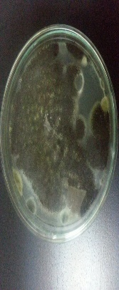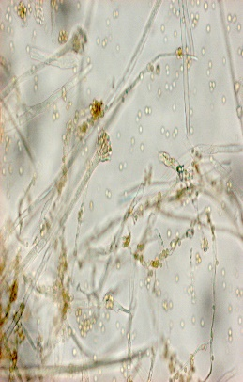
Fig. 8 Kiwi fruit with Sphaerotheca Fig.9 Orange culture with Penicillium
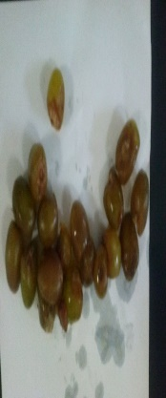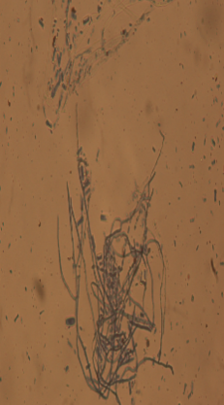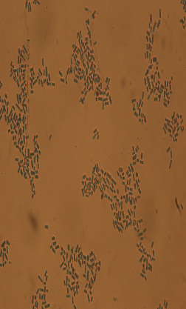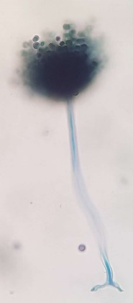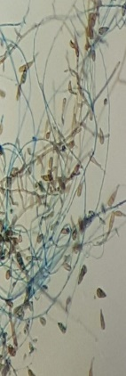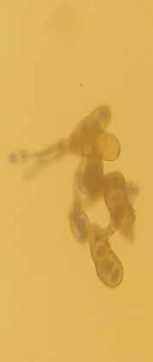
Fig. 10 Grapes with Saccharomyces sp., Aspergillus and Dresclera
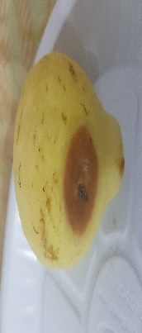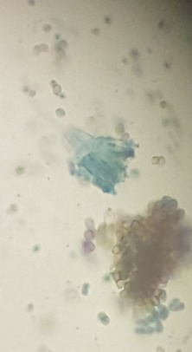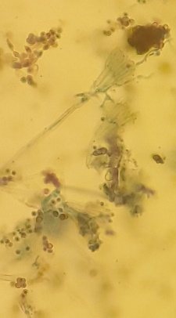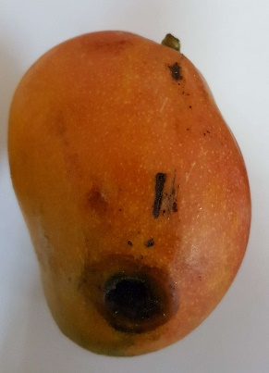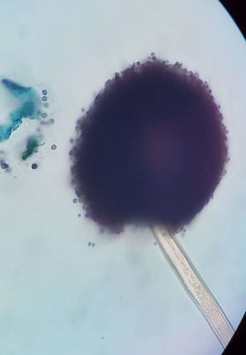
Fig. 11 Guava with Penicillium Fig.12 Mango with Aspergillus
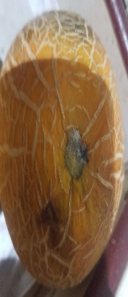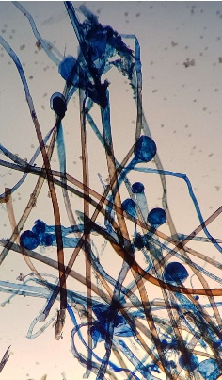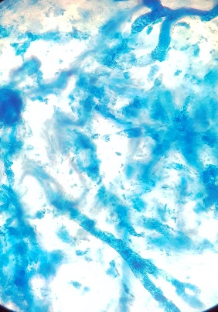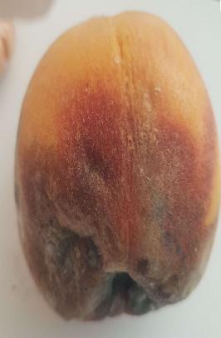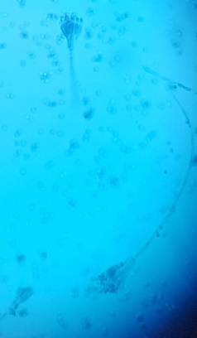
Fig.13 Musk melon with Rhizopus and Pythium Fig.14 Peach with Penicillium
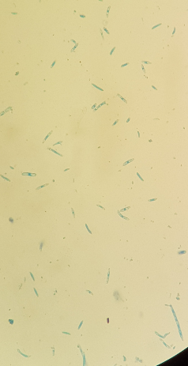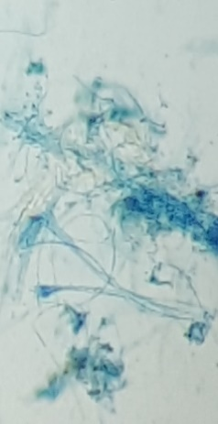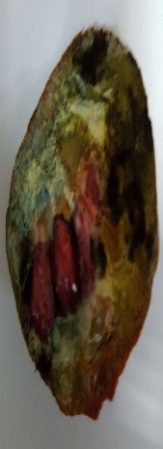
References :FAHAD Y. AL-JUHAIMI AND KASHIF GHAFOOR* BIOACTIVE COMPOUNDS, ANTIOXIDANT AND PHYSICO-CHEMICAL PROPERTIES OF JUICE FROM LEMON, MANDARIN AND ORANGE FRUITS CULTIVATED IN SAUDI ARABIA .Department of Food Science and Nutrition, College of Food and Agricultural Sciences, King Saud University, P.O. Box 2460, Riyadh 11451, Kingdom of Saudi Arabia Pak. J. Bot., 45(4): 1193-1196, 2013.
FOUZIA KHAN ,KSA imports fruits, vegetables worth SR4 billion annually
JEDDAH: | Published — Wednesday 24 July 2013.
Gulf states import 5 million tonnes fresh fruit and veg annually.http://www.freshplaza.com/article/138490/Gulf-states-import-5-million-tonnes-fresh-fruit-and-veg-annually, Publication date: 4/20/2015.
Hashem Al-Sheikh, Date-Palm Fruit Spoilage and Seed-Borne Fungi of Saudi Arabia. Research Journal of Microbiology, 4: 208-213, 2009.
IRFAN MOHAMMED ,Jazan mango’s sweet success,JEDDAH:(Arab News )Published — Friday 18 April 2014.
IRFAN MOHAMMED ,Taif’s pomegranate produce hit stalls across KingdomJEDDAH: Arab News Published — Thursday 26 September 2013
Biography :
This is Dr. Syeda Fatima Manzelat , Ph.D. in Botany from Osmania University. I was awarded Gold Medal for First rank in M.Sc. in the university.Also, I did B.Ed with English and Science methodologies.Besides, I qualified the national eligibility test forlectureship in universities \ colleges . I had a very excellent academic career throughout.I have more than 20 years of post Ph.D teaching and research experience .I have worked as Associate Professor of Botany at Misurata University Libya for a period of three years (From 2008 -2011). I am presently working as Associate Professor at Jizan University , Saudi Arabia since the past 5 years.
I have many recent publications .I am interested in attending the conference with my manuscript the title of which is : “Post Harvest Mycoflora of Fruits from Ad Darb Markets , Jizan , Saudi Arabia ”.

