FOOD AND BEVERAGES PROCESSING: DIETARY CULTURES AND ANTIQUITY OF FOOD AND BEVERAGES
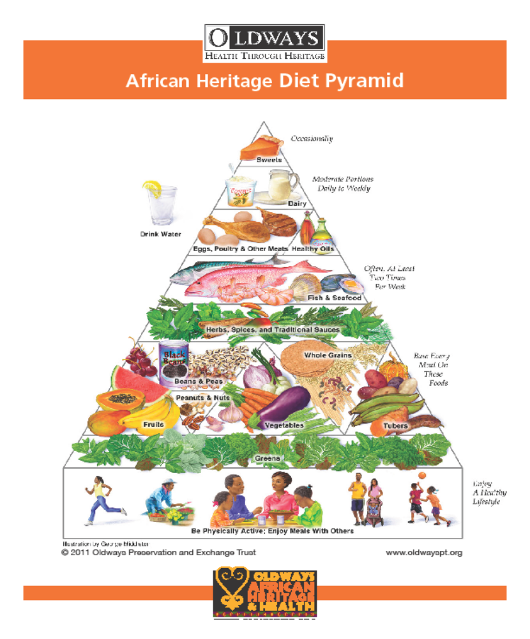

Abstract
Food culture refers to the practices, attitudes, and beliefs as well as the networks and institutions surrounding the production, distribution, and consumption of food.
Humans are biologically adapted to their ancestral food environment in which foods were dispersed and energy expenditure was required to obtain them.

Humans need to obtain nutrients from foods in order to survive and be healthy. The requirements of energy and nutrients are different due to differences in race, age, sex, and physical activity level. People living in different places take nutrients from different kinds of food; therefore, nutrition is a cultural biological process rather than a simple physiological and biochemical process. Food intake can directly influence one's biological function through life, as its results are on a biological level. When people eat, the process can be influenced by economic, politics, culture, and many other factors.

Factors to be considered in Dietary culture and antiquity of foods & beverages include: Socio functions of food; Purchase, Production, Distribution; Eating Behaviour and Conflicts of Interest

