Hazelnut Skin as a Functional Ingredient for Innovative-Functional Yoghurt Production
Merve AKTAS, MSc, Nayil DINKCI, PhD, Assoc.Prof., Ege University, Faculty of Agriculture, Dept. of Dairy Technology, 35100 Bornova, Izmir, Turkey

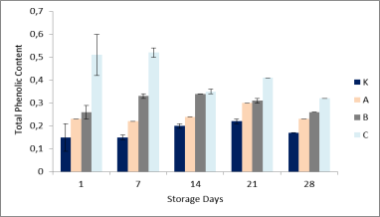
Abstract
Nearly 300 million tons of organic by products are been produced by the food industry in the European Union each year. That represents an additional cost for their disposal. From the Food waste of one industry could benefit other industries. New, profitable food waste processing methods have emerged all over Europe. There has been increasing interest in applying fruit-processing wastes as functional food ingredients. Because they are a rich source of antioxidants, dietary fibre and most of the beneficial bioactive compounds remain in these by-products. It becomes necessary on one hand an optimization of the process to reduce the by-products and on the other hand a valorisation of the waste obtained.
Fig.1:Total phenolic content of the yoghurt samples (GAE) K: Control, A: %2 Hazelnut skin, B: %3 Hazelnut
skin, C: %4 Hazelnut skin content.

The global hazelnut production amounted to 639 thousand tonnes in 2015. Two different by-products are obtained during the transformation of hazelnuts through the post harvesting processes, shells and hazelnut skin; among these only the shell has a direct commercial value as a heating source. Hazelnut skin is removed from kernel after roasting process and is normally discarded or burned. It represents about 2.5% of total hazelnut kernel weight and is an extremely rich source of dietary fibre and phenolic compounds with antioxidant properties.
The aim of this research was to evaluate the feasibility of hazelnut skin as an ingredient in functional set type yoghurt production. Hazelnut skin was added at four different levels (0%, 2%, 3%, 4%). 3% of fibre is required in the resulting product for labelling it as a “fibre source” by the European Community Regulation.
The samples were evaluated in terms of gross composition, chemical-biochemical characteristics, textural properties, microbiological counts and sensorial tests. The results underlined that the use of hazelnut skin increased dietary fibre and antioxidant capacity of the yoghurts without change of the consumer’s appreciation.

Image
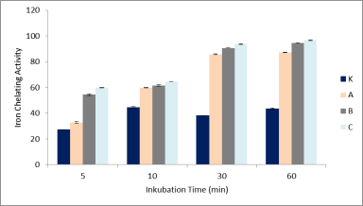

Fig.2: : Iron chelating activity (%) of the yoghurt samples K: Control, A: %2 Hazelnut skin, B: %3 Hazelnut
skin, C: %4 Hazelnut skin content.

Recent Publications
- A.S. AKALIN, H. KESENKAŞ, N. DINKCI, G. UNAL, E. OZER, O. KINIK; 2017. Enrichment of probiotic ice cream with different dietary fibers: Structural characteristics and culture viability. J. Dairy Sci. 101:1-10. https://doi.org/10.3168/jds.2017-13468
- A.S. AKALIN, G. UNAL, N. DINKCI; 2017. Angiotensin-converting enzyme inhibitory and starter culture activities in probiotic yoghurt: Effect of sodium–calcium caseinate and whey protein concentrate. International Journal of Dairy Technology.
- N. DİNKÇİ; 2016. An Alternative Source for Dietary Fibre and Phenolic Compounds. 8th Central European Congress on Food “Food Science for Well-being”. 23–26 May 2016, Kyiv, Ukraine.
- N. DİNKÇİ; 2016. Hazelnut Skin as an Alternative Source for Dietary Fibre and Phenolic Compounds. The Future of Food Waste: Challenges and Opportunities For Valorisation in Europe.. 20 – 21 September 2016, Wageningen, The Netherlands.
- G. ÜNAL, S.N. EL, A.S. AKALIN, N. DİNKÇİ, 2013. Antioxydant Activity of Probiotic Yoghurt Fortified With Milk Protein Based Ingredients. Italian Journal of Food Science, 25 (1) 63-69.
- A.S. AKALIN, G. ÜNAL, N. DİNKÇİ, A.A. HAYALOĞLU, 2012. Microstructural, textural and sensory characteristics of probiotic yogurts fortified with sodium calcium caseinate or whey protein concentrate. Journal of Dairy Science Vol: 95, Issue:7, 3617-3628.
- H. KESENKAŞ, N. DİNKÇİ, A.K. SEÇKİN, Ö. KINIK, S. GÖNÇ, 2011. Antioxidant Properties of Kefir Produced from Different Cow and Soy Milk Mixtures. Journal of Agricultural Sciences, V:17 253-259.

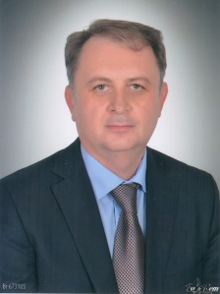
 Biography
Nayil DINKCI is fulltime Assoc. Prof. of Dairy Technology at Ege University Izmir-Turkey. And since 2015 is he the Vice Head of the Department of Dairy Technology and he is also a member of the Agriculture Faculty Committee. His research activity is documented by more than 15 SCI-indexed and 22 peer reviewed papers, several conference presentations. He has attended several workshops of the EU funded Connect4Action Project; some of them are “Talking About Innovation”, “Supporting Dialogue for Successful Innovations”, Collaborative Innovation in the Food Sector”. He is the secondary proposer of a COST action, and also member of the COST Actions “EUBIS: Food Waste Valorisation for Sustainable Chemicals, Materials and Fuels”, “ACTINPACK: Active and intelligent fibre-based packaging - innovation and market introduction”. His research activity is focused on dairy technology, innovation, valorisation of food waste and Active – Intelligent packaging.
Email: nayil.dinkci@ege.edu.tr - nayil.dinkci@gmail.com

Notes/Comment

