Epidemiological Studies on Occupational Hazards among Veterinarians
Dr. Ajay Kumar Upadhyay and Dr. Tanuja Parmar  Department of Veterinary Public Health and Epidemiology  College of Veterinary and Animal Sciences  G B pant University of Agriculture and Technology, Pantnagar-263145  Uttarakhand, India | 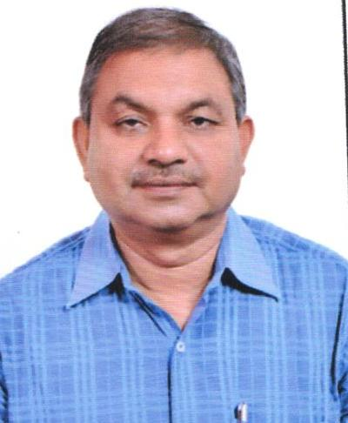

The present study was carried out by conducting a survey among veterinarians related to treatment of animals. As many as 392 veterinarians were surveyed consisting 242 field veterinarians of Uttarakhand and 150 academic veterinarians of Uttarakhand, Punjab and Uttar Pradesh. Out of 392 veterinarians 274 were male and 118 were females. All respondents considered for analysis had regular contact with animals and average working hours per day were 8. Majority of veterinarians reported some sort of injuries within last five year. Out of total 392 respondents, 5.1% (20) reported no injury, 47.5% (186) respondents had 1-5 injuries, 32.1% (126) encountered 5-10 injuries and 15.3% (60) veterinarians had more than 10 injuries during last 5 years. Many individuals reported more than one kind of injury. Individual showed 1 or more than 1 type of injury. The Bite (31.8%), scratch (65.1%), kick (62.8%), horn wound (14%), needle prick (89.2%), injuries due to falling/ lifting animals/ moving heavy equipments (61.3%) and fracture (3.8%) were commonly reported physical injuries. Proportion of injury reported by females was greater than males. Majority of veterinarian (74%) self-treated those physical injuries. 6.5% individuals hospitalized due to injuries like fracture, sprain and severe wound. A total of 19.1% (75/392) of veterinarians were involved in taking radiographic examinations. Most of the veterinarians taking x-rays were academic veterinarians.86.7% were using lead apron (61.3%), but large proportion did not use lead gloves, lead sleeves, lead glasses and monitor. Proportion of males taking x-rays (69.3%) and using protective gears is greater than females (30.7%).
Our findings are suggestive of reporting of low level of zoonotic diseases. Veterinarians contracted, ring worm, other fungal diseases, scabies, toxoplasmosis, parasitic infections, amoebiosis, influenza etc. Ringworm and fungal infection were most common zoonotic infection among veterinarians 13.5% and 26.5% respectively. The psychological hazards included stress due to work overload, exhaustion due to handling with animals, dealing and satisfying animal owners, going to visit patients at their places etc. all these lead to mental stress and loss of working days to alleviate stress. 45% participants reported low level, 34% moderate and 21% high level of stress. Stress level reported was greater for females, and those recently graduated and worked for more than average working hours. Majority of respondents of all age groups rarely go for medical checkup. 73% (286) veterinarians rarely go for medical checkup or only when required. 22.2% (87) respondents go for medical checkup within 1 year and 4.8% (19) respondents in every 3 months.
Biography
Dr. Ajay Kumar Upadhyay has completed his Ph. D. in the year 2000 and presently working as Professor and head Department of Veterinary Public Health and Epidemiology. He has vast research experience of 29 years. He is presently working on Epidemiology of common zoonotic disease in India and food borne pathogens like salmonella and campylobacter. He has authored 7 books and published 5 reviews, 116 research papers and 8 chapters in books. He has handled 11 research projects and in editorial board of 4 journals. He has presented lead papers in 4 international and 74 papers in national conferences.
Presenting author details
Full name: Dr. Ajay Kumar Upadhyay
Contact number: +919411195407
E mail: ajay.akup@gmail.com
Category: (Oral presentation)

