

Title: Does age modify the association between work stress and workability of nurses?
Lilian Tzivian, Faculty of Medicine, University of Latvia, Riga, Latvia
Inga Priede, Faculty of Medicine, University of Latvia, Riga, Latvia
Ina Mezina-Mamajeva, Faculty of Medicine, University of Latvia, Riga, Latvia
Valdis Folkmanis, Faculty of Medicine, University of Latvia, Riga, Latvia

Abstract (300 word limit)
Statement of the Problem: In aging societies there is increased interest in keeping older people in the workforce. This is especially true in the health care system where at the same time due to increasing age of the population more people need medical help and nursing, while the staff becomes older too and tends to leave the work force prematurely, thus leading to a shortage of health care workers. The development of technologies increases the professional duties of nurses but doesn’t reduce work stress. Association between work stress of nurses and their workability is still underestimated. In this study we aimed to investigate the association between work stress and workability of nurses from three major hospitals in Riga, Latvia. Methodology: We assessed cross-sectionally work- and health-related factors of nurses using structured questionnaires. Workability was assessed by self-reported 1 to 10 scale. Work stress was assessed using eight questions on anxiety, two questions on depressive symptoms, and three question on burnout. Multiple linear regression models adjusted for presence of children, year of experience, wage and position were built to investigate the association between work stress and workability. We investigated the effect measure modification of this association by age (dichotomized on median of 45 years). Findings: Study sample included 232 nurses aged from 18 to 79, had median 19 years of experience, mostly worked full wage. In fully adjusted multiple regression models, workability was associated with work stress (effect estimate, β=-0.03 [95% confidence interval -0.04; -0.01] and with position (β=-0.23 [-0.42; -0.05]). Younger participants had stronger association than those older than 45 years (Figure 1), proposing age as effect measure modifier in the association between stress and workability. Conclusion & Significance: Nurses should be particularly treated to reduce their level of stress to prevent a shortage of health care workers.

Image
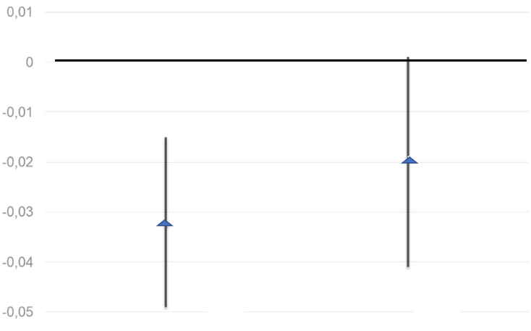
≥ 45 years
< 45 years
Β (95% confidence interval)

Figure 1. Effect modification by age of the association between stress and workability

References:
Recent Publications (minimum 5)
- Cheung T, Yip P. (2015) Depression, Anxiety and Symptoms of Stress among Hong Kong Nurses: A Cross-sectional StudyInt J Environ Res Public Health, 12(9): 11072–11100
- Drury V, Craigie M, Francis K, Aoun S, Hegney DG (2014) Compassion satisfaction, compassion fatigue, anxiety, depression and stress in registered nurses in Australia: Phase 2 results. J Nurs Manag., 22:519–531.
- Imarinen JE (2001) Aging workers . Occup Envir Med, 58:546.
- Perry L, Lamont S, Brunero S, Gallagher R, Duffield C (2015) The mental health of nurses in acute teaching hospital settings: A cross-sectional survey. BMC Nurs., 14:1–8.
- Prochnow A, Magnago T, Urbanetto J, Beck C, Lima S. (2013) Work ability in nursing: relationship with psychological demands and control over the work. Latino-Am. Enfermagem., 21:6.

Biography (150 word limit)
Lilian Tzivian has her expertise in the epidemiology of stress, well-being, and age-related processes. Investigating these processes, she worked on different fields of studies, such as environmental epidemiology, social epidemiology and public health. Her current research interests are related to age-associated personal changes and worsening of working condition of medical personal in Latvia with specific focus on nurses. In addition, professional burning of nurses is on the scope of her scientific interests, as this process cannot be separated from aging and years of experience. Lilian tries to assess using epidemiological methods of studies the main factors related to premature loss of work force in medicine, which is known as one of the main problems of contemporary health care.
Email: Liliana.Civjane@lu.lv
Phone: +371 20165566

Notes/Comments:

