Discovery and validation of microRNA biomarkers in circulation and bone tissue from a type-2 diabetes mellitus rat model
David Carro Vázquez, Msc, TAmiRNA GmbH, Austria
Co-authors: Lejla Emini, Martina Rauner, Christine Hofbauer, Johannes Grillari, Richard Eastell, Lorenz Hofbauer and Matthias Hackl.

Abstract (300 word limit)
Statement of the Problem: Metabolic changes in Type-2 Diabetes-Mellitus (T2DM) make patients more prone to develop osteoporosis and delayed bone healing. We hypothesize that microRNAs could be involved in the underlying mechanism and used as biomarkers in this context. To test this hypothesis, we analyzed microRNAs in samples from Zucker Diabetic Fatty (ZDF) rats, a T2DM model with reduced bone healing and bone mass. Methodology & Theoretical Orientation: 11-week-old male ZDF and wildtype rats with an induction of bone healing by a femur subcritical defect were treated with placebo, anti-sclerostin, PTH and insulin treatments for 12 weeks and serum and ulna samples were then obtained (n = 5-8 per group). RNA isolation and small RNA next generation sequencing (NGS) were performed using serum and ulna samples for untargeted genome-wide miRNA analysis. Significantly (adj. p<0.05) regulated miRNAs identified by NGS were validated by RT-qPCR. 2-way ANOVA analysis was applied to test for regulation in respect to T2DM and anti-osteoporosis treatment (p<0.05). Pearson correlation analysis was performed to identify correlation between microRNA levels and metabolic data and bone imaging by micro-CT (p<0.05). Conclusion & Significance: Significant increases in serum levels of miR-122-5p, a liver-enriched microRNA linked to T2DM, were observed in ZDF rats, supporting previous findings. In ZDF diabetic rats, miR-375 showed the highest up-regulation (up to 4-fold) in serum. In ulna samples, similar expression patterns (Figure 1) were observed, and miR-375 levels were found to be negatively correlated (p<0.05) to several bone structural parameters, suggesting that the de-regulation of miR-375 could contribute to decreased bone quality in T2DM.

Image 1
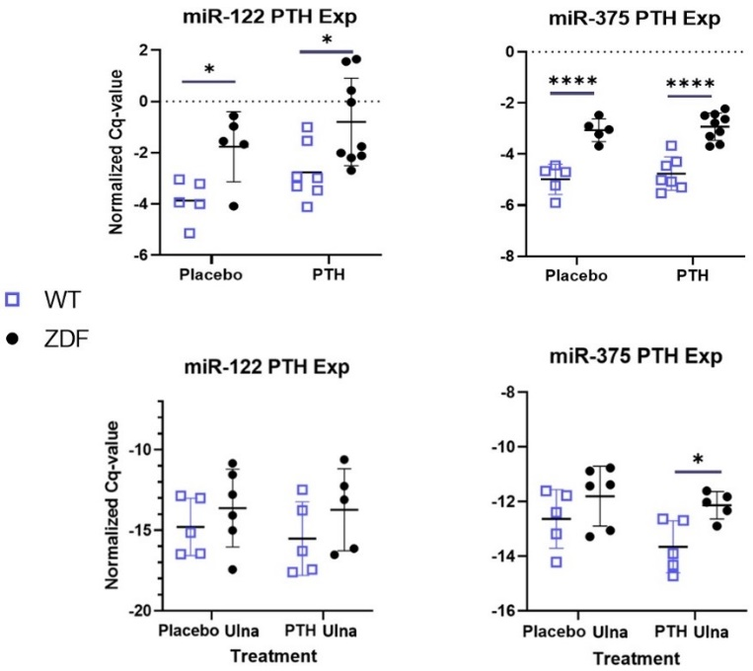

Validated miRNAs by RT-qPCR show a regulation in respect to T2DM in a 2-way ANOVA analysis.
Recent Publications (minimum 5)
- Johannes Grillari; Riikka E. Mäkitie; Roland Kocijan; Judith Haschka; David Carro Vázquez; Elisabeth Semmelrock, Matthias Hackl. Circulating miRNAs in bone health and disease. Bone, 2020 DOI: 10.1016/j.bone.2020.115787

Biography (150 word limit)
David Carro Vázquez has obtained both his Bachelor in Biochemistry and his Master’s degree in Biotechnology from the University
of Málaga, Spain, where he conducted mass spectrometry nuclear profiling of brain cancer cells In addition, he underwent placements for bone research projects both at the University of Ulm, Germany as well as at CNRS in Nice, France. After completing his Master project, David worked at the Charité Berlin, where his research focused on investigating the role of mesenteric fat T cells in Crohn’s disease. Currently, he is working within the FIDELIO Marie Curie ITN at TAmiRNA GmbH.
Email: david.carro.vazquez@tamirna.com Contact No: +4313913322

Notes/Comments:

