Diabetes and Sepsis: Multi Risk, Recurrence, and Multi Impact.
Achu Swiri Abah. BSc Professional Nursing. Cameroon.

Problem Statement: The high levels of death amongst diabetic patients can be mostly associated with sepsis. Sepsis kills and disables millions therefore requires early suspicion and a rapid treatment for survival.
Sepsis is defined as " life threatening organ dysfunction cause by a dysregulated host response to infection ". Sepsis is when the body's response toy infection causes injury to it's own tissues and organs. Signs and symptoms increase heart rates increase breathing rates and confusion. It causes immune response triggered by an infection. treatment intravenous fluids antibiotics. Risk factors, Young and old age. Cancer, diabetes, major trauma and burns sepsis is a medical emergence that become fatal or life changing for many of the individuals who develop this.
Statistics estimates for several hospitalized in United States each year, Sepsis top's 1 Million. and sepsis is one of the top 10 diseases leading to immortality in America. Sepsis is a medical emergence; the symptoms can be tricky to spot and maybe mistaken for other serious illnesses. Getting urgent medical treatment is a key to chances of sepsis. There is great relationship between sepsis and septicaemia. Relationships between sepsis and diabetes, the population that seem to have a high risk of having sepsis are diabetics. Statistics of those who survive is less then 5%.
Concerns. Diabetic patients depend on daily injection of insulin to stay healthy, delay healing and chronic wounds are common sources of infection, depressed immunity exposes diabetics to infection. To conclude unlike other people diabetic on insulin need daily injection to stay healthy, if not careful might contact infection at home or hospital. Therefore, improving the knowledge of sepsis among health care providers, diabetic educators and diabetic patients themselves is of almost importance In fighting against high mortality rates from diabetes.

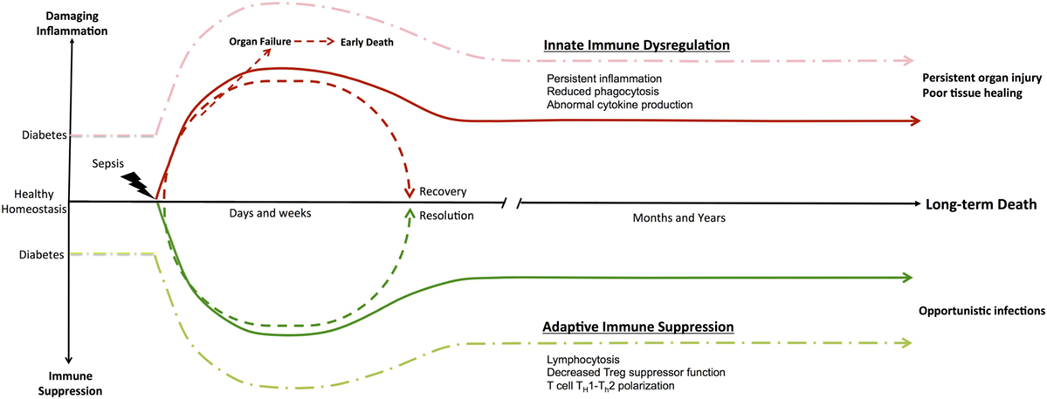
Diabetes and Sepsis: Risk, Recurrence, and Ruination:
https://www.frontiersin.org/articles/10.3389/fendo.2017.00271/full

Recent Publications:
1.Lynn M. Frydrych,1 Fatemeh Fattahi,2 Katherine He,1 Peter A. Ward,2 and Matthew J. Delano
Front Endocrinol (Lausanne). 2017; 8: 271. Published online 2017

2. Philipp Schuetz, MD1,2,3, Pedro Castro, MD, PHD1,2,4 and Nathan I. Shapiro, MD, MPH1,2.Corresponding author: Nathan I. Shapiro, nshapiro@bidmc.harvard.edu.
Diabetes Care 2011 Mar; 34(3): 771-778.
https://doi.org/10.2337/dc10-1185

3. Singer M, Deutschman CS, Seymour CW, Shankar-Hari M, Annane D, Bauer M, et al. The Third International Consensus Definitions for Sepsis and Septic Shock (Sepsis3). JAMA (2016) 315:801–10.10.1001/jama.2016.0287 [PMC free article] [PubMed] [Cross Ref]

4. Chris Higgins, Increased blood glucose in patients with sepsis
Summarized from Tiruvoipati R, Chiezey B, Lewis D et al. Stress hyperglycemia may not be harmful in critically ill patients with sepsis. J Critical Care 2012; 27:153-158

5. Sepsis Alliance: https://www.sepsis.org/sepsis-and/diabetes/
Published December 2017

 My biography: Achu Swiri Abah, has a BSc in Professional Nursing, has been working for 13 years as a practicing nurse, instructor in a Diabetic Clinic. She is an active member with the following: IDF Cameroon, Critical Care Nurses Association and The African Sepsis Alliance. Presently working as a nursing Coordinator at the District hospital in Cameroon.

