Session title: Role of Dental Professionals in Disaster victim identification
Identification is one of the core areas a forensic odontologist has to deal with. INTERPOL identifies dermatoglyphics, dental parameters and DNA as primary identifiers. Teeth remains are found intact even when the body is decomposed or incinerated to some extent. Thus teeth is one of the most important scientific evidence. Disaster is a very unpleasant, sudden experience which involves multiple bodies, chaotic surroundings. Most of the bodies are either left decapitated, decomposed which makes visual identification difficult. It becomes very important for a forensic odontologist to render their best services to help identify the bodies. A dental identification is possible only with the proper comparision of ante mortem and post mortem data. The countries with dental databases usually serves the best for dental identifications. Teeth can endure a lot of taphonomic changes and maintain its integrity, inspite of being exposed to high temperatures or effects of chemicals. In this particular session, we will discuss about the classification of disasters, deeper insights into the role of a forensic odontologist in identification and an essence of humanitarian forensics
Keywords – Disaster Victim Identification, Dental evidence, Forensic Odontologist

Biography
Dr. Pooja Chakraborty is a Forensic Odontologist by profession. She completed her bachelors of dental surgery in 2018 with outstanding marks. On her quest to do something different, she went on to pursue her masters in Forensic Odontology thereafter. To her credit she has numerous International and national Paper and Poster Presentations and also bagged few awards for the same. She has contributed articles in both national and international journals and has even co-authored a chapter on ‘Recent advances in Forensic Odontology’. She is trained in performing dental autopsies. She has keen interest for forensic archaeology and forensic facial reconstructions. She is actively involved in the field of forensics and has addressed various talks for the graduates, post graduates as well as security professionals. She has been invited as speaker on various platforms. She is actively involved with International agencies dealing with DVI Operations.
Designation: BDS, M.Sc Forensic Odontology
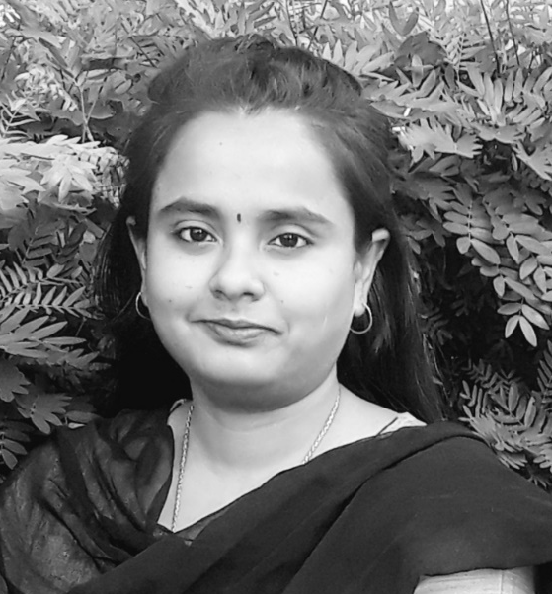
Dr. Pooja Chakraborty
BDS, M.sc Forensic Odontology
India

