Dental and Oral Health: The Unseen Team
Bene Ekine-Afolabi, PhD
ZEAB Therapeutic LTD, Department of Research and Development, England, United Kingdom
University of East London, School of Health, Sport and Bioscience, England, United Kingdom

Abstract
The oral cavity which is comprising of the dental sets, tongues, larynx and microorganisms, is an important part of the human body. Food intake in healthy individual passes through the oral cavity as the first point of call. This means that every element of food has its first contact with the dental set and the mucus membrane of the oral cavity. Thus, meaning the that dental set and the oral cavity will be the first home to unfriendly bacteria that are associated with food. Therefore, the initiation of immunity to unfriendly microorganisms will commence in the oral cavity. Maintaining healthy gum and teeth is a lifelong endeavor. Gum diseases and dental decay has often been treated with little or no attention to the genetic status of an individual. Glutathione is important in immune response and homeostasis of an individual, in disease prevention. Various disease including cancer, diabetes, and cardiovascular disease have been linked to poor oral hygiene; however, the implication of genetic status has not been elucidated. Accumulating evidence have shown the implication of glutathione dysfunction in diseases and shown to be common mostly in individuals with glutathione -S-transferases polymorphisms, an enzyme responsible for the function of glutathione. Microorganisms associated to food and genetic status of glutathione S-transferase as well as glutathione availability in individuals could be the unseen team to give answer to gum disease and oral cancer prevention and/ or treatment.
Keywords: microorganisms, GST, glutathione, prevention, diseases

Image
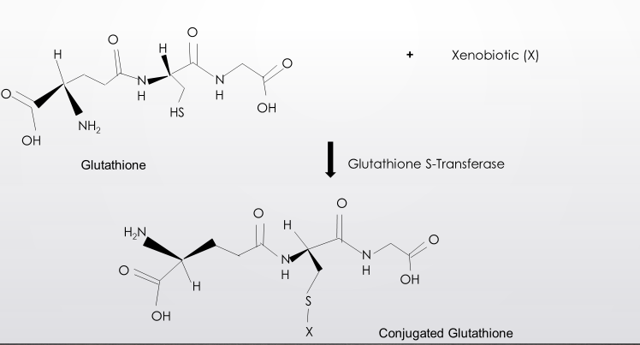
Fig 1: The functioning of glutathione
Recent Publications (minimum 5)
- The Impact of Diet on the Involvement of Non-Coding RNAs, Extracellular Vesicles, and Gut Microbiome-Virome in Colorectal Cancer Initiation and Progression. Frontiers in Oncology https://doi.org/10.3389/fonc.2020.583372 Bene A. Ekine-Afolabi, Anoka A. Njan, Solomon O. Rotimi, Anu R. I, Attia M. Elbehi, Elizabeth Cash, and Ademola Adeyeye

- Mutational Signatures, Variant Topography, and Signature Pathways in Breast Cancer: A Futuristic approach to personalized care. Translational genomics. doi:10.9777/tg.2020.10001. Anu R I, Attia M. Elbehi, Bene Ekine-Afolabi, Elizabeth Cash

- Emerging role of immune checkpoint inhibitors and predictive biomarkers in head and neck cancers. https://doi.org/10.1016/j.oraloncology.2020.104977 Attia M. Elbehi, R.I. Anub, Bene Ekine-Afolabi, Elizabeth Cash

- The role of the circadian clock in cancer hallmark acquisition and immune-based cancer therapeutics. Journal of Experimental and Clinical Cancer Research (2021) 40:119 https://doi.org/10.1186/s13046-021-01919-5 Elizabeth Cash, Sandra Sephton, Cassandra Woolley, Attia M. Elbehi, Anu R. I., Bene Ekine-Afolabi, and Victor C. Kok

 Biography (150 word limit)
te your Logo here
Bene Ekine-Afolabi is a graduate of River State University of Science & Technology in Applied Biology (Medical Microbiology option); with an MRes degree at University of East London, United Kingdom.
She had her PhD. study & worked at the Department of Natural Sciences, Middlesex University, UK. Trained in practical approach to toxicology in drug development (American College of Toxicology/British Toxicology Society). Bene does research in Microbiology, Molecular Biology and Cancer: Her current focus of research (which has yielded eight designed models), is on the Investigation of molecular mechanism of colorectal cancer and due to the current pandemic, has been involved in drug development for COVID-19. Bene had Harvard University part-sponsored training in therapeutic research in Cancer Biology & Therapeutic. Bene has been involved in three published peer reviewed article, two manuscript awaiting publication, among which one is on COVID-19 and was submitted to the Chief Medical Officer of United Kingdom to assist in response to the pandemic.

Presenting Author Details
Full Name: Dr Bene Ekine-Afolabi
Email ID: dcr@zeabtherapeutic.com
Phone No: +447581221509

Notes/Comments:
Oral Presentation is preferred

Presenting author details
Full name:
Contact number:
Mail id:
Category: (Oral presentation/ Poster presentation)

