The influence of the first coronavirus wave on the two-week-wait head and neck cancer referrals to a London hospital
Nermin Hayek BDS, King’s College London , UK

Abstract (300 word limit)
The coronavirus Covid-19 has sent reverberations in all aspects of healthcare, where its spread in 2019 has impacted multiple National Health Services, including the head and neck cancer clinics. Early diagnosis combined with the appropriate treatment plays an unquestionable significant role in the survival rates and prognosis for head and neck cancer patients. King’s College Hospital sits in the heart of south-east London, serving a population of 700,000; however also acts as a tertiary care centre receiving referrals for a multitude of specialties from across the South of England. A retrospective review was conducted of 365 cases referred for suspected head and neck cancer to the Oral and Maxillofacial Surgery and Oral Medicine two-week-wait clinic at King’s College Hospital during the first coronavirus wave (1st of March 2020 to 31st of September 2020) and the same time period in 2019. A total of 233 suspected head and neck cancer referrals were made via the Pan London referral pathway during the first wave in 2020, compared to 132 referrals made in 2019. A total of 3.4% (n=8) of the patients referred during the first wave were diagnosed with a subtype of head and neck cancer, compared with 9.8%(n=13) in 2019. Of these referrals, the proportion of patients not seen within the required 14-day period only slightly increased from 3.03% (n=4) in 2019 to 3.86% (n=9) in 2020. There was a significant impact from the government-enforced lockdown where reduced face-to-face examinations impacted the quantity of referrals and their diagnosis via the two-week-wait pathway. This study allows reflection of the impact of the first coronavirus wave on the two-week-wait head and neck cancer referrals and gives valuable insight for service implementation and staff reallocation in the event of future periods of waves to prevent overburdening of services.

Image

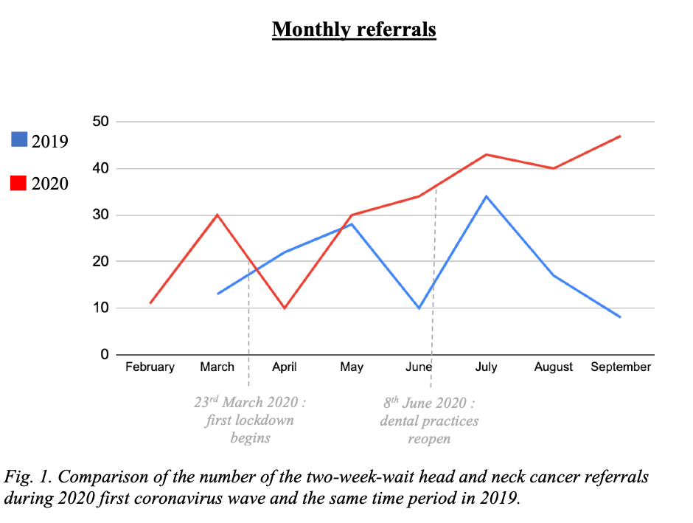

References:

1. Huang C, Wang Y, Li X, Ren L, Zhao J, Hu Y et al. Clinical features of patients infected with 2019 novel coronavirus in Wuhan, China. Lancet 2020;395:497–506
2. Hurley S, Neligan M. Changes to primary care services in England. 2020. Available at https://wokingham.moderngov.co.uk/documents/s43592/Issue%203%20Preparedness%20letter%20for%20primary%20dental%20care%20-%2025%20March%202020.pdf (accessed Feb 2021).
3. Sites DUDC. COVID-19 guidance and standard operating procedure [Internet]. Nhs.uk. [cited 2021 Jun 10]. Available from: https://www.england.nhs.uk/coronavirus/wp-content/uploads/sites/52/2020/06/C0581-covid-19-urgent-dental-care-sop-update-16-june-20-.pdf
4. Cancer Research, Head and neck cancer statistics. https://www.cancerresearchuk.org/health-professional/cancer-statistics/statistics-by-cancer-type/head-and-neck-cancers#heading-Zero (accessed Feb 2021) :
5. Oliver Jones, Stephanie Hackett, Despoina Chatzistavrianou, and David Newsum. Head and Neck cancer part 1: diagnosis and classification Dental Update 2019 46:8, 722-729
6. NICE Guideline. Suspected cancer: recognition and referral. 23rd June 2020. Available at https://www.nice.org.uk/guidance/ng12/resources/suspected-cancer-recognition-and-referral-pdf-1837268071621 (accessed Feb 2021)
7. Cadoni G, Giraldi L, Petrelli L, et al. Prognostic factors in head and neck cancer: a 10-year retrospective analysis in a single-institution in Italy. Fattori prognostici del tumore testa-collo: un’analisi retrospettiva monocentrica di 10 anni. Acta Otorhinolaryngol Ital. 2017;37(6):458-466. doi:10.14639/0392-100X-1246
8. Gerstner AO. Early detection in head and neck cancer - current state and future perspectives. GMS Curr Top Otorhinolaryngol Head Neck Surg. 2008;7:Doc06.
9. Head and Neck Cancer: Risk Factors and Prevention. Oct 2019. Available at https://www.cancer.net/cancer-types/head-and-neck-cancer/risk-factors-and-prevention (accessed May 2021)

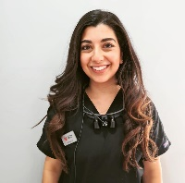 Biography
Nermin Hayek completed her Bachelor of Dental Surgery degree from King’s College London. She worked as a dental core trainee in the Oral and Maxillofacial Surgery deperatment in King’s College Hospital and is currently carrying out a dental core training year in Community Dental Services. She is focused on furthering her post graduate education by participating in post graduate training courses- particularly in the field of paediatric dentist and orthodontics.

.
Email: hayeknermin@gmail.com

Presenting author details
Full name:
Contact number:
Mail id:
Category: (Oral presentation/ Poster presentation)

