Title: Understanding anatomy and radiographic technique for better patient surgical outcome:
Farnaz Akbarian-Tefaghi
Barts and the London School of Medicine and Dentistry, Queen Mary University of London. E1 2AD
Identification of anatomical structures including all their morphological variations is essential when assessing the jaws for pathological changes. Conventional radiographs are the most common imaging modalities used for detection of any suspected jaw fracture. Multiple images are usually required, even then, it may not be possible to conclude the presence or absence of fractures with certainty.
A 30-year-old female attended the Oral and Maxillofacial department following a fall. The acquired panoramic radiograph (Fig.1) showed a radiolucent line in the right parasymphyseal region highly suspicious of a fracture. This however could not be identified on the posterior-anterior radiograph (Fig.2). A decision to carry out a low dose cone beam computed tomography (CBCT) was made to confirm the presence of a fracture ( Fig.3).
The CBCT evaluation revealed no fracture present however identified the radiolucent line as a prominent lateral lingual canal. The perforating branches of the vessels in the floor of the mouth enter the lingual cortical plate of the mandible through the lingual canals.
We need to appreciate the limitations of 2D imaging, importance of patient position during panoramic radiography and the usefulness of CBCT in dental imaging. Variation in the anatomy of the lingual surface of the mandible relating to vital structures that can be at risk during surgical procedures including dento-alveolar surgical procedures such as root extraction, biopsy, tori removal, block graft harvesting and osteotomy should be undertaken with an appreciation of the underlying anatomy to avoid causing a haematoma in the floor of the mouth.

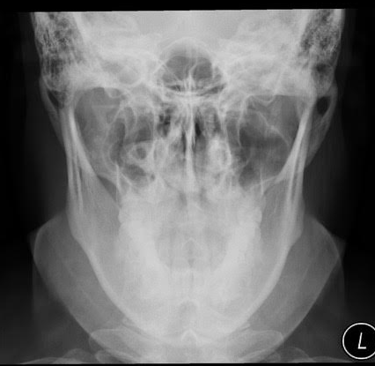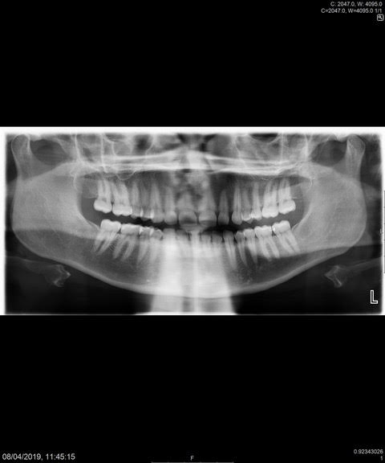Fig.2
Fig.1
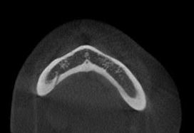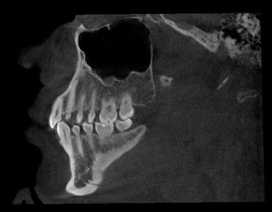
B
A
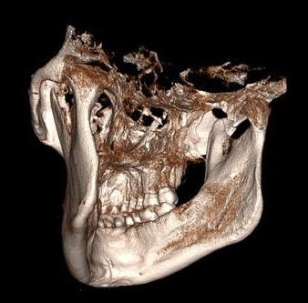Fig. 3
C
Fig. 1. Dental Panoramic Radiograph
Red arrow shows the radiolucent line in the right parasymphyseal region, which is highly suspicious of a fracture.
Fig. 2. Postero-anterior of the skull (PA skull)
Fig. 3. Reconstruction of axial view (A), sagittal view (B) and three-dimensional (C) visualisation of mandible of the patient on CBCT scan. Red arrows show the lateral lingual canal.

Biography:
Farnaz Akbarian Tefaghi has finished her BDS in 2008 in king’s college London University and then carried out SHO training in king’s college hospital in Paediatric dentistry, Oral Medicine, oral and maxillofacial surgery. And then carried out some SHO training in Germany in orthodontics and oral surgery and then joined Queen Mary university London to pursue a career in dental and maxillofacial Radiology.

Fist author:
Full name: Farnaz Akbarian Tefaghi :Lecturer in Dental and Maxillofacial Radiology. Institute of Dentistry, Barts and the London School of Medicine and Dentistry, Queen Mary University of London. E1 2AD
Contact number:00447377552344, email: f.akbarian-tefaghi@qmul.ac.uk
Category: (Poster presentation)

Co Author:
Jimmy Makdissi: Consultant in Dental and Maxillofacial Radiology. Institute of Dentistry,
Barts and the London School of Medicine and Dentistry, Queen Mary University of London.
E1 2AD.

