Title: Utilising previous radiographs: the forgotten principle of dose optimisation

Farnaz Akbarian-Tefaghi
Barts and the London School of Medicine and Dentistry, Queen Mary University of London. E1 2AD

The easy access to medical and dental imaging has made us clinicians more accepting to requesting radiographic examinations. As a result, a steady increase in the use of imaging modalities is leading to an increase in healthcare cost and increase in patients’ radiation exposure.

We present a case where the use of previous imaging has aided the diagnosis and prevented unnecessary exposure to the patient. This is a 67-year-old patient attended for a surgical removal of lower left third molar. A sectioned panoramic radiograph showed an incidental finding of a well-defined, unilocular radiolucency measuring 10x7 mm apical to the lower left second and third molars. This was partially superimposed over the outline of the ID canal. A Stafne’s bone cavity (SBC) was considered as the most likely diagnosis. Further imaging was considered due to location not being fully below the ID canal as usually described in the literature. A radiologist opinion was sought. Reviewing previous imaging on PACS revealed the patient has had a CT Angiogram of the head and neck five years prior. This showed a lingual bone defect of the surface of the mandible in the region of interest. The extension of the submandibular gland into the defect confirmed the likely nature of SBC. This is a benign condition also known as lingual mandibular bone defect (LMBD).

All examinations have to be justified to ensure the benefit to the patient outweigh the risk and should be optimised to ensure radiation exposures are kept as low as reasonably achievable.

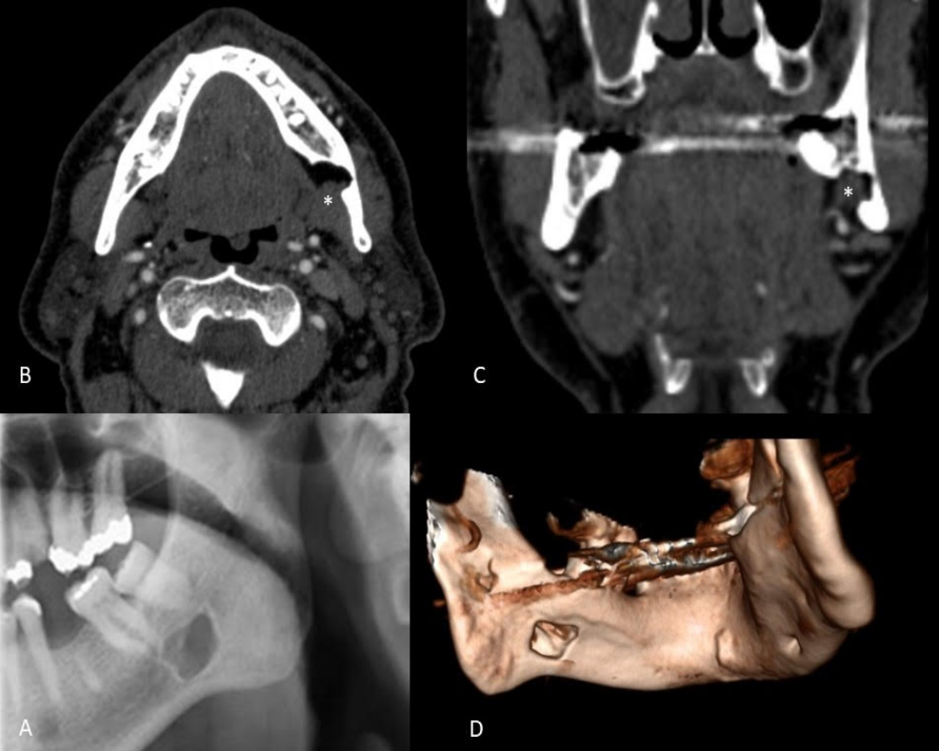

A: sectioned panoramic Radiograph
B, C: Constructed images of CT angiogram
D: 3D Image of mandible (constructed from CT angiogram)
Blue arrows indicate the lesion (Stafne’s bone cavity (SBC)

Biography:
Farnaz Akbarian Tefaghi has finished her BDS in 2008 in king’s college London University and then carried out SHO training in king’s college hospital and Germany for few years in Paediatric dentisry, Oral Medicine, orthodontics, oral and maxillofacial surgery and oral surgery and then joined Queen Mary university London to pursue a career in dental and maxillofacial Radiology.

Fist author:
Full name: Farnaz Akbarian Tefaghi :Lecturer in Dental and Maxillofacial Radiology. Institute of Dentistry, Barts and the London School of Medicine and Dentistry, Queen Mary University of London. E1 2AD
Contact number:00447377552344, email: f.akbarian-tefaghi@qmul.ac.uk
Category: (Poster presentation)

Co Authors :
Ashok Adams: consultant ENT/ Neuroradiologist. The Royal London Hospital, Whitechapel
Rd, London E1 1BB.
Jimmy Makdissi: Consultant in Dental and Maxillofacial Radiology. Institute of Dentistry,
Barts and the London School of Medicine and Dentistry, Queen Mary University of London.
E1 2AD.

