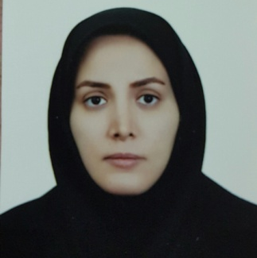

Relationship of the Gonial Angle and Inferior Alveolar Canal Course Using Cone Beam Computed Tomography

Farzeneh Eslami, Associate professor of orthodontics, Mashhad University of Medical Sciences, Mashhad,Iran

Statement of the Problem: Accurate localization of the inferior alveolar canal (IAC) is extremely important in some dental treatments. Anatomical variation of the canal means that it can be difficult to locate. Cone beam computed tomography (CBCT) can help in determining the exact location of the canal.
In this in vitro study, 61 dry adult human hemi-mandibles were used. The CBCT scans were taken of all samples and GA was measured on all CBCT scans. The samples were divided into two groups of low angle (≤125°) and high angle (>125°). The canal dimensions, length and course were evaluated. On the sagittal view, the IAC path was classified as type A, B or C. On the axial view, canal course was defined as A1 or A2 according to the mental foramen angle. The average GA size was 121.8±7.05° at the right side and 123.8±6.32° at the left side. On the sagittal view, there was a significant correlation between the GA size and the canal course. In the high-angle group, type A was dominant; whereas in the low-angle group, type B was more common. On the axial view of IAC course, type A1 was more common (73.43%). The results showed that GA size was associated with IAC course. In cases with a larger GA, the canal runs in a more straightforward path, and at the same level as the mental foramen.

Keywords: Cone Beam Computed Tomography; Mandibular Nerve; Mandible
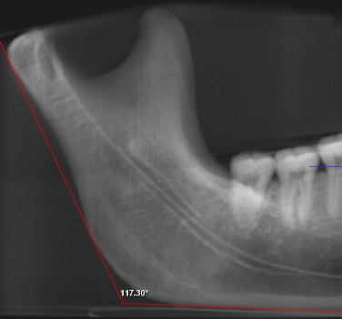
Fig. 1. Gonial angle measurements
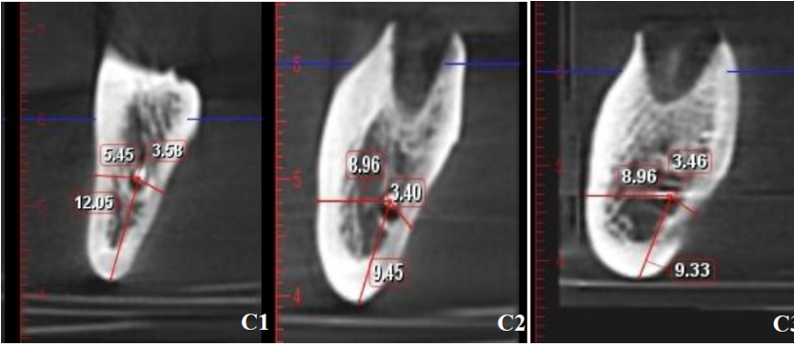
Fig. 2. Evaluation of the buccolingual position of the IAC by calculating the distance from the center of IAC to buccal, lingual, and inferior borders in C1, C2, and C3 slices
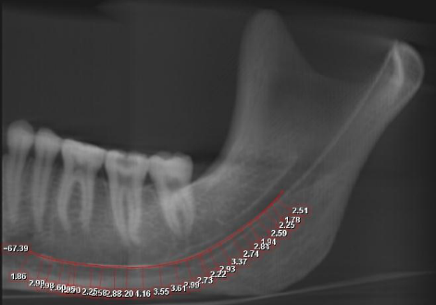

Fig. 3. Total length of IAC

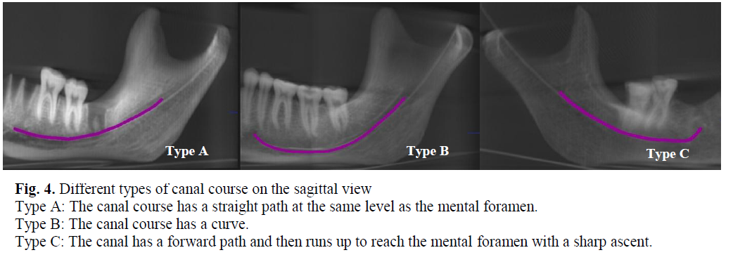
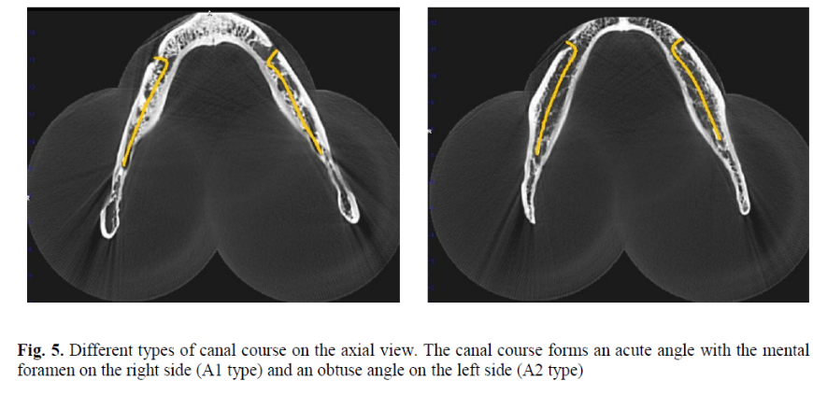
Recent Publications:
1-Yassaei S, Eslami F.Iranian Journal of Orthodontics. ; 9:43-9. 2014, Dentofacial Relapse in Class II Patients Treated with Functional Appliances.
2-Anbiaee N, Eslami F, Bagherpour A. Journal of dentistry (Tehran, Iran). 12(10):756.2, 2015 Oct; Relationship of the gonial angle and inferior alveolar canal course using cone beam computed tomography.
3-Yassaei S, Aghili H, Afshari JT, Bagherpour A, Eslami F. Lasers in medical science. 1;31(9):1751-9. 2016 Dec, Effects of diode laser (980 nm) on orthodontic tooth movement and interleukin 6 levels in gingival crevicular fluid in female subjects.
4-Aghili H, Yassaei S, Eslami F. Dental research journal.14(4):252. 2017 Jul; Evaluation of the effect of three mouthwashes on the mechanical properties and surface morphology of several orthodontic wires: An in vitro study.
5- Omidkhoda M, Jahnabin A, Khoshandam F, Eslami F, Zarch SH, Afshari JT, Kermani H. Iranian journal of otorhinolaryngology. 30(101):329. 2018 Nov; Efficacy of Platelet-Rich Fibrin Combined with Autogenous Bone Graft in the Quality and Quantity of Maxillary Alveolar Cleft Reconstruction.

Biography
Farzaneh has completed her MSc in orthodontics at the age of 27 years from Shahid Sadoughi University of Medical Sciences. She is an associate professor of orthodontics at Mashhad University of Medical Sciences. She had done the first long-term evaluation of the IL-6 concentration in orthodontic patients. She has published some papers in reputed journals and has been serving as an editorial board member of two dentistry journals.
Presenting author details
Full name: Farzaneh Eslami
University name: Mashhad University of Medical Sciences, Mashhad, Iran
Designation: Associate Professor
Country: Iran
Mobile number :00989151579646
Email:farzaneheslami1989@gmail.com

Track number: Track 1-3Dental Radiology
Category: Poster presentation
Research interest: Cone Beam Computed Tomograghy, Orthodontics
Year of birth:1988

