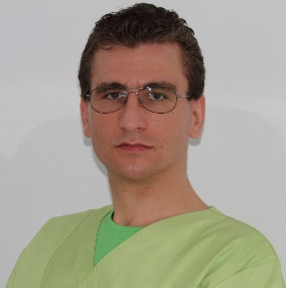 Official Photo 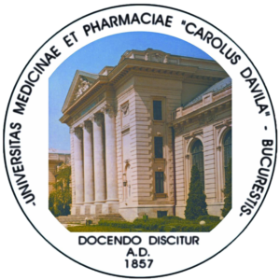 University/Organization Logo

Isolation of the teeth with large coronal destructions using the LC branches
Nicolae Cristian Eugen Cazacu, DMD, PhD, ROMANIA
Constantin Cazacu, DMD, CNC Dental ART, ROMANIA

Abstract (300-word limit)
The standard isolation of teeth with large coronal destruction, but with prosthetic value does not provide enough safety against saliva contamination or the passage of therapeutic liquids (sodium hypochlorite).
Light-curing branches improve sealing.
The method consists in placing a branch of photopolymerizable (light-curing) material on the neighboring teeth or clamp’s jaw, thus creating a barrier by laying the rubber dam on the soft tissues.
The branches are created either extemporaneously in the dental office directly into the oral cavity or on the gypsum cast or in the laboratory after a preliminary impression.

Key words: dental dam, clamp, dr. Cazacu dental dam isolation branches, supplemental isolation

Image (please select either the first 4 or the last 4)
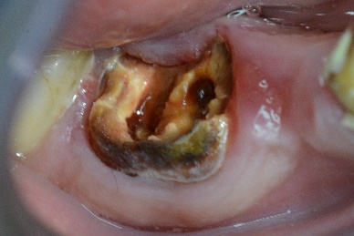 | 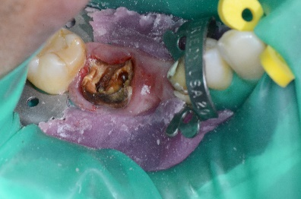
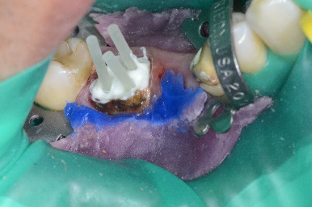 | 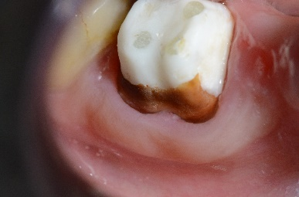
Or
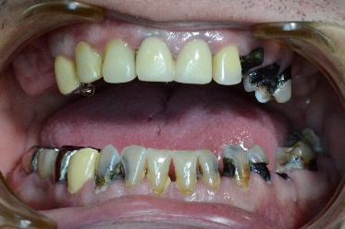 | 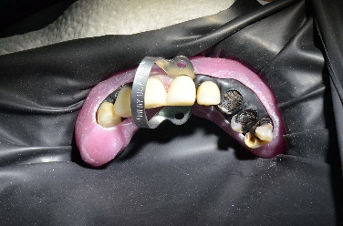
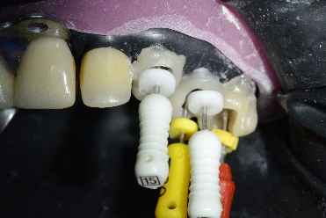 | 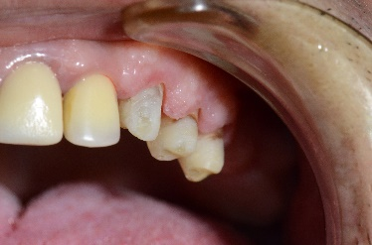

Recent Publications (minimum 5)
- Cazacu NCE, Cazacu C. (2006) „Dental dam isolation of mandibular wisdom teeth”. Magazine MedicDentist.ro, Nr. 4/2006: 24-26, ISSN 1841 – 5830.
- Cazacu N.C.E., Cazacu C. (2009) Dental Dam Handbook for Every day Practice Guide, Bucharest, University Press Carol Davila.
- Invention Patent nr. 125577 issued on 29.04.2011 by the Romanian State Office for Inventions and Trade Marks for “Dental Forceps for passing the dental dam through the tight contact surfaces of neighboring teeth”, inventors: Cazacu Nicolae Cristian Eugen, Cazacu Constantin, Bucharest.
- Cazacu N., Cazacu V., Cazacu C., (2012) Dental dam in endodontics – specific issues in clinical cases, Romanian Dentistry Magazine, 2012, Vol LVIII, Nr. 2:
- Cazacu NCE. (2014) Dental dam isolation of the teeth with large coronal destructions – illustrative clinical cases. Romanian Dentistry Magazine, vol LX, nr. 4, 2014: 255-265
- Cazacu NCE. (2014) Dental dam clamp adaptation method on carved gypsum cast, Journal of Medicine and Life 2014: Vol. 7, Issue 4: 499-506.
- Invention Patent nr. 131185 issued on 28.12.2018 by the Romanian State Office for Inventions and Trade Marks for “Dental Instrument with Mirror”, inventors: Cazacu Nicolae Cristian Eugen, Cazacu Constantin, Bucharest

Biography
Nicolae Cristian Eugen Cazacu (dentist and oral surgeon) has been involved since 2004 in dental dam improvements in difficult clinical cases and has obtained two patents from Romanian State Office for Inventions and Trade Marks. The first one in 2011 for an instrument which helps applying the dental dam on the teeth which have tight contact surfaces.
The second patent was issued for an instrument which improves the workflow when using the dental microscope.
His Ph. D thesis presented useful improvements for dental practitioners who prefer saving the teeth with real prosthetic value instead of replacing them with implants.

Presenting author details
Full name (As per the passport): Nicolae Cristian Eugen Cazacu
University/Industry/Organization name: Carol Davila University of Medicine and Pharmacy Bucharest
Designation (Director/Prof/Assistant or Associate prof/Researcher/Student): Assistant prof
Country: Romania
Mobile number (country code – number): +40723240665
Email: nicolae.cazacu@umfcd.ro
Track number: https://www.dentalcongress.com/europe/call-for-abstracts.php (For track number follow this link) 17-1 or 20-5
Category (Oral presentation/ Poster presentation/Young researcher forum/E-poster): Oral Presentation
Research interest: Rubber dam improvements for successful isolation in large coronal destructions
Your profile page URL in your department:
Year of birth: 1978
Linked In/Facebook/twitter account: https://www.facebook.com/nicky.cazacu

Note: Please fill up the Red mark fields so that it would be easier for us to cite your details in the conference particulars. (Please do not forget to fix your photo and Logo above the title)

