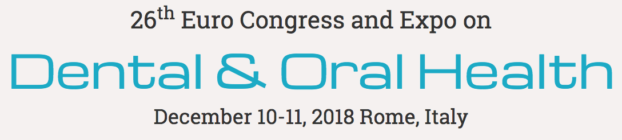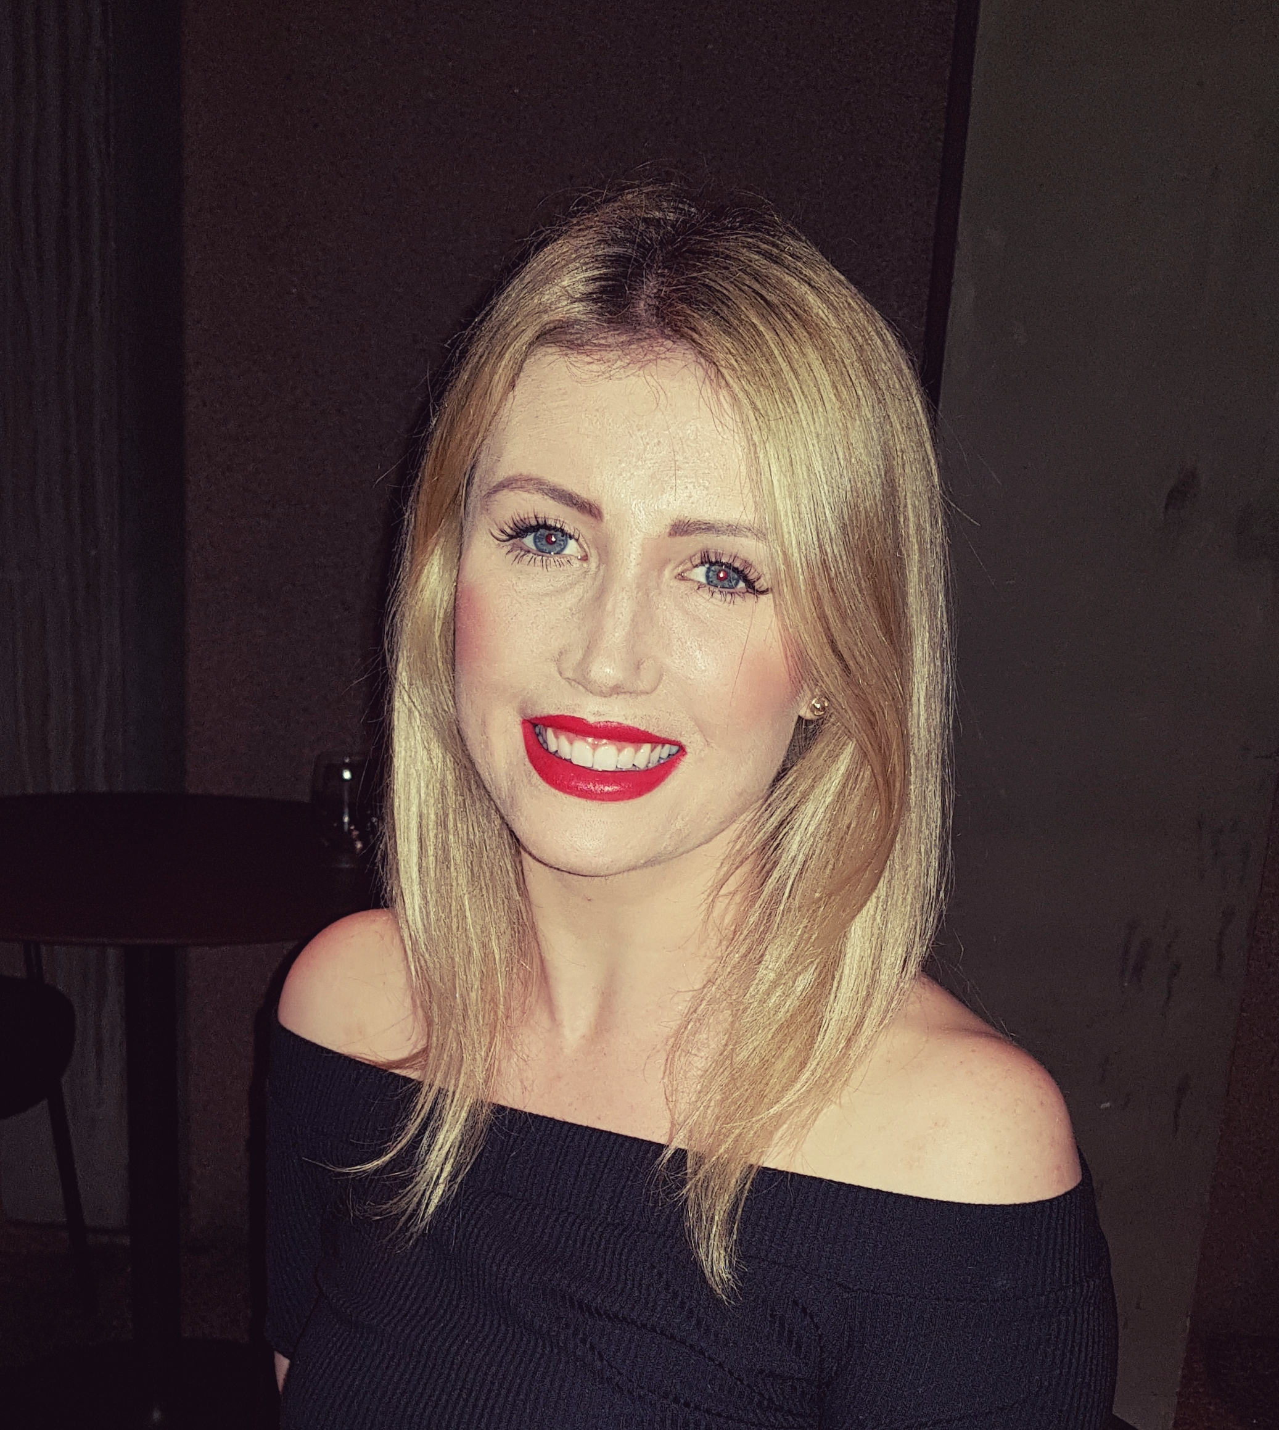

Title:
An Audit on the Quality of Pre-Operative Intra-Oral Digital Radiographs taken for Dental Extractions in a General Practice Setting

Name: Gabrielle O’Donoghue BSc BDS MFDS (RCSI)
Private General Dental Practice

Abstract:
Background: Pre-operative radiographs facilitate assessment and treatment planning in minor oral surgery. Quality assurance for dental radiography advocates the As Low As Reasonably Achievable (ALARA) principle in collecting accurate diagnostic information.
Aims: To audit the quality of digital intraoral periapicals (IOPAs) taken prior to dental extractions in a metropolitan general dental practice setting.
Standards: The National Radiological Protection Board (NRPB) guidance outlines three grades of radiograph quality: excellent (Grade 1 > 70% of total exposures), diagnostically acceptable (Grade 2 <20%), and unacceptable (Grade 3 <10%).
Methodology: A study of pre-operative radiographs taken prior to dental extractions by practitioners across 12 private general dental practices in a large metropolitan area. A total of 725 extractions were assessed, allowing 258 IOPAs to be reviewed in one audit cycle.
Results: First cycle: Of 258 IOPAs: 223(86.4%) scored Grade 1, 27(10.5%) Grade 2, and 8(3.1%) Grade 3. The standard was met. 35 dental extractions were performed without an available pre-operative radiograph.
Action Plan & Recommendations: Results were distributed to all staff and a continuous professional development evening organized to outline recommendations to improve image quality. A second audit cycle is proposed at a six-month interval to review the recommendations and appraise results.
Conclusion: The overall standard of radiographs taken in a private dental practice setting met the published guidelines. A significant improvement in the number of procedures undertaken without pre-operative imaging is expected at a six-month interval period. An investigation into undiagnostic imaging and associated adverse patient outcomes is being considered. Maintenance of the standards achieved is predicted in the second audit cycle to ensure consistent high quality imaging.

Key Words: Radiographs, Periapicals, Quality assurance, Audit, Dental extractions, Oral surgery, General Dental Practice

Biography:
Gabrielle O’Donoghue graduated with First Class Honours from the Bachelor of Dental Surgery (Honours) degree at University College Cork, Ireland in 2016. She worked as a general practitioner in private practice thereafter, taking an active interest in clinical research and audit. She is a Member of the Faculty of Dental Surgery at the Royal College of Surgeons in Ireland. This is her second poster presentation.

Presenting author details:
Full name: Gabrielle O’Donoghue
Organisation name: N/A
Designation: General Dental Practitioner
Country: Ireland
Contact number: +353872174741
Email: gabrielleodonoghue01@gmail.com
Category: E-poster presentation
Research interest: Prosthodontics and Restorative Dentistry
Year of Birth: 1992

