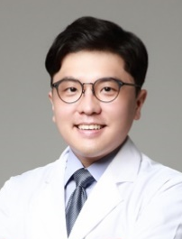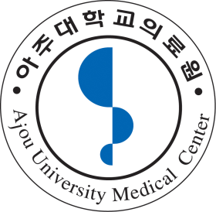

Photofunctionalization Enhances Bone-Implant Contact, Dynamics of Interfacial Osteogenesis, Marginal Bone Seal, and Removal Torque Value of Implants: A Dog Jawbone Study

Se-Wook Pyo, Department of Dentistry, College of Medicine, Ajou University, Suwon, Korea
Jae-Hoon Lee, Department of Prosthodontics, College of Dentistry, Yonsei University, Seoul, Korea
Takahiro Ogawa, Laboratory of Bone and Implant Sciences, Division of Advanced Prosthodontics, UCLA School of Dentistry, Los Angeles, CA, USA

Abstract (300-word limit)
Objective: Ultraviolet (UV) light treatment of titanium, ie, photo-functionalization, has been extensively reported to enhance the osteoconductivity of titanium in animal and in vitro studies. This is the first study to examine whether photo-functionalization is effective on commercial dental implants in vivo. Materials & Methods: Dental implants with a micro-roughened surface were placed into dog jawbones. Photo-functionalization was performed by treating implants with UV light for 15 minutes using a photo device immediately before placement. Four weeks after placement, bone-implant integration was evaluated using a removable torque test and static and dynamic histology. Results: Implant surfaces were converted from hydrophobic to super-hydrophilic after photo-functionalization. Removable torque for photo-functionalized implants was significantly higher by 50% than that for untreated implants. Bone to implant contact (BIC) was significantly higher for photo-functionalized implants in all zones examined: marginal, cortical, and bone marrow zones. An intensive mineralized layer was exclusively present in marginal bone at photo-functionalized interface. Dynamic histology identified earlyonset, long-lasting robust bone deposition at photo-functionalized interface. Conclusions: Photo-functionalization enhanced the morphology, quality, and behavior of periimplant osteogenesis, including the increased BIC, expedited robust interfacial bone deposition, and improved marginal bone seal and support.

Key words: Titanium, Superosseointegration, Ultraviolet, Superhydrophilic, Biological aging, Photo-functionalization

Image

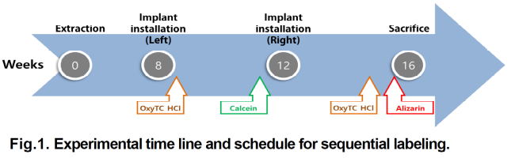

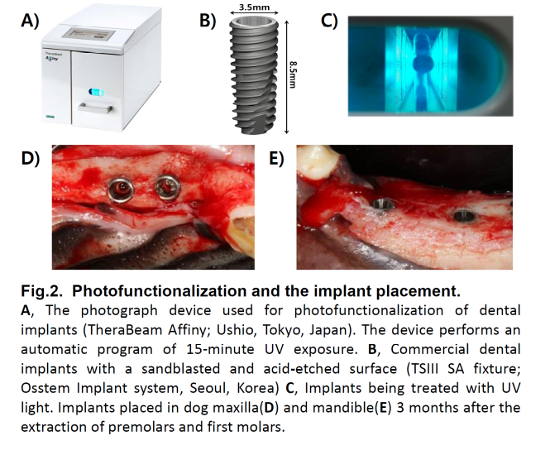

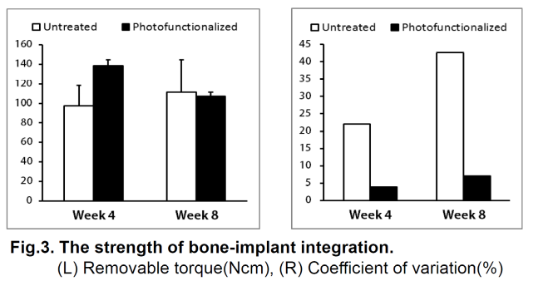

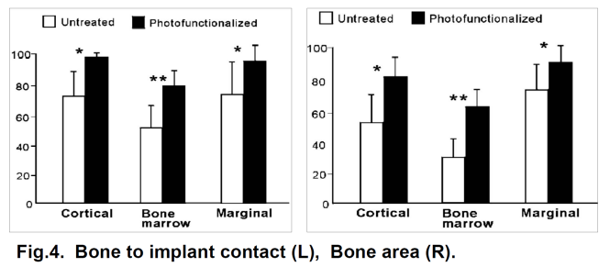

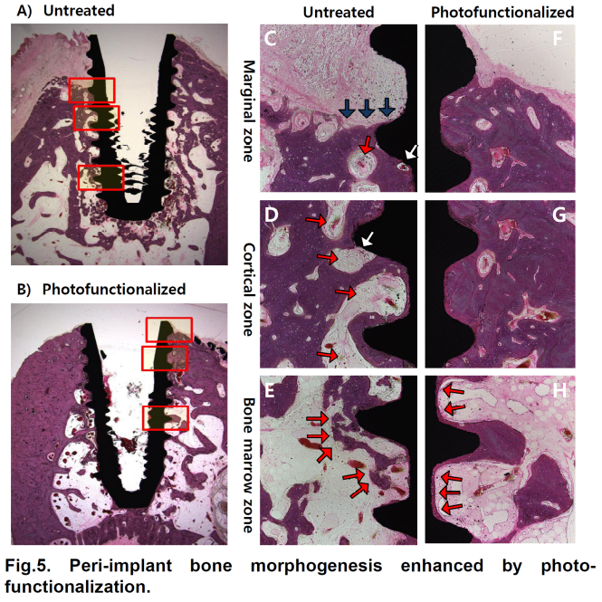

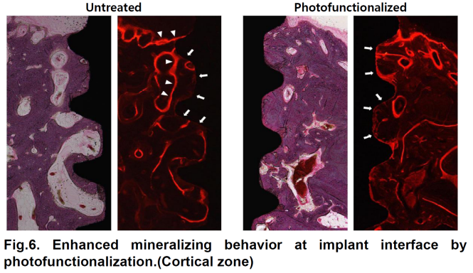

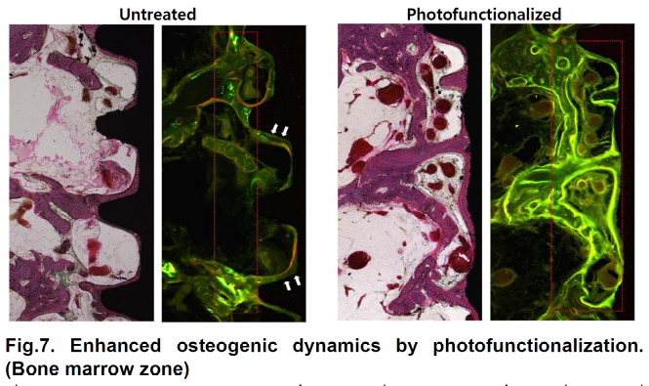

Recent Publications (minimum 5)
- Funato, A., M. Yamada and T. Ogawa (2013) Success rate, healing time, and implant stability of photofunctionalized dental implants. Int J Oral Maxillofac Implants 28(5): 1261-1271.
- Pyo, S. W., Y. B. Park, H. S. Moon, J. H. Lee and T. Ogawa (2013). Photofunctionalization enhances bone-implant contact, dynamics of interfacial osteogenesis, marginal bone seal, and removal torque value of implants: a dog jawbone study. Implant Dent 22(6): 666-675.
- Ogawa, T. (2014). Ultraviolet photofunctionalization of titanium implants. Int J Oral Maxillofac Implants 29(1): e95-102.
- Hirota, M., T. Ikeda, M. Tabuchi, T. Ozawa, I. Tohnai and T. Ogawa (2017). Effects of Ultraviolet Photofunctionalization on Bone Augmentation and Integration Capabilities of Titanium Mesh and Implants. Int J Oral Maxillofac Implants 32(1): 52-62.
- Hirota, M., T. Ozawa, T. Iwai, T. Ogawa and I. Tohnai (2018). Effect of Photofunctionalization on Early Implant Failure. Int J Oral Maxillofac Implants 33(5): 1098-1102.
- Jain, S., R. S. Williamson, M. Marquart, A. V. Janorkar, J. A. Griggs and M. D. Roach (2018). Photofunctionalization of anodized titanium surfaces using UVA or UVC light and its effects against Streptococcus sanguinis. J Biomed Mater Res B Appl Biomater 106(6): 2284-2294.

Biography
Se-wook Pyo (1984.11.24)
2003-2009 : Yonsei University College of Dentistry (DDS), 2010-2012: Yonsei University Graduate School (MSD)
2009-2013 : Intern & Resident, Yonsei University Dental Hospital, Board Certificate in Prosthodontics(2013)
2013-2016: Military service as an officer in the Navy Dental Corps, 2016-2018: Clinical fellow, Seoul National University Dental Hospital
2018-Present: Clinical assistant professor, Ajou University Dental Hospital

Presenting author details
Full name (As per the passport): SEWOOK PYO
University/Industry/Organization name: Department of Dentistry, College of Medicine, Ajou University
Designation (Director/Prof/Assistant or Associate prof/Researcher/Student): Clinical Assistant Professor
Country: Republic of Korea
Mobile number (country code – number): +82-10-9603-2407
Email: pyosewook@hanmail.net
Track number: 12-1
Category (Oral presentation/ Poster presentation/Young researcher forum/E-poster): Poster presentation
Research interest: Implant Surface treatment, Implant Stability, Prosthodontics
Your profile page URL in your department:
Year of birth:
Linked In/Facebook/twitter account:

Note: Please fill up the Red mark fields so that it would be easier for us to cite your details in the conference particulars. (Please do not forget to fix your photo and Logo above the title)

