Effectiveness of topical vancomycin in the prevention of spinal surgical site infections: a retrospective cohort study
Rawan Tafish, BSc, Pharm D, PGDipClinPharmD

Abstract (300 word limit)

The risk of surgical site infections (SSIs), particularly methicillin-resistant staphylococcus aureus (MRSA) SSIs, post spinal surgeries is one of the most daunting experiences to patients and surgeons. In some practices, vancomycin powder is applied directly on the wound before skin closure to minimize the risk of SSIs; however, this practice is not supported by well-established evidence. A retrospective cohort study was conducted using the hospital database. Patients who underwent spinal surgeries from the period of 09/2013 to 09/2019 were included and followed up to 30 days (surgeries without implantation) or 90 days (with implantation). The odds ratio (OR) of the first SSI observed in the follow-up period between vancomycin users vs. non-users was estimated using logistic regression adjusting for the measured confounders. A sensitivity analysis was conducted using a propensity score analysis. We included 81 vancomycin users vs. 375 non-users with 28 infections. The adjusted OR of SSIs between the two groups was 0.40 (95% confidence interval [CI] 0.11 to 1.34). The result of the propensity score analysis was consistent (OR: 0.97 [95% CI 0.35 to 2.68]).

We could not find a lower association of SSIs with intra-wound vancomycin in patients who underwent spinal surgeries. Conducting larger multicenter studies would add more emphasis to findings of this study
Image
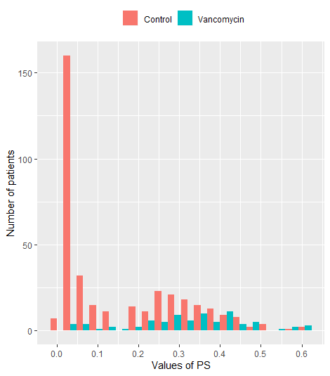
Figure 1. Propensity score distribution in the vancomycin (test) vs. control (non-user) groups

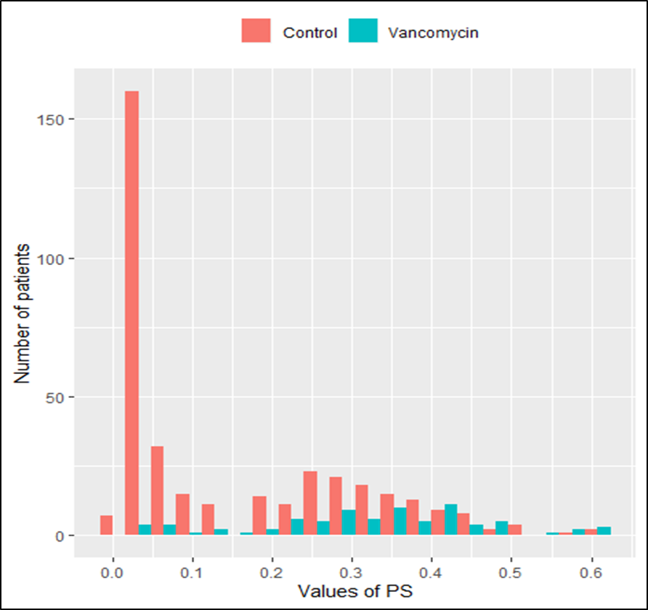
Recent Publications
- Rawan T. Tafish, Ahmed F. Alkhaldi, Anouar Bourghli & Turki A. Althunian. Effectiveness of topical vancomycin in the prevention of spinal surgical site infections: a retrospective cohort study. Antimicrobial Resistance & Infection Control volume 10, Article number: 136 (2021). September 2021

Biography (150 word limit)
Paste your Logo here

Dr. Rawan Tafish graduated from Beirut Arab University with a Bachelor of Pharmacy (BSc) degree in year 2012, then she joined the post-graduate program and earned the Doctor of Pharmacy degree in year 2014. She was interested in joining a distance learning program in Notting Hill College, UK from which she earned the Post Graduate Diploma in Clinical Pharmacy (PGDipClinPhar) in year 2019. Dr. Tafish is an SCFHS certified clinical pharmacist since year 2014, a member of the Saudi Society of clinical Pharmacy SSCP, and she has been working as a clinical pharmacist in Kingdom Hospital & Consulting Clinics, Riyadh since year 2015. To date, she has been working in various inpatient wards, particularly the critically-ill patient units, and she has been recognized as an active member in several scientific commitees and the Co-chairman of the Antimicrobial Stewardship committee. Dr. Tafish has participated in several CME-accredited conferences and workshops, and she is interested in scientific research for which she has conducted clinical studies in the fields of ‘Infectious Diseases’ and ‘Critical Care’.

Email: rawan_tafish@hotmail.com

Notes/Comments:

Presenting author details
Full name: Rawan Toufic Tafish
Contact number: 00966531552006
Twitter account:
Linked In account: https://www.linkedin.com/in/rawan-tafish-69a730a0
Session name/ number:
Category: Oral presentation

