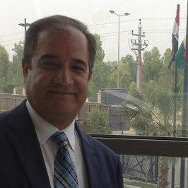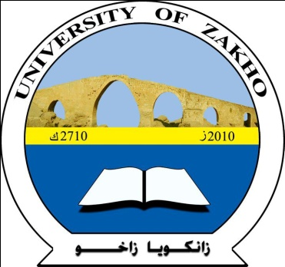
Primary Cutaneous Actinomycosis: The first case report from Kurdistan- Iraq
Yassob Sulaiman, Manahil Yehia and Husham Bayazed
College of Medicine, University of Zakho / Kurdistan
ABSTRACT
A case of primary cutaneous actinomycosis was diagnosed on clinical and bacteriological grounds. A fifty-five year woman presented with multiple discharging sinuses on both legs since 9 years with slowly progressive course; from rural area in Kurdistan Region-Iraq. Bacteriological study including macroscopical and cultural examination of the discharge and crust taken deep from the lesions revealed actinomyces as the causative organism. Good response with complete healing was noticed after 4 months of treatment with benzathine penicillin. Primary cutaneous actinomycosis is a rare variety of actinomycosis and this is the first case reported in Iraq. Good awareness of the full clinical spectrum of the disease aided by bacteriological study is needed to minimize the misdiagnosis of the case.
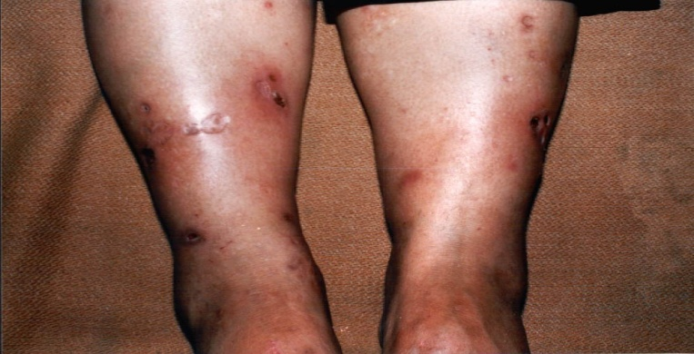
Fig.1: A 55 year female with Multiple discharging sinuses on both legs since nine years.
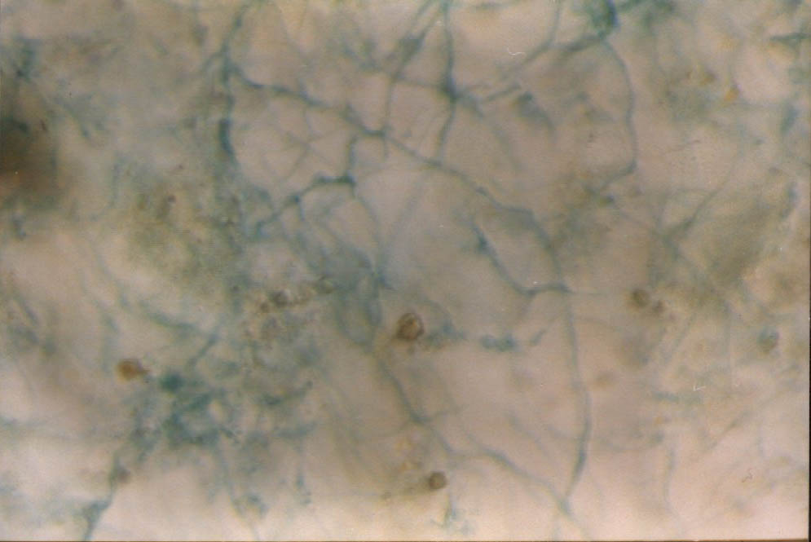
Fig.2: Gram staining of the lesions showing tangled masses of branching filaments of actinomyces.
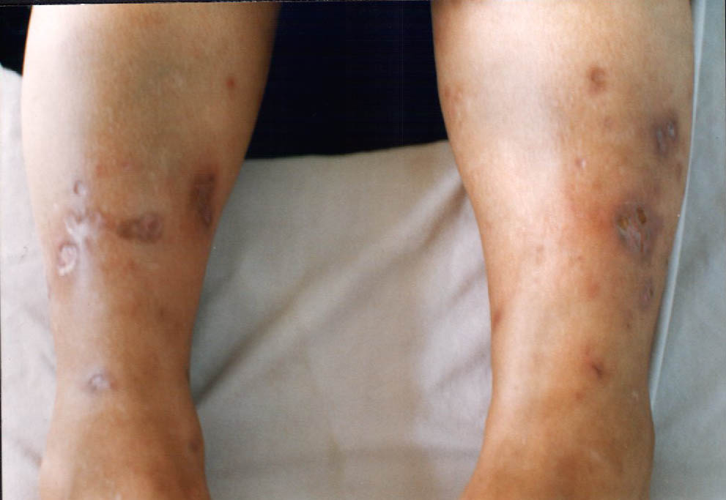
Fig.3: Healing of the discharging sinuses after two months of treatment with Benzathin penicillin.
Biography
Prof Dr Husham Bayazed has completed his PhD from University of Mosul, College of Medicine. He is now Consultant Immunologist at College of Medicine and Scientific Research Center, University of Zakho / Kurdistan Region, Iraq.
He is specialist in Microbiology & Immunology and has published more than 25 papers in reputed journals and has been serving as scientific reviewers of many local and international medical journals. In addition of being Fellowship of ISC, Infection, Cancer, Immunology Advisory Board Member (EUROMDnet) (Belgium), Membership of World Stroke Organization, Membership of Metabolomics (USA), and Membership of American Association of Science & Technology.
Presenting author details
Full name: Prof Husham Bayazed
Contact number: 009647504676544
Twitter account: @HISHAMALI
Linked In account: Linkedin1953
Session name/ number:
Category: (Oral presentation)

