Back to Nature: Combating Candida albicans Biofilm, Phospholipase and Hemolysin Using Plant Essential Oils
Basem A. Mansour. PhD, Delta University for science and Technology, Daahlya, Egypt.

Abstract (300 word limit)

Objectives; Candida albicans is the causative agent of fatal systemic candidiasis. Due to limitations of antifungals, new drugs are needed. Materials and method; The anti-virulence effect of plant essential oils (EOs) was evaluated against clinical C. albicans isolates including cinnamon, clove, jasmine and rosemary oils. Biofilm, phospholipase and hemolysin were assessed phenotypically. EOs were evaluated for their anti-virulence activity using phenotypic methods as well as scanning electron microscopy (SEM) and atomic force microscopy (AFM). Results; Among the C. albicans isolates, biofilm, phospholipase and hemolysins were detected in 40.4, 86.5 and 78.8% of isolates, respectively. Jasmine oil showed the highest anti-biofilm activity followed by cinnamon, clove and rosemary oils. SEM and AFM analysis showed reduced adherence and roughness in the presence of EOs. For phospholipase, rosemary oil was the most inhibitory, followed by jasmine, cinnamon and clove oils, and for hemolysins, cinnamon had the highest inhibition followed by jasmine, rosemary and clove oils. A molecular docking study revealed major EO constituents as promising inhibitors of the Als3 adhesive protein, with the highest binding for eugenol, followed by 1,8-cineole, 2-phenylthiolane and cinnamaldehyde. Conclusion; EOs have a promising inhibitory impact on Candida biofilm, phospholipase and hemolysin production, hence EOs could be used as potential antifungals that impact virulence factors.
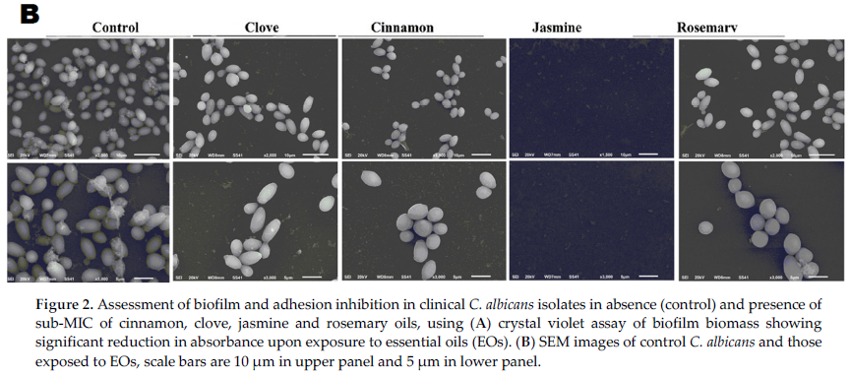
Recent Publications (minimum 5)
- H. El-Barabry, L. Habbak, B. Mansour, M.Y. Youssef, A. Taman, M.L. Salem, Blocking angiotensin pathway induces anti-fibrotic effects in a mouse model of schistosomiasis by decreasing egg burden and granulomatous reaction, International Journal of Cancer and Biomedical Research, 5 (2021) 37-48.
- A.M. El-Baz, R.A. Mosbah, R.M. Goda, B. Mansour, T. Sultana, T.E. Dahms, A.M. El-Ganiny, Back to Nature: Combating Candida albicans Biofilm, Phospholipase and Hemolysin Using Plant Essential Oils, Antibiotics, 10 (2021) 81.
- A.M. El-Baz, G. Yahya, B. Mansour, M. El-Sokkary, R. Alshaman, A. Alattar, A.M. El-Ganiny, The Link between Occurrence of Class I Integron and Acquired Aminoglycoside Resistance in Clinical MRSA Isolates, Antibiotics, 10 (2021) 488.
- Yahya, G.; Ebada, A.; Khalaf, E.M.; Mansour, B.; Nouh, N.A.; Mosbah, R.A.; Saber, S.; Moustafa, M.; Negm, S.; El-Sokkary, M.M.A.; El-Baz, A.M. Soil-Associated Bacillus Species: A Reservoir of Bioactive Compounds with Potential Therapeutic Activity against Human Pathogens. Microorganisms 2021, 9, 1131..
- Y. Galal, Basem Mansour, K. Kristina, S. Moataz, E.-B. Ahmed, Virtual screening attributes male biased COVID-19 mortality to predicted antiviral activity of female sex hormones, Letters in Drug Design & Discovery, 18 (2021) 1-1.

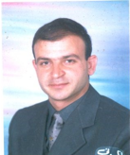 Biography
Basem A. Mansour was born in 1973, in Dikirness, Daqahlya, Egypt. He is lecturer of pharmaceutical organic chemistry, faculty of pharmacy, Delta University for Science and Technology, Gamasa 11152, Egypt. He has got his B.Sc. in May 1996 from faculty pharmacy, Mansoura University, Egypt. Conferred his Master degree in Pharmaceutical Organic Chemistry at the same college in March 2014. The experimental part was conducted in Prof. D. Boykin lab. at GSU, GA, USA.. Master thesis was entitled "Design and synthesis of novel benzimidazoles of potential anthelmintic activity". He had granted his PhD degree (2014 through 2018) in medicinal chemistry major, at the same faculty he had granted his master from. PhD thesis entitled "Design, Synthesis and Biological Evaluation of Novel 3-Substituted Quinoline Derivatives as Potential Anti-Cancer Agents".
.
Email: basem2412@yahoo.com

Notes/Comments:

