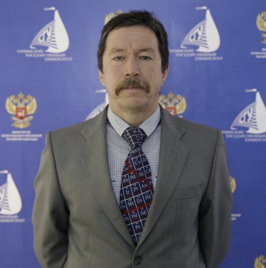 Official Photo 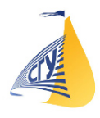 University/Organization Logo

New principals of extraction in the chemical analysis
Viktor Bekhterev, DS, Sochi state university, Russia

Abstract (300 word limit)
The solution of many problems in the analytical chemistry, ecology, hydrochemistry, biochemistry, pharmacology, toxicology are associated with the extraction and separation of the natural or synthetic organic compounds from aqueous media or from water-containing biological samples. In this report, a new approach to the isolation of hydrophilic organic substances from aqueous media in extractant is proposed: the extraction under the conditions of formation of the phase interface in the initially homogeneous system by thermal action.
A method of extractive freezing-out under the action of centrifugal forces (EFC) with the use of hydrophilic organic solvents has been developed [Patent RU2564999, Patent EP3357873]. The scientific basis of this method has been created, and the regularities of extraction of target components in the conditions of formation of the liquid – solid phase interface have been established. The EFC-methods in combination with GC and HPLC for determination of various organic substances are fast, cheaper and easier than QuEChERS. The expert's working conditions and safety have been improved by using a minimum amount of solvents.
A method of vapor-phase extraction (VPE) of organic substances from aqueous solutions is proposed [Patent RU2296716]. Its methodological foundations are developed, and the conditions for extraction of various substances are optimized. The partition coefficients of some hydrophilic and hydrophobic organic compounds in the water-extractant’s vapor system are determined. On the basis of theoretical representations for VPE the features of changing of the Gibbs energy are established in homological series of low-molecular carboxylic acids and phenols.
Based on this approach, new methods have been developed for determination of important analytes in water (natural and waste) and biological objects: drugs and narcotic substances in human urine, blood and organs, pesticides in the environment and food, food additives, biologically active substances in plants.
.
Key words: extractive freezing-out, vapor-phase extraction, new methods of chemical analysis, ecology, toxicology, GC, HPLC

Image
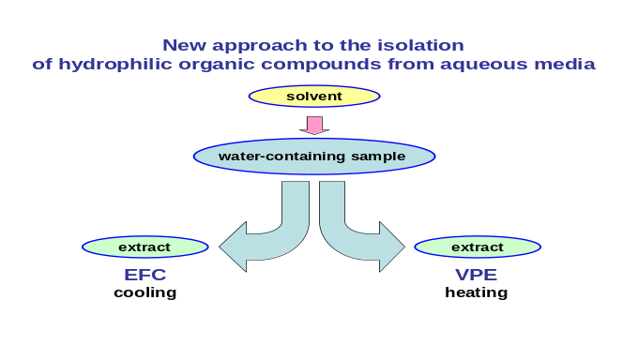
Recent Publications (minimum 5)
- Bekhterev V.N. et all (2019) Application of extractive freezing-out at the stage of preliminary preparation of bioassays in GC-MS chemical- toxicological analysis. Sudebno-medicinskaya Ekspetiza 62(6):53-57.
- Bekhterev V.N. et all (2017) The determination of pyrovaleron in the urine by gas chromatography In combination the with the method of extractive freezing-out and centrifugation. Sudebno-medicinskaya Ekspetiza 60(3):27-31.
- Bekhterev V.N., Kabina E.A. (2017) The isolation of organic compounds from hydrosulfuric mineral waters with the use of the extractive freezing-out technique with centrifugation. Voprosy kurortologii, fizioterapii… 94(1):56-61.
- Bekhterev V.N. (2016) Freeze-Out Extraction of Monocarboxylic Acids from Water into Acetonitrile under the Action of Centrifugal Forces. Russian J. of Phys. Chem. A 90(10):2055-2059.
- Bekhterev V.N., Kabina E.A., Loginova S.A. (2014) Removal of chloromethanes from water by the method of vapor-phase extraction. J. of Water Chemistry and Technology 36(3):134-138.

Biography
Victor Bekhterev is a specialist in chemical analysis and separation processes. Has experience in the development of methods for the determination of organic compounds in biological objects, food products and environment. Currently, he is a Professor at the Department of engineering and environmental of Sochi state university in Sochi (Russia).

Presenting author details
Full name (As per the passport): Viktor Bekhterev
University/Industry/Organization name: Sochi state university
Designation (Director/Prof/Assistant or Associate prof/Researcher/Student): Prof
Country: Russia
Mobile number (country code – number): +79183072980
Email: vic-bekhterev@yandex.ru
Track number: https://condensedmatterphysics.euroscicon.com/abstract-submission (For track number follow this link
Category (Oral presentation/ Poster presentation/Young researcher forum/E-poster): Oral presentation
Research interest: analytical chemistry, ecology, hydrochemistry, toxicology
Your profile page URL in your department: https://sutr.ru/about_the_university/management/staff/detail/1363/
Year of birth: 1959
Linked In/Facebook/twitter account:

Note: Please fill up the Red mark fields so that it would be easier for us to cite your details in the conference particulars. (Please do not forget to fix your photo and Logo above the title)

