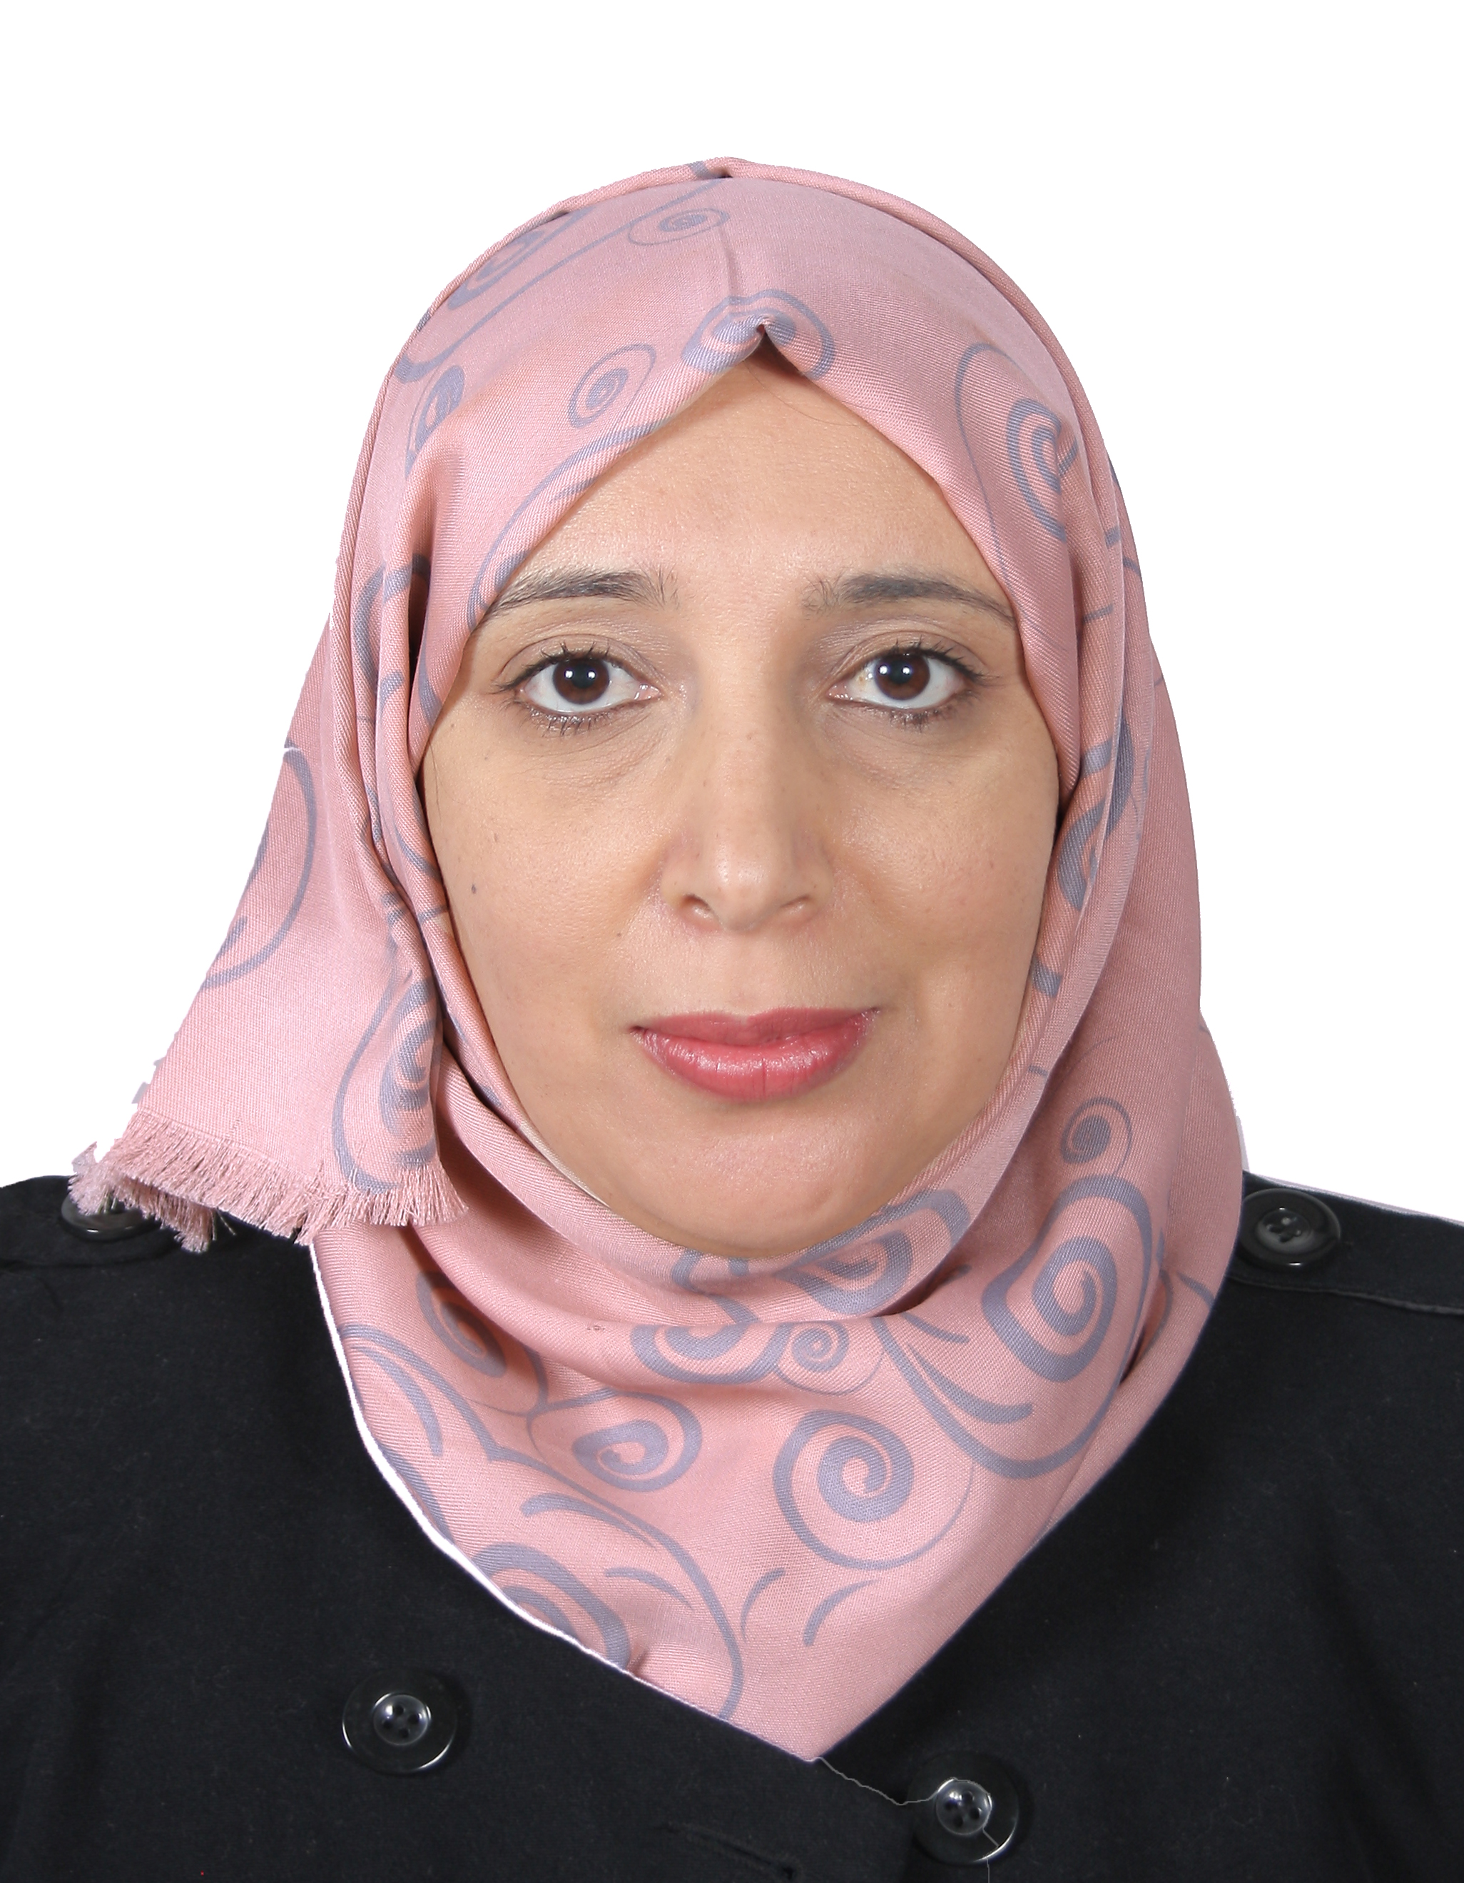

Title: Effect of sludge pH and treatment time on the electrokinrtic removal of aluminium from water potabilization treatment sludge
Cherifi Mouna

Laboratoire de traitement des eaux et valorisation des déchets industriels, département de chimie, faculté des sciences P.O. Box: 12, Annaba, 23000 Algérie.
Tel/Fax: 00.213.38.87.65.67.
ABSTRACT
Algerian’s municipal sewage treatment plants generate around 10⁶m³ of sewage sludge annually. Recently, there has been an increase concern about sewage sludge management due to the environmental risks, which resulted from the fast expansion of wastewater treatment plants without giving equal attention to the treatment of the produced sludges which are usually incinerated or used as agricultural fertilizer. Sludge may contain a number of nutrients but also contains series of harmful substances that complicate the task of sludge management. Hence the removal of pollutants from the sludge is necessary before its uses. This paper discusses the characteristics of potable water treatment sludge containing a high amount of aluminum. Furthermore, an electrokinetic treatment to remove aluminum from this sludge by varying the type of solution containing in the cathode compartment and the treatment time in order to optimize efficiency of the electrokinetic process. Successful results have been obtained by the use of this process where 60% of initial aluminium was collected in the cathode side with a consumed energy around of 1000 to 2000 Kwh Kg⁻¹ of weight sludge.
Biography
Cherifi Mouna has completed her PhD at the age of 36 years from Annaba University(Algeria). She has published to now 4 publications in reputed journals of which my name appears as first authors and three others as secondary author. Her areas of interest is the treatment of water, waste water treatment sludge and all that concerns the environment in conjunction with my united analytical training.
Author details
Full name: Cherifi Mouna
Contact number:00213.7.99.29.21.64
Twitter account: /
Linked In account: /
Session name/ number: Environmental chemistry
Category: (Poster presentation)

