Adsorption studies of CO₂ capture on carbon from waste PET
Balpreet Kaur, Simarjot Kaur, Jasminder Singh, Raj Kumar Gupta*, and Haripada Bhunia
Department of Chemical Engineering, Thapar Institute of Engineering and Technology, Patiala-147004, India

Abstract
Statement of the Problem: It is well recognized that porous carbons have been successfully prepared from novel raw materials and tested for their suitability as adsorbents. Also, many waste materials are used for the preparation of carbon to be used as adsorbent. In this work, carbon prepared from the PET waste is characterized and tested for its adsorption capacity for CO₂ at various concentration levels of CO2 in the feed gas. The carbon was found to maintain stability over several adsorption cycles without significant decrease in adsorption capacity. Further, this carbon adsorbent was activated and tested for adsorption of CO₂. The adsorbent was found to have surface area of about 1400 m2/g and adsorption capacities in the range of 1.3-1.5 mmol/g. The kinetics of the adsorption process was modeled using fraction order model. Further, the fixed bed adsorption process was modeled to estimate the breakthrough profiles at different experimental conditions.

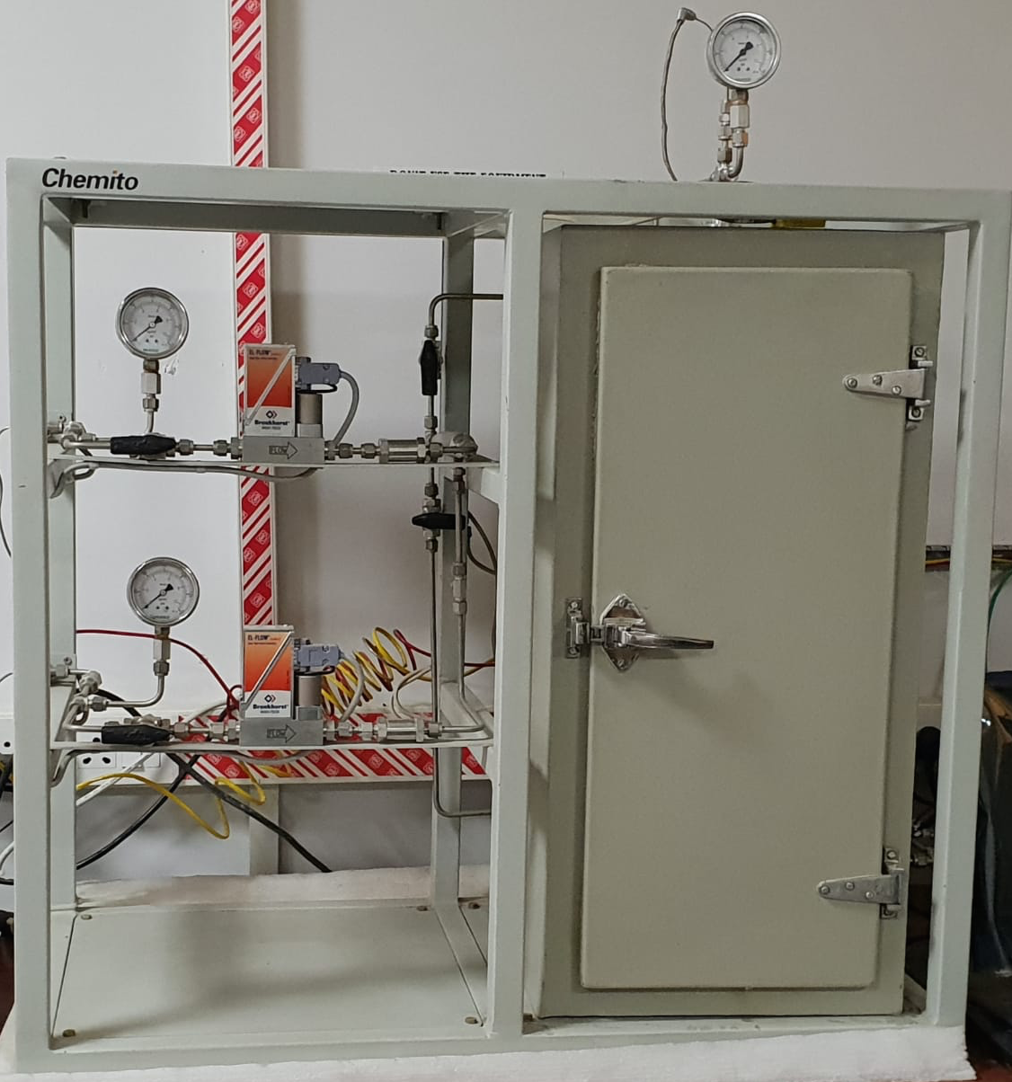

Figure 1: Adsorption setup used for CO₂ capture studies on carbon from waste PET

Recent Publications
- Thakur R, Barman, S, Gupta RK (2017) Kinetic investigation in Transalkylation of 1,2,4 Trimethylbenzene with toluene over rare earth metal modified large pore zeolite. Chemical Engineering Communications 204: 254-264.
- Thakur R, Gupta RK, Barman S (2017) A comprehensive study of catalytic performance of rare earth metal modified beta zeolites for synthesis of cymene. Chemical Papers 71: 137-148.
- Kaur H, Bulasara, VK, Gupta RK (2016) Effect of carbonates composition on the permeation characteristics of low-cost ceramic membrane supports. Industrial and Engineering Chemistry 44: 185-194.
- Singh D, Gupta RK, and Kumar V (2015) Simulation of a plant scale reactive distillation column for esterification of acetic acid. Computers and Chemical Engineering 73: 70-81.
5. Purandare PS, Lele M, Gupta RK (2015) Investigation on thermal analysis of conical coil heat exchanger. International Journal of Heat and Mass Transfer 90: 1188-1196.

Biography
Dr. Raj Kumar Gupta is Professor of Chemical Engineering, at Thapar Institute of Engineering and Technology Patiala. He joined the Department of Chemical Engineering in 1999 and is currently Head of the Department. His research interests are in the areas of modeling and simulation of chemical processes, specifically, FCC modeling and simulation, Reactive distillation modeling and simulation, Multiphase reaction kinetics, RTD modeling, CO₂ capture, Heat transfer enhancement, Water and wastewater treatment.
Email: rkgupta@gmail.com

Notes/Comments:

