Indoor Air Disinfection in Dynamic Dark Operating Conditions
Aliénor Chauvin*, Alexei Evstratov, Sandrine Bayle, and Lionel Sabourin

IMT-Mines Alès (https://www.imt.fr/mines-ales/); 6 avenue de Clavières 30319 Alès Cedex France

Abstract
It is already a well-known fact that, on the average, employed men spend 90% of the day (21.7 h) indoors; as for married housewives, they spend indoors till 95% of the day (22.8 h). In this context, the indoor air conditioning (climatic, chemical, and antimicrobial) is currently one of the strategic priorities in the domain of collective hygiene and healthcare.
Among modern technologies applied for the indoor air antimicrobial conditioning the greatest attention is currently drown to the photocatalytic air recycling procedures. However, all photocatalysts need to be activated by external energy inputs (energetically-dependent materials). For voluminous confined spaces the energy costs of long-duration recycling photocatalytic processes become very important.
The possibilities of application of non-photocatalytic dark-operating active materials for the environmental media germicidal conditioning were already discussed. These species occurring, in the majority of cases, as metal or metal oxide-based nanomaterials (M/MO-NMs), including free nanoparticle (NPs), are declared to be energetically independent: no external excitation is needed for their functioning. The oxidative stress provided by reactive oxygen species (ROS) formed in contact of M/MO-NMs and NPs surfaces with humid media is the most widely probed contributory factor to the germicidal ability of the materials under consideration. The second mechanism which can cause important mechanical cellular damages is available for certain fibrous and tube-like shaped species.
The dark-operating germicidal materials (DOGM) are applied predominantly in water medium and often in static conditions. The present contribution discusses the results of the implementation of two new DOGM types, a MnO2-based interactive ROS generator and a ZnO-based blade-needle-shaped cellular destructor, for dynamic indoor air antimicrobial conditioning carried out in recycling operating mode (300 L pilot unit, airborne bacteria, real-time viable particle counter 9510-BD BioTrak, different circulation rates).
Acknowledgments: to H2020 MSCA-RISE-2015 NANOGUARD2AR project.
Image

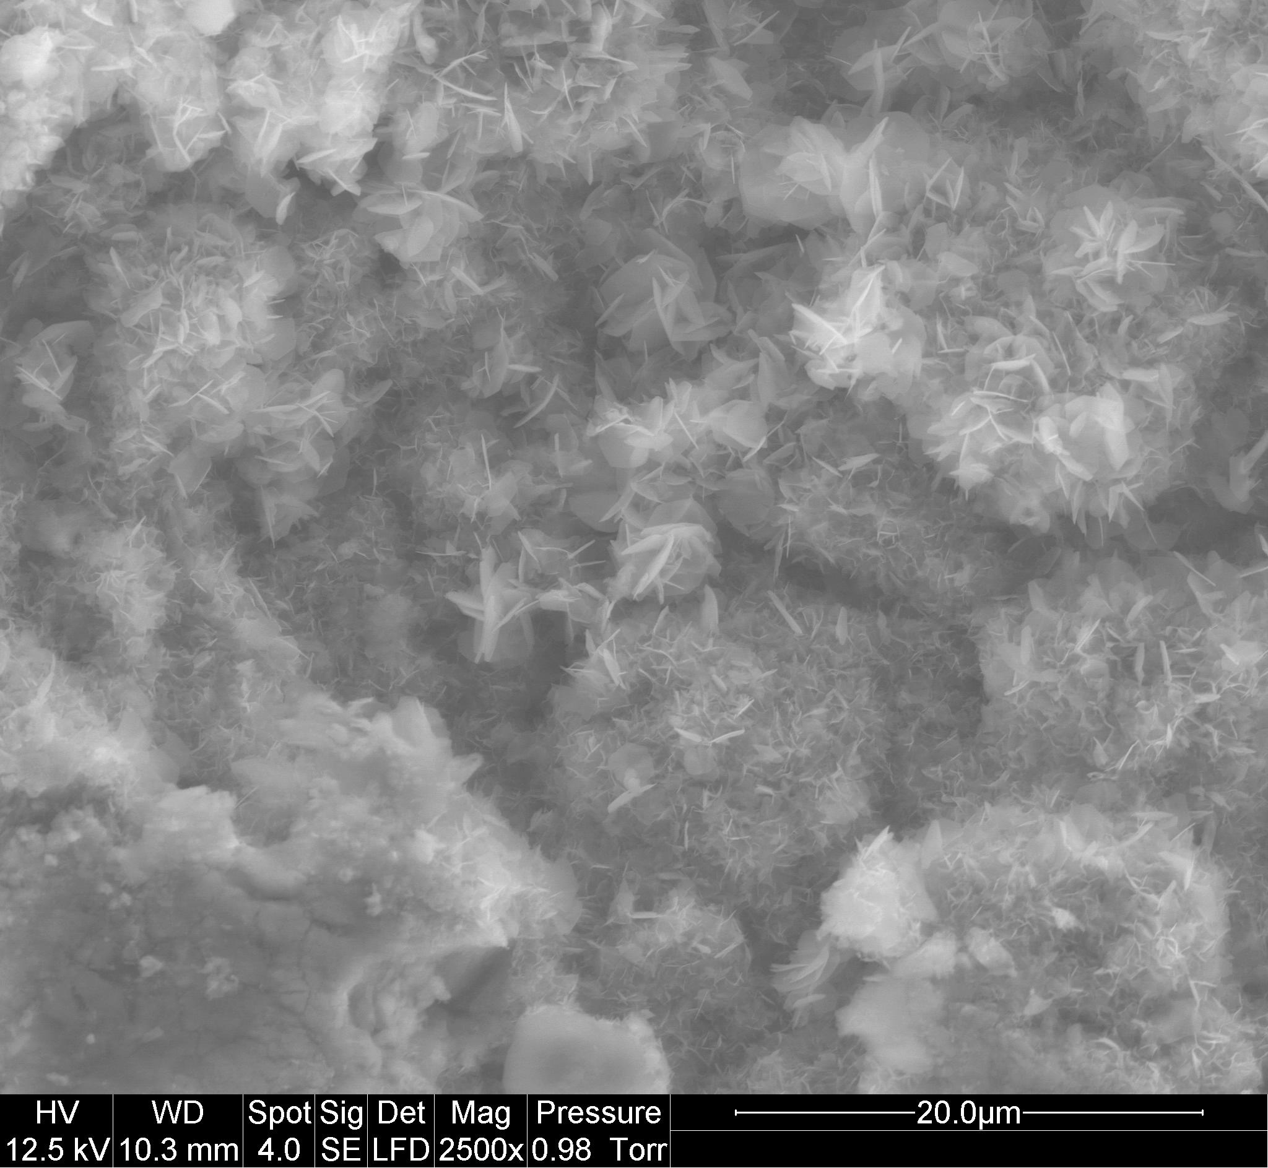
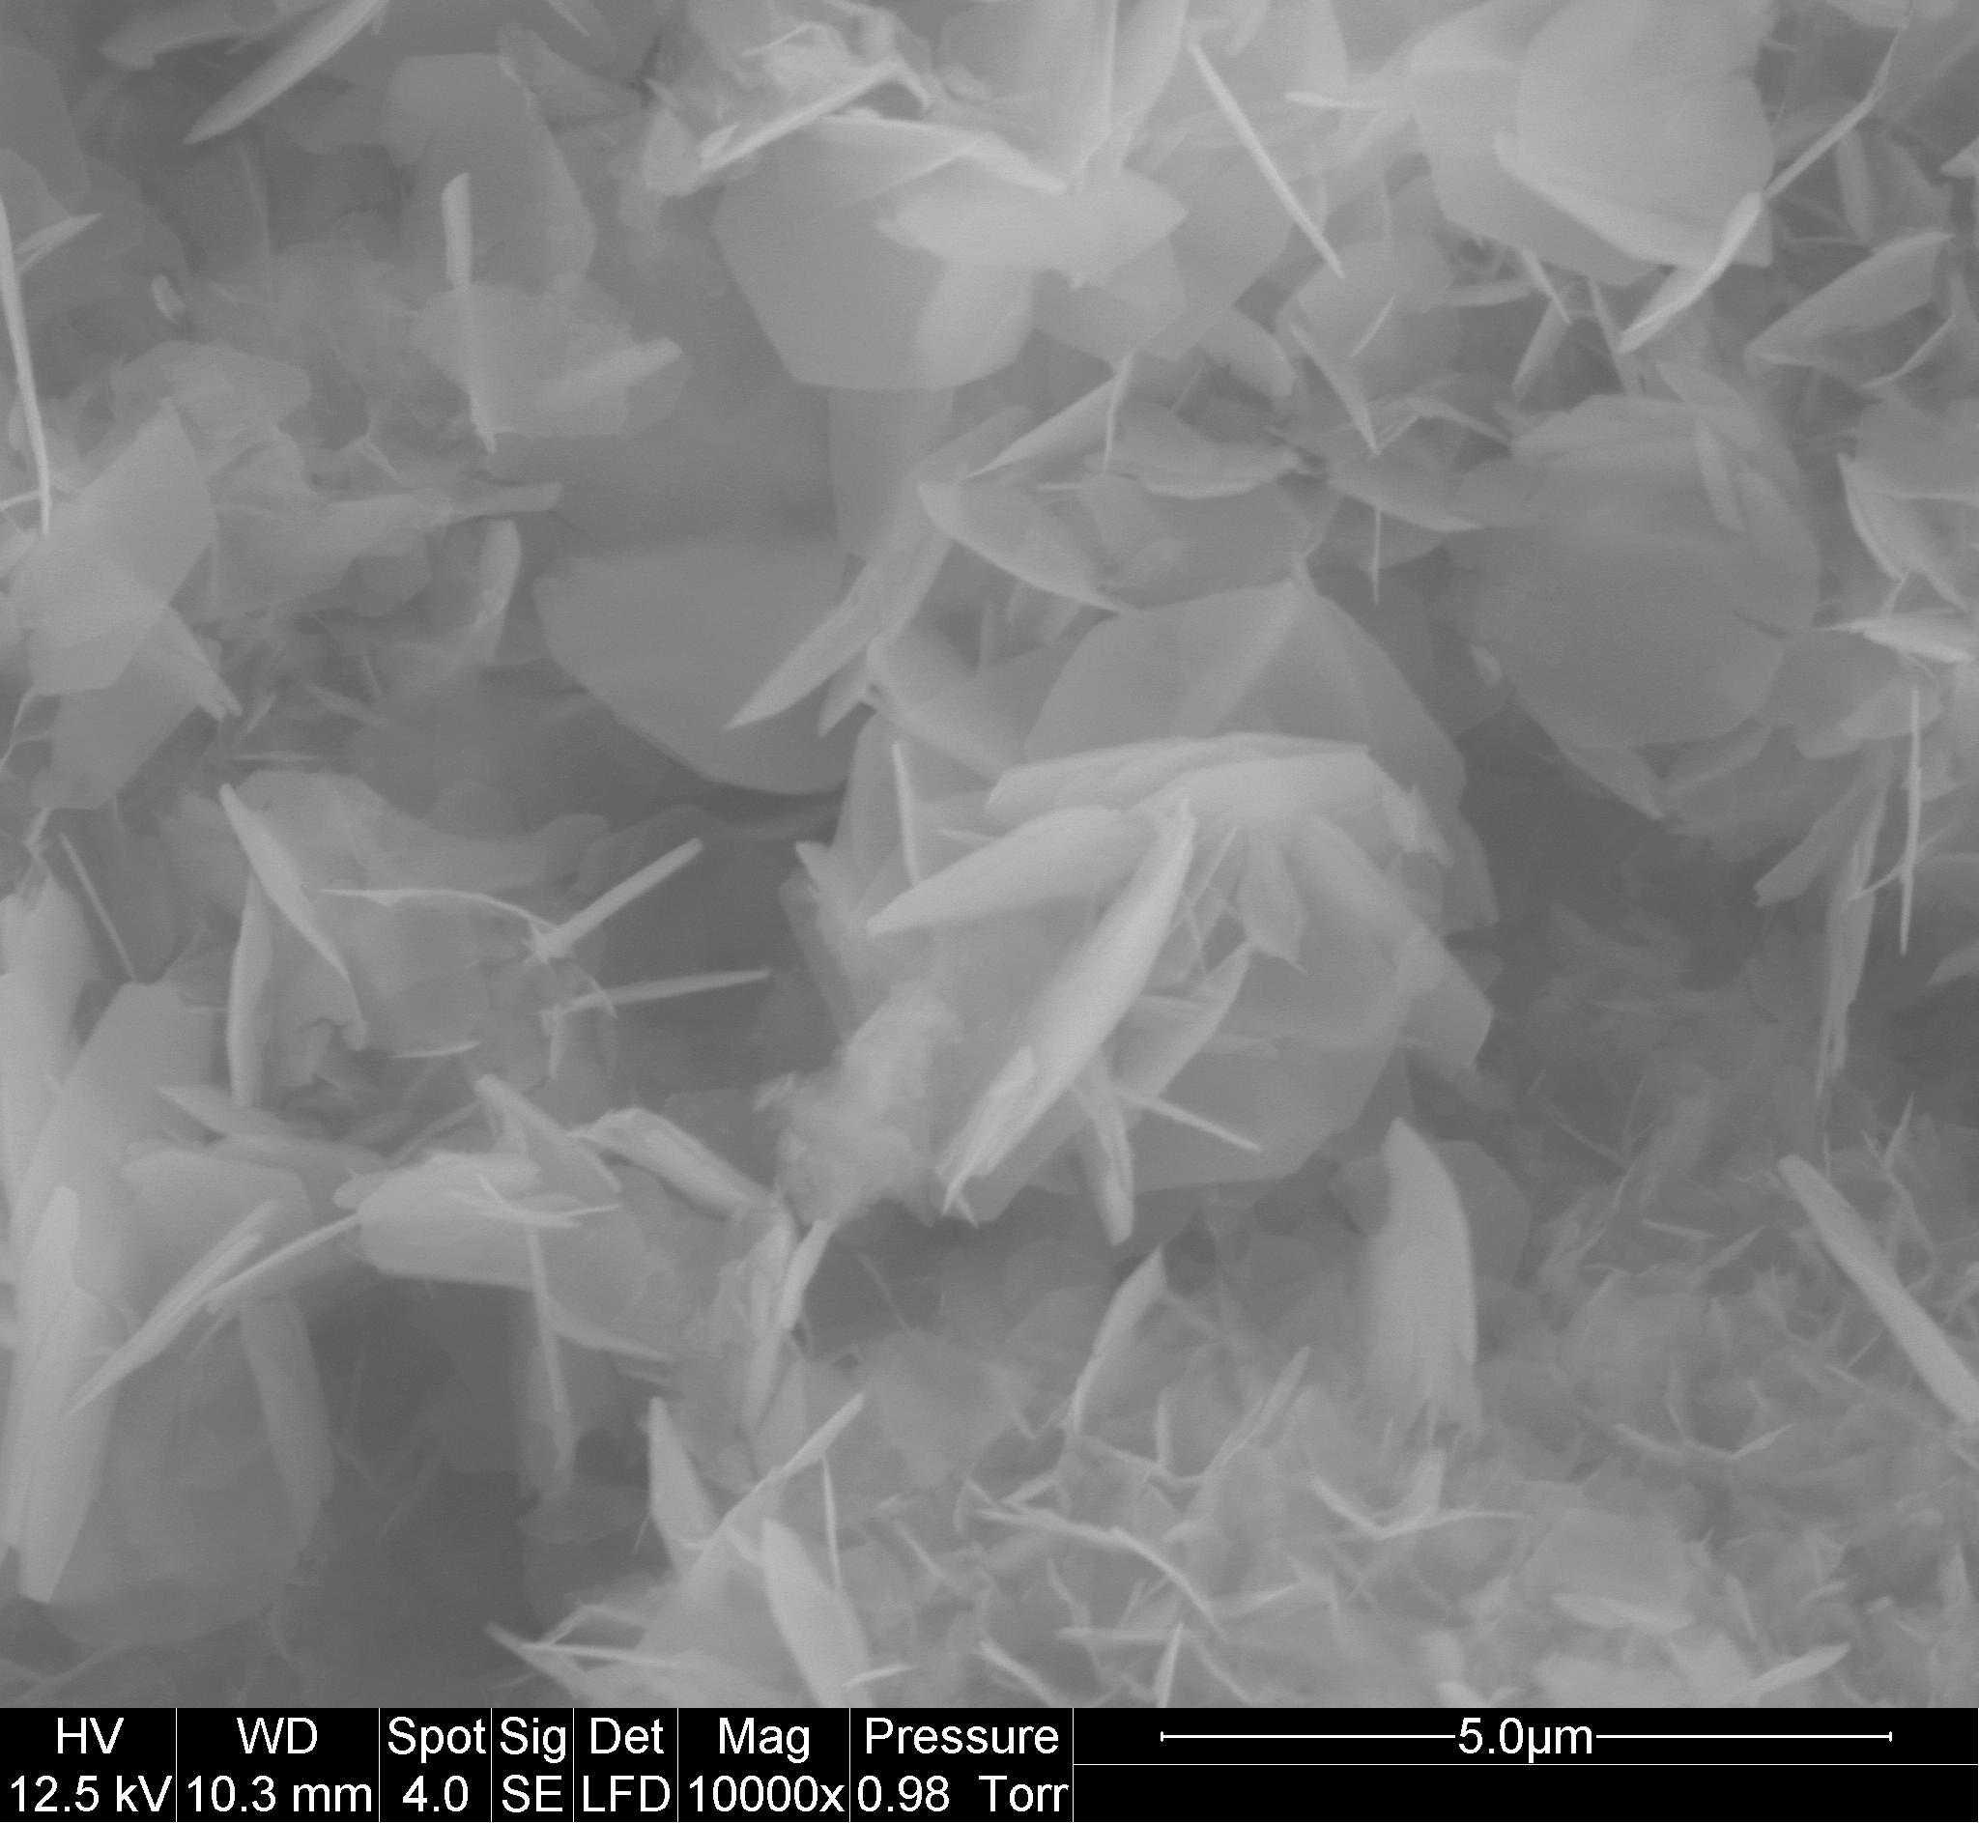

Recent Publications
- Balikhin, I. L., V. I. Berestenko, I. A. Domashnev, E. N. Kabatchkov, E. N. Kurkin, V. N. Troitski, and V. I. Nakhaev. 2016. ‘Photocatalytic Recyclers for Purification and Disinfection of Indoor Air in Medical Institutions’. Biomedical Engineering 49 (6): 389–393. https://doi.org/10.1007/s10527-016-9573-7.
- Beyth, Nurit, Yael Houri-Haddad, Avi Domb, Wahid Khan, and Ronen Hazan. 2015. ‘Alternative Antimicrobial Approach: Nano-Antimicrobial Materials’. Evidence-Based Complementary and Alternative Medicine, article ID 246012, 16 p.
https://doi.org/10.1155/2015/246012.
- Campos, Matias D., Paola C. Zucchi, Ann Phung, Steven N. Leonard, and Elizabeth B. Hirsch. 2016. ‘The Activity of Antimicrobial Surfaces Varies by Testing Protocol Utilized’. PLOS ONE 11 (8): e0160728. https://doi.org/10.1371/journal.pone.0160728.
- Indoor Pollutants / Report of National Research Council, 1981, Washington, DC: The National Academies Press, 552 p. https://doi.org/10.17226/1711.
- Miaśkiewicz-Peska, Ewa, and Maria Łebkowska. 2011. ‘Effect of Antimicrobial Air Filter Treatment on Bacterial Survival’. Fibres Text East Eur Vol 19, 1(84): 73-77.
- Saleh, Navid B., A. R. M. Nabiul Afrooz, Joseph H. Bisesi, Nirupam Aich, Jaime Plazas-Tuttle, and Tara Sabo-Attwood. 2014. ‘Emergent Properties and Toxicological Considerations for Nanohybrid Materials in Aquatic Systems’. Nanomaterials (Basel, Switzerland) 4 (2): 372–407. https://doi.org/10.3390/nano4020372.
- Simard, J. R., G. Roy, P. Mathieu, V. Larochelle, J. McFee, and J. Ho. 2004. ‘Standoff Sensing of Bioaerosols Using Intensified Range-Gated Spectral Analysis of Laser-Induced Fluorescence’. IEEE Transactions on Geoscience and Remote Sensing 42 (4): 865–874. https://doi.org/10.1109/TGRS.2003.823285.
- Vayssieres, Lionel, Karin Keis, Sten-Eric Lindquist, and Anders Hagfeldt. 2001. ‘Purpose-Built Anisotropic Metal Oxide Material: 3D Highly Oriented Microrod Array of ZnO’. The Journal of Physical Chemistry B 105 (17): 3350–3352. https://doi.org/10.1021/jp010026s.

SEM images of the ZnO coated γ-Al₂O₃ beads.


Biography
Aliénor Chauvin is a 2-nd year PhD student skilled in chemical engineering and applied microbiology. Currently, in the framework of the H2020 MSCA-RISE-2015 NANOGUARD2AR project, she is working on germicidal energetically independent dark-operating composite nanomaterials which present an alternative attractive way for the indoor air antimicrobial conditioning.

Email: alienor.chauvin@mines-ales.fr

* Coming to the Euro Chemical Engineering-2018

