GASTRIC SYNCHRONOUS STROMAL TUMOR AND ADENOCARCINOMA: A FORTUITOUS ASSOCIATION?
Anis Haddad, Selma Kacem, Amine Sebai, Houcine Maghrebi, Amine Makni,
Montassar Kacem

INTRODUCTION:
Stromal tumors (GIST) are the most frequent mesenchymal tumors of the digestive tract [1,2] with an incidence of 10 to 20 cases per 10 million people [3-7]. They sit mainly in the stomach [8-11] and represent 1 to 2.2% of malignant digestive tumors [4,12-14].
95% of malignant tumors of the digestive tract are adenocarcinomas [15].
The association of two types of tumors in the stomach is possible. These are mainly adenocarcinomas associated with lymphoma [16-19] or a carcinoid tumor [18,20,21]. The association of an adenocarcinoma with a stromal tumor in the stomach is rarely observed [22].
We report the observation of a patient operated for a synchronous tumor associating subcardial adenocarcinoma with a stromal tumor of the gastric body.

CASE REPORT:
It is a 74 year-old patient, diabetic, who was admitted, in December 2016, for epigastralgia associated with vomiting evolving for 2 months. Physical examination was strictly normal.
An oesogastroduodenal fibroscopy was performed showing a subcardial ulcerative-budding formation with a 3 cm diameter (figure 1) and the presence, in the gastric body, of a second submucosal nodular formation with a 4 cm diameter (figure 2).

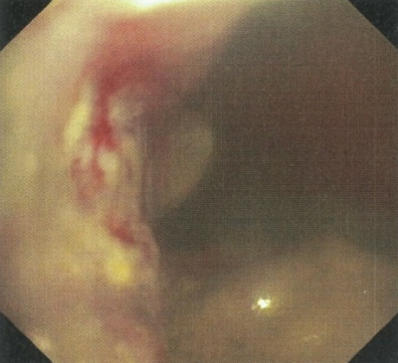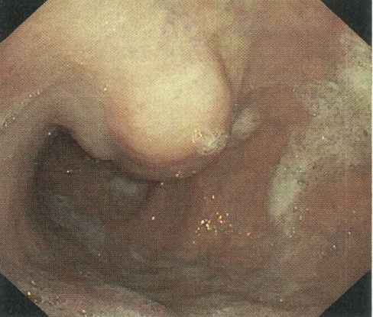
Figure 1: Sub-cardial region Figure 2 :Gastric body

The anatomopathological examination of the biopsies concluded to an infiltrating and slightly differentiated adenocarcinoma at the subcardial level associated with chronic HP + gastritis without signs of malignancy in the gastric body.
The computed tomography, performed as part of the extension study, revealed a macro-lobulated tissue mass, posterior, pre-pyloric, with submucosal development, prolapsed in the peritoneum, measuring 50 * 48 * 45mm and whose enhancement characteristics evoke a stromal tumor (figures 3 and 4) but also an irregular gastric cardio-tuberosal thickening predominant on the small gastric curvature (figure 5) and associated with necrotic pre-gastric centimetric satellite ganglia (figure 6)

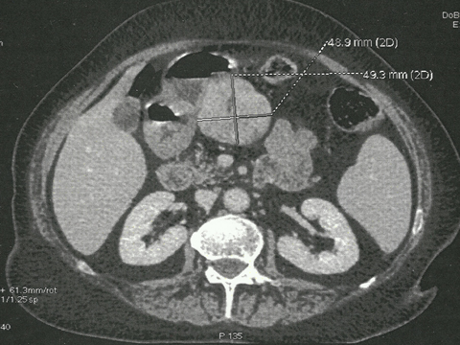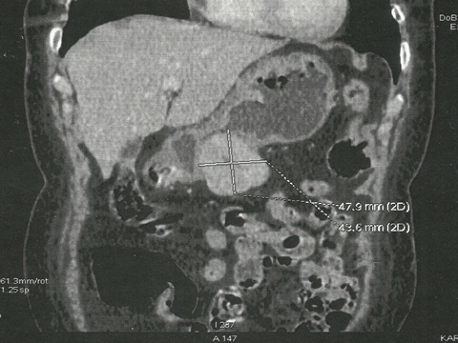
Figures 3 et 4: Gastric mass suggestive of stromal tumor

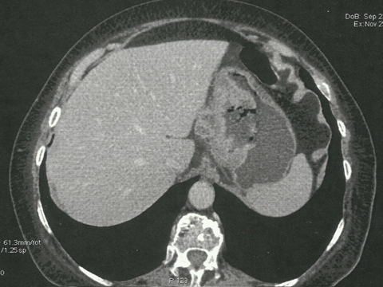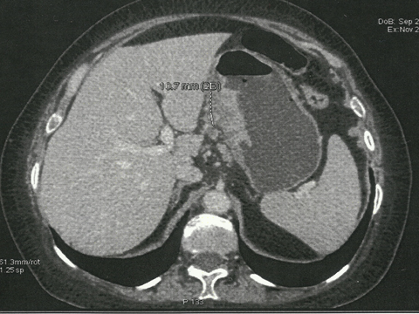
Figure 5 :Cardio-tuberosal thickening Figure 6 :Necrotic pre-gastric ganglia

The patient had a total gastrectomy with lymph node dissection type D1,5 and oeso-jejunal anastomosis on a Y-shaped loop.
The anatomo-pathological examination of the surgical specimen concluded to a slightly differentiated adenocarcinoma of the cardia classified as pT3N2, 3N + / 8N (figures 7,8,9,10) associated with a stromal tumor of the gastric body CD34-, CD117-, DOG1+, with rare mitoses, a mitotic index <5 and without nuclear atypia (figures 11,12,13,14) considered to be at low risk of recidivism.

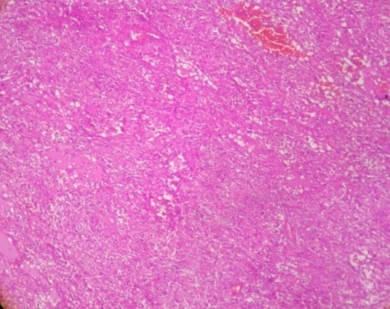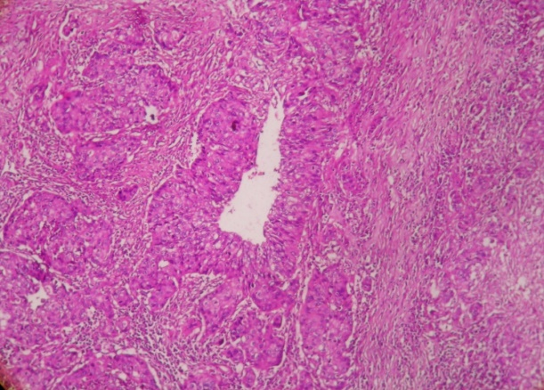
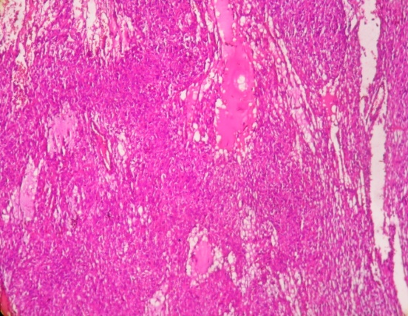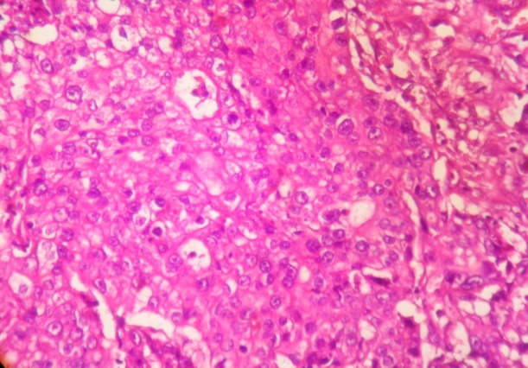
Figures 7,8,9,10 :Slightly differentiated adenocarcinoma of the cardia

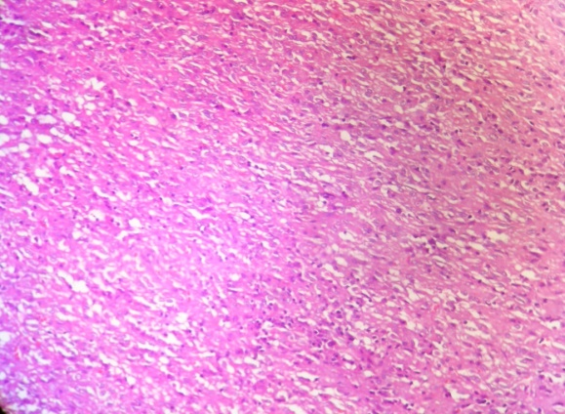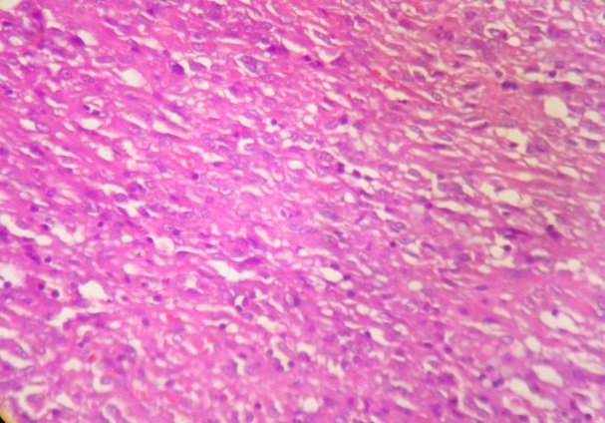
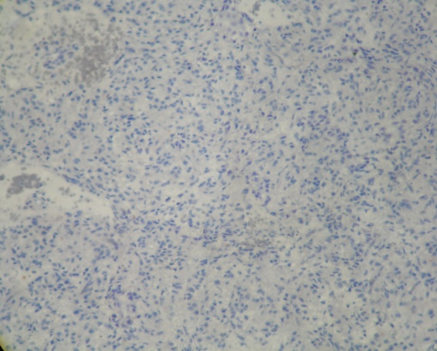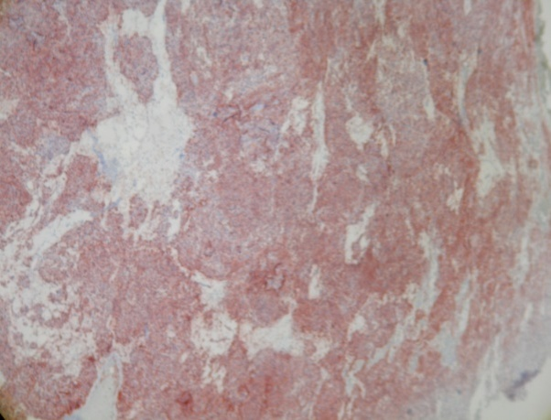
Figures 11,12,13,14: Stromal tumor CD117-, CD34-, DOG1
DISCUSSION:
Stromal tumors (GIST) are mesenchymal tumors developed from the interstitial cells of Cajal. They therefore express a specific marker to these cells, the c-Kit (CD117) and this in 95% of cases, which makes it possible to differentiate them, on the immunohistochemical level, from the other digestive mesenchymal tumors [23]. They may also express other markers such as the BCL-2 (80%), the CD34 (70%), the SMA (35%), the DOG-1, the protein S100 (10%) and the desmine (5%) [23-26].
CD117 is a gene encoding the protein tyrosine kinase receptor. This CD117 specificity of stromal tumors has made it the model of solid tumors that can regress under targeted therapy, namely the imatinib mesylate which is an inhibitor of this receptor [27].
Histologically, the cells may be fusiform (70%), epithelioid (20%) or mixed (10%). [23].
The preferred location of these tumors is the stomach (60 à 70%) followed by the small intestine (20 à 30%), the colon and rectum (5 à 10%) and finally the esophagus (5%) [8-11,28].
The most common clinical signs of GIST are abdominal pain, digestive hemorrhage and abdominal mass [29,30]. The symptomatology depends on the location and size of the tumor [30].
Preoperative diagnosis of the stromal tumor, if associated with adenocarcinoma, is difficult and rarely done. Generally, adenocarcinoma masks clinically and endoscopically the stromal tumor but also at imaging, in which it is confused with adenopathies [31].
In addition, the tumor is often submucosally developed, making in most cases endoscopic biopsies negative. Thus, in the case of an association of adenocarcinoma and a stromal tumor, the diagnosis of the GIST is usually performed peroperatively and / or by the anatomopathological examination of the surgical specimen [31,32]. Lin and al [31] estimated the preoperative diagnosis rate of such an association to be only 2.4%.
For our patient, endoscopic biopsies were negative. However, the imaging revealed a gastric tumor mass of 5cm with submucosal development, which made it possible to evoke the diagnosis of stromal tumor.
The association of a stromal tumor, whatever its location, with another malignant tumor is estimated from 4.5% to 35% depending on the series [27,33-44]. Generally, they are gastrointestinal adenocarcinoma (47%), prostatic adenocarcinoma (9%), lymphoma and leukemia (7%)and breast cancer (7%) [27,34]. A few cases of association of gastric stromal tumors and gastric adenocarcinomas have been reported in the literature [33,36,45-52].
Liszka et al [53] reported that during this association, the stromal tumor is generally small in size, often less than 2 cm [22,48],and presents a low risk of invasion and recidivism compared to isolated GIST, with a mitotic index often less than 5 and a Ki-67 less than 5% [27], suggesting a probable inhibition of the malignancy of the stromal tumor by adenocarcinoma [25].This was the case for our patient in whom the stromal tumor was considered to be at low risk of recurrence on the anatomopathological examination of the surgical specimen.
An immunohistochemical feature of stromal tumors associated with adenocarcinoma is the low expression of CD117 and CD34 [34] with often an intense expression of the DOG-1 [54]. This immunohistochemical profile was found in our patient.
The simultaneous presence in the stomach of an adenocarcinoma and a stromal tumor leads us to wonder whether this association is fortuitous or whether there is a causal relationship between the two lesions. Theoretically, a genetic mutation could induce a synchronous carcinomatous and mesenchymal proliferation. It would still have to be highlighted [37,55,56]. Some experimental models have proposed the hypothesis of an unknown oncogenic agent that is at the origin of the development of tumors from adjacent tissues [45,50,57-60]. It is reported that exposure to nitrosoguanidine and acetylsalicylic acid may induce the development of gastric adenocarcinomas and leiomyosarcomas [59]. It is also recognized that exposure to Helicobacter pylori may be responsible for the development of gastric adenocarcinomas, gastric lymphomas [61,62] or even gastric stromal tumors [30].
However, the hypothesis of a fortuitous association between these two tumors can not be ruled out, especially since most cases come from Japan, a country with a high incidence of gastric adenocarcinoma [45].
In the presence of such an association, an R0 resection of the adenocarcinoma and the stromal tumor is necessary [36,63]. Postoperative chemotherapy may be proposed for one or both tumors according to indications [64,65].

CONCLUSION:
Synchronous development of gastric adenocarcinoma and GIST is rare. During this association, the stromal tumor is often characterized by a small size, a low mitotic index, minimal or absent nuclear atypies, a low malignant potential but also a weak expression of CD117 and CD34 with significant expression of DOG-1.

REFERENCES :
1.Feng F, Liu Z, Zhang X, et al. Comparison of endoscopic and open resection for small gastric gastrointestinal stromal tumor. Transl Oncol 2015;8:504–8.
2.Pidhorecky I, Cheney RT, Kraybill WG, Gibbs JF: Gastrointestinal stromal tumors. current diagnosis, biologic behavior, and management. Ann SurgOncol 2000, 7:705-12.
3.Tzen CY, Wang JH, Huang YJ, et al. Incidence of gastrointestinal stromal tumor: a retrospective study based on immunohistochemical and mutational analyses. Dig Dis Sci 2007;52:792–7.
4. Nilsson B, et al. Gastrointestinal stromal tumors: the incidence, prevalence, clinical course, and prognostication in the preimatinib mesylate era—a population-based study in western Sweden. Cancer. 2005;103(4):821–9.
5. Monges G, et al. The estimated incidence of gastrointestinal stromal tumors in France. Results of PROGIST study conducted among pathologists. Bull Cancer. 2010;97(3):E16–22.
6. Espinosa I, et al. A novel monoclonal antibody against DOG1 is a sensitive and specific marker for gastrointestinal stromal tumors. Am J Surg Pathol. 2008;32(2):210–8.
7. Goettsch WG, et al. Incidence of gastrointestinal stromal tumours is underestimated: results of a nation-wide study. Eur J Cancer. 2005;41(18):2868–72.
8. Miettinen M, Lasota J. Gastrointestinal stromal tumors (GISTs): definition, occurrence, pathology, differential diagnosis and molecular genetics. Pol J Pathol 2003; 54: 3-24
9. Mehta RM, Sudheer VO, John AK, Nandakumar RR, Dhar PS, Sudhindran S, Balakrishnan V. Spontaneous rupture of giant gastric stromal tumor into gastric lumen. World J Surg Oncol 2005; 3: 11
10. Hersh MR, Choi J, Garrett C, Clark R. Imaging gastrointestinal stromal tumors. Cancer Control 2005; 12: 111-115
11. Zhao X, Yue C. Gastrointestinal stromal tumor. J Gastrointest Oncol2012;3:189–208.
12. Sheppard K, Kinross KM, Solomon B, et al. Targeting PI3 kinase/AKT/ mTOR signaling in cancer. Crit Rev Oncog 2012;17:69–95.
13. Miettinen ,et al: Gastrointestinal stromal tumors: pathology and prognosis at different sites. Semin Diagn Pathol 2006, 23(2):70-83.
14. Nowain A, Bhakta H, Pais S, Kanel G, Verma S: Gastrointestinal stromal tumors: clinical profile, pathogenesis, treatment strategies and prognosis. J Gastroenterol Hepatol 2005, 20:818-824.
15. Go JH. Collision of adenocarcinoma and schwannoma of the stomach: a case [2]report. Korean J Pathol. 2012;46:373-76.
16. Planker M, Fischer JT, Peters U, Borchard F. Synchronous double primary malignant lymphoma of low grade malignancy and early cancer (collision tumor) of the stomach. Hepatogastroenterology 1984; 31: 144-148
17. Nishino N, Konno H, Baba S, Aoki K, Nishimura T, Arai T, Kino I. Synchronous lymphoma and adenocarcinoma occurring as a collision tumor in the stomach: report of a case. Surg Today 1996; 26: 508-512
18. Goteri G, Ranaldi R, Rezai B, Baccarini MG, Bearzi I. Synchronous mucosa-associated lymphoid tissue lymphoma and adenocarcinoma of the stomach. Am J Surg Pathol 1997; 21: 505-509
19. Nakamura S, Aoyagi K, Iwanaga S, Yao T, Tsuneyoshi M, Fujishima M. Synchronous and metachronous primary gastric lymphoma and adenocarcinoma: a clinicopathological study of 12 patients. Cancer 1997; 79: 1077-1085
20. Yamashina M, Flinner RA. Concurrent occurrence of adenocarcinoma and carcinoid tumor in the stomach: a composite tumor or collision tumors? Am J Clin Pathol 1985; 83: 233-236
21. Morishita Y, Tanaka T, Kato K, Kawamori T, Amano K, Funato T, Tarao M, Mori H. Gastric collision tumor (carcinoid and adenocarcinoma) with gastritis cystica profunda. ArchPathol Lab Med 1991; 115: 1006-1010
22. Rong Cai, Gang Ren, Deng-Bin Wang. Synchronous adenocarcinoma and gastrointestinal stromal tumors in the stomach. World J Gastroenterol 2013 May 28; 19(20): 3117-3123
23. Miettinen M, Sarlomo-Rikala M, Lasota J. Gastrointestinal stromal tumors: recent advances in understanding of their biology. Hum Pathol 1999; 30: 1213-1220
24. Wada T, Tanabe S, Ishido K, Higuchi K, Sasaki T, Katada C, et al. DOG1 is useful for diagnosis of KIT-negative gastrointestinal stromal tumour of stomach. World J Gastroenterol. 2013;19:9133-36.
25.Simon S, Grabellus F, Ferrera L, Galietta L, Schwindenhammer B, Mühlenberg T, et al. DOG1 regulates growth and IGFBP5 in gastrointestinal stromal tumours. Cancer Res. 2013;73:3661-70.
26. Fletcher CD, Berman JJ, Corless C, Gorstein F, Lasota J, Longley BJ, Miettinen M, O’Leary TJ, Remotti H, Rubin BP, Shmookler B, Sobin LH, Weiss SW: Diagnosis of gastrointestinal stromal tumors: A consensusapproach. Hum Pathol 2002, 33:459-465.
27. Yan Yan &Ziyu Li &Yiqiang Liu &Lianhai Zhang &Jiyou Li &Jiafu Ji. Coexistence of gastrointestinal stromal tumorsand gastric adenocarcinomas. Tumor Biol. (2013) 34:919–927
28. Villias C, Gourgiotis S, Veloudis G, Sampaziotis D, Moreas H. Synchronous early gastric cancer and gastrointestinal stromal tumour in the stomach of a patient with idiopathic thrombocytopenic purpura. J Dig Dis. 2008;9:104-07.
29. Cypriano MS, Jenkins JJ, Pappo AS, Rao BN, Daw NC. Pediatric gastrointestinal stromal tumors and leiomyosarcoma. Cancer 2004; 101: 39-50
30. Lin YL, Tzeng JE, Wei CK, Lin CW. Small gastrointestinal stromal tumor concomitant with early gastric cancer: a case report. World J Gastroenterol 2006; 12: 815-817
31. Lin M, Lin JX, Huang CM, et al. Prognostic analysis of gastric gastrointestinal stromal tumor with synchronous gastric cancer. World J Surg Oncol 2014;12:25.
32. Narasimhamurthy MS, Vallachira GP, Mahadev PS. Synchronous adenocarcinoma and gastrointestinal stromal tumor in the stomach. Saudi J Gastroenterol 2010; 16: 218-220
33. Kountourakis P, Arnogiannaki N, Stavrinides I, Apostolikas N, Rigatos G. Concomitant gastric adenocarcinoma and stromal tumor in a woman with polymyalgia rheumatica. WorldJ Gastroenterol 2008; 14: 6750-6752
34. Agaimy A, Wünsch PH, Sobin LH, Lasota J, Miettinen M. Occurrence of other malignancies in patients with gastrointestinal stromal tumors. Semin Diagn Pathol 2006; 23: 120-129
35. Biasco G, Velo D, Angriman I, Astorino M, Baldan A, Baseggio M, Basso U, Battaglia G, Bertin M, Bertorelle R, Bocus P, Brosolo P, Bulzacchi A, Cannizzaro R, Da Dalt GF, Di Battista M, Errante D, Fedrigo M, Frustaci S, Lionetti I, Massani M, Mencarelli R, Montesco MC, Norberto L, Pantaleo MA, Pasquali C, Pastorelli D, Rossi CR, Ruffolo C, Salvagno L, Saponara MS, Vittadello F, Zaccaria F, Zovato S, Farinati F. Gastrointestinal stromal tumors: report of an audit and review of the literature. Eur J Cancer Prev 2009; 18: 106-116
36. Liu YJ, Yang Z, Hao LS, Xia L, Jia QB, Wu XT. Synchronous incidental gastrointestinal stromal and epithelial malignant tumors. World J Gastroenterol 2009; 15: 2027-2031
37. Felekouras E, Athanasios P, Vgenopoulou S, Papaconstantinou I, Prassas E, Giannopoulos A, Griniatsos J. Coexistence of hepatocellular carcinoma (HCC) and c-Kit negative gastrointestinal stromal tumor (GIST): a case report. SouthMed J 2008; 101: 948-951
38. Kawanowa K, Sakuma Y, Sakurai S, Hishima T, Iwasaki Y, Saito K, Hosoya Y, Nakajima T, Funata N. High incidence of microscopic gastrointestinal stromal tumors in the stomach. Hum Pathol 2006; 37: 1527-1535
39. Schneider-Stock R, Boltze C, Lasota J, Peters B, Corless CL, Ruemmele P, Terracciano L, Pross M, Insabato L, Di Vizio
D, Iesalnieks I, Dirnhofer S, Hartmann A, Heinrich M, Miettinen M, Roessner A, Tornillo L. Loss of p16 protein defines high-risk patients with gastrointestinal stromal tumors: a tissue microarray study. Clin Cancer Res 2005; 11: 638-645
40. Wang Q, Kou YW. Study of the expressions of p53 and bcl-2 genes, the telomerase activity and apoptosis in GIST patients. World J Gastroenterol 2007; 13: 2626-2628
41. Hechtman JF, DeMatteo R, Nafa K, et al. Additional primary malignancies in patients with Gastrointestinal Stromal Tumor (GIST): a clinicopathologic study of 260 patients with molecular analysis and review of the literature. Ann Surg Oncol 2015;22:2633–9.
42. Pandurengan RK, Dumont AG, Araujo DM, et al. Survival of patients with multiple primary malignancies: a study of 783 patients with gastrointestinal stromal tumor. Ann Oncol 2010;21:2107–11.
43. Ferreira SS, Werutsky G, Toneto MG, et al. Synchronous gastrointestinal stromal tumors (GIST) and other primary cancers: case series of a single institution experience. Int J Surg (London, England) 2010;8:314–7.
44. WronskiM, Ziarkiewicz-Wroblewska B, Gornicka B, et al. Synchronous occurrence of gastrointestinal stromal tumors and other primary gastrointestinal neoplasms. World J Gastroenterol 2006;12:5360–2.
45. Maiorana A, Fante R, Maria Cesinaro A, Adriana Fano R. Synchronous occurrence of epithelial and stromal tumors in the stomach: a report of 6 cases. Arch Pathol Lab Med 2000; 124: 682-686
46. Kaffes A, Hughes L, Hollinshead J, Katelaris P. Synchronous primary adenocarcinoma, mucosa-associated lymphoid tissue lymphoma and a stromal tumor in a Helicobacter pyloriinfected stomach. J Gastroenterol Hepatol 2002; 17: 1033-1036
47. Bircan S, Candir O, Aydin S, Başpinar S, Bülbül M, Kapucuoğlu N, Karahan N, Ciriş M. Synchronous primary adenocarcinoma and gastrointestinal stromal tumor in the stomach: a report of two cases. Turk J Gastroenterol 2004; 15: 187-191
48. Liu SW, Chen GH, Hsieh PP. Collision tumor of the stomach: a case report of mixed gastrointestinal stromal tumor and adenocarcinoma. J Clin Gastroenterol 2002; 35: 332-334
49. Nakaya I, Iwata Y, Abe T, Yokoyama H, Oda Y, Nomura G. Malignant gastrointestinal stromal tumor originating in the lesser omentum, complicated by rapidly progressive glomerulonephritis and gastric carcinoma. Intern Med 2004; 43: 102-105
50. Andea AA, Lucas C, Cheng JD, Adsay NV. Synchronous occurrence of epithelial and stromal tumors in the stomach. Arch Pathol Lab Med 2001; 125: 318-319
51. Rauf F, Ahmad Z, Muzzafar S, Hussaini AS. Synchronous occurrence of gastrointestinal stromal tumor and gastric adenocarcinoma: a case report. J Pak Med Assoc 2006; 56: 184-186
52. Katsoulis IE, Bossi M, Richman PI, Livingstone JI. Collision of adenocarcinoma and gastrointestinal stromal tumour (GIST) in the stomach: report of a case. Int Semin Surg Oncol 2007; 4: 2
53. Liszka Ł, Zielińska-Pajak E, Pajak J, Gołka D, Huszno J. Coexistence of gastrointestinal stromal tumors with other neoplasms. J Gastroenterol 2007; 42: 641-649
54. Zhen Liu et al. Clinicopathological features and prognosis of coexistence of gastric gastrointestinal stromal tumor and gastric cancer. Medicine (2016) 95:45
55. Lee FY, Jan YJ, Wang J, Yu CC, Wu CC. Synchronous gastric Rong C et al . Synchronous tumors in the stomach
WJG|www.wjgnet.com 3123 May 28, 2013|Volume 19|Issue 20| gastrointestinal stromal tumor and signet-ring cell adenocarcinoma:a case report. Int J Surg Pathol 2007; 15: 397-400
56. Samaras VD, Foukas PG, Triantafyllou K, Leontara V, Tsapralis D, Tsompanidi EM, Machairas A, Panayiotides IG. Synchronous well differentiated neuroendocrine tumour and gastrointestinal stromal tumour of the stomach: a case report. BMC Gastroenterol 2011; 11: 27
57. Sugimura T, Fujimura S, Baba T. Tumor production in the glandular stomach and alimentary tract of the rat by N-methyl-N’-nitro-N-nitrosoguanidine. Cancer Res 1970; 30: 455-465
58. Shitkov KG, Talalaeva AV. [Gastric sarcomas induced in rats by DMBA and cellophane]. Vopr Onkol 1979; 25: 62-65
59. Cohen A, Geller SA, Horowitz I, Toth LS, Werther JL. Experimental models for gastric leiomyosarcoma. The effects of N-methyl-N’-nitro-N-nitrosoguanidine in combination with stress, aspirin, or sodium taurocholate. Cancer 1984; 53: 1088-1092
60. Roncoroni L, Costi R, Canavese G, Violi V, Bordi C. Carcinoid tumor associated with vascular malformation as a cause of massive gastric bleeding. Am J Gastroenterol 1997; 92: 2119-2121
61. Moss SF, Malfertheiner P. Helicobacter and gastric malignancies. Helicobacter 2007; 12 Suppl 1: 23-30
62. Wotherspoon AC, Doglioni C, Diss TC, Pan L, Moschini A, de Boni M, Isaacson PG. Regression of primary low-grade B-cell gastric lymphoma of mucosa-associated lymphoid tissue type after eradication of Helicobacter pylori. Lancet 1993; 342: 575-577
63. Ramesh Babu Telugu1, Magesh Pushparaj2, Dipti Masih3, Anna Pulimood. Synchronous Appearance of Adenocarcinoma and Gastrointestinal Stromal Tumour (GIST) of the Stomach: A Case Report. Journal of Clinical and Diagnostic Research. 2016 Feb, Vol-10(2): ED16-ED18.
64. Salemis NS, Gourgiotis S, Tsiambas E, Karameris A, Tsohataridis E. Synchronous occurrence of advanced adenocarcinoma with a stromal tumour in the stomach: a case report. J Gastrointestin Liver Dis. 2008;17:213-15.
65. Theodosios Theodosopoulos, Dionysios Dellaportas et al. Synchronous gastric adenocarcinoma and gastrointestinal stromal tumor (GIST) of the stomach: A case report. World Journal of Surgical Oncology 2011, 9:60

