Case Report
Hepatic Tuberculosis Presenting as Acute Liver Failure
Laras Budiyani¹, Leonard Nainggolan²
¹Department of Internal Medicine, Faculty of Medicine, Universitas Indonesia
²Tropical Infection Division, Department of Internal Medicine, Faculty of Medicine, Universitas Indonesia

Abstract
Introduction: Tuberculosis (TB) is a worldwide health problem with a high prevalence in developing countries. Hepatobiliary tuberculosis, is uncommon even in endemic countries. The mortality is high due to lack of knowledge and nonspecific manifestation.^{1,3} Although the prevalence reported was low, hepatic involvement was reported quite high in post mortem examination. This shows that hepatic TB might be under diagnosed due to low awareness.^{3,10}
Methods: We reported a case of hepatic tuberculosis and reviewed the relevant literature.
Case report: A 24-year old male was admitted due to fever for 2 weeks with productive cough, worsening malaise and weight loss in 1 month. The physical examination showed hepatomegaly and shifting dullness. Laboratory assay showed thrombocytopenia and high transaminase level. Chest X-Ray showed miliary infiltrates. He was treated for TB, using ethambutol, streptomycin, and levofloxacin. Abdominal CT scan showed hepatosplenomegaly, para-aortic lymph node enlargements. Liver biopsy showed chronic granulomatous inflammation. During the therapy, the patient had developed acute liver failure. As liver transplant was not available in emergent manner in our center, the patient was only given supportive measures. He died on the next two days from suspected brain edema.
Conclusion
Diagnosing hepatic TB is difficult due to nonspecific clinical findings and can be timely as it needs histopathological confirmation. However, it can be cured if treated promptly. Acute liver failure, although uncommon, can present in hepatic TB and associated with adverse prognosis. Careful monitoring and adequate treatment may give a better prognosis.
Keywords: hepatic tuberculosis, acute liver failure

(Word count: 247)
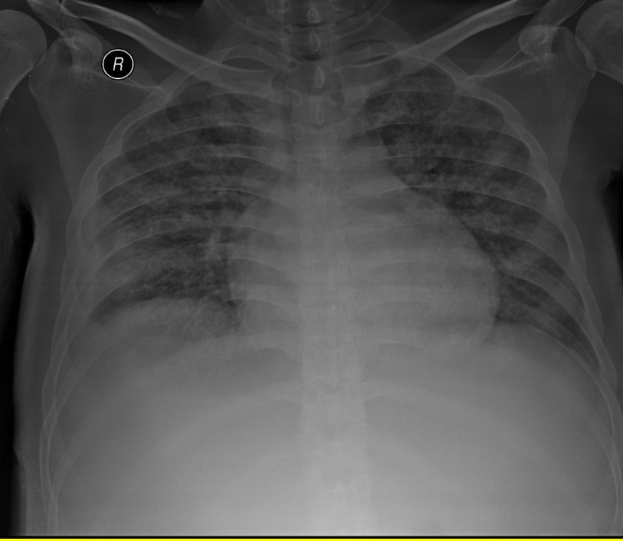
Figure 1. Miliary infiltrate shown in chest xray

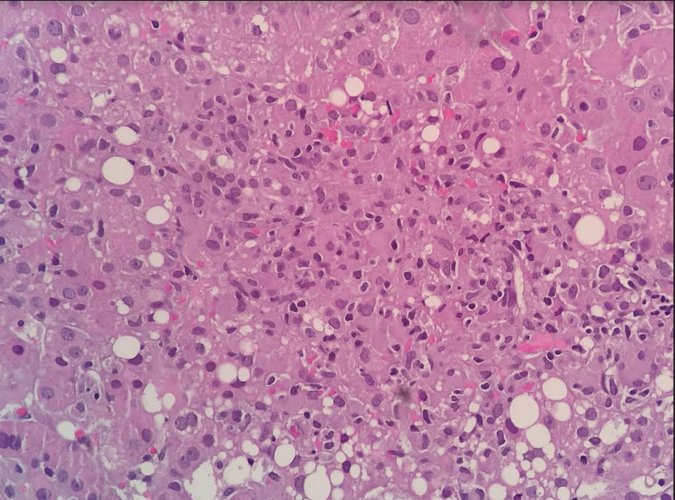
Figure 2. Formation of chronic granulomatous inflammation from liver biopsy

References:
- World Health Organization. Global Tuberculosis Report 2016. Geneva: WHO; 2016 (http://apps.who.int/iris/bitstream/10665/250441/1/9789241565394-eng.pdf?ua=1, assessed 13 March 2017)
- Tai WC, Kuo CM, Lee CH. Liver tuberculosis in Southern Taiwan: 15-years clinical experience. J Intern Med Taiwan 2008;19:410-417
- Chaudary P. Hepatobiliary tuberculosis. Annals of gastroenterology 2014;27:1-5
- Chejoh GO, Tanko MN, Manasseh AN, Ogala-Echejoh SE, Mandong BM, Okeke EN. HIV/TB co-infection: liver biopsy findings. J Med Med Sci 2011:2;648-52
- Reed DH, Nash AF, Valabhji P. Radiological diagnosis and management of a solitary tuberculous hepatic abscess. Br J Radiol 1990; 63:902-4
- Wu Z, Wang WL, Zhu Y, Cheng JW, Dong J, Li M, et al. Diagnosis and treatment of hepatic tuberculosis: report of five cases and review of literature. Int J Clin Exp Med 2013;6(9):845-850
- Hickey AJ, Gounder L, Mousa MS, Drain PK. A systematic revies of hepatic tuberculosis with considerations in human immunodeficiency virus co-infection. BMC Infectious Diseases 2015;15 (209):1-11
- Jain D, Aggarwal HK, Jain P, Pawar S. Primary hepatic tuberculosis presenting as acute liver failure. OMCR 2014; 12: 1-3
- Toptas T, Ilhan B, Bilgin H, Dincses E, Ozdogan O, Kaygusuz-Atagunduz I, et al. Miliary Tuberculosis Induced Acute Liver Failure. Case Reports in Infectious Disease 2015:1-3
- Bandyopadhyay S, Maity PK. Hepatobiliary tuberculosis. JAPI 2013;61: 44-47
- Wang JY, Hsueh PR, Wang SK, Jan IS, Lee LN, Liauw YS, et al. Disseminated Tuberculosis: A 10-Year experience in a medical center. Medicine 2007:86:39-46

Biography
Laras Budiyani is a senior resident in Internal Medicine Department Faculty of Medicine, Universitas Indonesia.
Email: larasbudiyani@gmail.com

