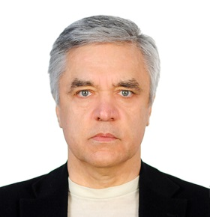


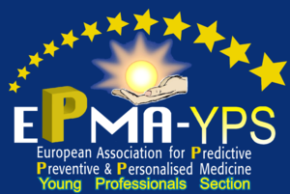

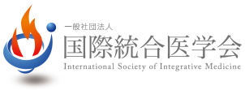

Preventive, Therapeutic and Rehabilitation Protocol to get the latter finalized and
to treat Pediatric disorders to suit the standards and rules of the Personalized Pediatry

Sergey Suchkov, Paul Barach, Vladimir Suhorukov

I.M.Sechenov First Moscow State Medical University, Russia
A.I.Evdokimov Moscow State University of Medicine & Dentistry, Russia
N.I.Pirogov Moscow National Medical Research University
Wayne State University, Chicago, USA

A new systems approach to diseased states and wellness result in a new branch in the healthcare services, namely, personalized medicine (PM). This key link in the healthcare strategy has been missed in pediatric services, in particular (personalized pediatry/PP). This strategy, in turn, would give a real opportunity to secure preventive measures whose personalization could have a significantly positive influence on demographics whilst monitoring family planning, gestation and early childhood stages.
To achieve the practical implementation of PP concept, it is necessary to create a new strategy based upon the subclinical recognition of biomarkers of hidden imbalances and defects long before the illness clinically manifests itself at any of the above-mentioned stages. PP as the big change to forecast, to predict and to prevent is rooted in a big and a new science to be rooted from the achievements of fundamental biomedicine and bioinformatics. As an allied portion of pediatric genomics, for instance, and thus an area of study to examine the impact of genetic variations on the response to medications is pediatric pharmacogenomics.
Tissue-derived (pediatric patient or person-at-risk) information we would accumulate might be combined with the: (a) individual's medical records; (b) family history; (c) data from imaging; (d) instrumental and laboratory tests to develop personalized and preventive treatment modes. two key objectives of PP are: (i) screening for subclinical imbalances and defects with a pre-selection of suitable targets for the next step of PM protocol, i.e., prevention; (ii) repair of the imbalances and defects mentioned to restore the function and to thus prevent the clinical illness. PP is thus a model of healthcare services being tailored to the individual child and dictates a construction of PP-based algorithms to diagnose, to predict, and to prevent in time whilst securing the childhood wellness! PM-oriented survey should be based on biomarkers and algorithms to differ essentially from those employed in traditional pediatric strategies, namely, (i) algorithms for predictive and subclinical diagnostics on one hand, and (ii) algorithms for preventive therapy,
on the other one.
Each decision-maker values the impact of their decision to use PP on their parenteral budget and well-being, which may not necessarily be optimal for society as a whole. A lack of pediatric guidelines has been identified by the majority of responders as the predominant barrier for adoption, indicating a need for the development of best pediatric practices and guidelines to support the implementation of PP! Implementation of PP requires a lot before the current model “pediatrician-children” could be gradually displaced by a new model “medical advisor-healthy child-at-risk”.
This is the reason for developing global scientific, clinical, social, and educational projects in the area of PP to elicit the content of the new branch. Individual children to be under regular monitoring that helps to detect pathological shifts at subclinical stages have a higher life expectancy and are able-bodied up to 8–15 years more than those under traditional treatment. At the community level, the annual savings from each individual may vary from several thousands to several tens of thousands U.S. dollars.

Biography
Dr Sergey V. Suchkov, MD, PhD
Sergey Suchkov was born in the City of Astrakhan, Russia, in a family of dynasty medical doctors. In 1980, graduated from Astrakhan State Medical University and was awarded with MD. In 1985, Suchkov maintained his PhD as a PhD student of the I.M. Sechenov Moscow Medical Academy and Institute of Medical Enzymology. In 2001, Suchkov maintained his Doctor Degree at the National Institute of Immunology, Russia.
From 1989 through 1995, Dr Suchkov was being a Head of the Lab of Clinical Immunology, Helmholtz Eye Research Institute in Moscow. From 1995 through 2004 - a Chair of the Dept for Clinical Immunology, Moscow Clinical Research Institute (MONIKI). In 1993-1996, Dr Suchkov was a Secretary-in-Chief of the Editorial Board, Biomedical Science, an international journal published jointly by the USSR Academy of Sciences and the Royal Society of Chemistry, UK.
At present, Dr Sergey Suchkov, MD, PhD, is:
● Professor, Chair, Dept for Personalized and Translational Medicine, I.M.Sechenov First Moscow State Medical University and Dept of Clinical Immunology, A.I.Evdokimov Moscow State Medical and Dental University;
● Secretary General, United Cultural Convention (UCC), Cambridge, UK.
Dr Suchkov is an author of more than 500 publications including 10 patents and more than 10 monographs, handbooks and textbooks published in Russia and USA. Dr Suchkov is a member of the:
● New York Academy of Sciences, USA
● American Chemical Society (ACS), USA;
● American Heart Association (AHA), USA;
● European Association for Medical Education (AMEE), Dundee, UK;
● EPMA (European Association for Predictive, Preventive and Personalized Medicine), Brussels, EU;
● ARVO (American Association for Research in Vision and Ophthalmology);
● ISER (International Society for Eye Research);
● Personalized Medicine Coalition (PMC), Washington, DC, USA
● All-Union (from 1992 - Russian) Biochemical Society;
● All-Union (from 1992 - Russian) Immunological Society.
Dr Suchkov is a member of the Editorial Boards of “Open Journal of Immunology”, EPMA J., American J. of Cardiovascular Research and “Personalized Medicine Universe”

