A PRACTICAL EXEMPLARY EXPERIENCE OF RHEUMIC HEART
DISEASE PREVENTION AT FARTA WOREDA OF SOUTH GONDER ZONE,
ETHIOPIA.

¹ Mestet Yibeltal (MD): jininuyibeltl@gmail.com
² Denekew Tenaw (BSC in PH): denekewtenaw7@gmail.com
² Rahel Mulatie (Msc in Epidemiology): rahelmul2112@gmail.com
² Dejene Shifera (MD): shiferad4545@gmail.com

Abstract
Background
While it is true that rheumatic heart disease continued being the commonest cause of acquired heart disease in children of Africa and Ethiopia with an established preventable cause, the practice of prevention is yet unsatisfactory as evidenced by rampant cases with significant morbidity and mortality. Currently, the practice of primary prevention of rheumatic heart disease is gaining more attention as this deadly disease showed no significant reduction with the previously emphasized secondary prevention especially to those setups where there are rudimentary level curative cardiac surgical services; underscoring the importance of instituting the most effective and integrated prevention strategy.
Methodology
First, the up-to-date recommendations on prevention of rheumatic heart disease were searched. The project site (Farta woreda) from woredas of South Gondar zone was made by lottery method. Two kebeles of Farta woreda were selected using similar sampling method. A total of 40 health extension workers from Farta woreda selected. Then the actual training & health education took 6 days. That is, a two days training for 40 health extension workers coming from Farta woreda. In addition, this project gave health education to 2 selected kebeles of Farta woreda selected by lottery method with the training site being the respective kebele centers just after the training for HEWs is completed.
Conclusion
The policy makers should give priority to the deadly rheumatic heart disease by making use of this exemplary project to scale up to a country level and integrating it to the existing other preventable diseases programme without adding a significant extra cost to the health sector.

ABBREVIATIONS
AHA:American Heart Association
ARF: Acute Rheumatic Fever
ASO: Anti-streptolysin O
BGP: Benzanthine G penicillin
CHWs: Community Health Workers
CRP: C-Reactive Protein
ESR: Erythrocyte Sedimentation Rate
GABHS:Group A Beta Hemolytic Streptococci
GAS: Group A Streptococci
HEWs: Health Extension Workers
IE: Infective Endocarditis
MR: Mitral Regurgitation
RF: Rheumatic Fever
RHD: Rheumatic Heart Disease
URTI: Upper Respiratory Tract Infection
WHO: World Health Organization

BACKGROUND
Rheumatic heart disease (RHD) is a preventable yet serious public health problem in poor countries (1). It results from damage to heart valves caused by a single or repeated attacks of rheumatic fever, an autoimmune inflammatory reaction to throat infection caused by group A streptococci (2 & 3). RHD is rare in developed nations mainly due to improved living standard (4). Yet it continued to be the most common cause of acquired heart disease in children & young adults in Africa (2 & 5).
Streptococcal pharyngitis/tonsillitis primarily affects children between the ages of 5–15 years though it can occur in people of any age (6).
Socioeconomic factors such as poor housing, under nutrition, overcrowding, poor access to health care and poverty are well known contributors to the incidence, magnitude and severity of ARF/RHD (4). Previous attack of ARF carries a 75% recurrence risk of another attack of ARF (7). Genetics is also known to have role as it explains why only 0.3–3% of individuals with acute streptococcal pharyngitis go on to develop ARF per a single attack (6-7).
The diagnosis of ARF is made by modified Jones criteria (6) while RHD is diagnosed by using clinical evidences and by using echocardiography (8). Acute streptococcal pharyngitis & ARF are treated medically. Once RHD develops, only surgery cures (8), which is generally expensive & absent in most developing countries, little if any; highlighting the essence of prevention (5).
12
There are three levels of prevention for RHD: primordial prevention which is reducing the risk factors of ARF; primary prevention is through treatment of streptococcal pharyngitis within 9 days of its onset (6) and secondary prevention through a monthly benzathine penicillin injections to patients with a previous history of ARF and /RHD. Primary prevention is gaining more attention as prevalence of RHD showed no decline in developing countries despite secondary prophylaxis have been advocated in the past. Prevention of RHD are most effective when delivered as part of routine child health care and integrated into existing health system (9-10).
ARF/RHD is crippling the productive young population with cardiac morbidity & mortality, increases school absenteeism and drop-out, and lost wages. Big budget is being lost for years of follow up & treatment (1, 4 & 11). Referral to abroad add double burden on poor countries (4).

Literature review
Ethiopian context concerning rheumatic heart disease
In Ethiopian school children, the prevalence of ARF/RHD is estimated to be in the range of 4.6 to 6.4 per 1000 children (8) and surprisingly enough, not more than 15% of parents of these children know their children had some form of heart disease related with infection and only 22% were on regular prophylaxis showing low knowledge and level of awareness about the disease (8).According to another study conducted at Ethiopian rural town(Butajira) to estimate the prevalence of RHD at school children showed a prevalence of 4.6/ 1000. Only 2 out of the 15 students were aware of their disease and neither of them were on regular secondary prophylaxis (9). Another study conducted at Tikur Anbesa Hospital to evaluate the severity of RHD using age at time of death as indicator showed an overall mean age at time of death of 25.89+/-11.05 years (10) and 22 years (11). Despite it is common problem, cardiac surgery service in the country is being barely given (8).
Updated recommendations on preventions and control of RHD worldwide
In a study conducted on a Comprehensive Rheumatic Heart Disease Control Programs, integration RHD with existing health care delivery systems [13 & 14] is advocated though achieving meaningful integration remains a challenge in most settings [15] and requires conscious attention during program planning [16]. It also emphasized a comprehensive prevention and control programs for RHD, highlighting the importance of both primary and secondary approaches in an attempt to intervene at multiple points along the protracted etiological pathway of RF/RHD [13 & 17]. Policy advocacy is an important role for RF/RHD control programs, particularly given the relative contribution of socioeconomic conditions to disease burden [13]. Broadly strengthening the advocacy capacity of the RF/RHD community is critical for addressing persistent neglect of the disease among decision makers [18].
Similarly, the second RHD forum underscored the necessity for political intervention and policy change stressing that the prevention of RHD is beyond medical management (19). It also highlighted the need to increase the health force by incorporating teaching, training, and task-shifting besides to the desperate need for universal access to high-quality penicillin. The nee d to involve the patient community in the ongoing discussion was also highlighted to escalate active community participation as these occasions can provide important opportunities for education and can draw much-needed media attention (e.g., the work in Vietnam around nephrotic syndrome (20).
Knowledge of Community Health Workers (CHWs aka HEWS) on RHD
Little if any is stated in literatures as to the knowledge, attitude and practice of HEWs is concerned but that there exist a great deal of unawareness by the patients and parents of the patients and the community might reflect poor awareness of HEWs of the country on the RHD. Poor patient & physician awareness are known to be obstacles for primary prevention and control of RHD (21); that is, informed and engaged health workers are a critical component of successful disease control programs (22). Without training, patients will get inconsistent messages and the follow up may not be delivered to those most in need (22).
The general objective of the review & project is to increase the awareness of the health extension workers and parents as to what are causes of RHD and the prevention ways of acquired heart disease in general with the ultimate goal of convincing policy makers to integrate RHD prevention with other preventable disease programs available in the nation.

JUSTIFICATION AND ASSUMTIONS IN DEVELOPING THIS PROJECT
- Poor knowledge about ARF & RHD by health extension workers and the community.
- Common to see ARF & RHD in poor set ups like South Gondar zone of Ethiopia as it is the commonest cause of acquired heart disease in children.
- Common in Ethiopian context though specific study in the south Gondar is lacking. (8-9)
- The problem is too severe and no curative services in the country.
- Studies showed prevention is more cost effective than curative services.
- Evidence shows that it is highly preventable disease as the cause is well established.
- No vaccine to date.
- South Gondar is one part of Ethiopia, a developing country. Hence, it is can be inferred that ARF and RHD is common in South Gondar though no prior research done in south Gondar zone regarding the problem.

GOAL OF THE PROJECT
To bring about a significant decrement of ARF and its chronic sequela RHD in children living in South Gondar as well as its consequences in the community.
GENERAL OBJECTIVE
To increase awareness on the causes and prevention of rheumatic heart disease in children by giving health education for parents and training health extension workers in Farta woredas of South Gonder zone.
SPECIFIC OBJECTIVES
- To increase knowledge of HEWs on causes & prevention of rheumatic heart disease in children for at one selected wereda of South Gondar zone 2018.
- To raise awareness of parents on causes & prevention ways of rheumatic heart disease in children for parents in selected six weredas of South Gondar zone 2018.
- Scale up the project to the country level so that policy makers can use this exemplary project.
PRIMARY BENEFICIARIES FROM THIS PROJECT
Children of age 5-15 years are the primary beneficiaries as the problem is most common in this age group.
SECONDARY BENEFICIARIES
The community (the whole society)
Health extension workers

Project design matrix
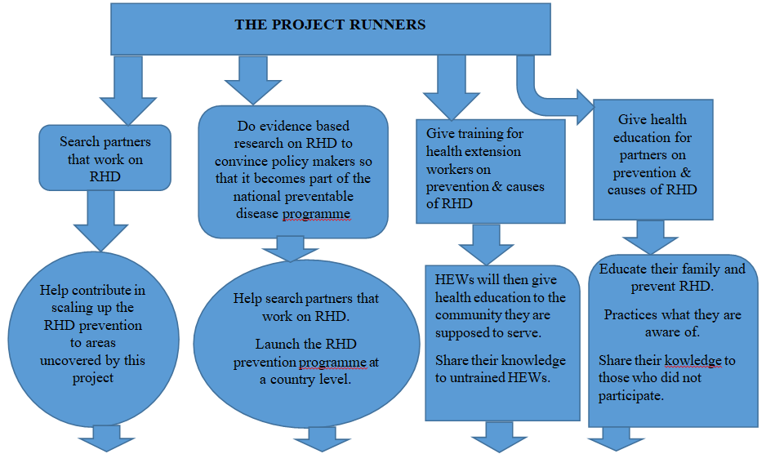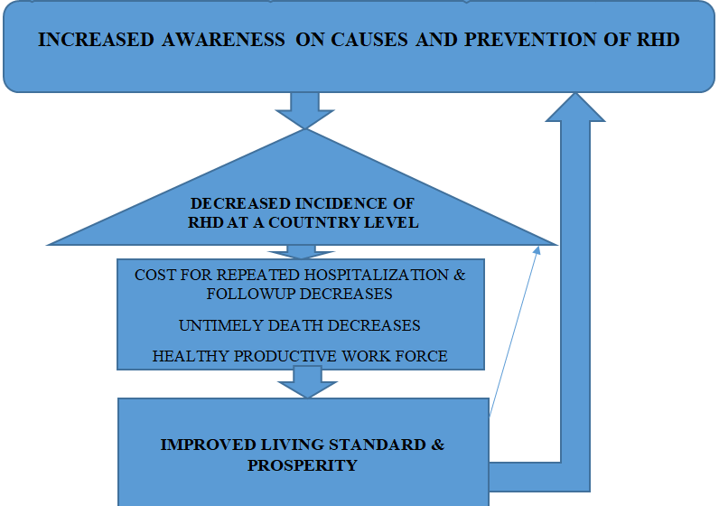

METHODOLOGY
First, the up-to-date recommendations on prevention of RHD were searched. The project site was then selected. The selection of Farta woreda from woredas of South Gondar zone was made by lottery method. A total of 6 days was needed for the actual training & health education. That is, a two days training for 40 health extension workers coming from Farta woreda. In addition, this project gave health education to 2 selected kebeles of Farta woreda selected by lottery method with the training site being the respective kebele centers just after the training for HEWs is completed.
The health education was given by 2 medical doctors in collaboration with 2 public health officers for parents in each kebeles that is planned to be addressed. Health extension workers were added for health education at kebeles selected so that they get experienced well. To sustain the outcome of the training and health education, parents who got health education and those trained health extension workers were linked to the woreda health office head and health extension supervisor to expand to the nearest weredas that were not included in this project.

ACTIONS TAKEN
- Training was given on causes and prevention of rheumatic heart disease among children for 40 health extension workers who come from selected one wereda (Farta woreda) of South Gondar Zone to improve the awareness, attitude and practice of HEWs in prevention of rheumatic heart disease as they are front-liner to the community.
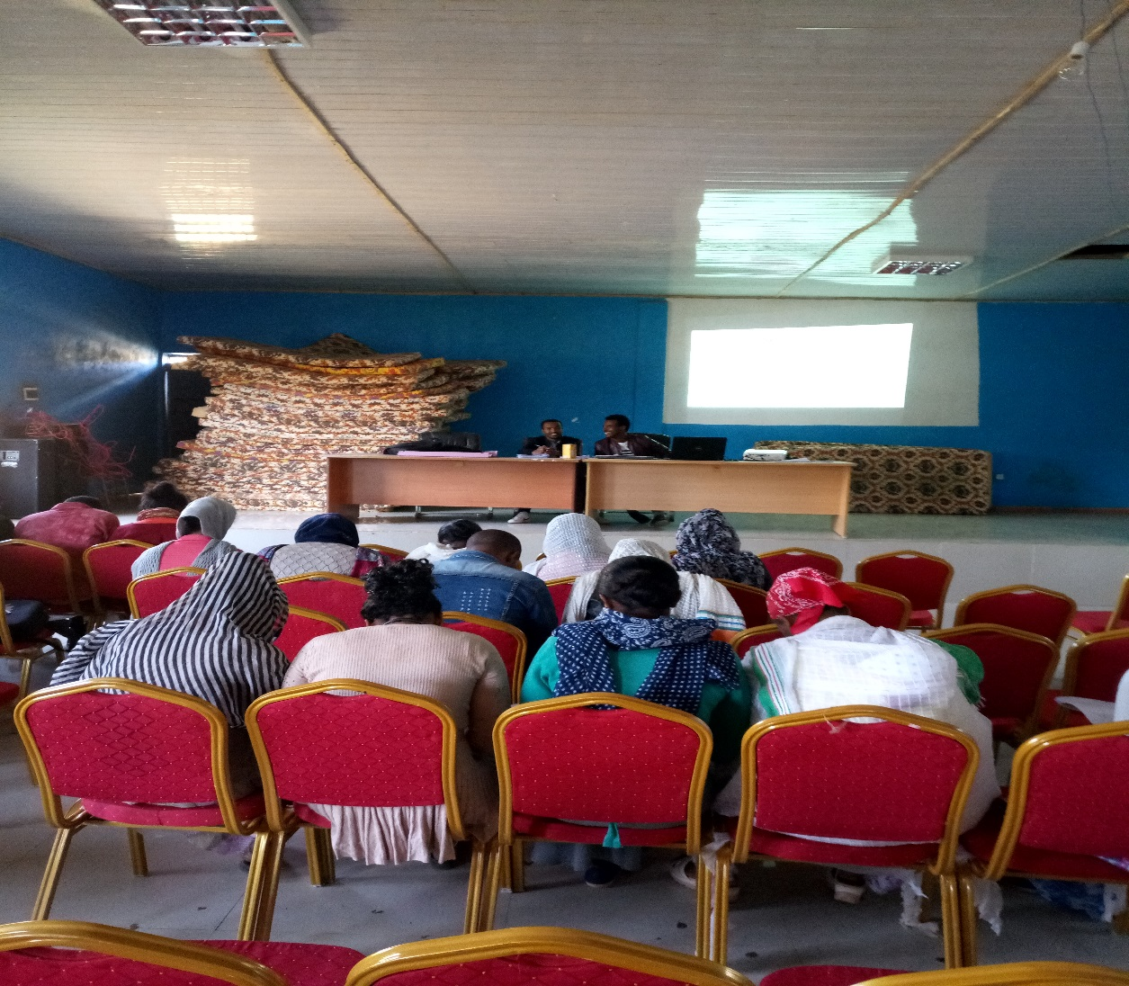
Picture 1: Trainers and trainee during Training (Partially)

- According to a study done at Ethiopian School children to assess the awareness, magnitude and prevention of rheumatic heart disease in children, not more than 15% of parents of children with rheumatic disease know their children had some form of heart disease related with infection. Hence, a two day health education on this important public health problem was given for parents of two kebeles selected from Farta woreda, South Gondar Zone.
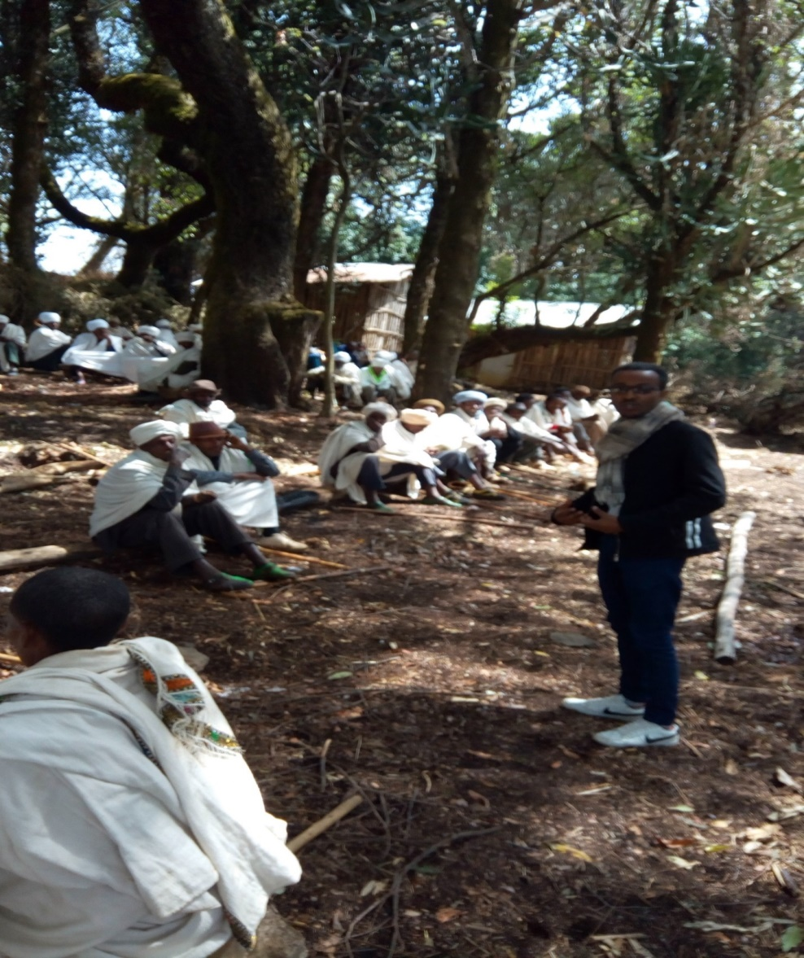
Picture 2: A photos taken during health education at Tsegur Adiko kebele center (Partially)

Outcome of the Project
- Health extension workers got awareness on what the commonest cause of heart problem in children. They also acquired knowledge on causes, risk factors, clinical presentation, treatment options and preventive ways of ARF/RHD. This will motivate them to help the community they are supposed to serve.
- Health extension workers (HEWs) admitted the practical role they have in prevention of ARF/RHD including giving health education to the community on causes and prevention of RHD, importance of adherence of both primary and secondary prophylaxis, what medication to give for primary and secondary prevention of RHD.
- They understood the feasibility of prevention over treatment ARF and RHD in developing country context (including Ethiopia).
- They become aware of the disadvantage of tonsillectomy & uvula cutting and absence of role in reducing acquired heart disease.
- The existing needs and /or challenges in prevention of rheumatic heart disease was better identified and a fertile ground for the future community service was laid.
- Parents at two kebeles (Kanat & Tsegur Adiko kebeles) of Farta woreda who got health education have got an idea about tonsil infection and its sever sequel RHD and understand what to do to prevent the occurrence of RHD.

SUSTAINABILITY OF THE PROJECT
This project must be sustainable as the problem is deep rooted and nothing can come out overnight. Hence, this project will become sustainable in the following ways:
- The project trains health extension workers, who directly help contribute making this project sustainable as they will continue giving health education to the community they are supposed to serve.
- The woreda health officers participated in the training will help supervise health extension workers work on the problem.
- The project overall coordinator & members will
- Have link to the woreda health officers so that the health education becomes continuous and scaled up to the nearby woredas of south Gondar zone.
- Arrange training when needed in collaboration with other stakeholders (NGO, government).
- Launch this project proposal to search for partners that work in this problem so that this project becomes long lasting to achieve a significant reduction of the problem in the zone.
- Try to scale up this project first to other zones then to region and the country level in collaboration with other stakeholders.
- Try to convince the health policy makers to incorporate the preventive actions of ARF & RHD to the national preventable disease programmes by doing evidence based researches without adding an extra cost.
Conclusion
The policy makers should give priority to the deadly rheumatic heart disease by making use of this exemplary project to scale up to a country level and integrating it to the existing other preventable diseases programme without adding a significant extra cost to the health sector.
Acknowledgment
We would like to acknowledge Debretabor University for arranging all the necessary cost to run this project.

REFERENCES
- Christian Barnard Division of Cardiothoracic Surgery University of Cape Town and Red Cross Children’s Hospital Children’s heart disease in sub-Saharan Africa: Challenging the burden of disease 2010; 7:18-29.
- Evidence-based, best practice New Zealand Guidelines for Rheumatic Fever: Proposed Rheumatic Fever Primary Prevention Programme. Pediatr Infect Dis J. 2009; 13: 1-120.
- Rheumatic Fever and Rheumatic Heart Disease: World Health Organ Techn Rep Ser 2004;923:1-130
- World Health Organisation. The WHO Global Programme for the prevention of RF/RHD. Report of a consultation to review progress and develop future activities. 2000.
- Alex B., Warren W. Diagnosis and management of acute rheumatic fever and rheumatic heart disease in Australia, National heart foundation of Australia; 2012, 590:1-100
- Carapetis JR, Bart J Currie. Preventing rheumatic heart disease in Australia. Med J Aust 1998, 168:428-9.
- Michael A. Gerber. Rheumatic Fever In: Robert M. Kliegman, Bonita F. Stanton, Joseph W. St. Geme III, Nina F. Schor, Richard E. Behrman, eds: Nelson text book of pediatrics 19th ed. Philadelphia: Elsevier Saunders; 2011. P140-144.
- FitsumDagmawi. Ethiopiafactors determining rheumatic fever recurrence among Rheumatic heart disease patients who are taking Monthly benzanthine g penicillin prophylaxis At pediatric cardiac clinic, TikurAnbessaSpeicialized Teaching Hospital, Addis Ababa University, College Of Health Sciences, Department Of Pediatrics And Child Health Addis Ababa, 2014.
- Oli, K, Tekle-Haimanot ,R,Forsgren,L,andEstedt, J. Rheumatic disease prevalence among school children of an Ethiopian rural town.Cardiology1992;80:152-155.
- Oli, K and Asmera, J. Rheumatic heart disease in Ethiopia: Could it be more malignant? Ethiop Med J.2004; 42:1-8.
- Gunar Gunther,JilaluAsmera. Death from rheumatic heart disease in rural Ethiopia. Ethiop Med J.2006; 367:391.
- Dejuma Y., Girma T., Girmaye A., Asfawossen B. Rheumatic Fever and Rheumatic Heart Disease for the Ethiopian Health Center Team. Ethiopian Public Health Training Initiative; 2005.
- Steer A, Colquhoun S, Noonan S, Kado J, Viale S, Carapetis J. Control of rheumatic
heart disease in the Pacific region. Pac Health Dialog 2006; 13:49–55.
- Carapetis J, Zuhlke L. Global reasearch priorities in rheumatic fever and rheumatic heart
disease. Ann Pediatr Cardiol 2011; 4:4–12.
- Atun R, de Jongh T, Secci F, Ohiri K, Adeyi O. Integration of targeted health interventions into health systems: a conceptual framework for analysis. Health Policy
Plan 2010; 25:104–11.
- Carapetis JR. Rheumatic heart disease in developing countries. N Engl J Med 2007; 357:439–41.
- Marijon E, Mirabel M, Celermajer DS, Jouven X. Rheumatic heart disease. Lancet 2012;
379:953–64.
- Watkins DA, Zuhlke LJ, Engel ME, Mayosi BM. Rheumatic fever: neglected again.
Science 2009; 324:37.
- . The Second Rheumatic Heart Disease Forum Report GLOBAL HEART World Heart
Federation (Geneva). Elsevier Ltd. VOL. 8, NO. 3, 2013.
- Caring and Living as Neighbors. Nephrotic Syndrome Club Meeting, Hanoi, Vietnam,
February 2012 [video]. September 10, 2012.
- Liesl J. Zühlke, Ganesan Karthikeyan y Cape Town, South Africa; and New Delhi, India
Primary Prevention for Rheumatic Fever Progress, Obstacles, and Opportunities
GLOBAL HEART, VOL. 8, NO. 3, 2013 221 September 2013: 221-226
- Wyber, R. Grainger Gasser, A. Thompson, D. Kennedy, D. Johnson, T. Taubert, K.
Carapetis, J. Tools for Implementing RHD Control Programs (TIPS) Handbook. World
Heart Federation and RhEACH. Perth, Australia 2014.

