Mechanisms and Biomarkers to Detect Chemotherapy‑induced Cardiotoxicity
Habib Haybar , Department of Cardiology, Atherosclerosis Research Center, Ahvaz Jundishapur University of Medical Sciences

Abstract (300 word limit)

Cardiotoxicity is a considerable event for cardiologists and oncologists during and after chemotherapy. The use of certain chemotherapy agents such as Trastuzumab, PD-1 inhibitors, and Doxorubicin increased in cancer therapy; however, these agents associate with an increase in mortality and cardiotoxicity. Detecting cardiotoxicity is based on patient’s medical history and physical examination since there is no exact biomarker or polymorphism for its early diagnosis. Therefore, we still need potential biomarkers for cardiotoxicity risk. Treatment of several cancers is manageable while preventing cardiotoxicity, as chemotherapy side effect, is essential since it might be a greater risk than the malignancy if not detected at early stages. Early detection of cardiotoxicity, during and after chemotherapy, is crucial to decrease permanent and devastating cardiac damages. Recently, troponin but also atrial-type and brain-type natriuretic peptides (ANP and BNP) were reported as good diagnostic biomarkers for cardiotoxicity. Micro-RNAs and inflammatory mediators are candidates as prognostic biomarkers. Genetic biomarkers such as C282Y allele of hemochromatosis gene makes the patients more susceptible to cardiotoxicity, therefore, genome studies are valuable in predicting chemotherapy results. In this review, we present the mechanisms of developing chemotherapy-induced cardiotoxicity and biomarkers for its detection in patients. Echocardiographic techniques are very strong techniques which could be used along with biomarkers for more reliable and quicker diagnosis

Our key points are:

cTn, BNP;B and NPs together are stronger predictive biomarkers for chemotherapy-induced cardiotoxicity.

Genetic polymorphisms for cytochrome P450 might have important association to cardiotoxicity.

MMPs can be predictive biomarkers in estimating cardiotoxicity.

Evaluating intracellular Ca⁺² can be a valuable biomarker in predicting chemotherapy-induced cardiotoxicity at early stages.

Image
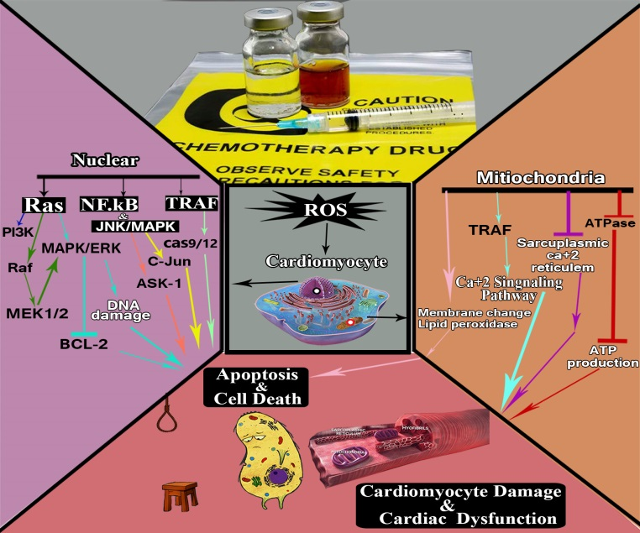
Recent Publications (minimum 5)
- Haybar H, Shahrabi S, Zayeri ZD, Pezeshki S. Strategies to increase cardioprotection through cardioprotective chemokines in chemotherapy-induced cardiotoxicity. International journal of cardiology. 2018;269:276-82.
- Haybar H, Jalali MT, Zibara K, Zayeri ZD. Mechanisms and biomarkers to detect chemotherapy-induced cardiotoxicity. Clinical Cancer Investigation Journal. 2017;6(5):207.
- Haybar H, Khodadi E, Shahrabi S. Wnt/β-catenin in ischemic myocardium: interactions and signaling pathways as a therapeutic target. Heart failure reviews. 2018:1-9.
- Haybar H, Goudarzi M, Mehrzadi S, Aminzadeh A, Khodayar MJ, Kalantar M, et al. Effect of gemfibrozil on cardiotoxicity induced by doxorubicin in male experimental rats. Biomedicine & Pharmacotherapy. 2019;109:530-5.
- Haybar H, Jalali MT, Zayeri ZD. What Genetics Tells us about Cardiovascular Disease in Diabetic Patients? Cardiovascular & Haematological Disorders-Drug Targets (Formerly Current Drug Targets-Cardiovascular & Hematological Disorders). 2018;18(2):147-52.

 Biography (150 word limit)
Dr Habib Haybar is a Cardiac Surgeon and a cardiologist in Department of Cardiology, Atherosclerosis Research Center,
Ahvaz Jundishapur University of Medical Sciences, Ahvaz,Iran. He is a researcher and published up to 100 valuable publications.
He is a professor in Department of Cardiology, Atherosclerosis Research Center,Ahvaz Jundishapur University of Medical Sciences, Ahvaz,Iran and he was the manager of Golestan Hospital in Ahvaz,Iran.
Email: takamoolsk@gmail.com
Phone: +989166131474

Notes/Comments:

