The Medical city, department of internal medicine

A CASE REPORT ON AN INCIDENTALLY-DIAGNOSED INTRACARDIAC TUMOR
By Ma. Estrella D. Genoveza, MD and Kristina Marie O. Rivera, MD
October 2017

Abstract
We present a case report on a 75 year old male who was incidentally diagnosed to have an intracardiac tumor by chest CT scan. The patient was on treatment for pulmonary tuberculosis who presented with chest pain. Impression was acute coronary syndrome. Immediate management was done with coronary angiography and percutaneous cardiac intervention. Due to chest xray finding of pulmonary nodule, chest CT scan was done which showed the intracardiac tumor. No biopsy of the cardiac tumor was done. Patient was on antiplatelet and was denied cardiac clearance to hold antiplatelet. Instead, excision biopsy of the right cervical lymph node was done. Histopathology report of the lymph node revealed metastatic poorly differentiated carcinoma. No surgical intervention was contemplated as family decided on palliative care.

Introduction
Cardiac tumors are relatively rare . Myxoma accounts for the most common type of primary cardiac tumor in all age groups (90% are sporadic while 10% familial with autosomal dominant). On the other hand, metastatic tumors to the heart are 20 to 40 times more common than primary cardiac tumors. This report aims to discuss how to diagnose an intracardiac tumor, its clinical manifestations and treatment.

Case Report
CR is a 75 year old male, Married, Filipino, Roman Catholic from Cainta, Rizal, admitted last April 1, 2017, who came in due to chest pain. History started 3 months prior to admission, patient started to experience chest pain, precipitated by cough, described as sharp, 7/10 in severity, radiating to the left shoulder, intermittent. Initially, no consult done. Self-medicated with Paracetamol 500 mg/tab which afforded temporary relief of chest pain, but with persistence of shoulder pain. In the interim, noted to have recurrences of chest pain.
2 weeks prior to admission - Due to persistence of aforementioned symptom, patient sought consult at TMC satellite clinic. Patient was worked up. Noted results: Chest Xray: PTB with cicatricial changes and atelectasis. ECG not brought. 2d echo revealed hypokinesia on the anterior wall and anteroseptum from base to apex. Patient was then started on Fixcom 4 tablets once a day.
3 days PTA- noted to have increased severity of chest pain, still precipitated by cough, heavy, 10/10 in severity, radiating to the left shoulder, persistent associated with easy fatigability and exertional dyspnea, patient does not tolerate walking around the house anymore. Persistence of aforementioned symptom prompted consult at the ER, hence admission. On review of systems, patient had unintentional, undocumented weight loss, noted dirty looking sclerae, a palpable lymph node on the right side of the neck.
In his past medical history, patient is a known diabetic since 2016 with latest hba1c 7 (March 2017), maintained on Insulin Glargine (Lantus) 18 units subcutaneous once a day at night time. He had a history of PTB: between 2013-2014 - incomplete treatment, unrecalled, and between 2015 -2016 – completed HRZE 6 months of treatment. He is a non hypertensive but his mother is known hypertensive. He is currently unemployed. He is a previous smoker- 90 pack years but stopped smoking last 2016. He is a occasional alcoholic beverage drinker.
At the Emergency Room, the patient had vital signs BP 160/80 HR105 RR 20 Temp 37.8, tachycardic, regular rhythm, rhonchi, both lung fields, oxygen saturation of sat 95% at, room air soft non tender abdomen, No edema, CBG 212. Impression at this time was to consider Acute Coronary Syndrome; Relapse of Pulmonary tuberculosis. The clinical pathway for possible ischemic Chest pain was activated. A 2DECHO was requested. Patient was referred to Cardiology service for consult and co-management. Other Laboratory examinations requested were the following: AFB x 2, sputum gram stain and culture. He was also given Insulin Glulisine (apidra 4 units subcutaneous) for CBG of 212 and started on an insulin glulisine fixed dose scale. His repeat CBG was 110. Paracetamol 500 mg/tab 1 tab and ISMN 30 mg/tab 1 tab were given for fever and chest pain respectively. His ECG showed sinus rhythm. His initial troponin was 81.8.
Still at the ER, repeat ECG and cardiac enzyme were done 6 hours after, noted deeper T wave changes on leads V1-V3 and AVL, repeat Troponin was 102. 2. A CODE STEMI was called. ACS regimen was started. Stat coronary angiography with possible PCI was done. Coronary angiography revealed 70% occlusion of the Left Anterior Descending Artery, 1 stent was deployed. Patient was admitted at the ICU for closer monitoring.
On the second hospital day, post operative day 1, patient was admitted at the ICU. He was noted to have BP elevations SBP 160-180/90 HR96 RR 20 Temp 36.5. 2D echo showed the hypokinesia (see Appendix) (Figure 1) A chest CT scan was requested due to finding of pulmonary nodule and a perilesional pneumonitis on chest xray. Chest CT scan incidentally showed a cardiac mass with thromboembolism to the main and right pulmonary arteries (refer to Appendix) (Figure 2).

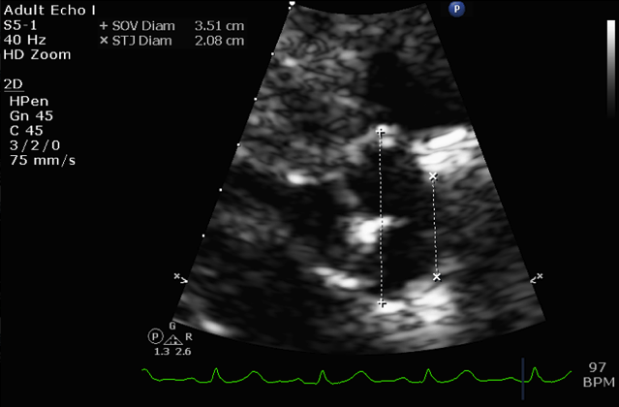
Figure 1. 2D echo of the patient

For increasing BP trends, Nicardipine push 2 mg IV was given. Carvedilol was increased to 12.5 mg/tab 1 tab 2x/daily. Also, the patient had episodes of hemoptysis. The main service suggested to decrease the dose of antiplatelet, but interventional Cardiology did not approve of it due to the possibility of stent thrombosis. Enoxaparin was placed on hold. The patient was referred to TCVS for CT-guided biopsy of intracardiac and pulmonary masses which were noted on 2decho and Chest CT scan. An multidisciplinary team conference was scheduled.

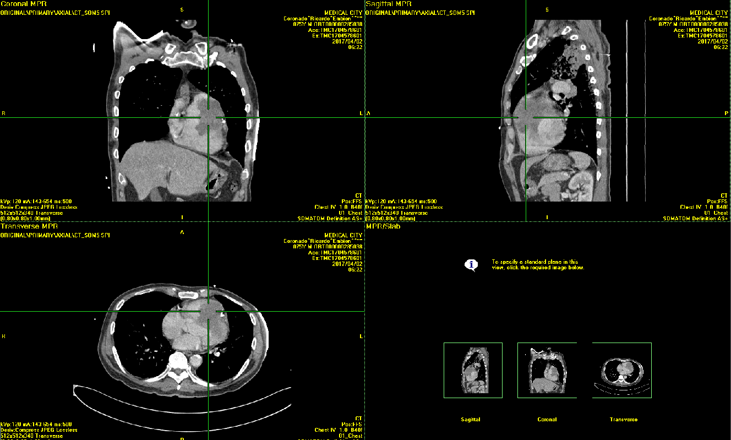
Figure 2. Chest CT scan of the patient

On the third hospital day, the patient was noted to have episodes of disorientation with stable vital signs. Consideration was bleed vs infarct vs metastasis. A Cranial CT scan was requested which revealed no intracranial hemorrhage and/or masses. The patient was cleared to transfer out to regular room.
On the fourth hospital day, the patient was noted to be oriented, with stable vital signs. Repeat laboratories were requested showed elevated wbc. He was started empirically on Levofloxacin 750 mg/tab 1 tab once a day, which was approved by Cardiology service. No clearance was given cardiac wise for the biopsy because the procedurę required to place the antiplatelet therapy on hold.
On the fifth hospital day, the patient was noted to have blood streaked sputum. Stable vital signs. No recurrence of disorientation.
On the sixth hospital day, the patient underwent excision biopsy of the right cervical lymph node. Histopathologic Report showed Metastatic poorly differentiated carcinoma.
On the seventh hospital day, the patient was referred to Radiation Oncology for palliative radiation.
On the eighth hospital day, the patient’s family decided to bring him home to continue palliation at home. The patient was then referred to Palliative service for continuity of care.
On the ninth hospital day, the patient was discharged per family’s request.
The patient was discharged with a diagnosis of Non ST elevation Myocardial Infarction, 1vessel Coronary Artery disease, s/p coronary angiogram with PCI of LAD (1 April 2017), Pulmonary Embolism, Metastatic Non-small cell carcinoma, Diabetes Mellitus type 2.

Discussion
The patient had a metastatic poorly differentiated carcinoma. In this paper, it was not determined whether the cardiac mass is primary or secondary (metastatic) tumor. We can only speculate that it is a primary tumor given the chest CT scan findings. If the tumor were metastatic, it would usually arise from lung, breast, renal cancer, melanomas, and lymphomas. ¹ The chest CT scan would have revealed lung mass, breast mass or a large lymph node but it shown otherwise. Based on Figure 3, most probable type of cardiac tumor that patient has is a sarcoma.

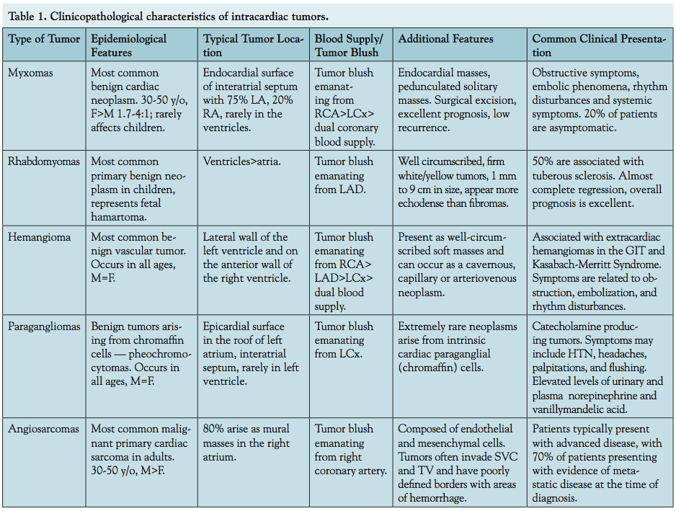
Figure 3. Clinicopathological characteristics of intracardiac masses (from the Journal of invasive Cardiology)

The clinical manifestations of cardiac tumors depend on the size and location of the mass and the infiltration of adjacent tissues rather than the type of the tumor itself.¹ The patient presented with a cardiac mass with thromboembolism to pulmonary arteries and possible pulmonary metastases. If the patient’s cardiac mass were metastasis, an array of other manifestations would have been observed . As seen Table 2, it is still possible that the patient presented with myocardial infarction secondary to tumor embolism or a pulmonary tumor emboli from right sided metastasis.

Table 2. Potential Clinical Manifestations of Cardiac Metastasis⁴
Pericardial metastasis | Pericarditis, pericardial effusions, and cardiac tamponade  Pericardial adhesions and constrictive pericarditis
Epicardial and myocardial metastasis | Atrial and ventricular arrhythmias and conduction disturbances, including atrial fibrillation with RVR, atrial flutter, complete AV block, PVCs, and ventricular fibrillation  CHF with systolic or diastolic dysfunction  Myocardial ischemia or infarction from perivascular coronary artery compression, tumor embolism, or coronary invasion  Cardiac rupture
Endocardial and intracavitary metastasis | Intracavitary obstruction, left and right heart failure, cardiogenic shock  Pulmonary tumor emboli from right-sided metastasis  Stroke from tumor emboli from left-sided metastasis
Superior or inferior vena cava metastasis | Superior vena cava syndrome  Inferior vena cava syndrome  Right heart metastasis

A few studies show similar accounts of an intracardiac tumor based on patient’s background. A study by Cannava et al in 2015 presents a case of a 48 year old male who came in with chest pain. The cause of the pain was from “coronary embolization from the myxoma.” Like the patient, he was a diabetic and previous smoker. Another study by Mousavi presents study of a 51-year-old female known hypertensive, diabetic, coronary artery disease and alcohol abuse who came in due to progressive dyspnea on exertion. This patient was later discovered to have a metastatic tumor to the heart.³ In this case, patient was a diabetic with coronary artery disease and had a metastatic tumor to the heart. Another study presents a patient with recurrent pulmonary tuberculosis, HIV positive and a cardiac tumor. This study though does not necessarily associate PTB, HIV and cardiac tumors.

The patient’s intracardiac tumor was discovered by echocardiography and by chest CT scan. Echocardiography is the main diagnostic tool for the detection of a cardiac mass.¹ The patient’s 2D echo showed auspicious echodensity seen in the right ventricle; to consider thrombus vs mass. A TEE was suggested for further evaluation. This shows one of the limitations of a 2D echo to diagnose cardiac tumors. Other than limited imaging of the right heart, 2D echocardiography is operator dependent and has a restricted field of view particularly in patient with pulmonary disease or a large body habitus. The second line diagnostic modality to assess cardiac masses is the cardiac computed tomography which provided better imaging of cardiac structures. Together with Positron emission tomography (PET), detection, staging, monitoring of therapy, and differentiation of benign from malignant lesion can be improved. MR imaging characteristics can be used to predict the likely malignancy of a cardiac mass with diagnostic accuracy of 0.92 (area under the curve) for determining a cardiac mass to be malignant (confirmed at histologic evaluation). In this case, MR was not done. But if MR were used, it is said that most cardiac tumors involving the right heart are suspicious of malignancy. In this case, patient’s mass was found on the right ventricle.

Once a cardiac tumor is diagnosed, options for treatment include surgery, chemotherapy and radiotherapy. For benign tumors, simple tumor resection is generally selected. Complex tumor resection can be done if the tumor is confined to the heart and if malignant, has not infiltrated the tissues. An advanced tumor that involves the right side of the heart included resection of the whole right half of the organ. Implantation of a total artificial heart is an option for cases where the tumor involves the left heart and there are no metastases. Heart transplantation can occasionally be considered as final treatment option in individual cases provided distant metastases can be ruled out.⁵ In this case, patient has already been diagnosed with metastastic poorly differentiated carcinoma; hence, surgery cannot be an option for him.

Conclusion

Ideally, the cardiac tumor itself should have been biopsied. However, due to recent percutaneous recent intervention which required dual antiplatelet therapy, patient was not allowed hold off antiplatelet therapy due to risk of stent thrombosis which could have been more fatal and insidious than the course of the cardiac tumor. Consequently, no surgical intervention for the intracardiac tumor. But as discussed, treatment for intracardiac tumors whether it would be benign or malignant, primary or metastatic will depend on the histologic features and prognosis.

Appendix A

Laboratories and Imaging

CBC
LABS | 4/1/2017 | 4/5/2017 | 4/8/2017
Hgb | 124 | 109 | 121
Hct | 0.37 | 0.33 | 0.38
Wbc | 29.5 | 44.21 | 44.15
Bands | 0.00 | 0.01 | 0.06
Neutrophils | 0.83 | 0.80 | 0.77
Lymphochytes | 0.06 | 0.20 | 0.26
Platelet | 175 | 336 | 623

Electrolytes and Cardiac Enzymes
 | 4/1/2017 | 4/5/2017
Creatinine | 0.83 | 1.24
eGFR | 90 | 56
Na | 133 | 132
Potassium | 4.1
iCa | 5.04
Mg | 2.09
BUN | 24.37
Uric Acid | 15.09
ALT | 8
TROP I | 81.8 102.2
CK TOTAL | 55
CK MM | 32
CK MB | 24

Bleeding Paramaters
Date | PTc | PTpx | INR | %act | APTTc | APTTpx
4/4 | 13.3 | 15.7 | 1.23 | 0.72 | 31.4 | 28.6
4/1 | 13.3 | 16 | 1.26 | 0.70 | 30.9 | 33.7

Urinalysis
Date | ph/Sg | Blood | CHON | Glucose | Leu | Ket | RBC | WBC | Epi
4/1 | 5.0/1.025 | +++ | ++ | - | - | + | 7 | 2 | 2

Imaging
Date | Imaging | Result
 | 2D echo | Wall motion analysis demonstrates hypokinesia of the basal anterior, basal anterolateral and mid anterior, mid anterolateral, apical anterior, and apical lateral walls.  Left ventricular ejection fraction was normal, estimated in the range of 55 to 65%.  The left ventricular cavity size appears normal. The left ventricular thickness is mildly increased. The left ventricular mass appears normal. Grade 1 impaired relaxation.  There is moderately reduced right ventricular systolic function.  There is evidence of sclerosis in the aortic valve.  There is evidence of mild mitral regurgitation.  There is evidence of mild tricuspid regurgitation. Estimated peak SPAP is in the range of 23-29.  Suspicious echodensity seen in the right ventricle . Consider thrombus vs mass. Suggest TEE for further evaluation.
4/4 | Cranial CT scan | No acute major avascular territory infarction, lesion, or hemorrhage, chronic infarcts, head of left caudate nucleus, and left lentiform nucleus, chronic ischemic microvascular white matter changes. Cerebro-Cerebellar volume loss  Atherosclerosis. Consider maxillary Right retention cyst. Degenrative osseous changes of cervical spine.
4/4 | Chest CT with contrast | Cardiac mass with thromboembolism to the main and right pulmonary arteries as described. Tissue correlatiom of suggested. Pulmonary findings may represent a granulomatous infection such as tuberculosis. The multiple nodular opacities in both UPPER lobes and the irregularly-shaped enhancing soft tissue focus in the apicoposterior segment of the left upper lobe may also be part of the process. ; howevermetastasiscannot excluded particularly aforementioned cardiac mass proved to be malignant. Follow up-recommended.  Mediastinalhilar lymph adenopathy  Left adrenal gland nodule  Non-specific pancreatic calcification  Atherosclerosis  Thoracolumbar spondylosis
4/1 | CXR | INITIAL: Pulmonary nodule, perilesional pneumonitis, suggest CT scan, bilateral upper lungs, T/C PTB with cicatricial changes. Degenerative osseous changes.

Bibliography Paraskevaidis, I. A., Michalakeas, C. A., Papadopoulos, C. H., & Anastasiou-Nana, M. (2011). Cardiac Tumors. ISRN Oncology. Retrieved from https://www.ncbi.nlm.nih.gov/pmc/articles/PMC3195386/.
(Harrison's) Harrison’s
Mousavi, S., & Zarrin-Khameh. (2017). An unusual metastatic tumor to the heart. Human Pathology: Case Reports, 30-32. Retrieved from http://www.sciencedirect.com/science/article/pii/S2214330016300840.
Goldberg, A., Blankstein, R., & Padera, R. (2013). Tumors Metastatic to the Heart. Circulation, 1790-1794. Retrieved from http://circ.ahajournals.org/content/128/16/1790
Cannava, G., & Curro, A. (2015). Left atrial myxoma presenting as acute coronary syndrome. International Journal of Cardiology, 148-150. Retrieved from http://www.internationaljournalofcardiology.com/article/S0167-5273(15)00859-1/abstract.
6 Sahasrabudhe, T. R. (2013). A deadly combination of AIDS, TB and cardiac tumor. BMJ Case Reports.Retrieved from https://www.ncbi.nlm.nih.gov/pmc/articles/PMC3670073/.
Motwani, M., Kidambi, A., Herzog, B., Uddin, A., Greenwood, J., & Plein, S. (2013). MR Imaging of Cardiac Tumors and Masses: A Review of Methods and Clinical Applications. RSNA Radiology. Retrieved from http://pubs.rsna.org/doi/full/10.1148/radiol.13121239.
Hoffmeier, A., Sindermann, J., Schled, H., & Martens, S. (2014). Cardiac Tumors-- Diagnosis and Surgical Treatment. Deutsches Arztebkatt International, 205-211. Retrieved from https://www.ncbi.nlm.nih.gov/pmc/articles/PMC3983698/.

