Title: Malignant Pleual Mesothelioma (MPM) Among Decades In Egypt.
Name: Fatma M.A. Abouelkasem
Associate Professor Of Medical Oncology, National Cancer Institute, Cairo University , Egypt.

Abstract (300 word limit)
Introduction: MPM is extremely aggressive and has a long-latency period. Hence, detected at advanced stages resulting in an unfavorable prognosis(1-2years). However, MPM prognosis has been improving over the past few years with availability of better diagnostic and treatment regimens. Purpose:
We aim to compare clinico-pathologic characteristics of old-MPM cases referred to National Cancer Institute(NCI)-Cairo university between( 2000-2003)and new MPM cases(2012-2015). Pearson's Chi(X²)and Fisher's Exact t-tests were used for statistical analysis. Results:
1)Old cohort(n=100):100 patients were encountered. Median age was 46 years. Males were 59% of cases. 30% has ECOG-PS1. Asbestos exposure in 74cases. 44cases were smokers, 25cases were industrial-workers. Family history was positive in 12cases. Dyspnea in 92cases,chest pain in 83% and effusion in all cases, pleural thickening in 80%, tracheal shift to the opposite-side in 23%, Epithelioid subtype represented 46.6%. Pathological T2 represented 34%. 2)New cohort(n=194):194 patients were encountered. Median age was 53 years (range;15-76). Males and females were nearly equally distributed. Pathological subtypes were epithelioid, biphasic and sarcomatoid in 63.4, 24.7 and 11.8% respectively. Right-sided lesions were evident in nearly two-thirds of the cases. Pleural thickening was nodular in 131(69.7%)cases. Inter-lobar fissure was thickened in 29.4%. Mediastinal Pleura was affected in 37.1%. Nearly, half of our cases had effusion. Ossification & calcification were detected in 8(4.1%) cases. CONCLUSIONS:
By comparing both groups, we found that more lymph node involvement(N+), less metastasis(M+),older median age, more females, more epithelial subtype, less pleural effusion presentation, more pleural thickening and OS (p< 0.001) were detected in group 2(new cases) reflecting better staging ( mediastinoscopy& PET-CT),early detection, more incidence in females and better treatment modalities.

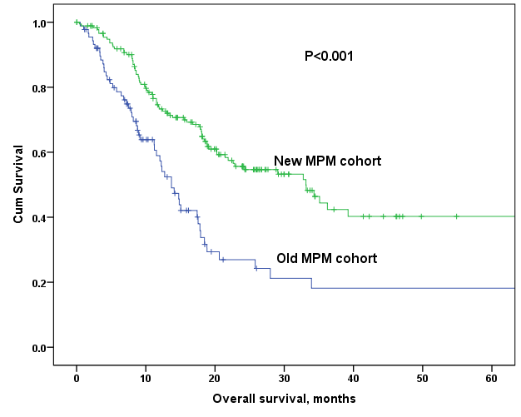

Refrences:
1- Bueno, R. Multimodality treatments in the management of malignant pleural mesothelioma: an update. Hematol. Oncol. Clin. North Am. 19, 1089–1097, vii (2005).
2- Rudd, R. Asbestos and the lung. Medicine 36, 261–264 (2008).
3- Carbone, M. et al. Malignant mesothelioma: facts, myths, and hypotheses. J. Cell. Physiol. 227, 44–58 (2012).
4- Frank, A.L. & Joshi, T.K. The global spread of asbestos. Ann. Glob. Health 80, 257–262 (2014).

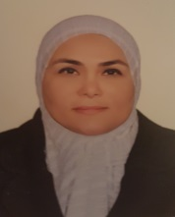
Paste your university/ org anization Logo here

Biography (150 word limit)
Fatma Abouelkasem has expertise in lung cancer especially malignant pleural mesothelioma. She has many published papers in lung cancer. She is a member of Thoracic Committee at National Cancer Institute , Cairo University, Egypt. She is a member of Egyptian Socity of Respiratory Neoplasms. And she is a reviewer in Asian Pacific Journal of Cancer prevention (APJCP).

Email: fatmakassem@yahoo.com

Notes/Comments:

