Title: The nuclear receptor FXR in different diseases
Name: Wei-Dong Chen
Henan University, Kaifeng, P. R. China

Abstract (300 word limit)
The farnesoid X receptor (FXR) is a key metabolic and homeostatic regulator in digestion system. Our publication has shown that bile acid nuclear receptor FXR is required for the promotion of liver regeneration/repair after physical resection or liver injury, and FXR is a key negative regulator in chronic inflammation and liver carcinogenesis. We found that defective activation of FXR could be an intrinsic defect in aging regenerating livers, and other transcription factors are present as constituents of the multi-protein-DNA complex at the IR-0 element in intron 3 of Foxm1b In liver carcinogenesis, we identified a novel role of FXR in antagonizing c-Jun N-terminal kinase (JNK) signaling pathway by activating SOD3 transcription. FXR may regulate SOD3 expression to suppress ROS production, resulting in decreasing JNK activity. The results highlight FXR as a potential target for drug design for prevention and treatment of liver cancer and insufficient liver regeneration after segmental liver transplantation or resection, which may also have potential implications for treatment of other age-related diseases. In recent days, we found that FXR activation suppresses cervical cancer and ovarian cancer cell proliferation and induces cancer cell apoptosis (unpublished data). These findings identify FXR as a negative mediator not only for digestive system cancers but also reproductive system cancers that may serve as an attractive therapeutic tool for human different cancers.

Image
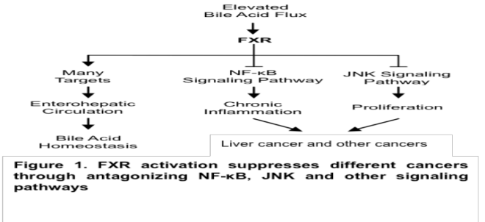
Recent Publications
- Lv SY, Cui B, Yang Y, Du H, Zhang X, Zhou Y, Ye W, Nie X, Li Y, Wang Q, Chen WD, Wang YD. Spexin/NPQ Induces FBJ Osteosarcoma Oncogene (Fos) and Produces Antinociceptive Effect against Inflammatory Pain in the Mouse Model. Am J Pathol. 2019 Apr;189(4):886-899. doi: 10.1016/j.ajpath.2018.12.009. Epub 2019 Jan 19
- Feng Q, Chen WD, Wang YD. Gut Microbiota: An Integral Moderator in Health and Disease. Front Microbiol. 2018 Feb 21;9:151. doi: 10.3389/fmicb.2018.00151. eCollection 2018. Review.
- Wang YD, Chen WD, Li C, Guo C, Li Y, Qi H, Shen H, Kong J, Long X, Yuan F, Wang X, Huang W. Farnesoid X receptor antagonizes JNK signaling pathway in liver carcinogenesis by activating SOD3. Mol Endocrinol. 2015 Feb;29(2):322-31. doi: 10.1210/me.2014-1225. Epub 2014 Dec 12.
- Chen WD, Fu X, Dong B, Wang YD, Shiah S, Moore DD, Huang W.Neonatal activation of the nuclear receptor CAR results in epigenetic memory and permanent change of drug metabolism in mouse liver. Hepatology. 2012 Oct;56(4):1499-509. doi: 10.1002/hep.25766.
- Chen WD, Wang YD, Zhang L, Shiah S, Wang M, Yang F, Yu D, Forman BM, Huang W. Farnesoid X receptor alleviates age-related proliferation defects in regenerating mouse livers by activating forkhead box m1b transcription. Hepatology. 2010 Mar;51(3):953-62.

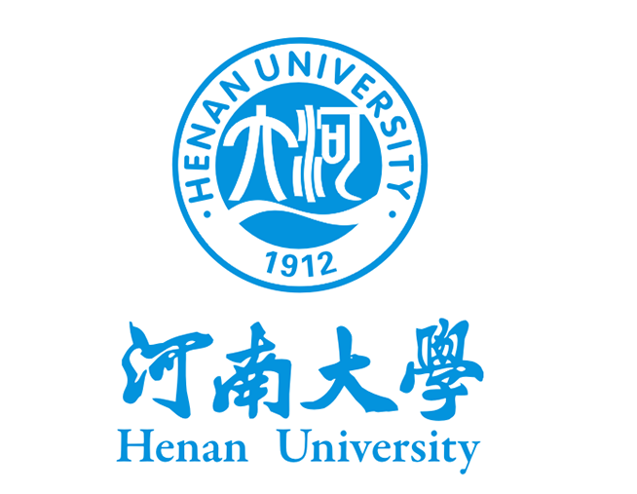
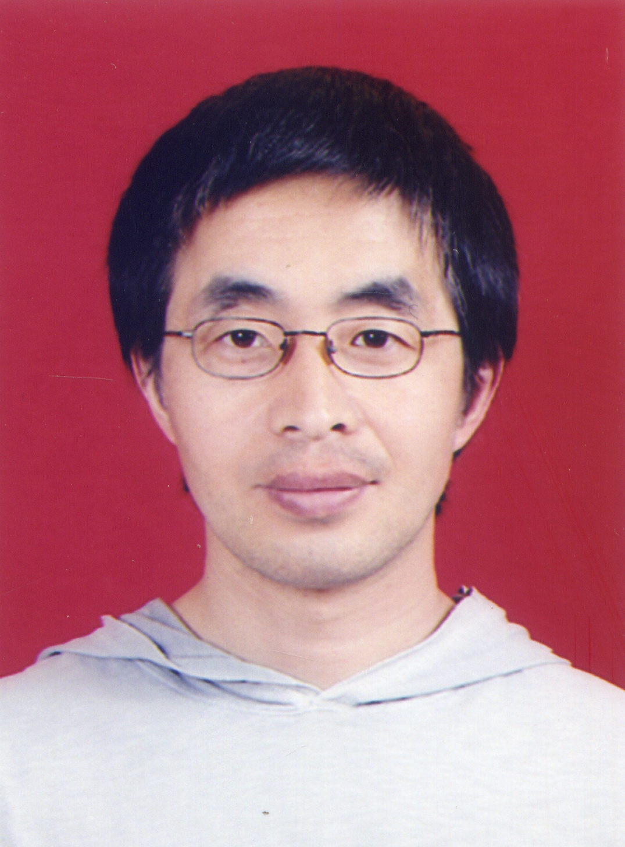
Paste your university/ organization Logo here

Biography (150 word limit)
Dr. Wei-Dong Chen is currently working as a professor at the School of Medicine, head of Key Laboratory of Receptor-Mediated Gene Regulation and Drug Discovery, Henan University in P. R. China. Dr. Chen received his PhD from Tianjin University in P.R. China in 2002. He then worked at the GSF in Germany and Beckman Research Institute, City of Hope National Medical Center in USA. Then he served as Professor at Henan University. Dr. Chen has authored several publications in various journals and books. His publications reflect his research interests in nuclear receptor functions in different diseases. Dr. Chen is awarded by “Millions of Talent Projects National candidates” in China.
Email: wdchen666@163.com

Notes/Comments:

