Comparison of 3DCRT, IMRT sliding window, VMAT techniques in radiotherapy treatments of distal esophageal cancer
Name: Lecio Leonardo Luvezuti
National Institute of Cancer, Brazil.

Abstract
The objective of this study was to compare three techniques of radiotherapy treatments, with correction of heterogeneities, in seven patients diagnosed with distal esophageal cancer: IMRT with seven co-planar fields evenly distributed at equal intervals, VMAT composed of two arcs of 359.8º and 3DCRT with four co-planar fields (two antero-posterior and two oblique). This study is retrospective and evaluated the treatments regarding PTV coverage, Paddick conformity index, monitor units, heterogeneity index and dose-volume parameters in organs at risk. The IMRT and VMAT plans reduced the irradiated lung volume with the 20 Gy dose (${V_{20}}^{lung}$) and, consequently, the mean dose in the lung ( ${\overline{D_{lung}}}^{}$). The mean reductions with the IMRT and VMAT techniques in relation to 3DCRT for ${V_{20}}^{lung}$ were, respectively, 5.69% and 5.72%. Regarding the parameter ${\overline{D_{lung}}}^{}$, the reduction was of 1.59 Gy and 1.26 Gy, respectively. The IMRT and VMAT techniques also showed better dose conformity values in the target volume. There was a significant dose reduction in critical organs (spinal cord and heart) in relation to 3DCRT plans. Thus, the lung volume exposed to radiation can be reduced with IMRT and VMAT and the dose prescribed and the dose prescribed for this type of treatment can be escalated, but future clinical studies that confirm this hyphothesis are still necessary.

Image
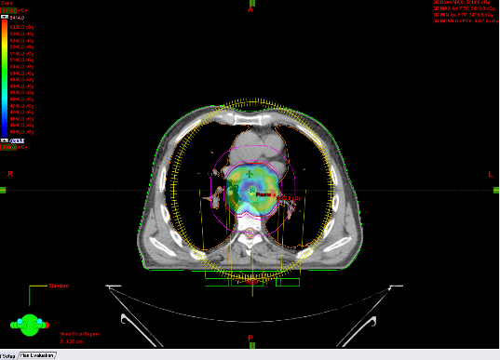

Figure 12: Ilustration showing fields arrangement (two opposing co-planar arcs) used in VMAT technique.
Recent Publications
- Nutting C.M. et al. (2001) A comparison of conformal and intensity modulated techniques for esophageal radiotherapy. Radiotherapy e Oncology 61: 157-63.
- Barret A, et al (2009) Practical Radiotherapy Planning, 4th edition. Hodder Arnold, London.
365: 519-530.
- RTOG 0436 (2011) Phase III trial evaluating the addition of CETUXIMAB to PACLITAXEL, CISPLATIN and radiation for patients with esophageal cancer who are treated without surgery. San Francisco.
- Chandra A, et al. (2005) Feasibility of using intensity modulated radiotherapy to improve lung sparing in treatment planning for distal esophageal cancer. Radiotherapy and Oncology 77: 247-253.
- Wu V, Sham J, Kwong D (2004) Inverse Planning in three dimensional conformal and intensity modulated radiotherapy of midthoracic esophageal cancer. Br J Radiol 77: 568-72


e rsity/ organization Log o here
Biography (150 word limit)
Lecio Luvezuti is a medical physicist who has been working on the field of radiotherapy for almost 4 years in Curitiba, Brazil. The work presented here is a term paper he developed for his residency program at National Institute of Cancer in Rio de Janeiro, Brazil. Through this study, we intend to establish strategies to be adopted in modulated techniques for esophageal cancer, besides obtaining preliminary results to delineate future clinical studies
Email: lecioluvezuti@hotmail.com

Notes/Comments:

