Predictive Value of PKM2 Expression in Advanced Non-Small Cell Lung Cancer Patients (NSCLC) Treated With Front-line Platinum-based Chemotherapy
Mohamed Sheta¹, MD, Omnia Abd –El-Fattah¹,MD and Hanan A. Alshenawy², MD

¹ Department of Clinical Oncology, ²Department of Histopathology, Tanta University Hospital, Tanta, Egypt
Mohamed_sheta1@yahoo.com

ABSTRACT
Background: The aim of the study was, to assess the expression of PKM2 in advanced NSCLC patients treated with front-line platinum-based chemotherapy and analyze its predictive value on both progression free and overall survival.
Methods: 72 cases with histologically confirmed stage IIIB and IV NSCLC who were treated with front-line platinum-based chemotherapy. Thirty two NSCLC patients were treated with front-line non-platinum-based doublets were enrolled in this study (as control), Immunohistochemical staining for PKM2 was evaluated.
Results: in Platinum group the median OS was 7 vs 19 months; P ˂ 0.001 for those patients with high compared to those with low expression respectively and the median PFS was 5 vs 9 months; P ˂ 0.001 for those patient with high PKM2 expression compared to those with low expression respectively. In control group there was no significant difference between high and low PKM2 expression as regard median OS (9 vs 10 months; P =˂ 0.451) and median PFS (7 vs 8 months; P = 0.638).
Conclusions: Our study proved that PKM2 expression may be a predictive biomarker of platinum sensitivity in advanced NSCLC patients treated with platinum-based chemotherapy.

INTRODUCTION
More than 220,000 new cases of lung cancer are expected to be diagnosed in 2015 while over158,000 people are expected to die from lung cancer that same year.¹
Non-small cell lung cancer (NSCLC) patients account for more than 80 % of those with lung cancers.²
Approximately fifty percent of patients diagnosed with nsclc present with advanced disease (stage iii or iv).³
Systemic platinum-based chemotherapy remains the mainstay for the treatment of advanced NSCLC as it improves symptom control, quality of life and survival compared to best supportive care.⁴
The 5-year survival of advanced NSCLC with current standard treatment is approximately 10–15% highlighting a real urgency to improve outcome for these patients.²
Over the last years growing evidence, from gene expression, mutational and proteomic profiling studies, led to the identification of molecular markers related with resistance to platinum analogs the role of pyruvate kinase isoform M2 (PKM2) in resistance to platinum analogs is under extensive investigation.⁵
Compared to normal tissue, most tumors have increased glucose utilization. In cancer cells, there are increased glucose consumption rates and high lactate production in the presence of oxygen, which is known as aerobic glycolysis (the Warburg effect), of which pyruvate kinase (PK) is considered as the main regulator. PK is a key rate-limiting enzyme that catalyzes the final step of glycolysis, converting phosphoenolpyruvate to pyruvate while phosphorylating adenosine diphosphate (ADP) to adenosine triphosphate (ATP).⁶ Also, this enzyme is involved in a variety of pathways, protein–protein interactions, and nuclear transport indicates its importance to perform multiple nonglycolytic functions with diverse implications, although multidimensional role of this protein is as yet not fully explored.⁷
In the present study, we assessed the expression of PKM2 in advanced NSCLC patients treated with front-line platinum-based chemotherapy and analyze its predictive value on both progression free and overall survival.
PATIENTS AND METHODS
This prospective study was carried out on seventy two cases with histologically confirmed stage IIIB and IV NSCLC who were treated with front-line platinum-based chemotherapy. Thirty two NSCLC patients were treated with front-line non-platinum-based doublets were enrolled in this study (as control)
All patients were treated and followed up at Clinical Oncology Departments, Tanta university hospital during the period from December 2013 to April 2016. Written, informed consent was obtained from each patient before enrollment into the study. Patients had to have an Eastern Cooperative Oncology Group (ECOG) performance status (PS) of 0-2; ⁸ with adequate organ functions and baseline imaging studies were done.
Histopahological examination
A total of 72 specimens of formalin-fixed, paraffin-embedded lung masses were analyzed. Cases were classified histologically after staining with H&E staining according to the recent WHO classification and grading.⁹
The study included 18 cases of squamous cell carcinoma, 43 cases of adenocarcinoma, 11 cases of large cell carcinoma. The cases were graded into grade 1, 2 and 3. Then clinicopathologic stage was determined according to the TNM classification system of the International Union against Cancer.¹⁰
Immunohistochemical staining for PKM2 and its evaluation
For the study, 4-μm-thick serial sections of formalin fixed, paraffin-embedded tissue were cut and mounted on po positively charged glass slides. After incubation at 60°C overnight and deparaffinization, the tissue sections subjected heat retrieval for 20 minutes with Tris-EDTA buffer (Thermo Fisher Scientific, Waltham, MA). Polyclonal rabbit anti-human PKM2 antibody (PKM2 (H-60), 1:50, Santa Cruz Biotechnology, Santa Cruz, CA). The standard avidin-biotin peroxidase complex (ABC) technique was performed using the LabVision Secondary Detection Kit (UltraVision Detection System Anti-polyvalent, HRP). The color was visualized by incubation with chromogen 3,3' diaminobenzidine for 5 minutes. The slides were then counterstained with Mayer hematoxylin and cover slipped with Permount (StatLab, McKinney, TX). Negative controls were set for each test without the primary antibodies. Positive control was done using the adjacent normal lung tissue in 10 cases. Results were expressed semi quantitatively. Saturation and intensity of immunostained cells was evaluated over 8 visual fields at a power of ×400 under a light microscope (Olympus Optical, Tokyo, Japan). Total staining of PKM2 was scored as the product of the staining intensity (on a scale of 0–3: negative = 0, weak = 1, moderate = 2, strong = 3) × the percentage of cells stained (positively recorded on an ordered categorical scale: 0 = zero, 1 = 1–25%, 2 = 26–50%, 3 = 51–100%), which resulted in a scale of 0–9. In correlation analysis, the survival data of patients were classified as low (0–4) and high (>4) expression of PKM2.¹¹
Statistical Considerations
The data were analyzed using SPSS 21.0 software package The correlation of PKM2 expression with different clinicopathologic characteristics was analyzed with chisquare test. The Kaplan–Meier method and Log-rank test were used to analyze the correlation of patient survival with PKM2 expression. Overall-survival was defined as the time from diagnosis to the date of death from any cause or last follow-up. progression-free survival (PFS), which was defined as the time from study to documented disease progression or death. A significance level of P < 0.05 was used

RESULTS
Histopathological and immunohistochemical results:
The study included 17 squamous cell carcinoma, 43 cases of adenocarcinoma, 12 large cell carcinoma with variable grades ranged from 1-3 and variable stage (fig 2a-7a)
Regarding PKM2 expression, in normal lung tissue which acts as a control, all the 10 cases showed low expression (Fig 1) while in the studied tumourous cases, it was showed variable expression values (Fig 2-7). In squamous cell carcinoma cases, there were no significant correlation between the grade of the tumour and PKM2 expression while this correlation was statistically significant in adenocarcinoma and large cell carcinoma as its expression increase in high grade tumours. Table ( 1 ).

a | 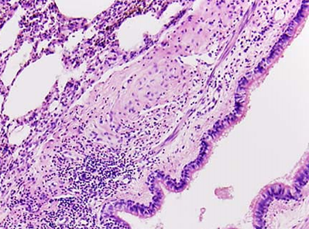 | b | 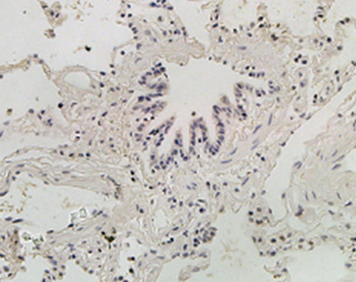
Fig 1. Normal lung tissue showing normal lining epithelial cells in the bronchioles and the alveoli (a) it showed weak expression of PKM2 in the epithelial cells (b) [x200]

a | 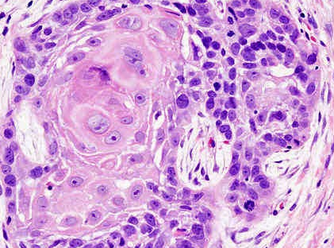 | b | 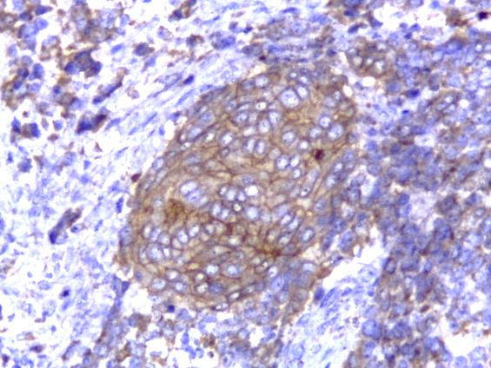
Fig 2. A case of squamous cell carcinoma grade II (a) showing low expression of PKM2 (b) (score 4). [x400]

a | 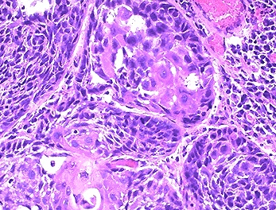 | b | 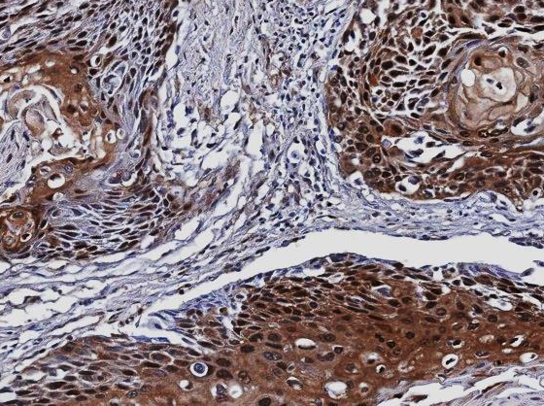
Fig 3. a case of squamous cell carcinoma grade II (a) showing high expression of PKM2 (b) (score 6). [x400]

a | 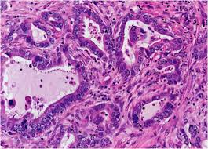 | b | 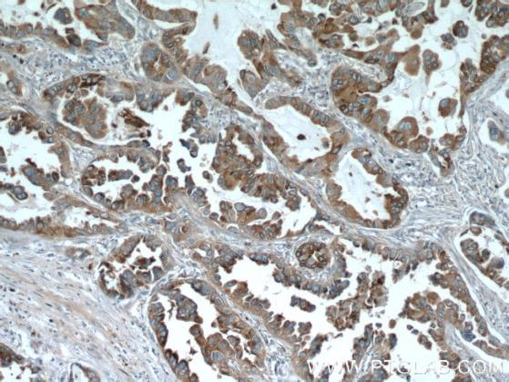
Fig 4. a case of adenocarcinoma grade II (a) showing low expression of PKM2 (b) (score 4). [x400]

a | 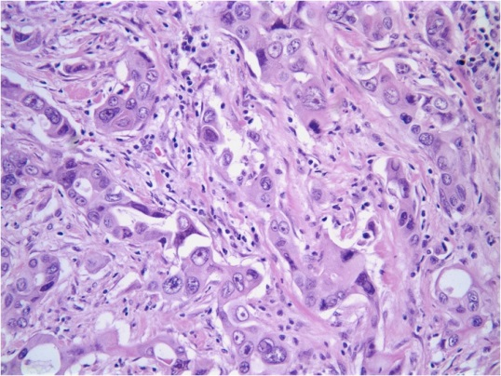 | b | 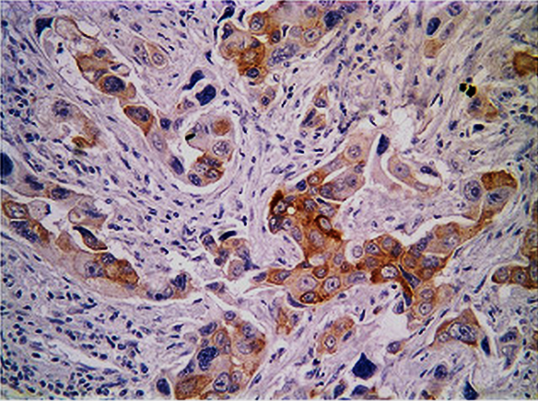
Fig 5. a case of adenocarcinoma grade III (a) showing high expression of PKM2 (b) (score 7). [x400]

a | 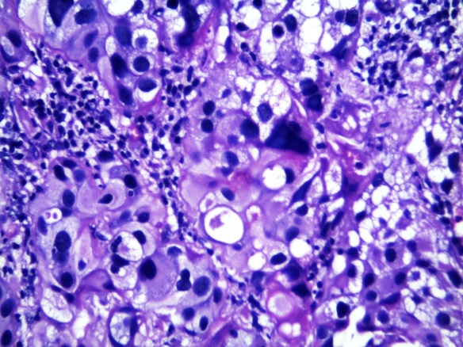 | b | 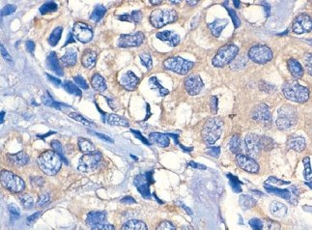
Fig 6. a case of large cell carcinoma grade III (a) showing low expression of PKM2 (b) (score 3). [x400]

a | 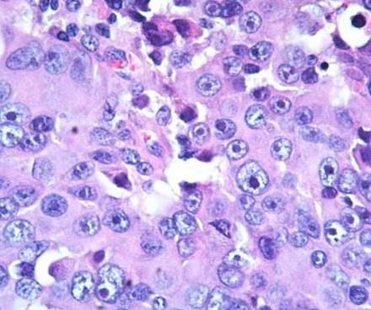 | b | 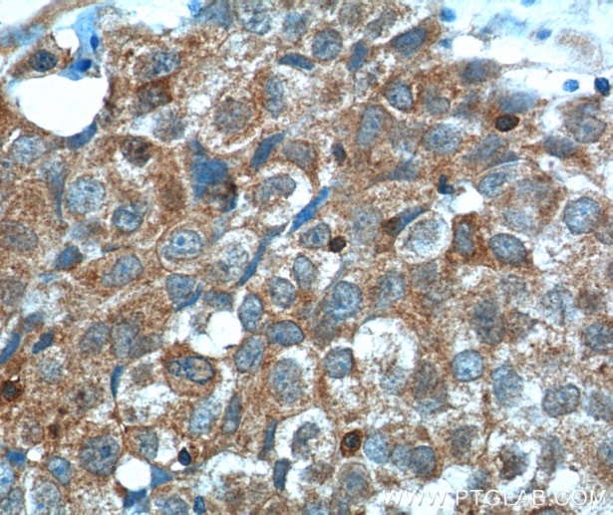
Fig 7. a case of large cell carcinoma grade III (a) showing high expression of PKM2 (b) (score 8). [x400]

Table 1. Correlation between the grade and PKM2 expression in the studied cases
Studied cases |  | PKM2 expression |  | P
 |  | Low | High | P
Squamous cell carcinoma n=17 | Grade1 Grade2  Grade3 | 3  5  5 | 0  2  2 | 0.12
Adenocarcinoma n=43 | Grade1 Grade2  Grade3 | 1  17  8 | 3  4  10 | 0.03*
Large cell carcinoma n=12 | Grade1 Grade2  Grade3 | 0  1  1 | 0  1  9 | 0.001*
Abbreviations: n denotes patient number *P ˂ 0.05.

Patient and tumors characteristics:
Patient and tumors characteristics are summarized in Table 2. The mean age was 63.5 and 62.7 years for the Platinum group and the control group respectively. Most patients in both groups were males received their treatment in Clinical Oncology department, Tanta University Hospital. In both groups more than two third of the lesions were non- squamous and the rest were squamous cell carcinoma. Tumor grades 3 represented in 48.6% and 46.9% of the patients in Platinum group and the control group respectively. Performance status 0-1 by ECOG scale represented in approximately half of the patients in both groups. PKM2 expression was low in one half of the patients and high in the other half in both groups.

Table 2. Patient and tumors characteristics
Control group (N = 32) |  |  | Platinum group (N = 72)
% |  | No. | % |  | No. | Characteristics
 | 62.7 |  |  | 63.5 |  | Mean age, years
 | 11.11 |  |  | 10.50 |  | SD
 | 39-74 |  |  | 34-74 |  | Range
 |  |  |  |  |  | Gender
62.5 |  | 20 | 77.8 |  | 56 | Male
37.5 |  | 12 | 22.2 |  | 16 | Female
 |  |  |  |  |  | ECOG Performance status
53.1 |  | 17 | 47.2 |  | 34 | 0-1
46.9 |  | 15 | 52.8 |  | 38 | 2
 |  |  |  |  |  | Histological types
15.6 |  | 5 | 23.6 |  | 17 | Squamous cell carcinoma
84.4 |  | 27 | 76.4 |  | 55 | Non- Squamous cell carcinoma
 |  |  |  |  |  | Tumor grade
53.1 |  | 17 | 51.4 |  | 37 | G1-2
46.9 |  | 15 | 48.6 |  | 35 | G3
 |  |  |  |  |  | Treatment regimens
NA |  |  | 75 |  | 54 | Platinum + docetaxel
NA |  |  | 15.3 |  | 11 | Platinum + gemcitabine
NA |  |  | 9.7 |  | 7 | Platinum + docetaxel + Avastin
100 |  | 32 | NA |  |  | Docetaxel + gemcitabine
78.1 |  | 25 | 72.2 |  | 52 | Post-progression treatment
 |  |  |  |  |  | PKM2 expression
50 |  | 16 | 50 |  | 36 | Low
50 |  | 16 | 50 |  | 36 | High
Abbreviations: SD = Standard Deviation; NA = not applicable.

Survival analysis:
Kaplan-Meier analyzes were also conducted the overall survival and progression free survival curves for PKM2 expression in both groups and presented in Figure 8 and 9 respectively where in Platinum group the median OS was 7 vs 19 months; P ˂ 0.001 for those patient with high compared to those with low expression respectively and the median PFS was 5 vs 9 months; P ˂ 0.001 for those patient with high PKM2 expression compared to those with low expression respectively. In control group there was no significant difference between high and low PKM2 expression as regard median OS (9 vs 10 months; P =˂ 0.451) and median PFS (7 vs 8 months; P = 0.638).
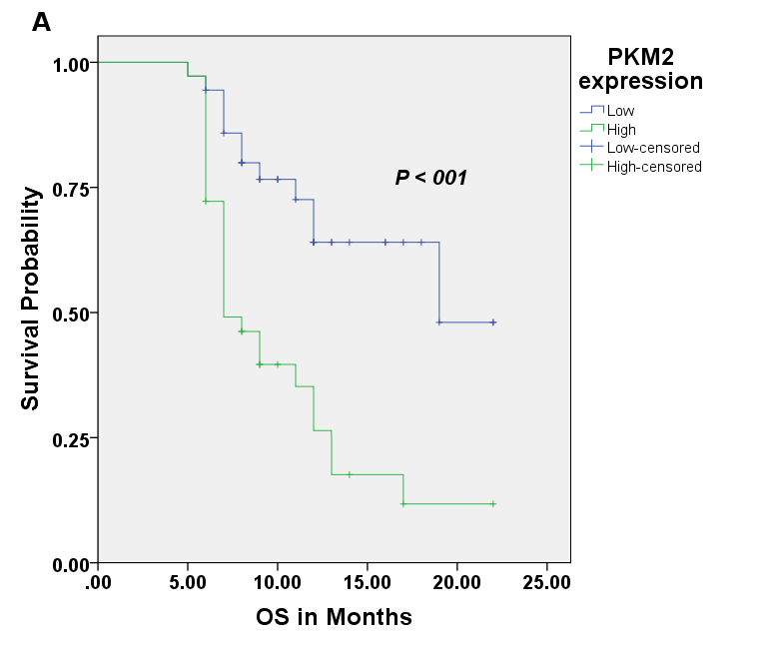 | 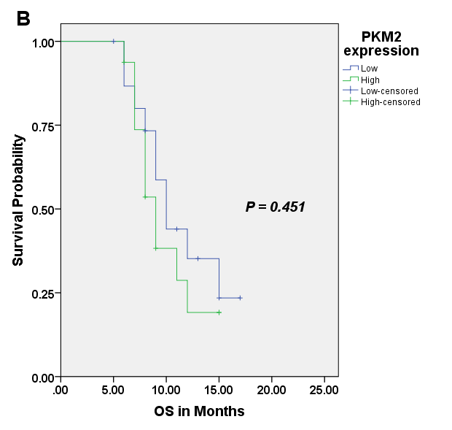
Figure 8. (A) Overall survival curve for PKM2 expression in Platinum group. (B) Overall survival curve for PKM2 expression in control group.

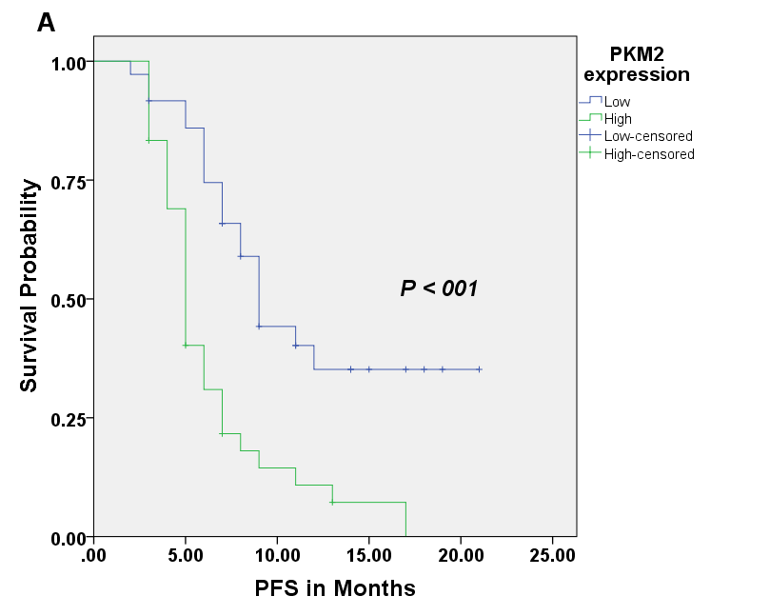 | 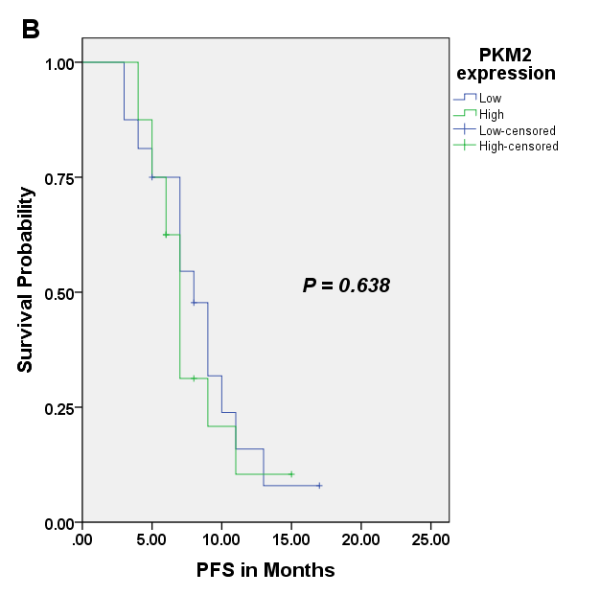
Figure 9. (A) Progression free survival for PKM2 expression in Platinum group. (B) Progression free survival for PKM2 expression in control group.

Variables found to be strongly significant (P˂ 0.05) with overall survival and progression free survival in the univariate Cox proportional hazards regression analyzes included age, performance status and PKM2 expression, while other was no survival significant relationship with sex, tumor grades and histological types as showed in tables 3 and 4 respectively.

Table 3. Overall survival and Univariate Hazard Ratios From Cox Proportional Hazards
Variable | Overall survival | HR | 95% CI | P
Age  >70 vs  ≤70 | 22.5%  42.8% | 2.80 | 1.31 to 5.98 | 0.008*
Sex  Female vs  Male | 48.0%  24.6% | 0.63 | 0.28 to 1.44 | 0.272
Performance status  2 vs  0-1 | 0.00%65.3% | 4.11 | 1.98 to 8.53 | ˂ 0.001*
Histological types |  | 0.96 0.47 to 1.94 0.901
Non- Squamous vs | 38.1%
Squamous | 24.4%
Tumor grade G3 vs  G1-2 | 27.6%  34.4% | 1.90 | 1.00 to 3.64 | 0.052
PKM2 expression  High vs  Low | 11.7%  48.0% | 3.29 | 1.65 to 6.54 | 0.001*
Abbreviations: CI denotes confidence interval; HR denotes hazard ratio
*P ˂ 0.05.

Table 4. Progression free survival and Univariate Hazard Ratios From Cox Proportional Hazards
Variable | Progression free survival | HR | 95% CI | P
Age  >70 vs  ≤70 | 06.5%  36.2% | 2.42 | 1.30 to 4.51 | 0.005*
Sex  Female vs  Male | 21.9%  15.2% | 0.89 | 0.47 to 1.70 | 0.729
Performance status  2 vs  0-1 | 00.0%  33.8% | 3.09 | 1.70 to 5.62 | ˂ 0.001*
Histological types |  | 0.92 0.50 to 1.70 0.789
Non- Squamous vs | 23.1%
Squamous | 08.3%
Tumor grade G3 vs  G1-2 | 17.5%  18.5% | 1.50 | 0.87 to 2.61 | 0.148
PKM2 expression  High vs  Low | 00.0%  35.2% | 2.91 | 1.64 to 5.15 | ˂ 0.001*
Abbreviations: CI denotes confidence interval; HR denotes hazard ratio
*P ˂ 0.05.

Table 5 summarizes multivariate hazard ratios and 95% CIs for OS for the variables that were significant in univariate analysis where performance status (hazard ratio [HR]: 2.77, 95% CI: 1.27- 6.06; P= 0.011) and PKM2 expression (hazard ratio [HR]: 2.24, 95% CI: 1.09- 4.58; P= 0.027) were significant and they represented as an independent predictive factors for OS.
.

Table 5. Multivariate Hazard Ratios From Cox Proportional Hazards for OS
Variable | Hazard Ratio | 95% CI | P
Age (>70 vs ≤70 years) | 1.80 | 0.82 to 3.97 | 0.146
Performance status (2 vs 0-1) | 2.77 | 1.27 to 6.06 | 0.011*
PKM2 expression (high vs low) | 2.24 | 1.09 to 4.58 | 0.027*
Abbreviations: CI denotes confidence interval; HR denotes hazard ratio.
*P ˂ 0.05.

Table 6 summarizes multivariate hazard ratios and 95% CIs for PFS for the variables that were significant in univariate analysis where performance status (hazard ratio [HR]: 2.06, 95% CI: 1.07- 3.96; P= 0.031) and PKM2 expression (hazard ratio [HR]: 2.24, 95% CI: 1.17- 3.91; P= 0.014) were significant and they represented as an independent predictive factors for OS.

Table 6. Multivariate Hazard Ratios From Cox Proportional Hazards for PFS
Variable | Hazard Ratio | 95% CI | P
Age (>70 vs ≤70 years) | 1.73 | 0.90 to 3.34 | 0.103
Performance status (2 vs 0-1) | 2.06 | 1.07 to 3.96 | 0.031*
PKM2 expression (high vs low) | 2.14 | 1.17 to 3.91 | 0.014*
Abbreviations: CI denotes confidence interval; HR denotes hazard ratio.
*P ˂ 0.05.

DISCUSSION

In general, systemic therapy is recommended for patients with metastatic disease.¹² Patients with stage IV disease with good performance status benefit from chemotherapy, usually with a platinum-based regimen.^{13,14}

PKM2 is an isoenzyme of the glycolytic enzyme pyruvate kinase and is expressed in some differentiated tissues, such as lung,¹⁵ and in all cells with a high rate of nucleic acid synthesis, such as normal proliferating cells, embryonic cells, and especially tumor cells.¹⁶

Pyruvate kinase catalyzes the last step within glycolysis, the dephosphorylation of phosphoenolpyruvate to pyruvate, and is responsible for net ATP production within the glycolytic sequence. In contrast to mitochondrial respiration, energy regeneration by pyruvate kinase is independent from oxygen supply and allows survival of the organs under hypoxic conditions found in solid tumors.¹⁷ , although multiple role of this protein is as yet not fully recognized.⁷ However, a functional role in angiogenesis the so-called process of blood vessel formation by interaction and regulation of Jmjd8 has been shown.¹⁸
PKM2 exists in vivo in two forms, dimers and tetramers. In normal cells, PKM2 mainly exists in the tetramer form while in cancer cells it mainly exists as dimers.¹⁹
When PKM2 is in the less active dimeric form, which is the case in tumor cells, all glycolytic intermediates above pyruvate kinase accumulate and are involved into synthetic processes, which branch off from glycolytic intermediates such as nucleic acid-, phospholipid-, and amino acid synthesis. Nucleic acids, phospholipids, and amino acids are important cell building-blocks, which are greatly needed by highly proliferating cells, such as tumor cells, ²⁰ and PKM2 was found to be required for the proliferation and survival of some tumors in vivo.²¹
In our study we assess the expression of PKM2 in advanced NSCLC patients treated with front-line platinum-based chemotherapy and analyze its predictive value on both progression free and overall survival and we observed that patients with low levels of PKM2 expression had significantly better PFS and OS (P˂ 0.001) than patients with high levels of PKM2 expression. Unlike the results in the platinum group , in the control group of 32 patients, who received regimens not containing platinum, there was no significant difference between those patients with low and high levels of PKM2 expression as regard PFS (P=0.638) and OS (P=0.451). Moreover multivariate analysis revealed that high PKM2 expression was an independent predictive factor for shorter PFS and decreased OS in platinum group.

Consistent with our findings, Papadaki et al reported that PKM2 expression was predictive for response to platinum-based regimens, with higher response rate in patients with low PKM2 levels while high PKM2 expression predicted for shorter survival.⁴ Also, Karachaliou et al demonstrated that limited-stage small cell lung cancer patients with high expression of PKM2 had shorter median PFS (P=0.046) and OS (P=0.026).⁵

In contrast to our finding, Yoo et al reported that PKM2 was identified as a protein that showing lower expression in cisplatin-resistant cells in human gastric carcinoma.²²
In correlation to our finding, Multiple studies have shown that interfering with PKM2 expression with shRNA and miRNA can both lead to cell apoptosis, reduced metabolic activity, and decreased tumorigenicity.^{23, 24} Other studies have shown that interfering PKM2 expression with shRNA can increase the sensitivity of cancer cells to docetaxel and cisplatin, thus promoting cell apoptosis and decreasing tumorigenicity.^{25, 26} Also Benjamin et al. study concluded that PKM2 knockdown impaired glioma cell metabolism, with decreased glutathione and ATP levels and accelerated activation of AMP-activated protein kinase. Since PKM2 is expressed in glioma cells and is important for their survival, but is lacking in the normal brain, its manipulation may serve as a brain-sparing therapy for glioblastoma.²⁴ From this study inhibition of PKM2 may decrease glutathione level and one of the mechanisms explain resistance of tumor cells to cisplatin is increased glutathione.²⁷ So, PKM2 may play indirect role in tumor cells resistance to platinum agents.²⁸
Steven et al, study the role of PKM2 activator in treatment of cancer as pyruvate kinase converts phosphoenolpyruvate to pyruvate, catalyzing the rate-limiting step of glycolysis. The M1 isoenzyme of pyruvate kinase (PKM1) is found in adult tissues; whereas, PKM2 is another variant found in embryonic and cancer cells. PKM2 expresed in malignant cells is a result of the tumor microenvironment and is responsible for maintaining a glycolytic phenotype. PKM2 has other nonmetabolic functions in malignant cells, including transcriptional coactivation and protein kinase activity. PKM2 activators have antitumor effects by inducing tetramerization of two PKM2 dimers causing PKM2 to function like PKM1. PKM2 activators have therapeutic potential in the treatment of cancer and other metabolic diseases.²⁹
Our study proved that PKM2 expression may be a predictive biomarker of platinum sensitivity in advanced NSCLC patients treated with platinum-based chemotherapy.

CONFLICT OF INTEREST
The authors declared that there is no potential conflict of interest.
REFERENCES
- Scarpace SL. Metastatic squamous cell non-small-cell lung cancer (NSCLC): disrupting the drug treatment paradigm with immunotherapies. Drugs Context. 2015 Oct 14;4:212-289.
- Zhang L, Xu Y, Shen J, et al..Feasibility study of DCs/CIKs combined with thoracic radiotherapy for patients with locally advanced or metastatic non-small-cell lung cancer. Radiat Oncol. 2016;11(1):60.
- Tsvetkova E, Goss GD. Drug resistance and its significance for treatment decisions in non-small-cell lung cancer. Curr Oncol. 2012;19(1):45-51.
- Papadaki C, Sfakianaki M, Lagoudaki E, et al. PKM2 as a biomarker for chemosensitivity to front-line platinum-based chemotherapy in patients with metastatic non-small-cell lung cancer. Br J Cancer. 2014;111:1757-1764.
- Karachaliou N, Papadaki C, Lagoudaki E, Trypaki M, Sfakianaki M, et al.Predictive value of BRCA1, ERCC1, ATP7B, PKM2, TOPOI, TOPΟ-IIA, TOPOIIB and C-MYC genes in patients with small cell lung cancer (SCLC) who received first line therapy with cisplatin and etoposide. PLoS One. 2013;8(9):e74611.
- Huang L, Yu Z, Zhang Z, et al. Interaction with Pyruvate Kinase M2 Destabilizes Tristetraprolin by Proteasome Degradation and Regulates Cell Proliferation in Breast Cancer. Sci Rep. 2016;6:224-49.
- Gupta V, Bamezai RN. "Human pyruvate kinase M2: a multifunctional protein". Protein Science.2010;19 (11): 2031–44.
- Oken M, Creech R, Tormey D, et al. Toxicity and response criteria of the Eastern Cooperative Oncology Group. Am J Clin Oncol. 1982;5:649-655.
- Petersen I, Warth A: Lung cancer: developments, concepts, and specific aspects of the new WHO classification. J Cancer Res Clin Oncol. 2016;142(5):895-904.).
- Wrona A, Jassem J: The new TNM classification in lung cancer. Pneumonol Alergol Pol. 2010;78(6):407-17.
- Xing-chen Peng, Feng-ming Gong, Yu-wei Zhao, et al. Comparative Proteomic Approach Identifies Pkm2 and Cofilin-1 as Potential Diagnostic, Prognostic and Therapeutic Targets for Pulmonary Adenocarcinoma. PLoS One. 2011; 6(11): e27309.
- Masters GA, Temin S, Azzoli CG, et al. Systemic Therapy for Stage IV Non-Small-Cell Lung Cancer: American Society of Clinical Oncology Clinical Practice Guideline Update. J Clin Oncol. 2015;33:3488-3515.
- Azzoli CG, Baker S Jr, Temin S, et al. American Society of Clinical Oncology Clinical Practice Guideline update on chemotherapy for stage IV non-small-cell lung cancer. J Clin Oncol. 2009; 27(36):6251-6266.
- Group NM-AC.Chemotherapy in addition to supportive care improves survival in advanced non-small-cell lung cancer: a systematic review and meta-analysis of individual patient data from 16 randomized controlled trials. J Clin Oncol 2008;26:4617-4625.
- Corcoran E, Phelan JJ, Fottrell PF (Sep). "Purification and properties of pyruvate kinase from human lung". Biochimica et Biophysica Acta. 1976; 446 (1): 96–104.
- Reinacher M, Eigenbrodt E (1981). "Immunohistological demonstration of the same type of pyruvate kinase isoenzyme (M2-Pk) in tumors of chicken and rat". Virchows Archiv B 37 (1): 79–88.
- Vaupel P, Harrison L. "Tumor hypoxia: causative factors, compensatory mechanisms, and cellular response". The Oncologist. 2004; 9 Suppl 5: 4–9.
- Boeckel JN, Dimmeler S. "JMJD8 Regulates Angiogenic Sprouting and Cellular Metabolism by Interacting With Pyruvate Kinase M2 in Endothelial Cells". Arteriosclerosis Thrombosis and Vascular Biology. 2016; Epub ahead of print. doi:10.1161/ATVBAHA.116.307695.
- Mazurek S. Pyruvate kinase type M2: a key regulator of the metabolic budget system in tumor cells. Int J Biochem Cell Biol 2011;43:969-980.
- Mazurek S, Boschek CB, Hugo F, Eigenbrodt E. "Pyruvate kinase type M2 and its role in tumor growth and spreading". Seminars in Cancer Biology 2005;15 (4): 300–8.
- Christofk HR, Vander Heiden MG, Harris MH, Ramanathan A, Gerszten RE, Wei R, et al. The M2 splice isoform of pyruvate kinase is important for cancer metabolism and tumour growth. Nature. 2008;452:230–233.
- Yoo BC, Ku JL, Hong SH, et al. Decreased pyruvate kinase M2 activity linked to cisplatin resistance in human gastric carcinoma cell lines. Int J Cancer. 2004;108:532-539.
- Christofk HR, Vander Heiden MG, Wu N, Asara JM, Cantley LC. Pyruvate kinase M2 is a phosphotyrosine-binding protein. Nature 2008;452:181-186.
- Kefas B, Comeau L, Erdle N, Montgomery E, Amos S, Purow B. Pyruvate kinase M2 is a target of the tumor-suppressive microRNA-326 and regulates the survival of glioma cells. Neuro Oncol 2010;12:1102-1112.
- Shi HS, Li D, Zhang J, Wang YS, Yang L, Zhang HL, Wang XH, et al . Silencing of pkm2 increases the efficacy of docetaxel in human lung cancer xenografts in mice. Cancer Sci 2010;101:1447-1453.
- Guo W, Zhang Y, Chen T, Wang Y, Xue J et al. Efficacy of RNAi targeting of pyruvate kinase M2 combined with cisplatin in a lung cancer model. J Cancer Res Clin Oncol. 2011;137: 65-72.
- Moyer AM, Sun Z, Batzler AJ, Li L, Schaid DJ, Yang P, et al. Glutathione pathway genetic polymorphisms and lung cancer survival after platinum-based chemotherapy. Cancer Epidemiol Biomarkers Prev 2010;19:811–21.
- Gupta V, Wellen KE, Mazurek S, Bamezai RN. "Pyruvate Kinase M2: Regulatory Circuits and Potential for Therapeutic Intervention". Curr Pharm Des. 2013;20: 2595–606.
- Steven L Warner, Kent J Carpenter & David J Bearss. Activators of PKM2 in cancer metabolism. Future Medicinal Chemistry 2014; 6 (10):1167-1178

