

University of Bahri
Faculty of Medicine
Batch 2013
Fifth year

Assessment of knowledge, attitude and practice of breast self-examination among reproductive age females in Altekaina village, July 2018

Submitted for partial fulfillment of the requirements for the degree of MBBS

Done by:
Wafaa Babiker Ali Mohammed
Nourelhuda Mustafa Abdalla Ali
Bashir Alhady Bashir

Supervisor:
Dr. Mohammed Almustafa
MCM, Community Medicine, University of Khartoum,1994, Associate professor

August 2018
Table of contents
الأية
Dedication
Acknowledge
Abbreviations
Abstract
1. In Arabic
2. In English
Lists of tables
Lists of figures
Chapter One: Introduction  1.1 Background  1.2 Problem statement  1.3 Objectives  1.3.1 General  1.3.2 Specific  1.4 Justification | 2
 | 2
 | 3
 | 3
 | 3
 | 3
Chapter Two: Literature Review  2.1 Risk factor  2.3 Presentation  2.4 Types  2.5 Investigation  2.6 Treatment  2.7 Self-examination method  2.8 Knowledge, attitude and practice of breast self-examination studies | 5
 | 5
 | 6
 | 6
 | 6
 | 7
 | 8
Chapter Three: Materials and Method  3.1 Study design  3.2 Study Area  3.3 Study population  3.3.1 Selection & inclusion criteria  3.4 Study variables  3.5 Sample size  3.6 Study tools  3.7 Method of data collection  3.8 Analysis  3.10 Ethical consideration | 12
 | 12
 | 12
 | 12
 | 12
 | 12
 | 13
 | 13
 | 13
Chapter Four: Results  4.1 Section A: Respondents’ demographic data  4.2 Section B: Respondents’ knowledge, attitude and practice of BSE | 15
 | 16
Chapter Five: Discussion, Conclusion, Recommendation  5.1 Discussion  5.2 Limitation  5.3 Conclusion  5.4 Recommendations | 24
 | 25
 | 26
 | 27
References | 28
Annexes | 30
1. Annex A: Questionnaire  2. Annex B: Map of Altekaina village  3. Annex C: Orientation session | 30
 | 32
 | 33

الأيــــــــــة

" وَالْــوَالــِدَاتُ يُـــرْضِــعْنَ أَوْلَادَهُـــنَّ حَوْلــــَيْنِ كَامِلَـــيْنِ ۖ لِــمَنْ أَرَادَ أَن يُــــتِمَّ الـــرَّضَـــاعَـــةَ ۚ"
(الأيـــة 233- ســـورة البقرة )

Dedication

We dedicate this research to our almighty god, to our families and friends, to all the respondents, to our professor and to all the people who make this study possible.

Acknowledge

We would like to thank the following people who helped us to make this study possible.
To our supervisor Dr. Mohammed Almustafa, Dr. Hamza Omer Hamza and Dr. Humeda Suekit Humeda for their patience and guidance.

Also, to our statistician Dr. Mohammed Ahmed Imam for making sure that all the statistical formulas, computations and tables were correct, we appreciate everything you have done for us.

Also, we would like to thank all people who supported us; especially our parents who helped us with everything financially and believed that we can finish the study.

Special thanks to Taha Mohammedali, Sara Mustafa, Abdallah Hesham, Mohammed Abdalla, Alshibly Alhadi and Amna Alhadi for helping us to meet our respondents, it was highly appreciated.

Abbreviation

BC | Breast Cancer
ACS | American Cancer Society
BSE | Breast self-examination
BRCA 1 | Breast cancer 1
BRCA 2 | Breast cancer 2
ASR | Age Standardized incidence Rates
KAP | Knowledge, Attitude and Practice

مخلص البحث

المقدمة و هدف الدراسة : ان الكشف الذاتي للثدي يمكن المرأة من اكتشاف وجود الأورام الصغيرة أو أي تغيرات قد تطرأ على الثدي فتلجأ الى الطبيب بشكل أسرع إضافة إلى كونه لا يتطلب مجهوداً و وقتاً فيمكن للمرأة أن تكشف بإنتظام . كما يعد فحص الثدي ذاتياً ذا أهمية في اكتشاف سرطان الثدي مبكراً بطريقة بسيطة و اقل في السعر مقارنةً بالطرق الاخرى . هذه الدراسة لتقييم المستوى المعرفي و السلوكي و التطبيقي من قبل النساء في مرحلة عمر الإنجاب نحو الكشف الذاتي لسرطان الثدي .
المنهج المتبع للدراسة : هي دراسة وصفية مستعرضة مجتمعية , و تضمنت 384 من نساء قرية التكينة اللواتي تتراوح اعمارهن بين 18-45 عاماً , تم استخدام استبيان مغلق , مفصل لمعرفة و سلوك و تطبيق النساء للكشف لذاتي بالإضافة إلى البيانات الشخصية. أكملت تغذية الاستبيان بواسطة الباحثين عن طريق الزيارات المنزلية .
ملخص النتائج : أوضحت الدراسة ان المستوى المعرفي للنساء المشاركات يعد ضعيفا 40.1% اما بالنسبة للمستوى التطبيقي فهنالك عدد بسيط من النساء يقمن بالكشف الذاتي 19% منهن 84.6 %يقمن به من حين لاخر و18 %منهن يعرفن الخطوات الصحيحة للكشف الذاتي.
كما أوضحت الدراسة ان المستوى السلوكي للنساء المشاركات يعتبر ايجابياً فهناك 4.5% فقط من يعتبرن ان الكشف الذاتي مخجلا بالنسبة لهن . و وجد بان اعلى المستويات المعرفية في الفئة العمرية 18-25 يقدر 40 امراة من 151اجمالي عدد النساء ذوات المستوى المعرفي العالي بالاضافة الى ان النساء ذوات المستوى التعليمي الجامعي هن الاعلى مقارنة بباقي المستويات التعليمية 51 من 120اجمالي عدد النساء ذوات المستوى المعرفي العالي.
الخلاصة و اهم التوصيات : تبين من نتائج هذه الدراسة ان المستوى المعرفي و التطبيقي متدني لدى نساء القرية بينما المستوى السلوكي فهو ايجابي .
يجب تثقيف النساء حول فعالية الكشف الذاتي المنتظم و اهمية المتابعة و الوقاية و تدريب النساء على الطريقة الصحيحة للكشف الذاتي .

Abstract

Background: Breast Self-Examination (BSE) is a process by which women examine their breasts regularly to detect any abnormal swellings or lumps in order to seek prompt medical attention. It has a role in early detection of the cancer. Moreover, it is convenient and cheap compared with the other screening methods.
Aim: This study was conducted to determine knowledge, attitude and practice towards BSE among reproductive age female in altekaina village.
Methods: This was a descriptive cross sectional study, in which reproductive age females in altekaina were participated. An interviewing questionnaire was used for data collection.
Result: 384 women participated in this study and their age range between 18and 45 years old. The respondents in this study showed they had poor knowledge on BSE 40.1%the practice of BSE, this study has shown that only 19% of respondents practiced BSE. Unfortunately, more than three quarters of our participants (84.6%) claimed to practice BSE only rarely with regard to knowing the right technique of BSE only fewest number (18%) known the right technique. Regarding attitude towards BSE, the result of our study revealed that 66% of the respondents had positive attitude towards BSE about 4.5% respondents reported that the BSE was embarrassing to them. The relation between age and excellent levels of knowledge found among the age range (18-25) were 40 females from 151 total of excellent levels of knowledge. With regard to respondents’ knowledge of definition of BSE according to educational level, our study revealed that excellent levels of knowledge detected among university students were (51) from 120 total of excellent levels of knowledge.
Conclusion: The finding showed that the knowledge and practice of BSE was inadequate among a reproductive age woman in altekaina village and they need more educational programs about BSE.

List of tables

 |  | Page n.
Table 4.1 | Respondents’ socio-demographic characteristics (n=384) | 15
Table 4.2 | Respondents’ knowledge of definition of BSE (n=384) | 16
Table 4.3 | Respondents’ knowledge of definition of BSE according to age category (n=384) | 17

List of figures

 |  | Page n.
Figure 2.1 | Five steps in breast self-examination | 7
Figure 4.1 | Respondent’s’ knowledge of definition of BSE according to educational level (n=384) | 18
Figure 4.2 | Respondents’ performance of BSE (n=74) | 19
Figure 4.3 | Respondents’ frequency of performing BSE (n=74) | 20
Figure 4.4 | Respondents’ knowledge of right technique of BSE (n=74) | 21
Figure 4.5 | Respondents’ BSE according to level of education (n=74) | 22

Chapter One
Introduction

1.0 Introduction:
  - Background
Cancer is a complex group of diseases with many possible causes. Collins English Dictionary (1994:234) defines cancer as “any type of malignant growth or tumor, caused by abnormal and uncontrolled cell division; it may spread through the lymphatic system or blood stream to other parts of the body” [C14: from Latin: crab, a creeping tumour; related to Greek karkinos, crab, Sanskrit karkata] [1]. Brest cancer is the most common female cancer in both developing and developed countries. The incidence and mortality of breast cancer are increasing in Africa and Asia [2] . Advances in medicine have shown that one-third of all cancers are preventable and a further one-third is potentially curable if diagnosed early [2] [3]. It is also the leading cause of cancer death in women between the ages of 15 and 54 years [2].
Breast Self-Examination (BSE), Clinical Breast Examination (CBE) and mammograms are important, traditionally available, and advisable methods used for detecting breast cancer in the early stage [4]. Breast self-examination (BSE) is a “procedure in which a woman inspects and examines her breasts and their accessory structures for evidence of change that could indicate an abnormal process. It is one of the three tests the American Cancer Society (ACS)recommends in order to help detect breast cancer in its earliest stages” [5].
The severity of the disease would be higher among older women with a family history of breast cancer and the prognosis will be poor thus the early identification of breast cancer will decrease the severity of the disease through proper management during early period [6].

  - Problem statement

According to (ACS), BC makes up 25 percent of all new cancer diagnoses in women globally. In 2012, nearly 1.7 million new cases were diagnosed worldwide. Survival rates vary worldwide but are improving overall. In countries with advanced care, the rate is 80 to 90 percent for those with a first-stage diagnosis, and 24 percent if diagnosis occurs at a later stage [7].BC constitutes 13–35% of all female cancers. Almost half of patients are below 50 and median age is 49–52 years as compared to 63 in industrialized nations. A recent rise of Age-Standardized Incidence Rates (ASR) is noted. Advanced disease remains very common in Egypt, Tunisia, Saudi Arabia, Syria, Palestinians and others. Mastectomy is still performed in more than 80% of women with breast cancer [8]. Women living in central Sudan encompassing al-Gezira, Blue Nile, White Nile, and Sennar States. Cases comprised 1255 women from central Sudan diagnosed with breast cancer and referred to and treated at Institute of Nuclear Medicine, Molecular Biology, and Oncology, from January 1999 to December 2006 [9].

  - Justification

Despite the advent of modern screening methods, more than 90% of cases of cancers of the breast in Sudan are detected by women themselves, stressing the importance of breast self-examination [10]. Moreover, it is observed that breast cancer present late in the advanced stages. Hence, in this study, we will assess the knowledge and practice of reproductive age females regarding BSE.

  - Objectives

1.4.1 General:
To determine knowledge, attitude and practice of village females regarding breast self-examination
    - Specific:

- To determine the level of knowledge about self-examination.
- To determine practice and attitude of self-examination
- To identify the relationships between sociodemographic variables (age, educational level) and level of knowledge.

Chapter two
Literature Review

2.0 Literature review

Brest cancer is the most common female cancer in both developing and developed countries. It is also the leading cause of cancer death in women between the age 18 and 54years old [2].
Most successful approach to decrease mortality due to breast cancer is the application of secondary prevention; breast self-examination (BSE), breast clinical examination and mammogram. Most of developing countries are unable to provide mammograms to all women at high risk, and most women do not have the financial ability to cover the cost [6] [4].
Breast self-examination is simple, inexpensive, safe examination method which require no invasive intervention and protect women privacy [2] [11] [12].
2.1 Risk factor [13]:
- Gender: The National Cancer Institute estimates that over 190,000 women will be diagnosed with BC annually.
- Age: On average, women over 60 are more likely to be diagnosed with BC. Only about 10 – 15% of breast cancers occur in women younger than 45.
- Genetics: Having a family history of BC, first degree relatives and Mutations in the BRCA1 and BRCA2 genes are the most common inherited causes.
- Body factor: Obesity After menopause, fat tissue may contribute to increases in estrogen levels, which increase the risk of BC. Certain benign (noncancerous) breast conditions.
- Menstrual history: Women who start menstruation at an early age (before age 12) and/or menopause at an older age (after age 55).
- Previous treatment: taking Birth control pills or Combined post-menopausal hormone therapy and Radiation exposure.

2.2 Presentation [14]:
- painless lump in one breast, most common in upper outer quadrant.
- A reddish nipple, Inversion of nipple, and discharge of blood or other fluid from nipple.
- Ulceration of skin over the breast

2.3 Types [15]:
- Ductal carcinoma: This begins in the milk duct and is the most common type.
- Lobular carcinoma: This starts in the lobules.
- Invasive breast cancer is when the cancer cells break out from inside the lobules or ducts and invade nearby tissue, increasing the chance of spreading to other parts of the body.
- Non-invasive breast cancer is when the cancer is still inside its place of origin and has not broken out. However, these cells can eventually develop into invasive breast cancer.

2.4 Investigation [16]:
- Screening tests:(such as yearly mammograms), their purpose is to find breast cancer early, before any symptoms can develop and the cancer usually is easier to treat.
- Diagnostic tests: (such as biopsy), these tests are used to determine whether or not breast cancer is present and, if so, whether or not it has traveled outside the breast.
- Monitoring tests: Once breast cancer is diagnosed, many tests are used during and after treatment to monitor how well therapies are working. Also may be used to check for any signs of recurrence.

2.5 Treatment [15]:
Depending on BC type and stage, other medical conditions, and individual preference. The main options include:
- Radiation, chemotherapy, Surgery.
- Hormonal, biological therapy, or targeted drug therapy.

2.6 Self-examination method [17]:
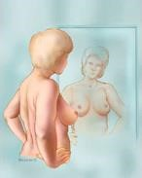
Step 1: The woman stands in front of a mirror, pressing her hands firmly down on her hips. This position helps to contract the chest wall muscles and enables visualization of any breast changes.

She will be looking at the size, shape, color .and contour noting any dimpling, redness, scariness of the nipple or breast skin.

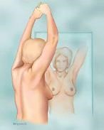
Step 2: The woman raises her arms and looks for the same changes as mentioned above. The woman must examine both underarms while sitting up or standing with her arms slightly raised

Step 3: While at the mirror, the woman looks for any
discharge coming from the nipples; for example, watery, milky or yellow fluid or blood.

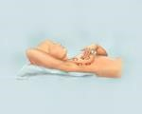
Step 4: The woman lies down with her right arm behind her head. This position spreads the breast tissue evenly over the chest wall, making it easier to feel. The woman uses the three middle finger pads of her left hand to feel for any right breast lumps. The woman needs to apply light pressure to feel the tissue closest to the skin; medium pressure to feel deeper, and firm pressure to feel the tissue close to the chest and ribs.
The woman examines her left breast by putting her left arm behind her head and using her right-hand finger pads to do the examination.
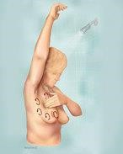
Step 5: Finally, the woman feels her breasts while she is standing or sitting. Most women find that the easiest way to feel their breasts is when their skin is wet and slippery, so they like to do this in the shower. The woman has to cover her entire breast, using the same hand movements described in step 4. Finally, the woman feels her breasts while she is standing or sitting.
Figure 2.1 Five steps in breast self-examination
(Source: Breastcancer.org.2016)

2.4 knowledge, attitude and practice of BSE studies:
A quantitative cross-sectional study under the title knowledge, attitude and practice of breast self-examination among undergraduate health science female students done by Hazne Azira Romli, Kasmah Wati Pardi was conducted in one of the public universities in Kelantan, Malaysia from December 2014 to February 2015.
This study aimed to assess the level of knowledge, attitude and practice (KAP) of BSE among undergraduate health science female students. A self-administered questionnaire to assess KAP of BSE was used.
The samples consisted of 220 undergraduate health science female students. Samples were recruited using simple random sampling method and used self-administered questionnaire.
Most of the respondents (89.5%) have heard about BSE and more than half (52.3%) of them knew that they should have started practicing BSE from the age of 18 to 20 years. However, less than half of the respondents (39.5%) knew that they should start practicing BSE a week after menstrual period. Sadly, more than three quarters (77.3%) claimed to practice BSE only rarely.
This study found that the undergraduate health science female students had good knowledge, positive attitude, but poor compliance in practicing BSE so they should have a good practice of BSE to reduce the incidence of breast cancer among them. Therefore, a structured health and educational programme is highly recommended to improve their compliance to practice BSE [18].

A descriptive cross-sectional survey research, under title knowledge, attitude, practice of breast self-examination among women in Qua’an pan local government area of plateau state, Nigeria conducted in march 2018, done by Dr. Emmanuel H. Da’am.
It aimed to determine the knowledge, attitude and practice of breast self-examination among women in Qua’an pan l.g.a. Of plateau state, Nigeria. The data collected by questionnaire.
The findings of the study revealed that the women’s level of knowledge and practice of breast self-examination was generally low (2039%, and 64% respectively), but the women have positive mean attitude of 3.07% towards breast self-examination [19].

Knowledge, attitude and practice of breast self-examination among females in medical and non-medical colleges in Qassim University, burayadah, Saudi Arabia. A cross-sectional study done by Safiya K Ibnawadh, Mashael A Alawad, Shorouq S Alharbi, Nada A Alduawihi, Feda S Alkowiter, Anfal E Alsalhy, Ameerah A Alzahrani, Lamia A Alenizy was conducted during 2014-2015.
It aims to investigate any difference between females in medical and non-medical colleges for knowledge and attitude of breast self-examination (BSE) and practice of BSE.
Cluster random sample method was used. The sample size consisted of 365 females. A confidential and self-administered questionnaire was used to collect data.
Results: Age range of the study participants was from 18 to 55 years, with a mean of 20.3 years. Regarding their knowledge levels about BSE, 95.8% of medical students had heard of BSE in comparison to 93.3% of non-medical students. Social media was the most commonly reported source of BSE information (50.14%). They found that 49.7% of medical students had carried out BSE previously in comparison to 35.71% of the non-medical students.
Conclusions: Both medical and non-medical students showed lack of knowledge in BSE and even though their attitude towards it was positive, medical students had a better attitude towards it.
Regarding the practice, the percentage of medical students who perform BSE was higher than that of non-medical students [20].

In a descriptive cross sectional study, conducted by Amir A. Hamza, Mohamed M. Hafiz, Mohammed Eltayeb A. Ali, Gamal E. H: A. El shallaly in female of final year medical student in three governmental universities participated, with title knowledge, attitude and practice of breast self-examination among final years’ female medical students in Sudan in December 2013.The Aim of study is to determine the knowledge and practice of female Sudanese medical student regarding breast self-examination. Questionnaire was used on for data collection.
Result found two hundred student participated in the study, their age arranged from 18to29 with mean of 23years old. Most respondent 86%wear aware of BSE.
Nevertheless, only two third of respondents reported preforming BSE; which shown that the knowledge and practice of BSE is inadequate among young female medical student. Suggest there is need for continuing education programs to change the attitude and behavior towards breast self-examination. Cumulatively 62,9%of respondent knew the Advantage of breast self-examination,74,5%of them can take care about themselves by BSE and in 64,5%regularly monthly self-examination might help in find lump early [21].

Chapter Three
Materials and Method

3.0 Materials and Method
3.1 Study design:

Descriptive cross sectional community based study was conducted among 18-45 years females in altekaina village to assessed knowledge, attitude and practice of BSE in June2018.

3.2 Study Area:

Altekaina village is located in Almassed unit, Al kamlin district, Al Gezira state. Altekaina is about 70km south of the state of Khartoum and bordered on the east by Blue Nile and on the west by Khartoum-Madani street, on the north by Ummaged village and on south by Al Bshagra gharb village. The area altekaina is 3 square km long and 1km wide. According to 2017 statistical count, population capacity was 18800 citizens, and the number of females 9000, nearly half of them were housewives.

3.3 Study population:

Reproductive age females 18-45 years.

3.3.1 Selection & inclusion criteria
This study included every female between 18-45 years. Any female who undergone mastectomy and not originally from Altekaina were excluded from the study.

3.4 Study variables:

1.knowledge, attitude regard BSE.
2.Sociodemographic: age, social status, educational level, occupation.
3.Performance of participants on practice.

3.5 Sample size:
$$n=\frac{ z^{2}pq}{σ^{2}}$$
n = sample size p = prevalence (0.48) q= 1-p
z =stander deviation (1.96) σ= sample error (0.05)
n= 384 female

3.6 Study tools:

Knowledge, attitude and practice measured by interview questionnaire.

3.7 Method of data collection:

We selected females by systemic random method. by a self-administered pre-tested close-ended questionnaire.
The questionnaire contained the following sections:
Section A Personal and sociodemographic data such as age, educational level and marital status, Family history of breast cancer.
Section B contained four items regarding their knowledge about BSE. We included questions about whether they know BSE and the meaning of it and the resources they learnt it from. We also asked details about the age and time at which BSE must be performed, whether they believe in its efficacy. Three marks were given for a correct answer; 2 marks for answering I don’t know; and 1 mark for an incorrect answer. The score for the knowledge items ranged between 4 and 12. Participants with an excellent knowledge of BSE would score between 10 and 12 marks; participants with an average knowledge of BSE would score between 5 and 9; while participants with a poor knowledge of BSE would score between 0 and 4 marks. Questions about their attitude regarding BSE.
Also contained five items on the practice of BSE. The participants were asked to report whether or not they practice BSE; how often they practice BSE; at what time they practice BSE; if they were knowing the five correct steps of performing BSE. No specific score would be awarded for this section.

3.8 Analysis:

Data were analyzed using statistical package for social science (SPSS) version21. We used chi square test to define the relationships between (age, educational level) and level of knowledge.

3.10 Ethical consideration:

Permission to collect data was requested and obtained from popular committee of village. All data included in this research was collected after approval verbal informed consent from all participants and this research document information followed all research ethical guidelines in collection and present.

Chapter four
Results

4.0 Results

A total of 384 reproductive age females from altekaina were targeted participated in this study. All of them complete the questionnaire of this study giving a response rate of (100%). The age of the participants ranged from 18 to 45 years.
4.1 Section A: Respondents’ demographic data
Table 4.1 respondents’ sociodemographic characteristics (n=384).
Variable | Frequency | Percentage
Age
18-25  26-30  31-35  36-40  41-45 | 151  84  43  64  42 | 39.3  21.9  11.2  16.7  10.9
Total | 384 | 100.0
Level of education
Primary  Intermediate  High school  University  Khalawi | 56  35  168  97  28 | 14.6  9.1  43.8  25.3  7.3
Total | 384 | 100.0
Social status
Single  Married  Divorced  Widowed | 63  234  56  31 | 16.4  60.9  14.6  8.1
Total | 384 | 100.0
Occupation
Governmental  Private  Freestyle  Housewife  Student | 54  36  23  257  14 | 14.1  9.4  6.0  66.9  3.6
Total | 384 | 100.0

4.2 Section B: Respondents’ knowledge, attitude and practice of BSE

Table 4.2 Respondents’ knowledge of definition of BSE (n=384).

Knowledge | Frequency | Percentage
Poor  Average  Excellent | 154  110  120 | 40.1  28.6  31.3
Total | 384 | 100.0

Table 4.3 Respondents’ knowledge of definition of BSE according to age category (n=384).

Age | Level of knowledge |  |  | Total
Age | Poor | Average | Excellent | Total
18-25  26-30  31-36  37-40  41-45 | 55  39  15  32  14 | 55  13  12  15  13 | 40  32  16  17  15 | 151  84  43  64  42
Total | 155 | 109 | 120 | 384

Figure 4.1 Respondents’ knowledge of definition of BSE according to educational level (n=384).

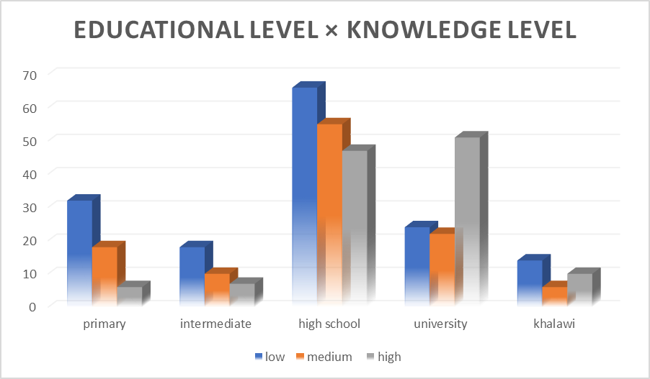

Figure 4.2 Respondents’ performance of BSE (n=384)

Figure 4.3 Respondents’ frequency of performing BSE (n=74)

Figure 4.4 Respondents’ knowledge of right technique of BSE (n=74)

Figure 4.5 Respondents’ impression about BSE (n=74)

Chapter five
Discussion, Limitation, Conclusion, Recommendation

5.1 Discussion

This study was conducted to assess the level of knowledge, attitude and practice of BSE among reproductive age females in altekaina. The respondents in this study showed they had poor knowledge on BSE 40.1%. The finding of this study is similar to those of studies conducted among female of final year medical student in three governmental universities participated in Sudan 2013 by Dr. Amir A. Hamza which found that most respondent 86% were aware of BSE [21], also the study done by Dr. Emmanuel H. Da’am in Nigeria revealed that the women’s level of knowledge of breast self-examination was low (20.39%) [19]. On other hand, study done by Safiya K Ibnawadh was conducted during 2014-2015, among females in medical and non-medical colleges in Qassim University, burayadah, Saudi Arabia, regarding their knowledge levels about BSE, 95.8% of medical students had heard of BSE in comparison to 93.3% of non-medical students [20]. We expected this finding as they living in a rural area and no previous orientation campaigns about BSE.
Meanwhile, for the practice of BSE, this study has shown that only 19% of respondents practiced BSE. this result is very least compare to study done in Qassim university, Saudi Arabia,2014-2015, They found that 49.7% of medical students had carried out BSE previously in comparison to 35.71% of the non-medical students [20]. But it is similar to Dr. Emmanuel H. Da’am’s study, revealed that the women’s level of practice of BSE was generally low 64% [19]. Also, Dr. Amir A. Hamza found that only two third of respondents reported preforming [21].
Unfortunately, more than three quarters of our participants (84.6%) claimed to practice BSE only rarely, that was similar to previous study done by Dr. Hazne Azira Romli, in Malaysia, revealed that the (77.3%) claimed to practice BSE only rarely [18]. But Dr. Amir A. Hamza found that 64.5%of respondents were practicing it regularly on a monthly basis [21].
With regard to knowing the right technique of BSE only fewest number (18%) known the right technique. In the study done by Dr. Amir A. Hamza reported that study revealed that 46.5% of participants can perform BSE correctly [21].
Regarding attitude towards BSE, the result of our study revealed that 66% of the respondents had positive attitude towards BSE, this is in agreement with the result obtained by Dr. Emmanuel H. Da’am conducted in Nigeria march 2018, revealed that positive mean attitude of 3.07% towards BSE [19].
About 4.5% of respondents reported that the BSE was embarrassing to them. This is in agreement with the result obtained by Dr. Amir A. in Sudan where it was embarrassing in 14.5% [21].

In our study, the relation between age and excellent levels of knowledge found among the age range (18-25) were 40 females from 151 total of excellent levels of knowledge. We expected that because this age range having more connection with social media and internet
With regard to respondents’ knowledge of definition of BSE according to educational level, our study revealed that excellent levels of knowledge detected among university students were (51) from 120 total of excellent levels of knowledge. We expected that because this educational level may have had orientation lectures and educational materials such as posters and leaflets freely available at universities.

5.2 Limitation

- The study was confined to females at Altekaina village and cannot generalized to all Sudanese females.
- Many answers in the questionnaire were subjected to female educational level and social limitations.

5.3 Conclusion

In conclusion, respondents in this study had positive attitudes towards BSE, but their compliance in knowledge and practicing BSE was poor. Therefore, it is important for continuing to continue education programs to play the important role of inculcating the knowledge and practice of BSE among reproductive age women of altekaina village.

5.4 Recommendations

Based on the findings, we make the following recommendations for practice and further research.
In order to bridge the gap between knowledge and practice of BSE, the Ministry of Health should design and implement an intensive health education programme for schools, colleges, universities, hospitals and clinics. We suggest that campaigns be started to increase awareness about BSE and breast cancer screening for women. In addition, educational materials such as posters and leaflets should be freely available at hospitals and clinics to facilitate better learning.
Furthermore, researches are needed to identify the causes of inadequate knowledge of BSE and breast cancer screening among females in Sudan.

References

[1] | c. harper, Collins English Dictionary, 4. edition, Ed., Glasgow, 1994.
[2] | A.-N. D. B. Y. C. R. Al-Naggar RA, "practice and barriers toward breast self examination among malaysian women," Asian Pacific J Cancer Prev, vol. 12, pp. 1173-1178, 2011.
[3] | A. T. O. G. Kayode FO, "knowledge,attitude and practice of breast self examinatio among female secondry school teachers in Ilorin,nigeria," european journal of scientific research , vol. 3, no. 10, pp. 42-47, 2015.
[4] | M. J. V. M. T. M. Sreedharan J, "Breast Self-Examination: Knowledge and Practice among Nurses in United Arab Emirates," Asian Pacific J Cancer Prev, vol. 11, pp. 651-654, 2010.
[5] | "breast self-exam for breast awareness," [Online]. Available: www.mayoclinic.org/tests-procedures/breastexam/basics/prc-20020418. [Accessed 17 6 2018].
[6] | N. R. NH., " Knowledge, Attitude and Practice of Breast Self-examination Among Women in a Suburban Area in Terengganu, Malaysia," Asian Pacific J Cancer Prev, vol. 11, pp. 1503-1508, 2010.
[7] | J. Berry, "Worldwide statistics on breast cancer," 26 april 2017. [Online]. Available: https://www.medicalnewstoday.com/articles/317135.php. [Accessed 27 april 2018].
[8] | N. S. El Saghir, M. . K. Khalil , T. Eid , A. R. El Kinge, M. Charafeddine , F. Geara, M. Seoud and A. . I. Shamseddine, "Trends in epidemiology and management of breast cancer in developing Arab countries: A literature and registry analysis☆," International journal of surgery, vol. 5, no. 4, pp. 225-233, august 2007.
[9] | E. M. Elgaili , D. Abuidris, M. Rahman, A. M. Michalek and S. . I. Mohammed, "Breast cancer burden in central Sudan," august 2010. [Online]. Available: https://www.researchgate.net/publication/47756204_Breast_cancer_burden_in_central_Sudan. [Accessed 27 april 2018].
[10] | M. C. W. S. e. a. Parkin DM, " Cancer incidence in five continents," ARC Scientific Publication, IARC Lyon , vol. 120, pp. 13 -16, 1992.
[11] | U. Y. Tasçi A, "comparison of knowledge and practices of breast self examination (bse). a pilot study in turkey," asian pacific J cancer prev, vol. 11, pp. 1417-1420, 2010.
[12] | U. M. S. E. e. a. Kiliç S, "Determination of the knowledge and practice level of breast self-examination among the nurses of the gata hospital, the students of the gata nursing school and some female patients," Gülhane Med J., vol. 48, pp. 200-4, 2006.
[13] | "breast cancer," 11 march 2017. [Online]. Available: https://www.cancercenter.com/breast-cancer/risk-factors/. [Accessed 27 april 2018].
[14] | f. o. stephens and r. k. aigner, basics of oncology, london - new york : springer dordecht heidelberg, 2009, pp. 154-365.
[15] | C. Nordqvist, "What you need to know about breast cancer," 27 november 2017. [Online]. Available: https://www.medicalnewstoday.com/articles/37136.php. [Accessed 4 may 2018].
[16] | "Breast Cancer Tests: Screening, Diagnosis, and Monitoring," 1 February 2018. [Online]. Available: http://www.breastcancer.org/symptoms/testing/types. [Accessed 4 may 2018].
[17] | "How to Do a Breast Self-Exam: The Five Steps," 19 February 2018. [Online]. Available: http://www.breastcancer.org/symptoms/testing/types/self_exam/bse_steps. [Accessed 27 april 2018].
[18] | H. A. Romli and K. W. Pardi, "KNOWLEDGE, ATTITUDE AND PRACTICE OF BREAST SELF-EXAMINATION AMONG UNDERGRADUATE," International Journal of Public Health and Clinical Sciences, vol. 4, no. 5, pp. 2289-7577, September/October 2017.
[19] | E. H. Da’am , "knowledge, attitude, practice of breast self-examination among women in Qua’an pan local government area of plateau state, Nigeria," Researchjournali’s Journal of Public Health, vol. 4, no. 3, p. 18, march 2018.
[20] | S. K. Ibnawadh, M. A. Alawad, S. S. Alharbi, N. A. Alduawihi, F. S. Alkowiter, A. E. Alsalhy, A. . A. Alzahrani and L. A. Alenizy, "Knowledge, attitude and practice of breast self-examination among females in medical and non-medical colleges in Qassim University," Journal of health specialties, vol. 5, no. 4, pp. 219-224, 2017.
[21] | S. . A. Idris, A. A. Hamza, M. M. Hafiz, M. E. A. Ali and G. . E. H. A. El Shallaly, "Knowledge,attitude and practice of breast self examination among final years female medical students in Sudan," International Journal of Public Health Research, vol. 1, no. 1, pp. 6-10, 30 december 2003.

Annexes
Annex A: Questionnaire
بسم الله الرحمن الرحيم
جامعة بحري
كلية الطب – المستوي الخامس
إستبيان عن مدي فهم ومعرفة الكشف الذاتي لسرطان الثدي

- العمر: 18 -25 ( ) 26 – 30 ( ) 31 – 36 ( ) 37 – 40 ( ) 41 – 45 ( )
- الحالة الإجتماعية: عزباء ( ) متزوجة ( ) مطلقة ( ) أرملة ( )
- المراحل الدراسية: أساس ( ) متوسط ( ) ثانوي( ) جامعي( ) أخرى ............
- الوظيفة: طالبة ( ) ربة منزل ( ) اخرى .................
- هل سمعتي من قبل بسرطان الثدي ؟ نعم ( ) لا ( )
إذا كانت الإجابة بنعم من أين ؟ التلفزيون ( ) الراديو ( ) الصحف ( ) وسائل التواصل الإجتماعي ( ) أخري ( )...............
- في رايك ماهي أعراض وعلامات مرض الثدي ؟ ظهور ورم في الثدي( ) ظهور ورم علي الإبط ( )
ألم في الثدي ( ) خروج إفرازات غير طبيعية من حلمة الثدي ( )
- هل هناك حالات إصابة بسرطان الثدي في منطقتكم ؟ نعم ( ) لا ( )
- إذا كانت الإجابة بنعم من المصاب ؟ أم ( ) أخت ( ) خالة( ) عمة ( ) اخرى ......
- هل يمكن إكتشاف سرطان الثدي في مرحلة مبكرة ؟ نعم( ) لا ( )
- هل سمعتي عن الكشف الذاتي لسرطان الثدي ؟ نعم ( ) لا ( )
- إذا كانت الإجابة بنعم من أين ؟ التلفزيون ( ) الراديو ( ) الصحف ( ) وسائل التواصل الإجتماعي ( ) أخرى ...........
- ما فائدة الكشف الذاتي برايك ؟ مهم للكشف المبكر لسرطان الثدي ( ) لا فائدة منه ( ) لا أعرف ( )
- ما هو أنسب وقت للكشف الذاتي ؟ قبل الدورة الشهرية ( ) أثناء( ) بعد ( ) لا أعرف ( )
- في أي عمر يبداء الكشف الذاتي ؟ أقل من 18 ( ) أكثر من 18 ( ) لا أعرف ( )
- هل قمتي بالكشف الذاتي من قبل ؟ نعم ( ) لا( )
- إذا كانت الإجابة بنعم ، كم مرة ؟
مرة إسبوعيا ( ) مرة شهريا( ) مرة سنويا ( ) أحيانا إذا كان لدي وقت( )
- ماهو إنطباعك عن الكشف الذاتي لسرطان الثدي ؟ عادي ( ) مخجل ( )
- هل تعرفين الطريقة الصحيحة للكشف الذاتي ؟ نعم ( ) لا ( )

Annex B: Map of study area (Altekaina)
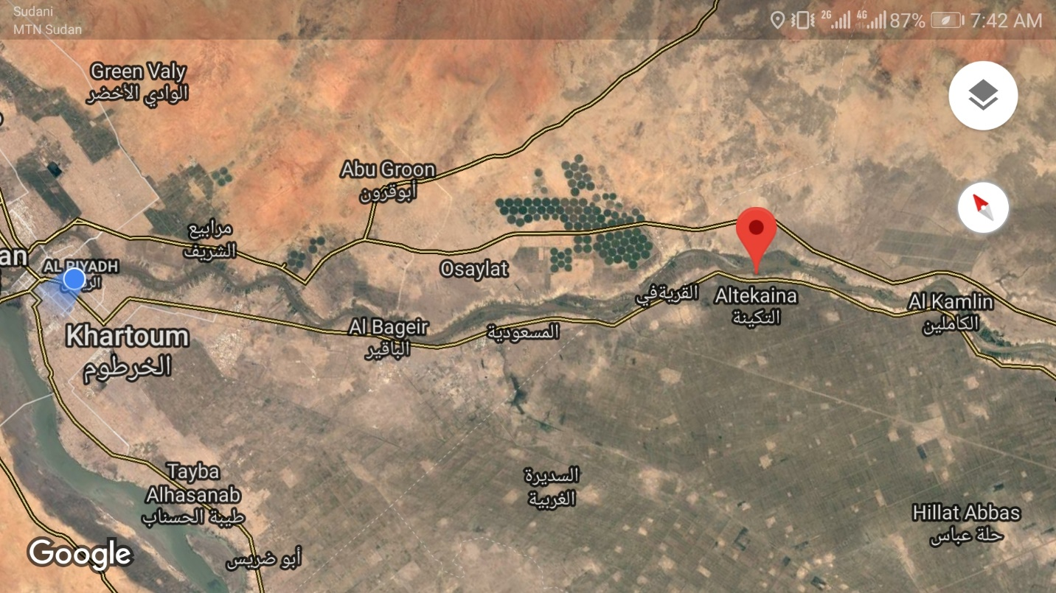

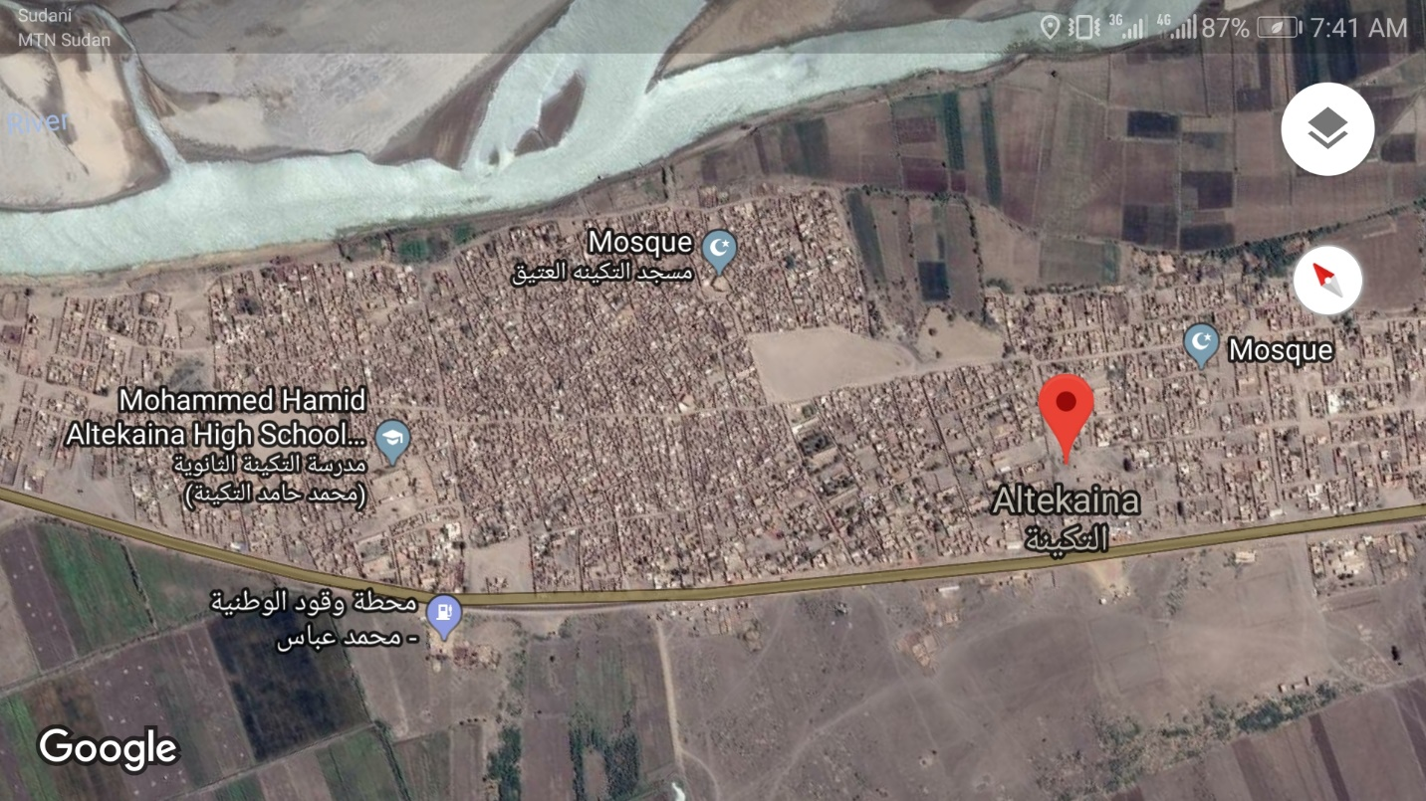
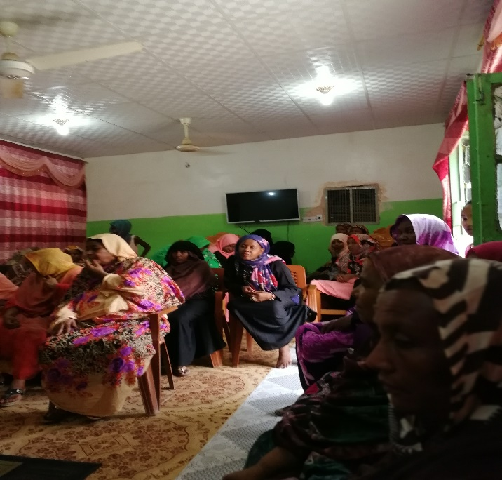
Annex C: Orientation session about BSE


