Title: Epigenetic maternal somatic landscapes: Rewriting historical obstetric models to convey epigenetic environmental influences impressing upon maternal-foetal bodies.

Clare Nicholson.
University of New South Wales Art and Design, Sydney, Australia.

Abstract

Epigenetics is a comparatively new line of inquiry that shows how environmental influences have the ability to impress upon the body, altering gene expression, without altering the sequencing of DNA. This alteration is said to be transferable across generations. Epigeneticists are particularly interested in maternal-foetal programming; how detrimental environmental exposures by gestating women can induce heritable foetal plastic changes leading to offspring adversity and adult-onset chronic disease (Kenny and Müller, 2017; Heijmans et al, 2009). This pathogenesis theory is called the Developmental Origins of Health and Diseases (DOHAD) (Burgio, 2015).

Epigenetic maternal ‘risk’ is rapidly being integrated within public health discourses, clinical texts and across popular media, with women’s ‘environments’ and reproductive bodies (or more succinctly the uterus), becoming increasingly explored. Lock (2017) states, “… the environment in this type of research is effectively scaled down to molecular activity inside a single organ of the body – the uterus and its foetal contents.” Such selective scientific approaches regarding acquired molecular biomechanisms not only frame and direct bodies in particular ways, but also create societal attitudes towards those who inhabit such bodies - culturally, politically, racially, geographically, legally, economically, medically, socially, ethically and philosophically. Consequently, mothers and their ‘lifestyle choices’ are increasingly attracting attention and opinion, with an onus of responsibility placed on mothers to control and manage their environmental exposures.
Low socioeconomic status is of great concern to many epigeneticists concerning maternal ‘risk’, so using the non-traditional anatomical model-making materials of bronze and silver-plate, I rework William Smellie’s gravid uterus from his 1754 medical treatises to create the obstetric model entitled Silver Spoon. By fusing this historical illustration with materials that are loaded with hierarchical cultural baggage I convey an alternative socio-political framing of women’s gestational bodies to question the empirical measures of ‘wealth’. In this way my unusual iterations of a speculative obstetric model questions if gestational bodies can be understood differently - to include and question epigenetic exterior environmental influences.
Unlike traditional anatomical models, my material selection and structural artmaking elements target issues relating to the entanglement of dominating societal power networks and political structures as a way of re-defining and re-presenting biological inequity driven by economic, gender and racial disadvantage; the ramifications of epigenetic biopolitical subjugation resulting in the production and reproduction of altered bodies. Silver Spoon challenges the homogenised messages embedded within traditional gestational models, articulating instead a partial understanding of lived maternal lives and mothering experiences. In this way my work speaks of larger societal influences materialising through maternal-foetal bodies that transcend the responsibility of the individual mother.

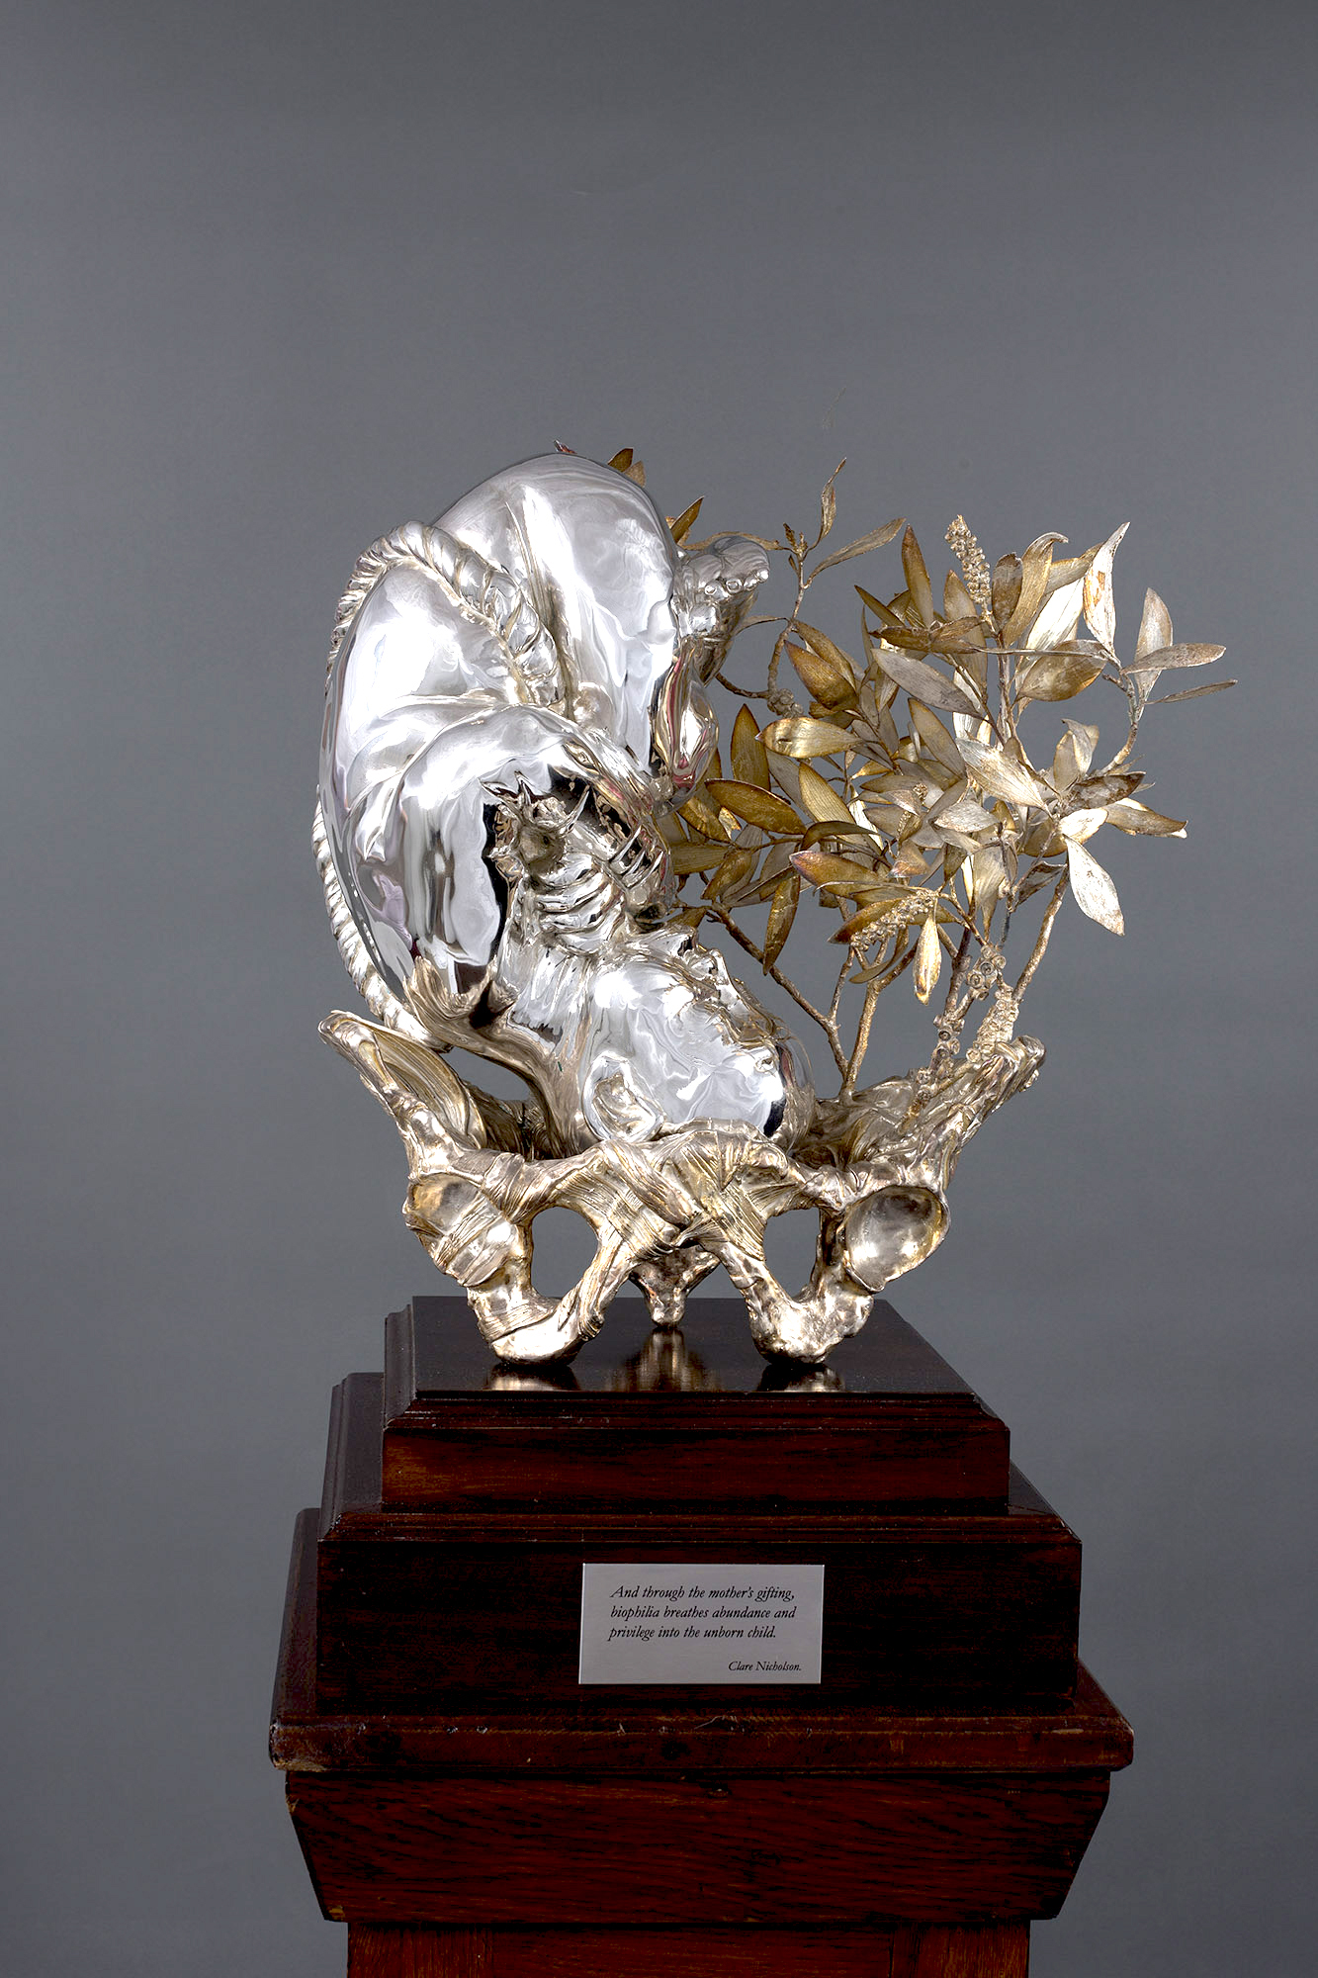
Clare Nicholson. Silver Spoon, (2018). Bronze, Silver-plate, antique oak, stainless steel.

References
1) Kenney, M., & Müller, R. (2016). Of rats and women: Narratives of motherhood in environmental epigenetics. BioSocieties. 12(1), 23-46. doi: 10. 1057/s41292-016-0002-7
2) Heijmans, B. T., Tobi, E. W., Lumey, L. & Slagboom, P. E. (2009). The epigenome: Archive of the prenatal environment. Epigenetics, 4(8), 526-531. doi: 10.4161/epi.4.8.10265
3) Burgio E. (2015). Environment and Fetal Programming: the origins of some current “pandemics”. Journal of Pediatric Neonatal Individual Medicine, 4(2). doi: 10.7363/040237
4) Lock, M. (2017). Recovering the Body. Annual Review of Anthropology, 46, 1–14. Retrieved from https://doi.org/10.1146/annurev-anthro-102116-041253

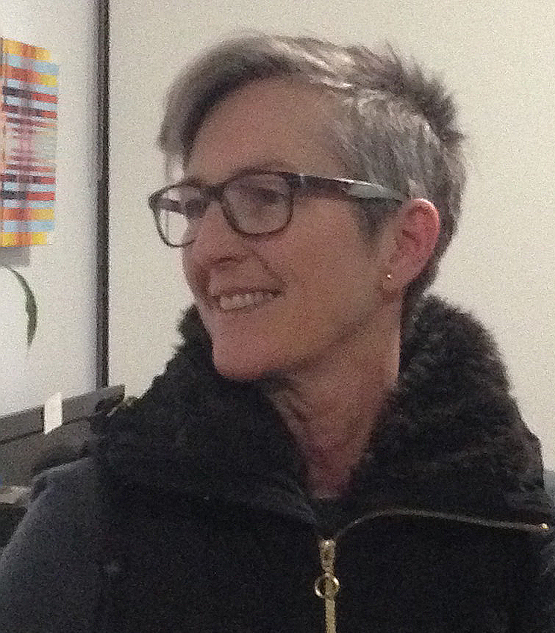

Biography:

Clare Nicholson is a Sydney-based sculptor completing her practice-led PhD on epigenetic and maternal-foetal programming. With a distant nursing background, Nicholson has a fascination for how the internal body is positioned and understood across clinical settings and the public domain. She holds a Master of Fine Art research degree (first class equivalent), Graduate Diploma of Education degree (first class equivalent) and a Bachelor of Arts honours degree. Nicholson exhibits and presents at academic conferences regularly.

- Full Name: Clare Louise Nicholson
- Personal email: info@clarenicholson.com
- Website: www.clarenicholson.com
- Mobile Number: +61 402525087
- Category: Oral presentation with projected images
- Date of Birth: 30/05/1960
- Postal Address: 264 Hawthorne Parade, Haberfield, NSW 2045.

Email: info@clarenicholson.com

