PROBLEMS ASSOCIATED WITH SMALL SCALE PLASMID DNA ISOLATION, RESTRICTION DIGESTION AND AGAROSE GEL ELECTROPHORESIS
Magaji, S. B.tech, PGD, Msc. ATAPOLY, Bauchi Nigeria. Magnus, E. Bsc. Msc ATAPOLY, Bauchi Nigeria

Abstract
Two experiments on alkaline lysis method of plasmid DNA isolation was carried out utilizing strains of E.coli JM109, a non- pathogenic bacteria that has been deliberately disabled. Restriction digests and gel electrophoresis carried out. The result of the first gel electrophoresis reveals only traces of RNA, hence no DNA fragments on the samples loaded labeled A to D this could be attributed to possible contamination from the procedures. For the second gel electrophoresis samples, A is plasmid free, B and C contains small fragments approximately 2.3 to 5.6 and D contains the fertility plasmids.

Image

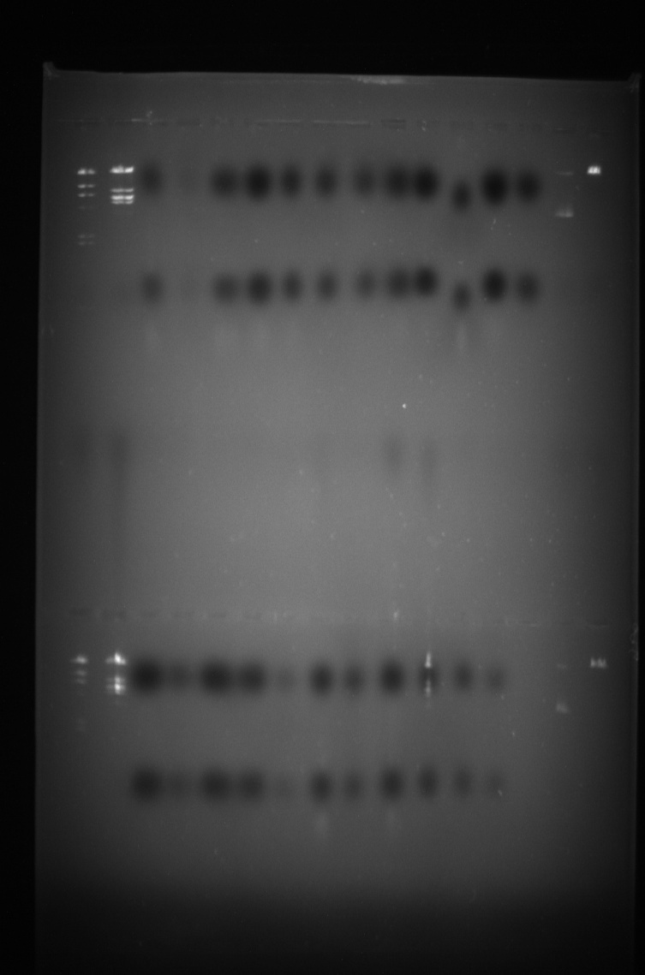

References
- Brown, T. (2010) Gene cloning and DNA analysis: an introduction. [online] John Wiley & Sons.
- Gellar, B., Trempy, J. and Field, K. (2012) Molecular microbiology laboratory: a writing-intensive course. [online] Academic Press.
- Ishido, T., Ishikawa, M. and Hirano, K. (2010) Analysis of supercoiled DNA by agarose gel electrophoresis using low-conducting sodium threonine medium. Analytical Biochemistry [online], 400(1), pp. 148-150 .Room R, BaborT, Rehm J (2005) Alcohol and public health.Lancet
365: 519-530.
4. Sullivan EV, Zahr NM (2008) Neuroinflammation as a neurotoxic mechanism in alcoholism: Commentary on “Increased MCP- 1 and microglia in various regions of human alcoholic brain”. Experimental neurology 213:10-17.
5. Wang, J., Stephan, R., Power, K., Yan, Q., Hachler, H. and Fanning, S. (2014) Nucleotide sequences of 16 transmissible plasmids identified in nine multidrug-resistant Escherichia coli isolates expressing an ESBL phenotype. The Journal of antimicrobial chemotherapy [online], 69(10), pp. 2658-

Biography
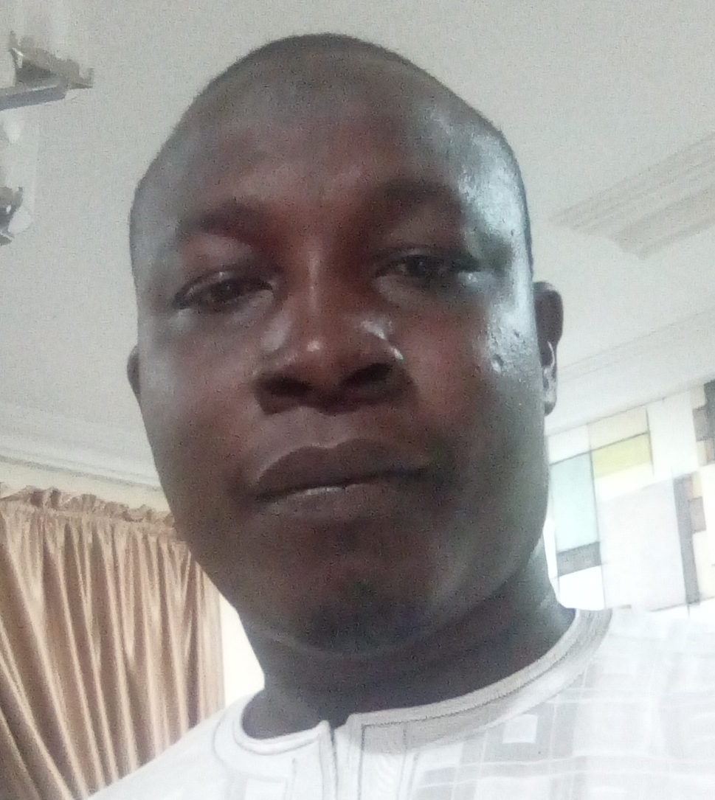
Sanusi Magaji is a carrier academic with special interest in biological sciences specifically molecular biology, health sciences and bioinformatics. Born 1979 in Bauchi city of Nigeria, Sanusi holds a bacheclor of technology from ATB University Bauchi, PGD public health ATB Bauchi, Msc Molecular Biology with Bioinformatics University of Wolverhampton. Sanusi is a lecturer at the department of science lab. Tech. ATAPOLY Bauchi Nigeria. Sanusi has a special interest on bioinformatics analysis of CCR5 in HIV therapeutics.
Email: limaminchanji@yahoo.com
Contact No.:+2348034254060

